**SUMMERIZE OF FINDINGS**

**EXPLANATORY OF THE DATA**

**Timeline of the Production Band**

We analysed defect Timeline Chart according to the product types.

There is not a specific time interval for defects, but it spreads along to all dates in general.

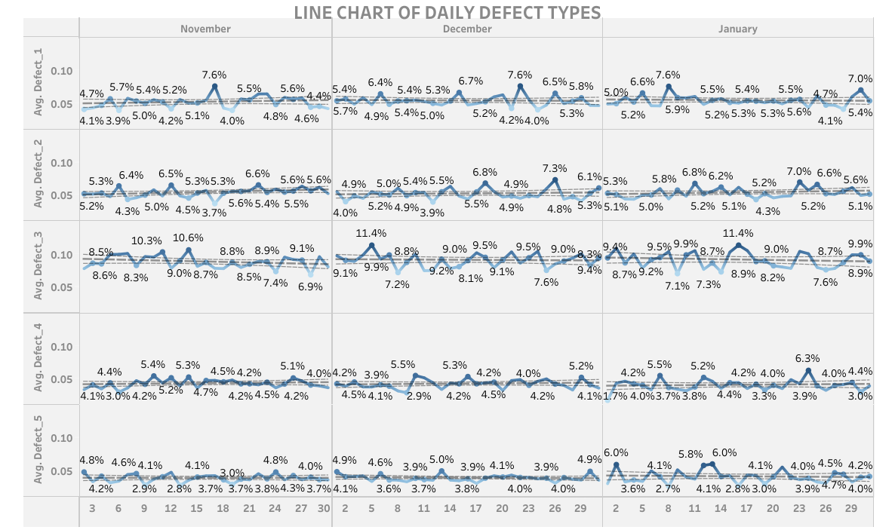

**Zone Duration Analysis of Production Band**

We made the comparison that time spends on zone & between zones for each SKUs.

* We identified that there is no noticeable time difference between zones for each SKUs.
* Customer confirmed that information along with a note that the reason we don’t see much difference between zones is the automation process in place.

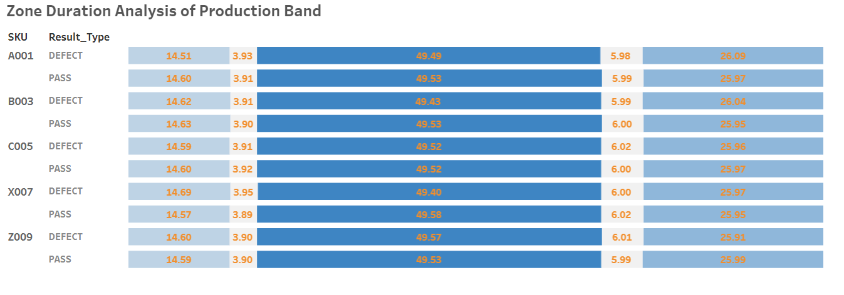

**ANALYSIS**

**ANOVA and REGRESSION**

We have identified some pain points based on temperature and humidity for the production positions of products in the Zone3 region. When we solve these specific points, we increase production quality and decrease the defect cost of products. This will save us up to 4 – 7.5 million euros in cost savings.

We reached these information using firstly Anova than Regression for Zone3 in all SKUs .

Here are the findings:

* Each defected product coming over 326 and 846 positions decrease the temperature of Zone3 by 0.25 C degrees. If the defected product comes over 631 position, it increases the temperature of Zone3 by 0.25 C degrees.
* Each defected product coming over 326 position increases humidity of Zone3 by 0.3.
* If the defected product SKU is C005, it increases the humidity of Zone3 by 0.1.

**FINDINGS FOR A001 PRODUCT**

**SKU - Zone Area Relation of Defects**

Besides, the findings above, we have more information, especially the A001 SKU product.

Here are my findings:

* As you see from SKU-Zone analysis for Defect graph below, A001 product is always getting high defect ratio for every zone.
* According to information from Customer, due to the fragility of A001 product, it is expected that we see a high defect ratio.
* Furthermore, we observed in our Zone3 analysis, each defected A001 product coming over 531 ,534 ,631 positions, creates a difference in Zone3 temperature +/- 0.6 C degrees.
* This will save us up to 500,000 euros in cost savings.

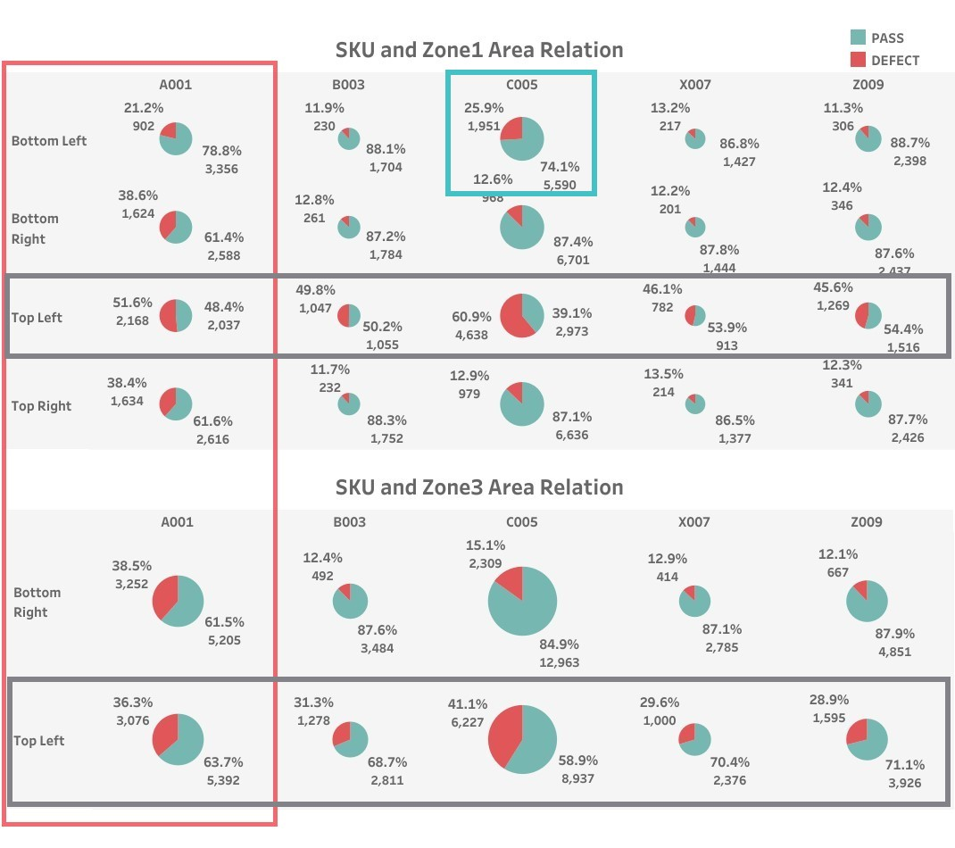

**SUMMARIZE**

According to the graphics and our analysis:

**OVERALL**

* Top Left path on Zone 1 & Zone 3 always produce high defective products
* Product defects are highly correlated with temperature on Zone3, especially in 326 ,486 ,631 positions.
* Product defects are highly correlated with humidity on Zone3 in 326 position.
* C005 product defects are highly correlated with humidity on Zone3.

|  |  |  |
| --- | --- | --- |
|  | All_Zones | |
| Zone_Position | min | max |
| 326 | 1,490,364 | 2,687,663 |
| 631 | 966,585 | 2,080,255 |
| 846 | 1,556,206 | 2,855,008 |
| Total savings | 4,013,155 | 7,622,926 |

Suggestions:

Actions to reduce cost:

* You can save maintenance costs up to 4 – 7.5 million euros by fixing 326 ,846 ,631 positions on Zone3 according to our statistical analysis.
* You can save maintenance costs up to 1 million euros by fixing 326 positions for C005 on Zone3 according to our statistical analysis.

Areas for development:

* We highly recommend fixing issues seen on Top Left path on Zone 1 & Zone 3
* Taking necessary actions for humidity in 326 position on Zone3, besides on Zone3 for C005 to reduce defect ratio, maintenance costs and increase profits overall.
* C005 has high defect at Bottom Left area in Zone 1 and needs improvements. Our analysis also shows that, this issue is not statistically correlated with temperature or humidity. To able to nail down root cause, we need more time to analyze this defect details.

**A001**

* A001 product have higher defect rate as oppose to other products overall.
* A001 product defects are highly correlated with temperature on Zone1/Bottom Left & Zone2/Top Left paths in 531 ,534 ,631 positions.

|  |  |  |  |
| --- | --- | --- | --- |
|  | Zone3 | | |
| Zone_Position | c005 | A001 | Total_savings |
| 326 | 958,400 |  | 958,400 |
| 531 |  | 253,890 | 253,890 |
| 534 |  | 270,165 | 270,165 |
| 631 |  | 273,420 | 273,420 |
| Total savings | 958,400 | 797,475 | 1,755,875 |

Suggestions:

Actions to reduce cost:

* You can save maintenance costs up to 800,000 euros by fixing 531 ,534 ,631 positions on Zone3 according to our statistical analysis.

Areas for development:

* We highly recommend improving product quality or take necessary actions throughout production line for A001 to reduce defect ratio, maintenance costs and increase profits overall.