Hospital Appointment System

Requirements Specification and Analysis

Version 0.1

03.07.2016

Muhammed Bilal Kutlu

Dilara Turanlı

Didar Turanlı

Duygu Ergin

Prepared for

SE301 Software Engineering



Table of Contents

1. Introduction 1

1.1. Purpose of the System 1

1.2. Scope of the System 1

1.3. Objectives and Success Criteria of the Project 1

1.4. Definitions, Acronyms, and Abbreviations 1

1.5. Overview 1

2. Current System 1

3. Proposed System 1

3.1. Overview 1

3.2. Functional Requirements 2

3.3. Nonfunctional Requirements 2

Usability 2

Reliability 2

Performance 2

Supportability 2

Implementation 2

Interface 2

Packaging 2

Legal 2

3.4. System Models 2

Scenarios 2

Use case model 2

Object model 2

Dynamic model 2

User interface—navigational paths and screen mock-ups 3

4. Glossary 3

5. References 3

6. Project Plan 3

REQUIREMENTS ANALYSIS DOCUMENT

# Introduction

## Purpose of the System

* Hospital Appointment System (HAS) is a web-based application that provides the users get appointment from the hospital. It is like hospital automation.
* There are two level of users;

1. User
2. Administration
3. Staff

* We will call Hospital Appointment System as HAS.
* HAS includes a few information about the user (patient) like Name, disease, appointment date etc. for future usage.
* HAS provides user to list the available date and the personal (doctors) to get appointment in that time interval.
* HAS generates reports for the appointment information and identification number for that appointment.

## Scope of the System

* The system will be used to get social and personal information from the patient and creating an online appointment by using that information.
* The system will be stored data for every staff and patient.
* The system will be used to list of the patients, their quick information and their appointment information.
* The system will be provided to the staff if the patient attended to his own appointment or not.
* The system will be blocked the user who did not come his appointment for 3-times.

## Objectives and Success Criteria of the Project

* Proper and conducive project plan
* Assigning tasks to the team members by using GitHub.
* Reviewing and doing a rework when needed.
* Managing project risks efficiently.
* Allocating time for process improvement

## Definitions, Acronyms, and Abbreviations

HAS: Hospital Appointment System.

## Overview

* After this section, you will be facing with cases, our models, system requirements, glossary of the system.
* RAD is organized on our group member’s meeting.

# Current System

Current system was not enough for the person who wants to book an appointment from a hospital which he/she wants. This system provides you to get an appointment from any hospital you want. So the user doesn’t have to visit website for each hospital. We can call this system as All-in-one Hospital Appointment System.

# Proposed System

First of all, this system offers the possibility to choose according to status of user. If user is patient, login on system and he/she get an appointment from this system. Also this system offer opportunity to edit information about appointment if user is personnel. At the same time, doctors follow their patient’s appointment on this system. Finally, users have knowledge about hospitals’ vision and mission on this website.

## Overview

Hospital on-line appointment system offers users the option of it easier and faster procedure. Also, it could be solution to prevent the confusion which may occurs when an appointment and appointment get tracking. Because of all these reasons we can reach the large masses in accordance with the purpose of this project.

## Functional Requirements

* + 1. **User Mode**
* **Register;**

Patients may register on the system with required information.İf users not registered in the system, they can login the system after registered

* **Request Password Reminder;**

When patient forgot his/her password, use reminder password button to remember password.

* **Authentication;**

Patients can enter the system with own SSN number and password which is created by own on register. Patients who is previously registered in the system can access next step from this part.

* **Book an Appointment;**

When patients enter get appointment option, they do selection hospital, department, doctor, day and hour step by step.

* **Edit an appointment;**

When patient finished his/her selection, warning appears on the screen. The warning is “Please check the appointment information and confirm.” If patient see any error, exit the page which has information about appointment then return back the selection page and edit appointment.

* **Save an appointment;**

After he or she checked appointment’s information on the page which is show patient’s choosing if all information are true he/she click the save button and get an appointment.

* **Cancel an appointment;**

Patient’s all appointment showing same page on system. Patient click the appointment button if patient is not going to go to appointment then he can cancel which he wants.

* **Logs Off;**

Patients exit the system when they finished their operations on the system.

* + 1. **Personnel mode**
* **Authentication;**

Personnel part is different from Doctor Authenticationand Patient Authentication. Personnel should enter the different uml such as; [www.has.com/personnel](http://www.has.com/personnel). In this

page, personnel can login on system with SSN number and password.Password is given by the hospital.

* **Set Available Date for Doctor ;**

First of all personnel choose hospital which he/she is work there. Then enter information (department, doctor, date and hour) which are contained monthly work program.Monthly program is given to him/her by doctors.

* **Edit appointment information;**

Personnel update information which must be change, on saved program by personnel.

* **Save;**

Personnel record all doctors’ programs on the system when he or she entered all informations.

* **Add Doctor;**

Personnel updates which is necessary such as a doctor come to work the hospital.

* **Delete Doctor;**

Personnel update which is necessary such as a doctor arrive the hospital.

* **Log Off;**

Personnel exit the system when they finished the operations on the system.

* + 1. **Doctor mode**
* **Authentication;**

Doctor part on home page, doctor can login on system with SSN number and password which is given by hospital which is doctor work.

* **List the Upcoming Appointments**

Doctor sees appointment patient and when they are going to come appointment when doctor enter this part.

* **Assign as the Appointment Over;**

Doctor tick up patients came or not came their appointment on page which shows appointment.

* **Log Off;**

Doctors exit the system when they finished their operations on the system.

## Nonfunctional Requirements

* Usability

Program should be use easily by People who have the average information about using computer .It must be usable at any time.

* Reliability

People can’t access personal information which recorded on database by developer.

* Performance

This system must be quick.

It supports more than one user at same time. But it is not developed to people who are take appointment at the same time and same appointment.

Information which are uploads on database must be updatable according to the requirements.

* Supportability

Developer will be responsible to provide continuance, compatibility and testability on created program.

* Implementation

There is not unproblematic system so there will be errors. However those errors should be decreases.

* Interface

Application can use on devices which have Internet and its browser should be usable.

* Packaging

System’s all steps as a package are within GitHub.

* Legal

Project’s all contents are protected by the law of copyright.

## System Models

Describe the scenarios, use cases, object model, and dynamic models for the system. This section contains the complete functional specification, including mock-ups illustrating the user interface of the system and navigational paths representing the sequence of screens.

* ***Scenarios***

## Scenario 1

|  |
| --- |
| **Scenario name:** Login Personnel |
| **Participant actor instances: Didar:**Personel **Dilara**:Doctor |
| **Flow of events:**   1. Didar takes monthly programs to Dilara and she wants to add or edit these information to the system. 2. Firstly Didar writes [www.HAS.com/personnel](http://www.HAS.com/personnel) on browser. 3. Didar sees login pages and she enter SSN number into SSN number text field also enter password into Password text field on this pages. 4. If SSN number,password and role match to information which are in HAS database Didar can login to the HAS. |

## Scenario 2

|  |
| --- |
| **Scenario name:** Setting Appointment Program |
| **Participant actor instances: Ali:**Personel **Can:**Doctor |
| **Flow of events:**   1. Ali takes monthly programs to Can and he wants to add these information to the system. 2. Firstly Ali logs in to HAS. 3. When Ali selects appointment program button, sees doctors who work the same hospital with Ali. 4. Then Ali choose a doctor one by one. 5. Ali add Can’s monthly program as date and hour on the system. 6. Ali click “save” button when he added all iformation on the system. 7. HAS edit this appointment and saves it in to the appointment table on the database. 8. Ali successfully completed that adding appointment information. 9. He logs of the system. |

## Scenario 3

|  |
| --- |
| **Scenario name:** Editing appointment program |
| **Participant actor instances:Hülya:**Personnel **Ezgi:**Doctor |
| **Flow of events:**   1. Ezgi have a illness and she received report for once a week.Therefore Ezgi’s appointment program must be change. 2. Firstly Hülya logs into the HAS. 3. Hülya selects “Edit Appointment” button 4. She sees all doctor who work the same hospital with Hülya. 5. Hülya chooses Ezgi. 6. Then change Ezgi’s program according to report. 7. She click “save” button. 8. HAS find Ezgi and her appointment on database and update appointment information. 9. The Message shown on screen that “The program is update successfully”. 10. Hülya logs of. |

## Scenario 4

|  |
| --- |
| **Scenario name:** Adding Doctor |
| **Participant actor instances: Büşra:**Personnel **Melis:**Doctor |
| **Flow of events:**   1. Büşra hears that Melis came to the same hospital with Büşra. 2. Firstly Büşra logs into the HAS. 3. Büşra selects “Add Doctor” button. 4. Büşra fills the related field with the personal information of the Melis. 5. Then Büşra click “save” button. 6. HAS save the Melis’s personal informations on database . 7. Büşra sees a "Saved successfully" message on screen.Then Büşra logs of. |

## Scenario 5

|  |
| --- |
| **Scenario name:** Deleting Doctor |
| **Participant actor instances: Doğa:**Personnel **Yağmur:**Doctor |
| **Flow of events:**   1. Doğa hears that Yağmur leave to the same hospital with Doğa. 2. Firstly Doğa logs into the HAS. 3. Doğa selects “Delete Doctor” button 4. She sees all doctor who work the same hospital with Doğa. 5. Doğa chooses Yağmur. 6. Then Doğa click “save” button. 7. HAS finds the Yağmur on database and delete her all informations on system. 8. The message shown on screen that “The doctor is deleted successfully”. 9. Doğa logs of. |

## Scenario 6

|  |
| --- |
| **Scenario name:** Half the remainin Appointments |
| **Participant actor instances: Didar:**Patient |
| **Flow of events:**   1. Didar starts browser and types URL of the HAS system. 2. Didar enter her SSN number. 3. Didar enter her password. 4. Didar click login button and enter the system 5. Didar choose hospital than click departments part 6. Choose department according to her disease 7. She gave up to get an appointment 8. After that she close the page when she does not click the books an appointment button 9. Finally she will be log off. |

## Scenario 7

|  |
| --- |
| **Scenario name:** Same Time Appointment |
| **Participant actor instances: Didar:**Patient1 **Dilara:**Patient2 |
| **Flow of events:**   1. Didar and Dilara starts browser and types URL of the HAS system. 2. Didar and Dilara enter their own SSN number. 3. Didar and Dilara enter their own password. 4. Didar and Dilara click authentication button and they enter the system. 5. They click book an appointment button. 6. They choose same hospital on the hospital option. 7. In the next step they choose same departments on the department option 8. Then they choose same doctor on the doctors option. 9. In the last selection they choose same day and time. 10. When all selection finished Didar and Dilara click books an appointment button at the same time and system give a warning to users. 11. Didar and Dilara not get an appointment and return back the page which is include books an appointment button to this operations. 12. Finally repeat all operations to get an appointment. |

## Scenario 8

|  |
| --- |
| **Scenario name:** Books Appointment |
| **Participant actor instances:** Bilal: Patient |
| **Equipment:** Any computer with a supported browser. |
| **Flow of events:**   1. Bilal starts browser and types URL of the HAS system. 2. Bilal authenticates. 3. Bilal list options of the system. 4. Bilal clicks the option ‘book appointment’. 5. Bilal list available departments, doctors and the date of the examination. 6. Bilal selects Department A, 29.06.2016 12:00 as a date with the Doctor B. 7. Bilal clicks ‘book appointment’ button to get appointment. 8. Bilal is navigated by the HAS system to confirmation page. 9. Bilal checks his appointment details. 10. Bilal clicks ‘confirm’ button to send HAS system a confirmation request. 11. Bilal logs off. |
| **Entry Condition:** Bilal wants to get an appointment from a specific hospital and date. |
| **Exit Condition:** There is no available date for Bilal – OR – Bilal cannot login to the HAS system. |

### **Scenario 9**

|  |
| --- |
| **Scenario name:** Edit Appointment |
| **Participant actor instances:** Bilal: Patient |
| **Equipment:** Any computer with a supported browser. |
| **Flow of events:**   1. Bilal starts browser and types URL of the HAS system. 2. Bilal authenticates. 3. Bilal list options of the system. 4. Bilal clicks the option ‘book appointment’. 5. Bilal list available departments, doctors and the date of the examination. 6. Bilal selects Department A, 29.06.2016 12:00 as a date with the Doctor B. 7. Bilal clicks ‘book appointment’ button to get appointment. 8. Bilal is navigated by the HAS system to confirmation page. 9. Bilal checks his appointment details. 10. Bilal realize a mistake in the appointment information. 11. Bilal clicks ‘edit my appointment’ in the confirm section. 12. Bilal navigated by the HAS system to book appointment page. 13. Bilal fix his information. 14. Bilal clicks to ‘book appointment’ button. 15. Bilal navigated by the HAS system to confirmation page. 16. Bilal again check his appointment details. 17. Bilal send confirmation request to the HAS system by clicking ‘confirm’ button. 18. Bilal confirm his details. 19. Bilal navigated to the ‘patient-dashboard’ page by the HAS system. 20. Bilal clicks log-off. 21. Bilal logs off. 22. Bilal authenticates. 23. Bilal, now wishes to change the date of the appointment. The system does not permit changes of the appointment once the appointment has been submitted. 24. Bilal logs off. |
| **Entry Condition:** Bilal wants to change his appointment information. |
| **Exit Condition:** The system does not permit changes of the appointment once the appointment has been submitted. |

### **Scenario 10**

|  |
| --- |
| **Scenario name:** List Appointment |
| **Participant actor instances:** Bilal: Patient |
| **Equipment:** Any computer with a supported browser. |
| **Flow of events:**   1. Bilal starts browser and types URL of the HAS system. 2. Bilal authenticates. 3. Bilal list options of the system. 4. Bilal clicks the option ‘list appointments’. 5. Bilal list his appointment which he already booked. 6. Bilal is navigated by the HAS system to the ‘list appointment’ page. 7. Bilal clicks one of his appointments. 8. Bilal is navigated by the HAS system to the ‘appointment-information’ page. 9. Bilal checks his appointment information which is detailed. (Hospital, department, date etc.) 10. Bilal clicks HAS system logo to redirect to patient-dashboard. 11. Bilal clicks logs off. 12. Bilal logs off. |
| **Entry Condition:** Bilal wants to list one of his appointment information. |
| **Exit Condition:** There is no current appointment in Bilal’s book. |

### **Scenario 11**

|  |
| --- |
| **Scenario name:** Cancel an Appointment |
| **Participant actor instances:** Bilal: Patient |
| **Equipment:** Any computer with a supported browser. |
| **Flow of events:**   1. Bilal starts browser and types URL of the HAS system. 2. Bilal authenticates. 3. Bilal list options of the system. 4. Bilal clicks the option ‘list appointments’. 5. Bilal list his appointment which he already booked. 6. Bilal is navigated by the HAS system to the ‘list appointment’ page. 7. Bilal clicks one of his appointments. 8. Bilal is navigated by the HAS system to the ‘appointment-information’ page. 9. Bilal clicks ‘cancel this appointment’ to delete from his book. 10. The appointment is canceled by Bilal. 11. Bilal clicks HAS system logo to redirect to patient-dashboard. 12. Bilal clicks logs off. 13. Bilal logs off. |
| **Entry Condition:** Users want to get an appointment and visits the Has Home Page and choose patients |
| **Exit Condition:** SSN number which entered user and SSN number which registered on database is not matching. |

### 

***Scenario 12***

|  |
| --- |
| **Scenario name:** Login for Patient |
| **Participant actor instances:** Bilal: Patient |
| **Equipment:** Any computer with a supported browser. |
| **Flow of events:**   1. Bilal starts browser and types URL of the HAS system. 2. Bilal clicks to the login button. 3. Bilal is navigated to the ‘login’ page by the HAS system. 4. Bilal fills the needed information SSN and Password. 5. HAS system checks the information which is entered by Bilal. 6. If the SSN and password match with the SSN and password which is stored in database. Bilal authenticates. |
| **Entry Condition:** Users want to get an appointment and visits the Has Home Page and choose patients |
| **Exit Condition:** SSN number which entered user and SSN number which registered on database is not matching. |

***Scenario 13***

|  |
| --- |
| **Scenario name:** Password Reminder |
| **Participant actor instances:** Doctor |
| **Flow of events:**   1. User URL girer 2. User clicks doctor login button 3. New Page opens that doctor login the system. 4. If doctor can not remember his/her password ,user directly clicks the password reminder button. 5. System sets an e-mail to his/her e-mail address. 6. Or doctor enters his/her password and SSN number. 7. System checks the SSN number and password that stored in the database. 8. If his/her SSN number and password do not match the database system give an error and system shows this error as a message on screen. 9. Doctor see message on screen. 10. He/She try one more time to login system. 11. He/She can not login the system results of these trying. 12. Doctor clicks the password reminder because of this reason and open new page. 13. Doctor enters his/her e-mail in the box which is seperated to enter e-mail. 14. System sents his/her password by using e-mail. 15. Then Doctor enter his/her e-mail and see password. 16. Finally,doctor login the system with this password. |

***Scenario 14***

|  |
| --- |
| **Scenario name:** Mark an Appointment |
| **Participant actor instances:** Doctor,Patient and Personnel |
| **Flow of events:**   1. Doctor prepares an appointment ‘s mothly program and he/she gives this program to personnel. 2. Personnel login the system and clicks the set appointment button. 3. Personnal enters this program in this system and clicks the save button. 4. Then,patient login the system to book an appointment. 5. Patient choose hospital,department,doctor,day and time step by step. 6. Patient clicks ? (randevu kaydet butonu)? 7. Doctor opens the system when he/she Works to view a Daily appointment. 8. Patient goes to hospital for his/her appointment. 9. Doctor Views this appointment on the page that shows the appointment . 10. When this appointment comletes,doctor mark it in the box which is across the appointment’s informations. 11. Doctor click save button to save final of table. |

### 

### Use case model

**Use case 1:**

|  |
| --- |
| **Use case name:** Register |
| **Participant actors:** Patient |
| **Flow of events:**   1. User starts browser and types URL of the HAS system 2. User click patients button. 3. User click register button. 4. User fill blank his/her Personal information. 5. User create a new password on password field. |
| **Entry Condition:** Users want to get an appointment and visits the Has Home Page and choose patients |
| **Exit Condition:** SSN number which entered user and SSN number which registered on database is not matching. |

**Use case 2:**

|  |
| --- |
| **Use case name:** Login Personnel |
| **Participant actors:** Personel |
| **Flow of events:**   1. Personnel starts browser and types URL as [www.HAS.com/personnel](http://www.HAS.com/personnel) of the HAS system. 2. Personnel sees the login page and enter his/her SSN number into SSN number text field also enter password into Password text field on this pages. 3. When he/she clicks login button HAS checks the SSN numer ,password and role. 4. If the personnel informations match the HAS database information personnel can login. |
| **Entry Condition**:The personnel enter the login screen. |
| **Exit Condition:** The personnel logs in successfully. |
| **Quality Requirements:** 3*If personnel entered missing information HAS displays a warning that “You have entered missing information”.  4* If information are not match on database or role is different from personnel displays a warning message that “Your SSN number or Password is wrong.” |

**Use case 3:**

|  |
| --- |
| **Use case name:** Set Appointment Program |
| **Participant actors:** Personel and Doctor |
| **Flow of events:**   1. Personnel takes the monthly program to the doctor. 2. Personnel starts browser and types URL of the HAS system. 3. Enters his/her SSN number into SSN text field and password into password text field on main page. 4. If the SSN number,password and role matches the information on database ,Personnel can login. 5. Personnel sees a new page which has some option such as;Set appointment,add doctor,delete doctor,Edit appointment. 6. Clicks “Set Appointment Program” button on this pages . 7. HAS shows doctor who work the same hospital with personnel and he/she choose a doctor one by one. 8. Personnel enter the informations which are in doctors’ monthly program . 9. Personnel click “save“ button. 10. He/she save all program and HAS shows a messages that “Appointments are saved successfully” 11. HAS edit informations which are in Appointment table on database. 12. Finally Personnel logs of. |
| **Entry Condition:** The personnel is logged into HAS.  The personnel choose “set appointment program”button. |
| **Exit Condition:**Personnel is loged of. Or saves the program successfully. |
| **Quality Requirements:**4* If information are not match on database displays a warning message that “Your SSN number or Password is wrong.”  9*If personnel does not fill all fields on set appointment program page there is a warning that “You have entered missing information”appears on screen.  11* If system fails to save informations to the database, it displays a "saving is unsuccessful" message. |

**Use case 4:**

|  |
| --- |
| **Use case name:** Edit Appointment Program |
| **Participant actors:** Personnel and Doctor |
| **Flow of events:**   1. A doctor wants to make difference from his/her monthly program. 2. Personnel logs in the HAS system. 3. HAS show option that add/delete doctor,set appointment,edit appointment a main page.He/she click “Edit Appointment” button on this page. 4. Then she/he chooses a doctor who want to make difference. 5. Personnel change the appointment program according to Doctor’s request. 6. He/she click “Save” button and HAS shows a messages that “The program is update successfully” 7. Finally Personnel logs of. |
| **Entry Condition:**Personnel has created a appointment program.OR  Personnel choose “Edit Appointment Program” button. |
| **Exit Condition:**Personnel edit and save the appointment program successfully.OR  HAS show a message that explains why the editing could not be done successfully |
| **Quality Requirements:**2*When personnel logs in system if he/she enter wrong information ,database displays a warning message that “Your SSN number or Password is wrong.”  4* If personnel does not choose a doctor from doctors list, system displays a warning message that "You must choose a doctor".  6*İf personnel logs of the system without clicking “save” button,information are not save. |

**Use case 5:**

|  |
| --- |
| **Use case name:** Add Doctor |
| **Participant actors:** Personnel |
| **Flow of events:**   1. Personnel logs in the HAS system. 2. HAS show option that add/delete doctor,set appointment,edit appointment a new page.He/she click “Add Doctor” button on this page. 3. Personnel fills the field with informations of the new doctor. 4. He/she click “save” button and HAS shows a messages that “The doctor is saved successfully” 5. HAS add informations into Doctor and Person table on database. 6. Finally Personnel logs of. |
| **Entry Condition:**The personnel want to add information about a new doctor who coming same hospital. |
| **Exit Condition:**HAS save the informations which entered by Personnel to the database and personnel returns to the home page. |
| 1*When personnel logs in system if he/she enter wrong information ,database displays a warning message that “Your SSN number or Password is wrong.”  4* If personnel does not fill all fields on set appointment program page there is a warning that “You have entered missing information”appears on screen. |

**Use case 6:**

|  |
| --- |
| **Use case name:** Delete Doctor |
| **Participant actors:** Personnel |
| **Flow of events:**   1. Personnel logs in the HAS system. 2. HAS show option that add/delete doctor,set appointment,edit appointment a new page.He/she click “Delete Doctor” button on this page. 3. Then she/he see all doctor who work with she/he and chooses a doctor who leaving the hospital. 4. He/she click “Save” button and HAS shows a messages that “The doctor is deleted successfully” 5. HAS delete informations which are in Doctor table on database. 6. Finally Personnel logs of. |
| **Entry Condition:** A doctor leave the hospital so HAS system must be updated.OR  Personnel choose “Delete Doctor” button. |
| **Exit Condition:**System delete informations on database and personnel returns to the home page. |
| **Quality Requirements:** 1*When personnel logs in system if he/she enter wrong information ,database displays a warning message that “Your SSN number or Password is wrong.”  3* If personnel does not choose a doctor from doctors list, system displays a warning message that "You must choose a doctor".  4*İf personnel logs of the system without clicking “save” button,deleting are not save on system.  5*İf database is not find the deleting doctor, it displays a "This doctor is not find on system" message. |

**Use case 7:**

|  |
| --- |
| **Use case name:** AddNewHospitalRecord |
| **Participant actors:** Initiated by Administrator |
| **Flow of events:**   1. Administrator clicks the "Add New Hospital Record" button on administrator main page. 2. Hospital Appointment System fetches the screen which adding process can be done. 3. Administrator fills the related areas with informations of the new hospital. 4. Administrator clicks "Save" button. 5. Hospital Appointment System saves the new hospital and its informations to the database and displays a "Saved successfully!" message in a dialogue box. 6. Administrator clicks the "Add New Clinic" button. 7. System fetches the screen which adding clinic process can be done. 8. Administrator fills the related areas with clinic informations of the new hospital. 9. Administrator clicks "Save & Exit" button. 10. System saves the new clinic and its informations for the new hospital to the database and displays a "Saved successfully!" message on a dialogue box. 11. System fetches the main screen of administrator. |
| **Entry Condition:** . Administrator logs in to the Hospital Appointment System.  Administrator displays his/her main page. |
| **Exit Condition:** System saves the informations to the database and directs administrator to his/her main page. |
| **Quality Requirements:** 3*. If administrator does not fill all necessary areas for the new record, system displays a warning message.  5*. If system fails to save informations to the database, it displays a "saving is unsuccessful" message.  8*. If administrator does not fill all necessary areas for the new record, system displays a warning message.  8**. If administrator closes the page without saving, system does not save the informations.  10*. If system fails to save informations to the database, it displays a "saving is unsuccessful" message. |

**Use case 8:**

|  |
| --- |
| **Use case name:** ListHospitals |
| **Participant actors:** Initiated by Administrator |
| **Flow of events:**   1. Administrator clicks the "List Hospitals" button on administrator main page. 2. Hospital Appointment System fetches the screen which list of hospitals can be displayed. 3. Administrator clicks "Back" button. 4. The system directs administrator to his/her main page. |
| **Entry Condition:** Administrator logs in to the Hospital Appointment System.  Administrator displays his/her main page. |
| **Exit Condition:** Administrator clicks "Back" button and system directs him/her to the administrator main page. |
| **Quality Requirements:**None |

**Use case 9**

|  |
| --- |
| **Use case name:** UpdateHospitalInformations |
| **Participant actors:** Initiated by Administrator |
| **Flow of events:**   1. Administrator selects a hospital from the list and clicks the "Update Hospital Informations" button. 2. System fetches the screen which selected hospital informations is displayed by retrieving the informations from database. 3. Administrator fills the necessary fields that is going to be changed. 4. Administrator clicks "Save" button. 5. System displays a "Saved successfully!" message on a dialogue box. 6. System redirects the administrator to the administrator main page. |
| **Entry Condition:** Administrator logs in to the Hospital Appointment System.  Administrator displays the screen which hospitals are listed. |
| **Exit Condition:** Administrator clicks "Save" button and system redirects him/her to the administrator main page. |
| **Quality Requirements:** 1*. If administrator does not select any hospital from the list, system displays a warning message, like "Please select a hospital to update.".  3*. If administrator leaves an area empty, system displays a warning message.  4*. If administrator closes the page without saving, system does not save the informations.  4**. If administrator clicks the "Update Clinics" button, system fetches the screen that list of clinics is displayed. |

**Use case 10**

|  |
| --- |
| **Use case name:** CheckAccountInformations |
| **Participant actors:** Initiated by Administrator |
| **Flow of events:**   1. Administrator clicks the "Account Informations" link on administrator main page. 2. System retrieves the informations of administrator from database and fetches the screen that contains all saved personal informations. 3. Administrator clicks "Back" button. 4. The system redirects administrator to his/her main page. |
| **Entry Condition:** Administrator logs in to the Hospital Appointment System.  Administrator displays his/her main page |
| **Exit Condition:** Administrator clicks "Back" button and system redirects administrator to his/her main page. |
| **Quality Requirements:**None |

**Use case 11**

|  |
| --- |
| **Use case name:** UpdateAccountInformations |
| **Participant actors:** Initiated by Administrator |
| **Flow of events:**   1. Administrator changes necessary areas to update and clicks the "Update" button. 2. System saves the new informations to the database. 3. System displays a "Update successfully!" message on a dialogue box. 4. Administrator clicks "Back" button. 5. System redirects the administrator to the administrator main page. |
| **Entry Condition:** Administrator logs in to the Hospital Appointment System.  Administrator displays account informations screen. |
| **Exit Condition:** Administrator clicks "Back" button and system redirects administrator to his/her main page. |
| **Quality Requirements:** 1*. If administrator leaves a field empty, system displays a warning message, like "This area can not be empty.".  1**. If administrator closes the page without saving, system does not save the informations.  3*. If system fails to save informations to the database, it displays a "saving is unsuccessful" message. |

**Use case 12**

|  |
| --- |
| **Use case name:** MakeAnnouncements |
| **Participant actors:** Initiated by Administrator |
| **Flow of events:**   1. Administrator clicks "Announcements" link on administrator main page. 2. System fetches the screen that announcements can be entered. 3. Administrator enters the announcement to the related field. 4. Administrator selects the destination pages from dropdown box. 5. Administrator clicks the "Send Announcement" button. 6. System displays a "Announcement is sent" message in a dialogue box. 7. System redirects administrator to the administrator main page. |
| **Entry Condition:** Administrator logs in to the Hospital Appointment System.  Administrator displays his/her main page. |
| **Exit Condition:** System displays a "Announcement is sent" message in a dialogue box and redirects administrator to the administrator main page. |
| **Quality Requirements:** 3*. If administrator leaves announcement field empty, system displays a warning message, like "This area can not be empty.".  4*. If administrator does not select a destination from dropdown box, system displays a warning message, like "A selection must be done".  5*. If administrator closes the page without clicking send button, system does not send the announcement. |

**Use case 13**

|  |
| --- |
| **Use case name:** CheckProcessHistory |
| **Participant actors:** Initiated by Administrator |
| **Flow of events:**   1. Administrator clicks "Process History" button on administrator main page. 2. System fetches the screen that the processes are done by administrator. 3. Administrator clicks "Back" button. 4. System redirects administrator to the administrator main page. |
| **Entry Condition:** Administrator logs in to the Hospital Appointment System.  Administrator displays his/her main page. |
| **Exit Condition:** Administrator clicks "Back" button and system redirects to the administrator main page. |
| **Quality Requirements:**None. |

**Use case 14**

|  |
| --- |
| **Use case name:** Login |
| **Participant actors:** Initiated by Administrator |
| **Flow of events:**   1. Administrator displays the login screen of the application. 2. Administrator enters username and password to the related areas. 3. Administrator clicks "Login" button. 4. System checks the informations from database. 5. System fetches the main screen of administrator. |
| **Entry Condition:** 1. Administrator displays the login screen of the system.  Administrator saves his/her informations to the database. |
| **Exit Condition:** Administrator clicks "Login" button and system displays the administrator main page. |
| **Quality Requirements:** 2*. If administrator leaves one or more fields empty, system displays a warning message, like "This area can not be empty.".  4*. If the informations checked from database are not true, system displays a warning message, like "Wrong username or password, please retry.". |

**Use case 15**

|  |
| --- |
| **Use case name:** ListPersonnels |
| **Participant actors:** Initiated by Administrator |
| **Flow of events:**   1. Administrator clicks the "List Personnels" button on administrator main page. 2. System fetches the screen which list of personnels can be displayed. 3. Administrator clicks "Back" button. 4. The system directs administrator to his/her main page. |
| **Entry Condition:** Administrator logs in to the Hospital Appointment System.  Administrator displays his/her main page. |
| **Exit Condition:** Administrator clicks "Back" button and system directs administrator to his/her main page. |
| **Quality Requirements:** None. |

**Use case 16**

|  |
| --- |
| **Use case name:** Logout |
| **Participant actors:** Initiated by Administrator |
| **Flow of events:**   1. Administrator clicks "Logout" button. 2. System redirects administrator to the login page. |
| **Entry Condition:** Administrator logs in to the Hospital Appointment System.  Administrator displays his/her main page. |
| **Exit Condition:** Administrator clicks "Logout" button and system redirects administrator to the login page. |
| **Quality Requirements:** None. |

**Use case 17**

|  |
| --- |
| **Use case name:** AddNewPersonnel |
| **Participant actors:** Initiated by Administrator |
| **Flow of events:**   1. Administrator clicks "Add New Personnel" button. 2. System fetches the screen that new personnel can be added. 3. Administrator fills the related areas with the personal information of the new personnel. 4. Administrator clicks "Save" button. 5. System saves the new personnel and his/her informations to the database. 6. System displays a "Saved successfully!" message on a dialogue box. 7. System redirects administrator to the administrator main page. |
| **Entry Condition:** Administrator logs in to the Hospital Appointment System.  Administrator displays his/her main page. |
| **Exit Condition:** System saves the new personnel and his/her informations to the database, then system displays a "Saved successfully!" message and system redirects administrator to the administrator main page. |
| **Quality Requirements:** 3*. If administrator leaves a field empty, system displays a warning message, like "This area can not be empty.".  4*. If administrator closes the page without saving, system does not save the informations.  6*. If system fails to save informations to the database, it displays a "saving is unsuccessful" message. |

**Use case 18**

|  |
| --- |
| **Use case name:** EditPersonnelInformations |
| **Participant actors:** Initiated by Administrator |
| **Flow of events:**   1. Administrator selects a personnel that is going to be editted. 2. Administrator clicks the "Edit Personnel Informations" button. 3. System fetches the screen that displays the informations of selected personnel. 4. Administrator changes necessary areas with the personal information of the selected personnel. 5. Administrator clicks the "Save" button. 6. System saves the changes to the database. 7. System displays a "Saved successfully!" message on a dialogue box. 8. System redirects administrator to the administrator main page. |
| **Entry Condition:** Administrator logs in to the Hospital Appointment System.  Administrator displays the screen that list of personnels is displayed. |
| **Exit Condition:** System saves the changes to the database and displays a "Saved successfully!" message, then redirects administrator to the administrator main page |
| **Quality Requirements:** 1*. If administrator does not select a personnel from personnel list, system displays a warning message, like "A selection must be done to edit".  4*. If administrator leaves a field empty, system displays a warning message, like "This area can not be empty.".  5*. If administrator closes the page without saving, system does not save the informations.  7*. If system fails to save informations to the database, it displays a "saving is unsuccessful" message. |

**Use case 19**

|  |
| --- |
| **Use case name:** DeletePersonnel |
| **Participant actors:** Initiated by Administrator |
| **Flow of events:**   1. Administrator selects a personnel that is going to be deleted. 2. Administrator clicks the "Delete Personnel" button. 3. System deletes the selected personnel record from database. 4. System displays a "Deleted successfully!" message on a dialogue box. 5. System reloads the personnel list screen. |
| **Entry Condition:** . 1.Administrator logs in to the Hospital Appointment System.  2. Administrator displays the screen that list of personnels is displayed. |
| **Exit Condition:** System displays a "Deleted successfully!" message and system reloads the personnel list screen. |
| **Quality Requirements:** 1*. If administrator does not select a personnel from personnel list, system displays a warning message, like "A selection must be done to delete".  4*. If system fails to delete informations from the database, it displays a "deleting is unsuccessful" message. |

**Use case 20**

|  |
| --- |
| **Use case name:** Books Appointment |
| **Participant actors:** Patient |
| **Flow of events:**   1. Patient type URL adress of the HAS system to the browser. 2. Patient enter his/her SSN and password and send HAS system an login request if the SSN and password match with the SSN and password which is stored in database, Patient authenticates. 3. Patient clicks ‘book appointment’ button to be navigated to the book appointment page. 4. HAS system provides available dates for specific doctor, departments and hospitals in the books appointment page. 5. Patient select hospital, date, doctor and department to book an appointment. 6. Patient clicks ‘send for approval’ to get appointment. HAS system check the information which is provided by the patient. HAS system navigate patient to the confirmation page. 7. Patient checks his/her information which he/she selected in the book appointment page. 8. Patient confirm his/her information. 9. Patient get the appointment. |
| **Entry Condition:** Patient wants to get an appointment. |
| **Exit Condition:** Patient can’t authenticate with the HAS system. - OR - There is no available date for the Patient. |

**Use case 21**

|  |
| --- |
| **Use case name:** List Appointments |
| **Participant actors:** Patient |
| **Flow of events:**   1. Patient type URL adress of the HAS system to the browser. 2. Patient enter his/her SSN and password and send HAS system an login request if the SSN and password match with the SSN and password which is stored in database, Patient authenticates. 3. Patient clicks ‘list appointments’. 4. HAS system navigate Patient to the list appointment page. 5. Patient select his/her appointment. 6. HAS system navigate Patient to the appointment information page. 7. Patient check his appointment information. |
| **Entry Condition:** Patient wants to list his/her appointment information. |
| **Exit Condition:** Patient can’t authenticate with the HAS system. - OR - There is no current appointment in Patient-dashboard. |

**Use case 22**

|  |
| --- |
| **Use case name:** Edit the Appointment |
| **Participant actors:** Patient |
| **Flow of events:**   1. Patient type URL adress of the HAS system to the browser. 2. Patient enter his/her SSN and password and send HAS system an login request if the SSN and password match with the SSN and password which is stored in database, Patient authenticates. 3. Patient clicks ‘book appointment’ button to be navigated to the book appointment page. 4. HAS system provides available dates for specific doctor, departments and hospitals in the books appointment page. 5. Patient select hospital, date, doctor and department to book an appointment. 6. Patient clicks ‘send for approval’ to get appointment. HAS system check the information which is provided by the patient. HAS system navigate patient to the confirmation page. 7. Patient checks his/her information which he/she selected in the book appointment page. 8. Patient clicks the edit the appointment. 9. Patient is navigated to the page ‘book appointment’. 10. Patient fill the wrong filled boxes again. 11. Patient clicks ‘send for approval’ to get appointment. 12. HAS system check the information which is provided by the patient. HAS system navigate patient to the confirmation page. 13. Patient confirm his information. |
| **Entry Condition:** Patient wants to edit his appointment before he/she get it. |
| **Exit Condition:** Patient can’t authenticate with the HAS system. |

**Use case 23**

|  |
| --- |
| **Use case name:** Cancel an Appointment |
| **Participant actors:** Patient |
| **Flow of events:**   1. Patient type URL adress of the HAS system to the browser. 2. Patient enter his/her SSN and password and send HAS system an login request if the SSN and password match with the SSN and password which is stored in database, Patient authenticates. 3. Patient clicks list appointment. 4. HAS system navigate Patient to the list appointment page. 5. Patient select his/her appointment which he/she want to make a difference on it. 6. HAS system navigate Patient to the appointment information page. 7. Patient selects the ‘cancel the appointment’ section. 8. Patient cancels the appointment. 9. HAS system automatically navigate Patient to the patient-dashboard page. |
| **Entry Condition:** Patient wants to get an appointment. |
| **Exit Condition:** Patient can’t authenticate with the HAS system. - OR - There is no current appointment in Patient-dashboard. |

**Use case 24**

|  |
| --- |
| **Use case name:** Login for Patient |
| **Participant actors:** Patient |
| **Flow of events:**   1. Patient type URL adress of the HAS system to the browser. 2. Patient clicks login section. 3. Patient is navigated to the login page by HAS system. 4. Patient fills the SSN and Password fields. 5. Patient clicks to the login button. 6. By clicking login button Patient sends a login request to the HAS system. 7. HAS system checks the SSN and Password with the data which is stored while the Patient registered if the information match patient authenticates. |
| **Entry Condition:** Patient wants to login to the system. |
| **Exit Condition:** Patient is not registered. - OR – Patient forgot his account details. |

**Use case 25**

|  |
| --- |
| **Use case name:** Login as Doctor |
| **Participant actors:** Doctor |
| **Flow of events:**   1. User starts browser and types URL of the HAS. 2. Main page that includes a doctor login button, patient login button and register button opens. 3. User clicks the doctor login button. 4. User enters his/her SSN number and password to enter the system. 5. HAS checks the SSN number and password that stored in the database. 6. If his/her SSN number and password match the database,user is directed to 7. the page and he/she can start operation. |
| **Entry Condition:** User enters the HAS’s main page and he/she wants to login |
| **Exit Condition:** Doctor is loged in. |
| **Quality Requirements:** 4* User forget his/her password  5* User enters wrong password or SSN number to enter the system and they don’t match informations which stored in database. |

**Use case 26**

|  |
| --- |
| **Use case name:** View an Appointment by doctor |
| **Participant actors:** Doctor |
| **Flow of events:**   1. User(doctor) enter password and SSN number to login the system. 2. He/She clicks the doctor login button. 3. The doctor is logged in the system. 4. The doctor(user) clicks the view an appointment button to display the appointment system previously recorded by staff. 5. Doctor view all appointment for that a day. 6. Finally he/she log off when all appointments finished |
| **Entry Condition:** User wants to viewes all appointments in a day. |
| **Exit Condition:** If there is no registered appointment on the System  User(doctor) consummated all appointments in a day. |
| **Quality Requirements:** 1* If User enter password incorrect,system displays “your password is incorrect” message. |

**Use case 27**

|  |
| --- |
| **Use case name:** Mark an Appointment |
| **Participant actors:** Doctor |
| **Flow of events:**   1. Main page that includes a doctor login button, patient login button and register button opens. 2. User(doctor) enter password and SSN number to login the system. 3. User clicks the doctor login button. 4. The doctor is logged in the system. 5. The doctor(user) clicks the view an appointment button to display the appointment system previously recorded by staff. 6. When user click the button,new page open that include appointments. 7. Doctor follow his/her all appointments from this page. 8. If patient come to his/her appointment,doctor mark an this appointment. 9. When all appointment finished,user log off. |
| **Entry Condition:** *User login the system.  *User must click the view an appointment button.  *User(doctor) wants to view an appointments. |
| **Exit Condition:** *Users can not login.  * If there is no registered appointment on the System  * There isn’t any patient come to hospital for their appointments. |
| **Quality Requirements:** 2* If User enter password incorrect,system displays “your password is incorrect”.  5*System displays “you have not an appointment for today”message if there is no registered appointment on the system . |

**Use case 28**

|  |
| --- |
| **Use case name:** Password Reminder |
| **Participant actors:** Doctor |
| **Flow of events:**   1. User starts browser and types URL of the HAS. 2. Main page that includes a doctor login button, patient login button and register button opens. 3. User clicks the doctor login button. 4. User(doctor) enter incorrect password or forget his/her password. 5. If still unable to login to the system,user clicks password reminder button. 6. System open new page to password reminder. 7. Then,user enter e mail address in the releated part on this page. 8. System send his/her password to e-mail adrees that entered by user. 9. Finally he/she log off |
| **Entry Condition:** *User want to login on this system and he/she can not remember his/her password.  *To view an appointment.  *To follow his/her appointment |
| **Exit Condition:** * Users received an e-mail that include password or give up to login the system. |
| **Quality Requirements:** 4**\***System displays a “incorrect password” message if user enter incorrect password.  5*User can try enter password one or more time. |

**Use case 29**

|  |
| --- |
| **Use case name:** Forget password |
| **Participant actors:** Patient, OR Personel, OR Doctor |
| **Flow of events:**   1. When user authenticate he/she forget the password. 2. He/she click Password reminder button. 3. User enters his/her SSN number. 4. HAS checks if the SSN number on database and send a mail which have a new password to user’s mail. 5. User check his/her mail. 6. Users can login with password which received by e-mail. |
| **Entry Condition:** User forgot password. |
| **Exit Condition:** User can not access e-mail. |

**Use case 30**

|  |
| --- |
| **Use case name:** Register |
| **Participant actors:** Patient |
| **Flow of events:**   1. User starts browser and types URL of the HAS system 2. User click patients button. 3. User click register button. 4. User fill blank his/her Personal information. 5. User create a new password on password field. |
| **Entry Condition:** Users want to get an appointment and visits the Has Home Page and choose patients |
| **Exit Condition:** SSN number which entered user and SSN number which registered on database is not matching. |

**Diagram**

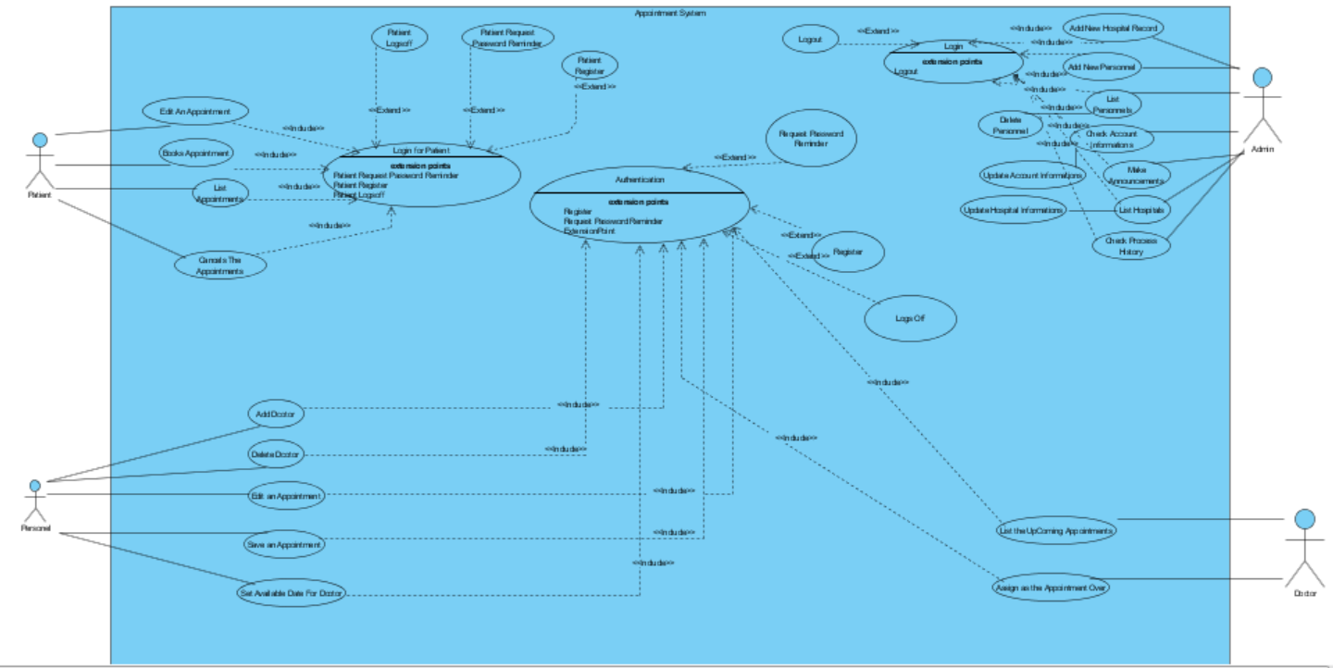

### 

### Object model

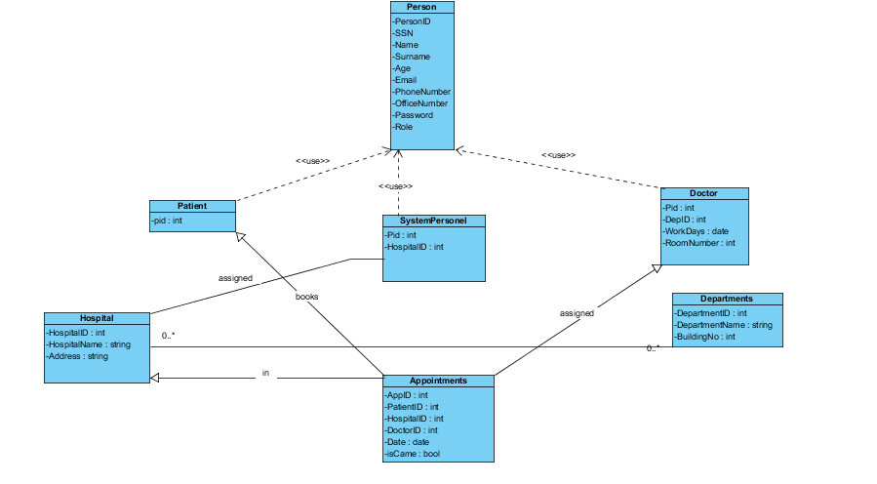

### **Dynamic model**

***Sequence Diagram***

BooksAppointment

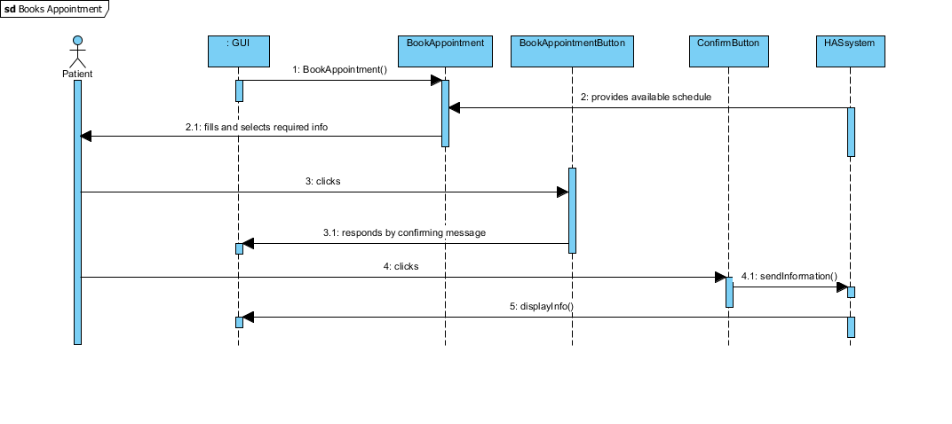

CancelAppointment

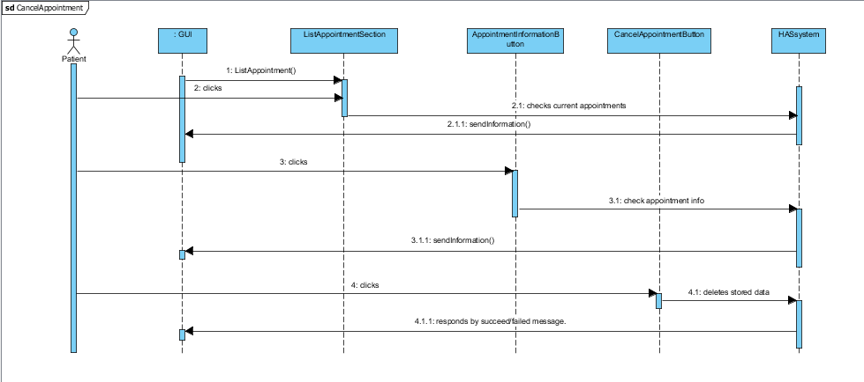

EditAppointment

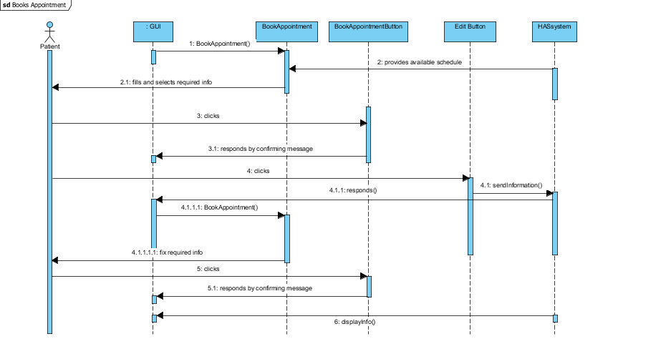

ListAppointment

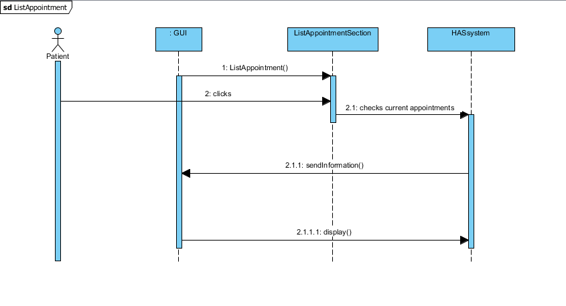

PersonnelSetAppointment

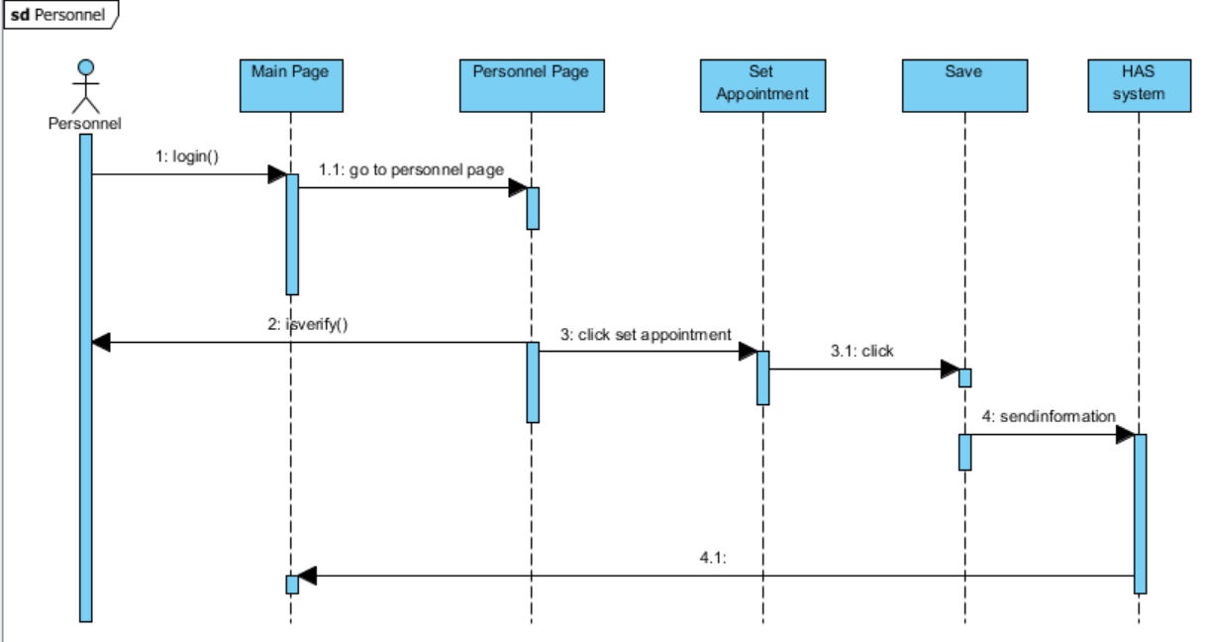

LoginAdmin

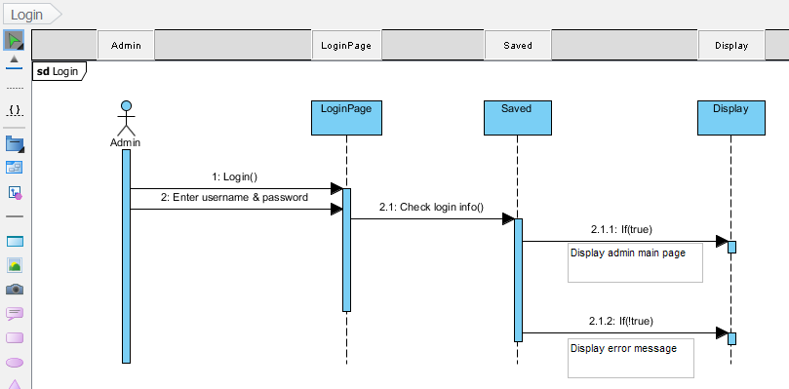

Add new Hospital

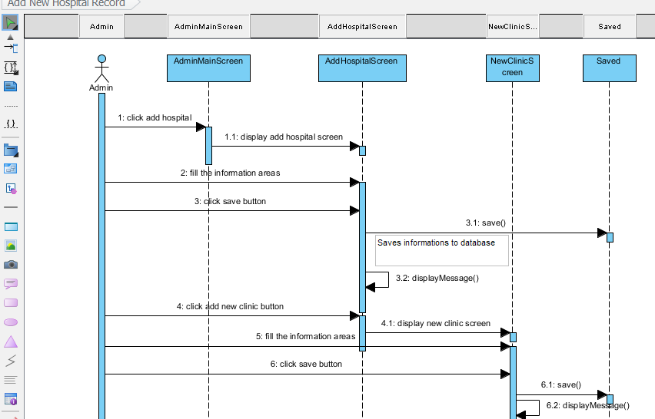

List and edit hospital

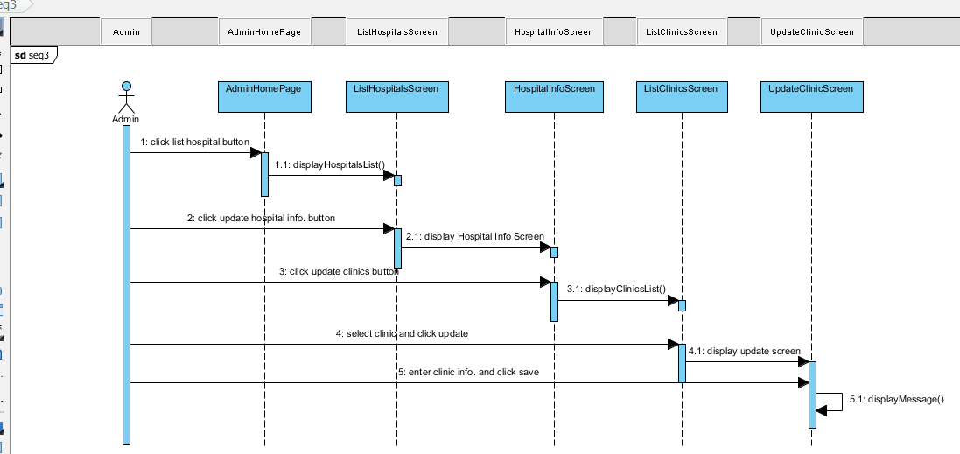

List and edit personnel

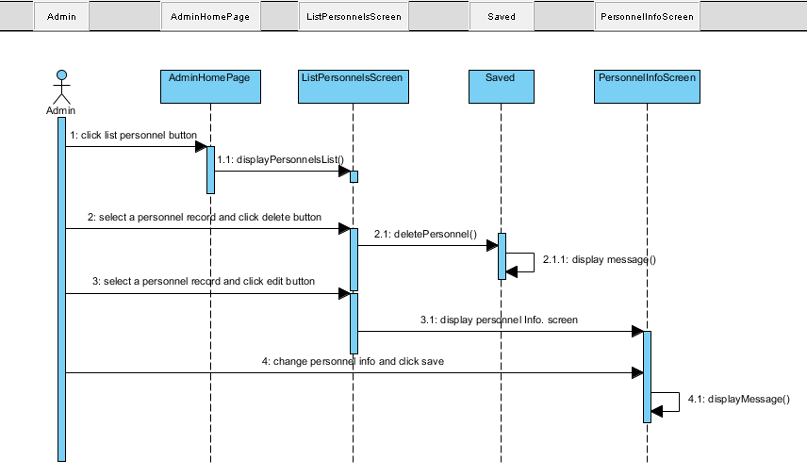

LoginPersonnel

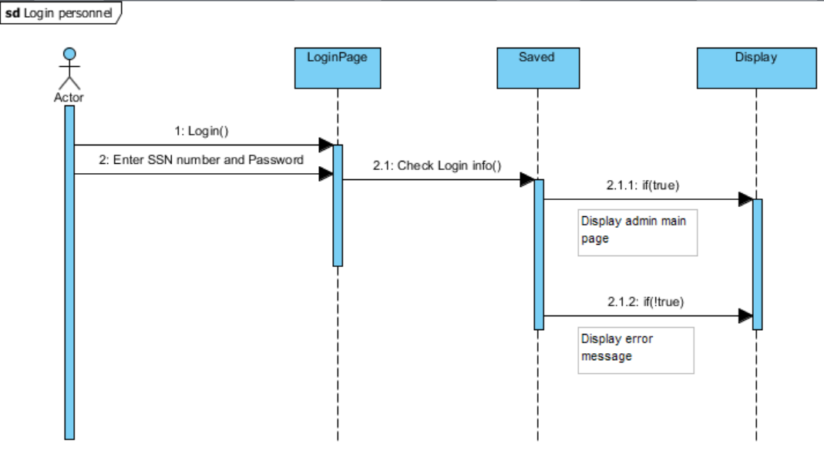

Mark Appointment

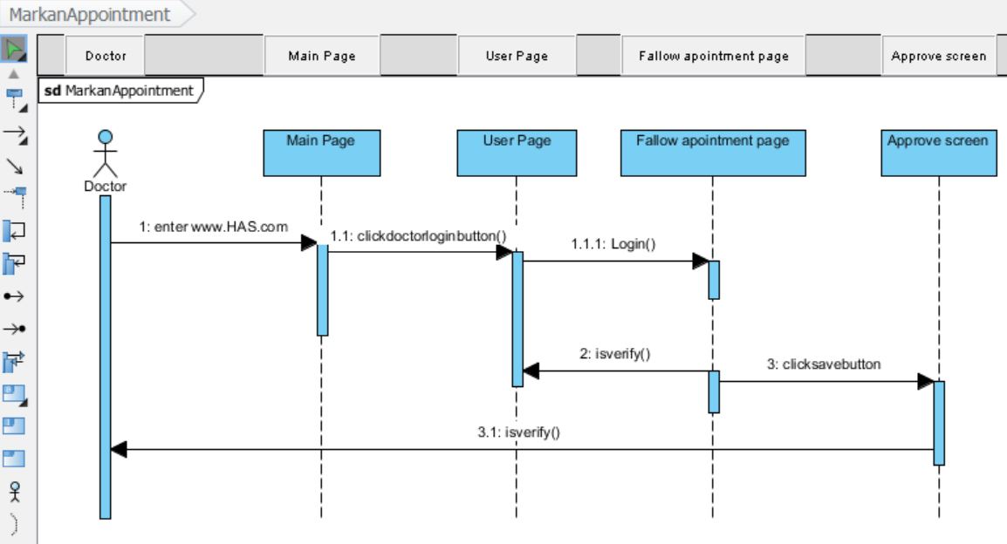

***Activity Diagram***

***Doctor***

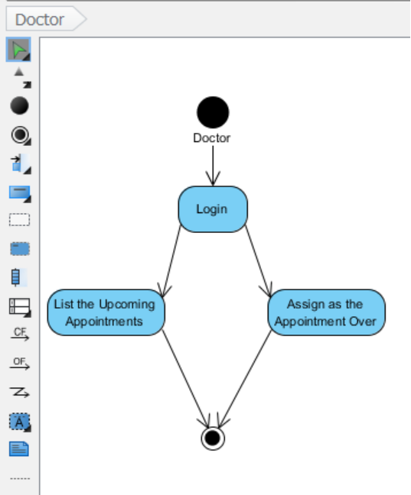

***Personnel***

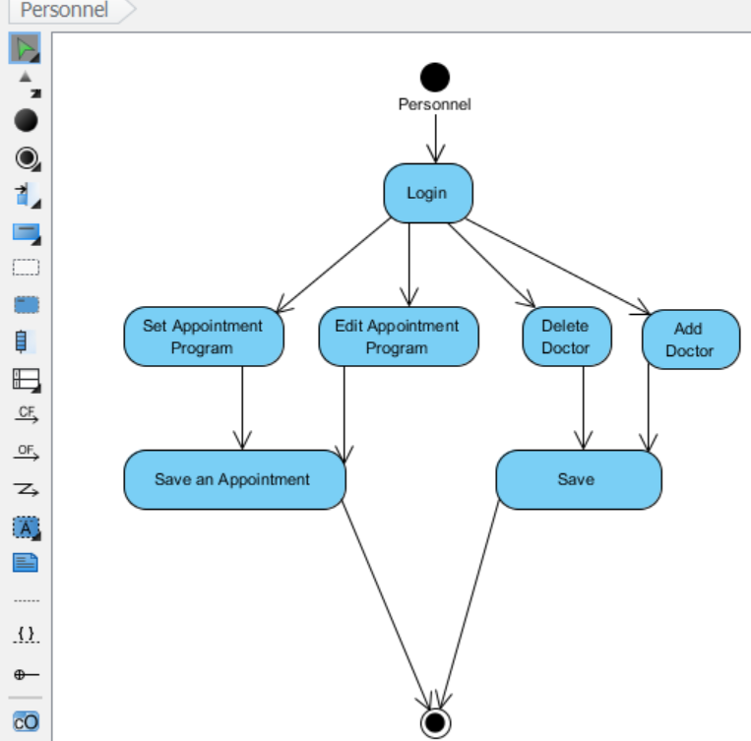

*Interfaces*

*Personnel UI*

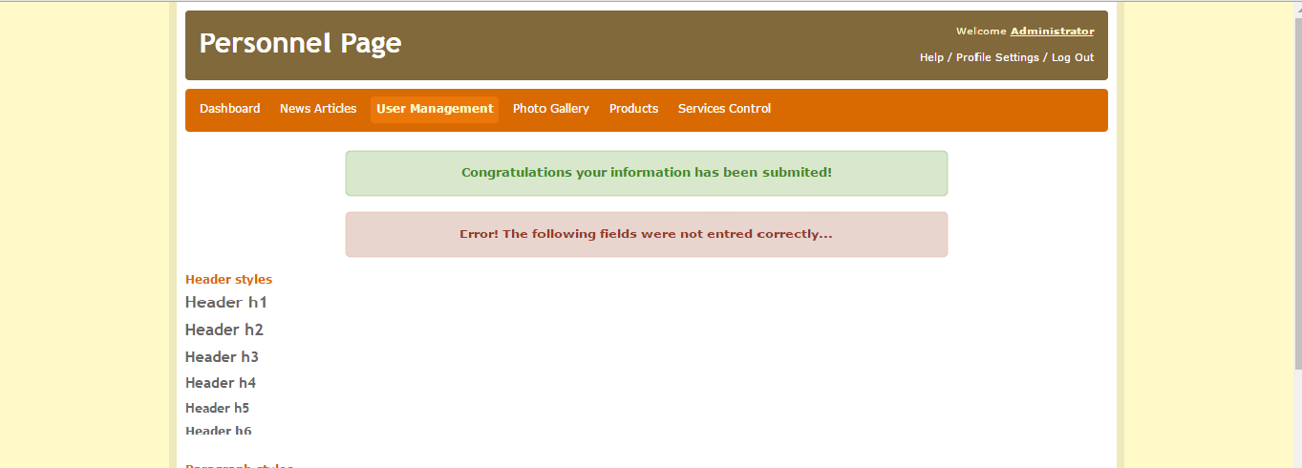

*Doctor & Patient UI*

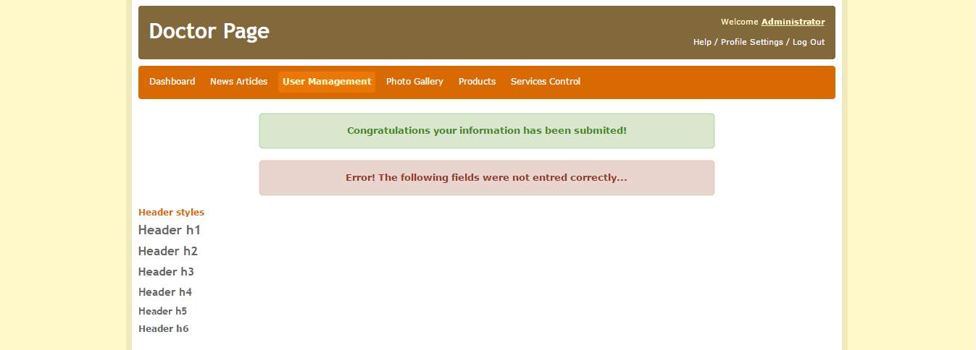

*Visitor UI*

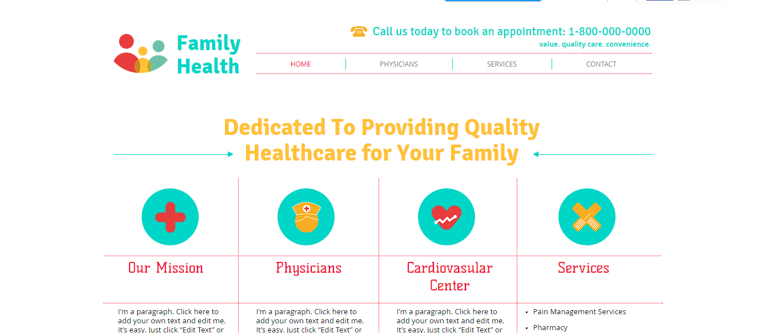

# Glossary

**Online Hospital Appointment System**:Patinets use the system to get an appointment and they go to doctor from the system.

**Personnel:**Personels take an monthly program to doctor and they record these informations on the system.Also they can upload the information if it is neccesary.

**Doctor:**Patient get an appointment and go to the doctor that is to say doctor who treated patients.

**Patient:**Person who get an appointment to go to dotcor to be treated .

**Appointment**:Operation or order which is neccesary to doctor can examine the patient.

# References

1. UML Use Case Diagrams: Tips and FAQ

* <https://www.andrew.cmu.edu/course/90-754/umlucdfaq.html>

1. Introduction to Software Engineering/UML

* <https://en.wikibooks.org/wiki/Introduction_to_Software_Engineering/UML>

1. Bruegel B. & Dutoit A.H.. (2010). Object-Oriented Software Engineering Using UML, Patterns, and Java, Prentice Hall, 3rd ed.

# Project Plan

Not yet.