<Hospital Appointment System>

System Design Document

<0.2>

<16.07.2016>

<Muhammed Bilal Kutlu
Duygu Ergin
Dilara Turanlı
Didar Turanlı>

Prepared for
SE301 Software Engineering

Table of Contents
1.Introduction 4
1.1.Purpose of the System 4
1.2.Design Goals 4
1.3.Definitions, Acronyms, and Abbreviations 4
1.4.References 4
2.Current Software Architecture 4
3.Proposed Software Architecture 4
3.1.Overview 4
3.2.System Decomposition 4
3.3.Hardware Software Mapping 4
3.4.Persistent Data Management 4
3.5.Access Control and Security 4
3.6.Global Software Control 4
3.7.Boundary Conditions 5
4.Subsystem Services 5
5.References 5

SYSTEM DESIGN DOCUMENT[Bruegge B. & Dutoit A.H.. (2010). Object-Oriented Software Engineering Using UML, Patterns, and Java, Prentice Hall, 3rd ed.]

Introduction
SDD document designed for any user.Therefore, system architecture and properties must be understandable.It summarizes software architecture and design goals.System design be defined to meet the requirements in the using system and provide the best services to users.We have divided the project into smaller units to implement with easy terms and best the Hospital Appointment system that we done.

In this Project firstly We identify the needs of present system.We designed the system that we will do in line with these requirements.

1.1. Purpose of the System
Purpose of the Hospital appointment system devise a appointment system with
simple,easy to use, and internet and web browser that can be usable from any device
as described in the previous report of Requirements Specification and Analysis.

1.2 . Design Goals
When users enter the system,they can be choose hospital.They book an appointment or cancel an appointment if they want.At the same time all users view appointment at the part of appointments.

Usability:The system should be user friendly and easy to understand and use.

Reliability:The system will be safety.All user enter the system with their SSN numbers and password.

Flexibility:It requires Internet and available web browser with the device.

Implementation:System can be modified and readable.The number of errors must be minimized.

Interface:The interface of the system must be defined as good.

Supportability:Developer are responsible for testabilty,modified and compatibility of the system.

Scalability:Application should be able to handle large number of clients.

1.3. Definitions, Acronyms, and Abbreviations
HAS : A name of the system
User :Who use the HAS system
Doctor: : A person who selected patient to get an appointment.
Personnel: : A person who Setting appointments and update doctor information
Admin: : A person who do some operations on database.
Patient: A person who make appointment operation and register the system
RAD: Requirement Analysis Document.

1.4 References
-There are many Hospital Appointment System on internet but our system different from others.

Current Software Architecture
Today there a lot of Hospital appointment system. However our system different from them.
There is a doctor login in addition to user login on page in the system as we indicate in Requirements Specification and Analysis document.

Proposed Software Architecture
The system design has been documented in RAD part.

Overview

I) User Mode
- Register;
Patients may register on the system with required information.İf users not registered in the system, they can login the system after registered
- Request Password Reminder;
When patient forgot his/her password, use reminder password button to remember password.
- Authentication;
Patients can enter the system with own SSN number and password which is created by own on register. Patients who is previously registered in the system can access next step from this part.

- Book an Appointment;
When patients enter get appointment option, they do selection hospital, department, doctor, day and hour step by step.

- Edit an appointment;
When patient finished his/her selection, warning appears on the screen. The warning is “Please check the appointment information and confirm.” If patient see any error, exit the page which has information about appointment then return back the selection page and edit appointment.

- Save an appointment;
After he or she checked appointment’s information on the page which is show patient’s choosing if all information are true he/she click the save button and get an appointment.

- Cancel an appointment;
Patient’s all appointment showing same page on system. Patient click the appointment button if patient is not going to go to appointment then he can cancel which he wants.

- Logs Off;
Patients exit the system when they finished their operations on the system.

II) Personnel mode

- Authentication;
Personnel part is different from Doctor Authentication and Patient Authentication. Personnel should enter the different uml such as; www.has.com/personnel. In this
page, personnel can login on system with SSN number and password.Password is given by the hospital.

- Set Available Date for Doctor ;
First of all personnel choose hospital which he/she is work there. Then enter information (department, doctor, date and hour) which are contained monthly work program.Monthly program is given to him/her by doctors.
- Edit appointment information;
Personnel update information which must be change, on saved program by personnel.

- Save;
Personnel record all doctors’ programs on the system when he or she entered all informations.
- Add Doctor;
Personnel updates which is necessary such as a doctor come to work the hospital.

- Delete Doctor;
Personnel update which is necessary such as a doctor arrive the hospital.

- Log Off;
Personnel exit the system when they finished the operations on the system.

III) Doctor mode

- Authentication;
Doctor part on home page, doctor can login on system with SSN number and password which is given by hospital which is doctor work.
- List the Upcoming Appointments
Doctor sees appointment patient and when they are going to come appointment when doctor enter this part.

- Assign as the Appointment Over;
Doctor tick up patients came or not came their appointment on page which shows appointment.

- Log Off;
Doctors exit the system when they finished their operations on the system.

System Decomposition
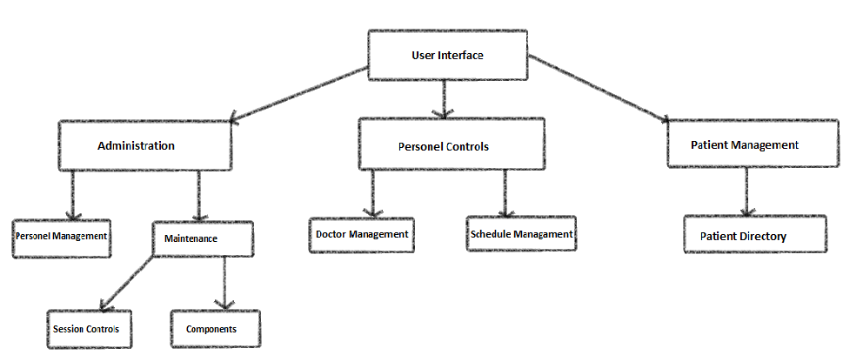

Hardware Software Mapping
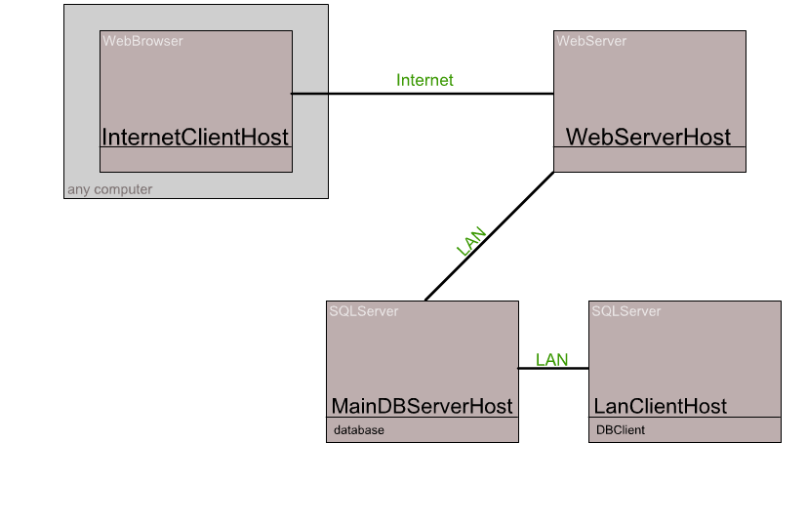

Persistent Data Management
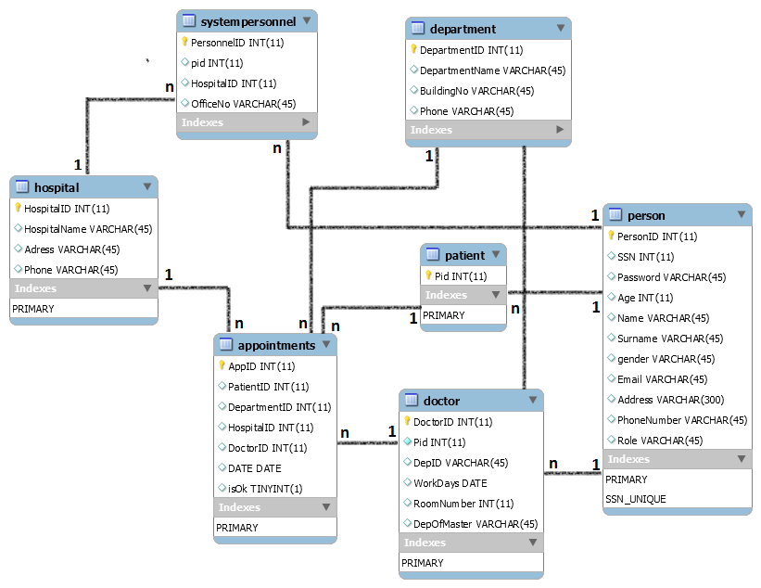
3.5 ACCESS CONTROL AND SECURITY

The application is a multiuser application so it consists of 4 types of users which are patient, doctor, personnel and administrator. Because of this, the application will provide different interfaces for each user type.
First, administrator will login to the system with the belonging interface, and do admin's own duties about appointment system such as adding, updating, editting, deleting etc. By the way, registration is not needed for the administrator via the system's website, because administrator's information will be entered to the database manually in the beginning of the system and administrator is the authority who will access database directly. The registration process of personnel -another type of user- will be done by administrator too. Personnel is responsible with the registration of doctors. As a summary, administrator does not need to register, because he/she is initially registered to the database and system. Administrator makes the registration of personnels, and personnels make the registration of doctors. Every registration process included personnel registration done by administrator, will be done with system user interfaces. The system will save all informations to the database and in login processes again the system will use them by fetching data from database. The informations from database will be used both confirmation and system usage for users. All of the user types have to login to the system with their personal id (T.C. number) as username and password.
After these steps, the system will be ready for patient appointment. Normal users such as patients will register to the application, and system will add a new user to the database. Then, patients will login to the system with their informations such as T.C. number and password. During login procedure, data from the user database table will be fetched and compared with the data entered by the user. Since this operation requires a read-only access to the database, it can be performed from different points of access simultaneously.
During registration, the filling of the fields requires no database access, whereas finalizing the process requires data to be written to the database which requires read-write access to the database. In that case, necessary fields of the database will be blocked and simultaneous access from multiple users will be denied.
For some situation like updating or deleting information requires updating one of the tables in the database in its finalization phase and therefore must be handled with greater care since multiple users may be cause to update the table at the same time. This will also be prevented by blocking.
Finally, viewing of the informations or lists requires again a read-only access to the database . Therefore, multiple user access imposes no problems and new restrictions.
As last words, the usernames and passwords for users will be stored in user table. No one else accept administrator can access these informations. The authentication interfaces are different for each type of users and they will be directed to their own main pages after the login process.

Actors/  Classes | User | Authentication | Appointment | Hospital | Clinic
Admin | <<create>>  createPersonnel()  updatePersonnel()  deletePersonnel()  updateInfo()  listPersonnel()  makeAnn() | Login()  logout() |  | ListHospital()  updateHosp()  addHospital() | addClinic()
Personnel | <<create>>  createDoctor()  updateDoctor()  deleteDoctor()  updateInfo() | Login()  logout()  resetPwd() | EditApp()  saveApp()  setDate()
Doctor | updateInfo() | Login()  logout()  resetPwd() | ListApp()  checkApp()
Patient | <<create>>  createPatient()  updateInfo() | register()  login()  logout()  resetPwd() | EditApp()  bookApp()  listApp()  cancelApp()

Figure 3.1 Access Control Matrix for Hospital Appointment System

Admin, User, {<<create>>, createPersonnel(), updatePersonnel(), deletePersonnel(), updateInfo(), listPersonnel(), makeAnn()}
Admin, Authentication, {login(), logout()}
Admin, Hospital, {listHospital(), addHospital(), updateHospital()}
Admin, Clinic, addClinic()
Personnel, User, {<<create>>, createDoctor(), updateDoctor(), deleteDoctor(), updateInfo()}
Personnel, Authentication, {login(), logout(), resetPwd()}
Personnel, Appointment, {editApp(), saveApp(), setDate()}
Doctor, User, updateInfo()
Doctor, Authentication, {login(), logout(), resetPwd()}
Doctor, Appointment, {listApp(), checkApp()}
Patient, User, {<<create>>, createPatient(), updateInfo()}
Patient, Authentication, {register(), login(), logout(), resetPwd()}
Patient, Appointment, {editApp(), bookApp(), listApp(), cancelApp()}

3.6 GLOBAL SOFTWARE CONTROL

External Control Flow (Between Subsystems) : Control flow of the HAS(Hospital Appointment System) has the simple characteristic defined by web applications. Web server processes requests submission of data from the user. Since the system is multiple user, concurrent runs may happen. However, control flow of a single user’s has a predefined shape. After the login step, the system has a tree-shaped web page structure formed of links or buttons.

Concurrent Control : Since the application is web based, all subsystems and components can run concurrently for different users in the application.
Internal Control (Within a Single Process) : Process control will be implemented by the designed forms on the web. The system is based on the request page - show page structure. This makes the designed procedures simple and mostly linear. However, there can be procedure calls to other subsystems or current subsystem. Threads or multiple processes for a process can be needed.The system uses a database, so the response time from the database should minimize too.
User Interface : The user interface of the system will be done through web pages. Control of next step is up to the user. In addition to this, the flow is implemented within the web page. Most of the subsystems have a different web page, thus they are regarded as having different interfaces. Due to the event driven design of the system, subsystems cannot be thought to have their own event loop. However, the events are controlled by the web pages and are considered to form a global event system.

3.7 BOUNDARY CONDITIONS

3.7.1 Initialization
3.7.1.1 Dynamic Model of the System Startup
The system is an event-driven system working on the web server without explicit startup and termination. However, there are two points in time when startup is necessary. First is the installation time and the second is the startup after backup operation.
For the system to start working properly, the system should be installed on the web server and the database should be installed on the Data Server. The login subsystem has to start functioning before the others, which may be started concurrently. Since they all request service from the user subsystem, it will be enough if the login and user subsystem is started before the others, both in the case of installation and after backups.
3.7.1.2 Description of Data Accessed at Startup
Since the system has operations related with user informations, these should be gathered at the startup. All the subsytems except the users subsystem, need to access information about the users, which makes it necessary for the user tables to be available at startup. This is particularly important to keep the response time shorter.
3.7.1.3 User Interface at Startup
Startup requires the web pages to be displayed on internet for all types of users. They will have the option of registration, modification of profile, logout etc. using the links and buttons on these pages.
3.7.1.4 Presentation of System to the User
The system is presented to the user through web pages which are categorized in two groups. First the pages that can be visited by patients will be reached through following the links from the entrance page of the system.
The program behind the web pages, will all be transparent to the patients, who will know nothing about the internal working of the application while performing the necessary operations, such as registration, login, logout and modification of informations. Patients will use the objects on the web page, such as button, combobox, dropdownbox, single or multiline entry field in order to enter necessary information which will later be processed. The second group is the personnel side of the program. The login page of the personnels will be reached through specifying the corresponding URL from the web browser and the next pages that can be visited by the personnels will be reached through following the links from the entrance page after login process. Similar to that in the patient side, personnels will not have the access to the whole program but simply use the web pages for performing necessary operations.
3.7.2 Termination
The application is designed to be worked online all the time without interruptions from the internet. Termination of one or more of the subsystems or the whole application is not anticipated except in the case of taking backup. Backups will be taken at the time when the user access is statically at its lowest and downtime will not damage the user satisfaction. Therefore, the exact time of backup taking will be performed after the first statistics are taken following the opening of the system's web site on the internet.
User will be informed about the termination in the case of backups in advance and interactions with the web site will be banned by replacing the web pages with those that give information about the expected downtime. After letting some time for the current processes to finish, the system will be terminated as a whole. Still, no termination for single subsystem is possible.
3.7.3 Failure
3.7.3.1 Behavior of System in Failures
Failures can be classified as runtime errors and database connection errors. At runtime, the application may be crushed or after startup there can be failure in connecting to database or retrieving data from database.
In addition, failures can be classified as node and communication link failures, where the first one represents deviation from the normal usage in one particular server and the later between nodes. In the first one, if the failure is on the web server, the display of the pages will be effected but the consistency of the database will not be distorted. However, if the failure is on the database side, the transactions may not be performed according to the specified behaviour. Therefore, in this kind of failure, access from the web pages will be banned during the downtime in order not to let additional deviations from the expected behaviour.
In the case of communication failures, the web server will not be able to communicate with the web server, and a message indicating the reason of the failure of the operation will be displayed on the web page, and the user will be asked to try the performance of the same operation later. This kind of failure is less serious than the previous one, since consistency of the database is not in danger.
3.7.3.2 Recovery From Failure
Recovery from failure will be handled by the Database Management System, which is Microsoft SQL Server. The routines for recovery will be handled by the DBMS and no special handling will be performed by the application.
3.7.3.3 Differences Between Recovery and Initialization
Recovery is different from initialization, such that after recovery, the consistency of the database has to be checked using the synchronization points in time and logs of database operations, whereas database can immediately start functioning after startup. This contol over the status of the database is performed by the DBMS, Microsoft SQL Server.

glossary
Analysis An activity during which developers ensure that the system requirements are correct, complete, consistent, unambiguous, and realistic.
Authentication The process of associating a person with access rights.
Boundary condition A special condition the system must handle. Boundary conditions include startup, shutdown, and exceptions.
Control flow The sequence of execution of operations in the system.
Design Rationale See Rationale
Error State of the system such that further processing will lead to a failure.
Exception An unexpected event that occurs during the execution of the system.
Failure Deviation of the observed behaviour from the specified behaviour.
Goal High level principle that is used to guide the project. Goals define the attributes of the system that are important. For a transportation vehicle, safety is a goal. For shrinkwrapped software, low cost is a goal.
Installation An activity during which the system is installed and tested in its operating environment. Installation can also include the training of users.
Layer Subsystem in a hierarchical decomposition. A layer can only depend on lower level layers and has no knowledge of the layers above it.
Login procedure used to get access to an operating system, or application, usually in a remote computer.
RAD See Requirements Analysis Document
Rationale The justification of decisions. For example, selecting myDBMS as a database management system is a system design decision. Stating that myDBMS is reliable and responsive enough to attain the project’s goals is part of the rationale for this design decision. Also called design rationale.
Reliability The ability of an apparatus, machine or system to consistently perform its intended or required function or mission on demand and without degradation or failure.
Requirements Analysis Document A document describing the analysis model.
SDD See System Design Document.
Security Property of a system indicating its ability to protect the resources against unauthorized use.
Service A set of related operations offered by a class.
Subsystem In general, a smaller, simpler part of a larger system; in system design, a well defined software component that provides a number of services to other subsystems. Examples of subsystems include storage subsystems (managing subsystem data), user interface subsystems (managing the interaction with the user), networking subsystems (managing the communication with other subsystems over a network).
Subsystem decomposition Division of the system into subsystems. Each subsystem is described in terms of its services during system design and its API during object design. The subsystem decomposition is part of the system design model.
System Organized set of communicating parts designed for a specific purpose. For example, a car, composed of four wheels, a chassis, a body, and an engine, is designed to transport people. A watch, composed of a battery, a circuit, wheels, and hands, is designed to measure time.
System design An activity during which developers define the system design model, including the design goals of the project and decompose the system into smaller subsystems that can be realized by individual teams. System design also leads to the selection of the hardware/software platform, the persistent data management strategy, the global control flow, the access control policy, and handling of boundary conditions.
System Design Document A document describing the system design model.
System design model High level description of the system, including design goals, subsystem decomposition, hardware/software platform, persistent storage strategy, global control flow, access control policy, and handling of boundary conditions. The system design model represents the strategic decisions made by the architecture team, which allows subsystem teams to work concurrently and cooperate effectively.
Thread Control flow paradigm in which the system creates an arbitrary number of threads to handle an arbitrary number of input channels.
User A role representing the persons who interact directly with the system when accomplishing their work.

References
The following is an example of listing a book in this section. Check the text to see how it is cross referenced (The whole document is based on [Bruegge B. & Dutoit A.H.. (2010). Object-Oriented Software Engineering Using UML, Patterns, and Java, Prentice Hall, 3rd ed.]).

- Bruegge B. & Dutoit A.H.. (2010). Object-Oriented Software Engineering Using UML, Patterns, and Java, Prentice Hall, 3rd ed.

