2018-2019 EDUCATIONAL YEAR
KASTAMONU SCIENCE HIGH SCHOOL FIRST SEMESTER FIRST GRAMMAR QUIZ UNIT 1 ARTICLES PRONOUNS-PREPOSITIONS OF PLACE

A) Look at the pictures below and fill in the blanks with the prepositions of place (15X2=30).
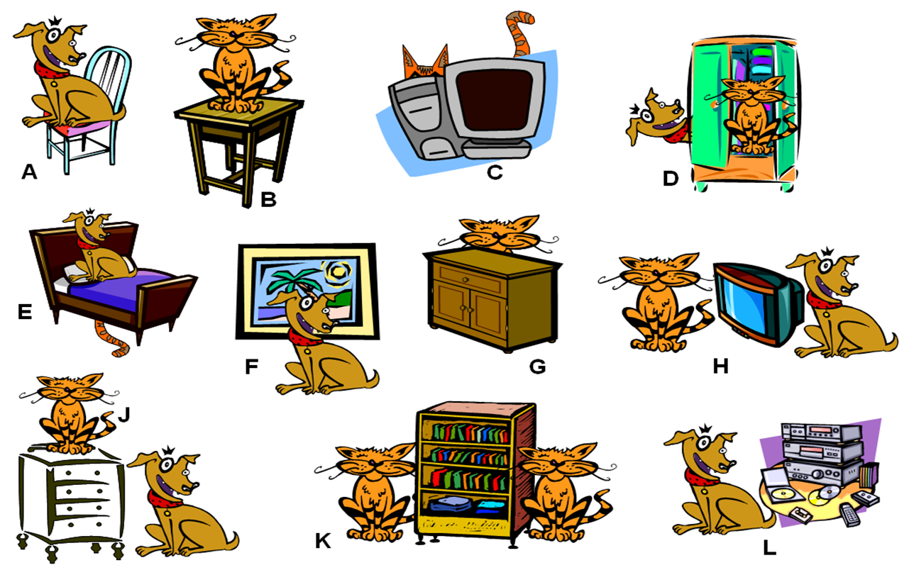

1) A) The dog is…………………...the chair.  2) B) The cat is…………………....the tripod.  3) C) The cat is ……………………the television.  4) D) The cat is ………………...…the wardrobe.  5) D) The dog is…………………...the wardrobe.  6) E) The dog’s tail is …………………..the bed.  7) E) The bed is …………………..the dog.  8) F) The dog is …………………..the picture.  9) G) The cat is ………………the cupboard. | 10) H) The television is……………….the cat and the dog.  11) J) The dog is ……………….the cupboard.  12) J) The cat is ………………..the cupboard.  13) K) The bookshelf is …………………the cats.  14) K) The cat on the right is…………………the Bookshelf.  15) L) The CD player is ………………..the dog.

B) Fill in the blanks with the suitable subject or possessive pronouns (10X3=30).

1) Jane has already eaten her lunch, but I am having………….later. I am not hungry.
2) ………………has broken her leg.
3) My mobile phone does not work. I cannot use…………………
4) His computer is a Mac and………………..it is very good.
5) We are giving them our telephone number, and they are giving us …………………..
6) My pencil is broken. Can I borrow………………………..?
7) Their car is cheap, but………………..is expensive, because we are rich.
8) You can't have any chocolate! It's all…………………..!
9) That pen is mine!…………………over there.
10) Jane is a good student. …………………gets high marks in the exams.

C) Choose the correct article: a, an, the or x (no article) (20x2=40).
1) Are you coming to……………..party next Saturday?  2) I bought………………new TV set yesterday.  3) I think…………….man over there is very ill. He can't stand on his feet.  4) I like reading………………….history books.  5) She is…………………nice girl.  6) Do you want to go to………….restaurant near my house?  7) He is………………engineer.  8) I bought………………pair of shoes.  9) I am watching …………..movie now.  10) They are staying at………………hotel. | 11) I do not like……………basketball.  12) I think………….man over there is very unfriendly.  13) …………..night is quiet. Let's take a walk!  14) …………………price of gas keeps rising.  15) John travels to………Mexico every year. 16) Juan is………………Spanish.  17) I am reading……..amazing story now.  18) My brother doesn't eat…………chicken.  19) I would like……………piece of cake.  20) I live in an apartment………….apartment is new.



GOOD LUCK
AYHAN DUYGULUOĞLU

THE ANSWER SHEET OF THE QUIZ 1
A) Look at the pictures below and fill in the blanks with the prepositions of place (15X2=30).
1) A) The dog is ON the chair.  2) B) The cat is ON the tripod.  3) C) The cat is BEHIND the television.  4) D) The cat is IN the wardrobe.  5) D) The dog is BEHIND the wardrobe.  6) E) The dog’s tail is UNDER the bed.  7) E) The bed is UNDER the dog.  8) F) The dog is IN FRONT OF the picture.  9) G) The cat is BEHIND the cupboard. | 10) H) The television is BETWEEN the cat and the dog.  11) J) The dog is NEAR the cupboard.  12) J) The cat is ON the cupboard.  13) K) The bookshelf is BETWEEN the cats.  14) K) The cat on the right is NEXT TO the Bookshelf.  15) L) The CD player is BEHIND the dog.

B) Fill in the blanks with the suitable subject or possessive pronouns (10X3=30).

1) Jane has already eaten her lunch, but I am having MINE later. I am not hungry.
2) SHE has broken her leg.
3) My mobile phone does not work. I cannot use IT.
4) His computer is a Mac and………………..IT is very good.
5) We are giving them our telephone number, and they are giving us THEIRS.
6) My pencil is broken. Can I borrow YOURS?
7) Their car is cheap, but OURS is expensive, because we are rich.
8) You can't have any chocolate! It's all MINE!
9) That pen is mine! YOURS is over there.
10) Jane is a good student. SHE gets high marks in the exams.
C) Choose the correct article: a, an, the or x (no article) (20x2=40).
1) Are you coming to THE party next Saturday?  2) I bought A new TV set yesterday.  3) I think THE man over there is very ill. He can't stand on his feet.  4) I like reading ----------- history books.  5) She is…………………nice girl.  6) Do you want to go to THE restaurant near my house?  7) He is AN engineer.  8) I bought A pair of shoes.  9) I am watching A movie now.  10) They are staying at A hotel. | 11) I do not like------------basketball.  12) I think THE man over there is very unfriendly.  13) THE night is quiet. Let's take a walk!  14) THE price of gas keeps rising.  15) John travels to-----------Mexico every year.  16) Juan is------------Spanish.  17) I am reading AN amazing story now.  18) My brother doesn't eat---------chicken.  19) I would like A piece of cake.  20) I live in an apartment. THE apartment is new.

