KASTAMONU SCIENCE HIGH SCHOOL THEME 1 CONTENT 1 WRITING TASK CLASSES 9-A-B-C

MY FAMILY

INSTRUCTIONS

1) Write a paragraph about your family and your relatives.
2) Write at least 20 sentences.
3) Use the structure ‘I have’ or ‘he-she has..’ in at least 10 of the sentences.
4) Write about what your family members or relatives do?

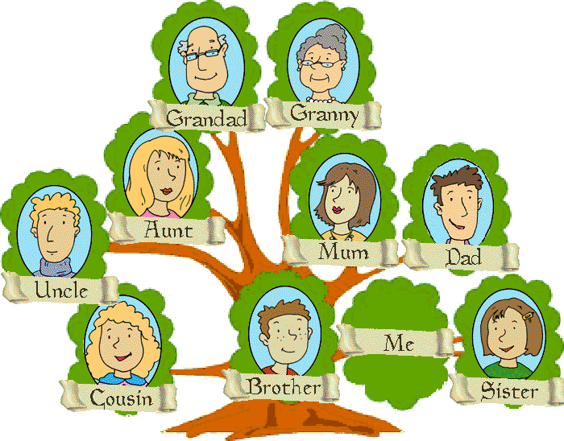
❝Those who know nothing of foreign languages know nothing of their own.❞
‒Johann Wolfgang von Goethe

❝Language is the road map of a culture. It tells you where its people come from and where they are going.❞
‒Rita Mae Brown

❝Language is the blood of the soul into which thoughts run and out of which they grow.❞
‒Oliver Wendell Holmes

GOOD LUCK
AYHAN DUYGULUOĞLU

