KASTAMONU SCIENCE HIGH SCHOOL THEME 1 CONTENT 2 WRITING TASK CLASSES 9-A-B-C

JOBS

INSTRUCTIONS

1) Write about your favorite job?
2) Write about what you want to be in the future?
3) Explain why?
4) Use Simple Present Tense.
5) Use expressions like ‘I want to be a teacher because I like children’.
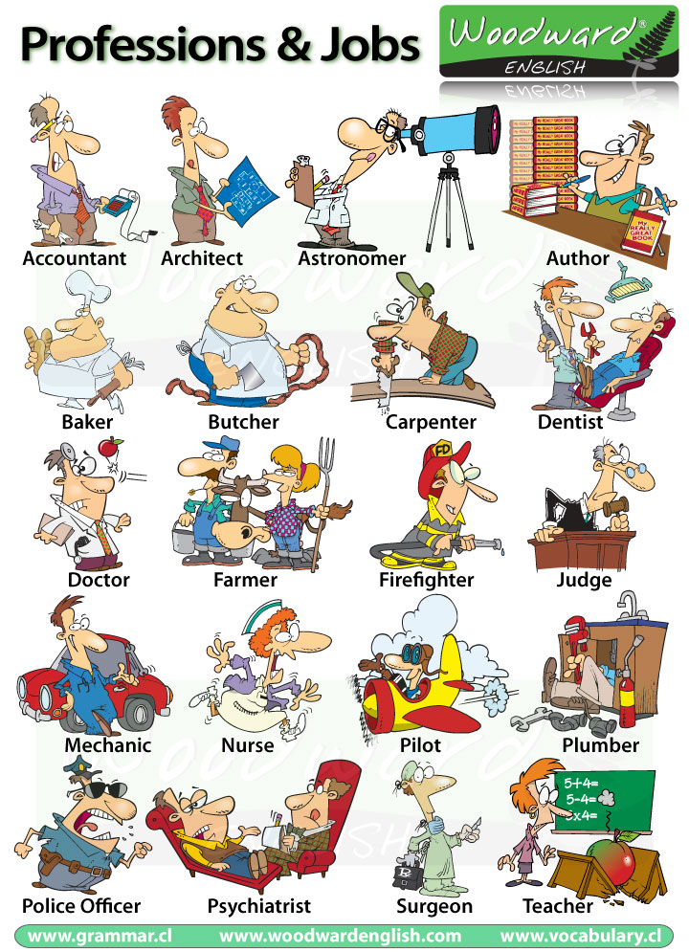
Coming together is a beginning; keeping together is progress; working together is success.
Henry Ford
Ayhan DUYGULUOĞLU

