KASTAMONU SCIENCE HIGH SCHOOL GRAMMAR SUBJECT PRACTICE FOR

PREPOSITIONS OF PLACE
- Write the correct prepositions in the blanks.

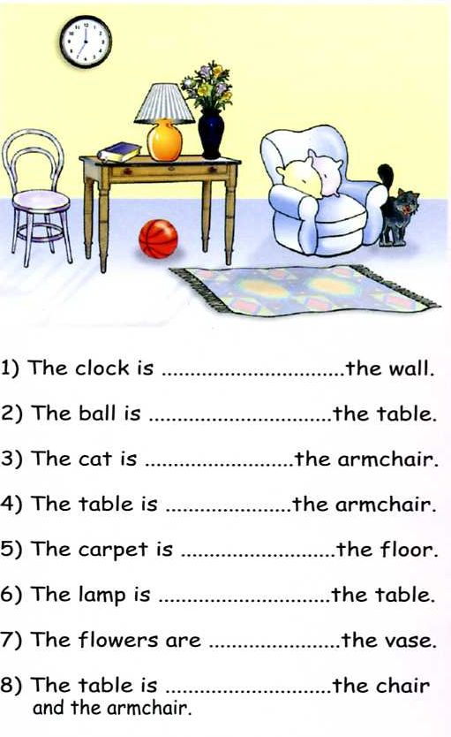

- Match the pictures with the correct prepositions.

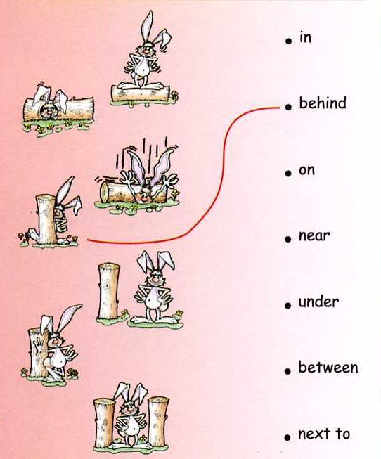
C) Fill in the blanks with the correct prepositions.
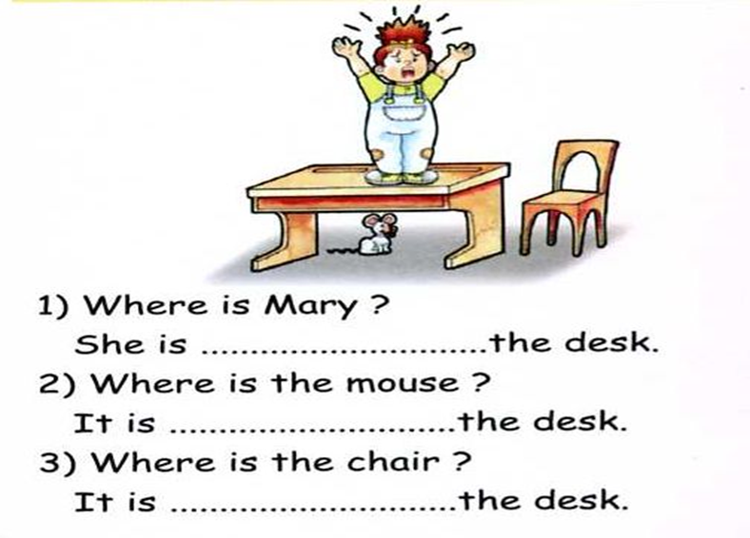
D) Choose the correct option.
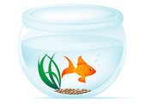 The fish is …IN….the tank.

 The man is IN FRONT OF…of the computer.

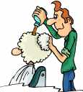 The hairdresser is …BEHIND…his client.

 The frog is ON…..a log.

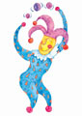 The balls are ABOVE…..the juggler.

 The puppy is IN…….the box.

 The girl is sitting ……IN FRONT OF..of the piano.

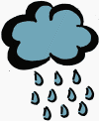 There are raindrops BELOW…….the cloud.

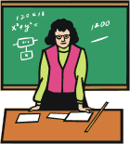 The chalkboard is …BEHIND…..the teacher.

 The monster is NEAR..the bed.

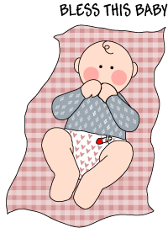 The baby is ON……a blanket.

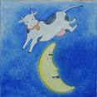 The cow is jumping ………OVER…..the moon.

