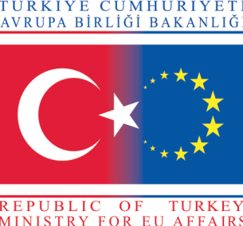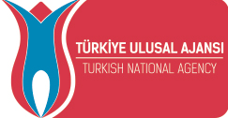

LETTER OF INVITATION

This is to inform any authority in Turkey that ‘Liceul Tehnologic "Alexandru Macedonski", Melinesti, Romania is going to be the host institution for the fourth meeting of the Comenius School Partnership project titled ‘Testing Tastes to Fight Obesity’ between the dates 8-12 October 2014. The names and surnames of the participants from Turkey are as follows;

Mr. İsmail COŞKUN_______________ (Assistant of the Headmaster)
Mr. Ender ÜNLÜ __________________(Teacher)
Mr. Cahit KÖMLEKSİZ______________(Teacher)
Mr. Ufuk SÖZCÜ___________________(Teacher)

Mr. Alican ÜNALDI_____________ (Student)
Mr. Muharrem Fatih BAYRAKTAR__(Student)
Miss Beyza KAHVECİOĞLU_______(Student)
Miss Berru DOĞAN______________(Student)
Miss Zehra Berna TÜMOĞLU_______(Student)

The Brief Agenda of the Meeting

- Demonstration of the meals by each country
- Watching the videos showing how the meals are cooked or made
- Showing the flashcards of the meals presented
- Speech by a dietician about the dangers of junk food
- A culture night by the host institution
- Cultural visits to the nearby cities and towns

……./……./2014
Mrs. Adriana POPESCU ‘Liceul Tehnologic "Alexandru
The Headmistress Macedonski",

Stamp of The School
Signature

