KASTAMONU SCIENCE HIGH SCHOOL
GRAMMAR SUBJECT EXPLANATION FOR MAKING PREFERENCES

Questions about preferences
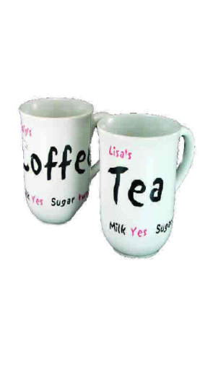
- Which do you prefer tea or coffee?
- Which do you prefer drinking science or physics?
- Which do you prefer to drink juice or mineral water? (Notice: prefer to + present simple)
- Which do you like better basketball or football?
- Do you prefer pizza or spaghetti?
- Would you prefer to eat a cake or a fruit?
- Would you rather eat a cake or a fruit?

Replies
- I prefer baseball.
- I'd prefer to drink juice
- I'd rather drink mineral water
- If I had a choice, I would eat a sandwich.
- A cup of coffee would be suitable.

Things to remember about preferences
- "I'd prefer" + to + verb
- "I'd rather" + verb

