2015-2016 EDUCATIONAL YEAR-KASTAMONU SCIENCE HIGH SCHOOL
THE VOCABULARY
THEME 1:STUDYING ABROAD

CONTENT 1:  FAMILY MEMBERS | CONTENT 2:  JOBS | CONTENT 3:
 |  | COUNTRIES | NATIONALITIES | LANGUAGES
1) mother  2) mom  3) father  4) dad  5) parent  6) children  7) son  8) daughter  9) sister  10) brother  11) grandmother  12) grandfather  13) grandparent  14) grandson  15) granddaughter  16) grandchild  17) aunt  18) uncle  19) niece  20) nephew  21) cousin  22) husband  23) wife  24) sister-in-law  25) brother-in-law  26) mother-in-law  27) father-in-law  28) partner  29) fiance | 1) accountant  2) actor  3) actress  4) athlete  5) author  6) baker  7) banker  8) barber  9) beautician  10) broker  11) butcher  12) carpenter  13) chauffeur  14) chef  15) clerk  16) coach  17) craftsman  18) cook  19) dentist  20) doctor  21) editor  22) engineer  23) farmer  24) fire fighter  25) fisherman  26) judge  27) lawyer  28) magician  29) mechanic  30) musician  31) nurse  32) pharmacist  33) pilot  34) poet  35) policeman  36) politician  37) printer  38) professor  39) priest  40) pastor  41) sailor  42) salesman  43) shoemaker  44) soldier  45) tailor  46) teacher  47) veterinarian  48) waiter  49) waitress  50) stuntman  51) fishmonger | One syllable  France French French  Greece Greek Greek  ends in '-ish'  Britain English British  Denmark Danish Danish  Finland Finnish Finnish  Poland Polish Polish  Spain Spanish Spanish  Sweden Swedish Swedish  Turkey Turkish Turkish  ends in '-an'  Germany German German  Mexico Spanish Mexican  The United States English American  ends in '-ian' or '-ean'  Australia English Australian  Brazil Portuguese Brazilian  Egypt Arabic Egyptian  Italy Italian Italian  Hungary Hungarian Hungarian  Korea Korean Korean  Russia Russian Russian  ends in '-ese'  China Chinese Chinese  Japan Japanese Japanese  Portugal Portuguese Portuguese

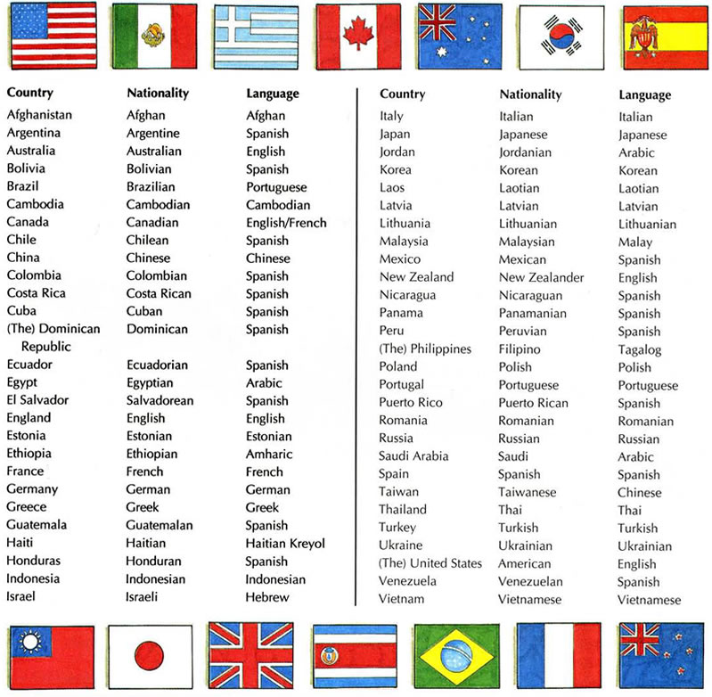

ÖNEMLİ NOT

YAZILIDA İLK SAYFADA BULUNAN ÜLKE, MİLLİYET VE DİLLERDEN SORUMLU TUTULACAKSINIZ

