KASTAMONU SCIENCE HIGH SCHOOL THEME 2-CONTENT 1 WRITING TASK
CLASSES 9-A-B-C

INSTRUCTIONS
- Find a partner for yourself.
- Look at the map below and choose a destination for your friend and give him directions.
- You should write a dialogue with a friend.
- Both of you should write the dialogue on your notebooks.
- In your dialogue, you should use at least five of the prepositions given at the end of this activity.

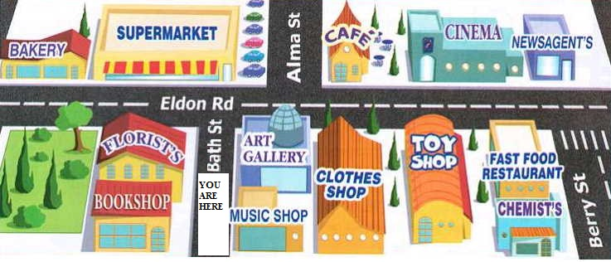
❝Those who know nothing of foreign languages know nothing of their own.❞
‒Johann Wolfgang von Goethe
❝Language is the road map of a culture. It tells you where its people come from and where they are going.❞
‒Rita Mae Brown
❝Language is the blood of the soul into which thoughts run and out of which they grow.❞
‒Oliver Wendell Holmes

GOOD LUCK
AYHAN DUYGULUOĞLU

USEFUL EXPRESSIONS FOR GIVING DIRECTIONS

Go past = continue past something so that is is now behind you

Go across = cross something, like a road or crossroads

Go along = continue down a road

Go straight on = don't turn left or right

Go up = walk / drive up a hill

Go down = walk or drive down a hill or a road

Go through = pass through something, such as a tunnel or a town

Go out of = exit (i.e. a railway station)

It's in front of you = you can see it facing you

It's opposite the bank = it faces the bank

It's on the corner = it's where two roads meet at a 90° angle

Turn right

Turn Left

Take the first turning on your right

Take the second turning on your right

Take the first turning on your left

To be able to learn the correct pronunciation of the expressions, look at the following link;

http://www.speakenglish.co.uk/phrases/asking_and_giving_directions

PREPOSITIONS TO USE IN THE DIALOGUES

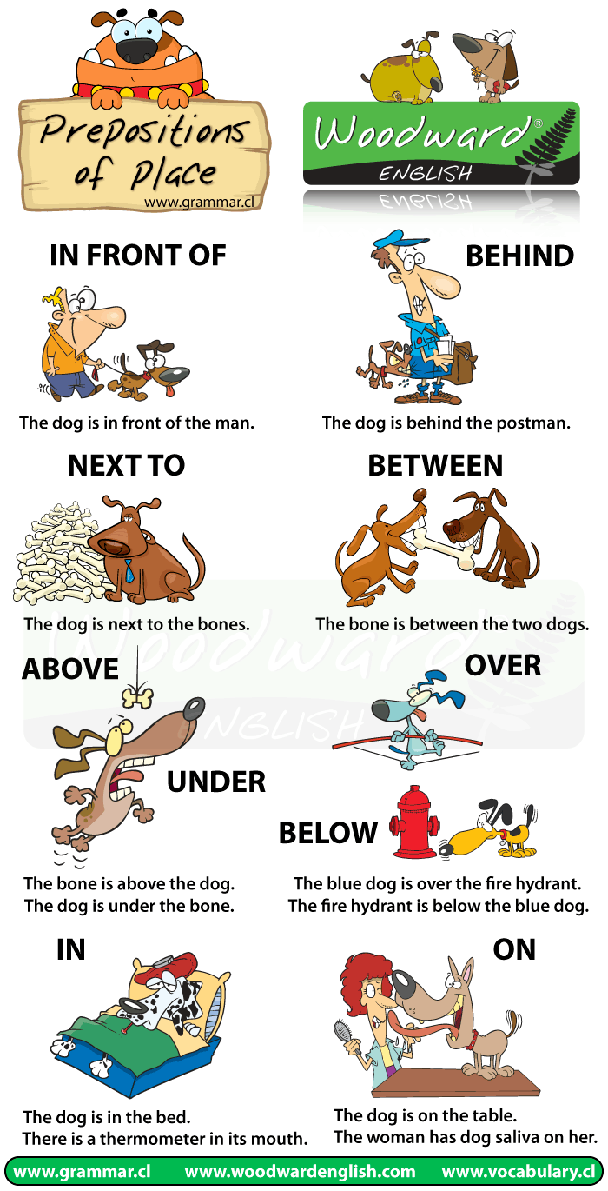
Success is not the key to happiness. Happiness is the key to success. If you love what you are doing, you will be successful.
Albert SCHWEITZER
AYHAN DUYGULUOĞLU

