KASTAMONU SCIENCE HIGH SCHOOL THEME 2-CONTENT 2 WRITING TASK
CLASSES 9-A-B-C
INSTRUCTIONS
- Write a paragraph about your house?
- Give information about the place where you live?
- Write how many rooms are there in your house?
- Describe your own room.
- Use the structure ‘there is’ and ‘there are’.
- Use the adjectives and words in the vocabulary list for theme 2.
- Write at least 20 sentences.
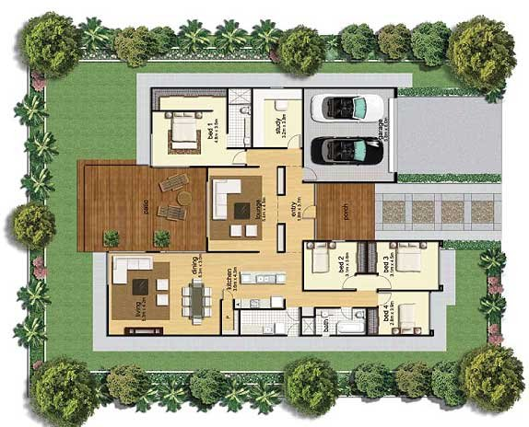
Desire is the key to motivation, but it's determination and commitment to an unrelenting pursuit of your goal - a commitment to excellence - that will enable you to attain the success you seek.
Mario Andretti

AYHAN DUYGULUOĞLU
THE TEACHER OF ENGLISH LANGUAGE

