KASTAMONU SCIENCE HIGH SCHOOL THEME 2 CONTENT 2 WRITING TASK
CLASSES 9-A-B-C

INSTRUCTIONS
- Find a partner for yourself.
- Two of you are roommates at a private student dormitory at the university. It is weekend and your friend says he or she will go to the market for shopping. You are in the kitchen and he is in the living room. He is trying to prepare a shopping list and as you are in the kitchen he asks you about the things in the fridge by using the structure; ‘Is there…….?’ or ‘Are there………?’.
- Use the picture below for asking and answering the questions.
- You should write down a dialogue with your partner.
- You should ask and answer at least 10 questions.
- You should write the introduction and the ending of the dialogue with expressions like ‘Hello or Bye’.
- Use the expressions of quantity such as ‘a little, little, few, a few, some, any, a lot of, much and many’.

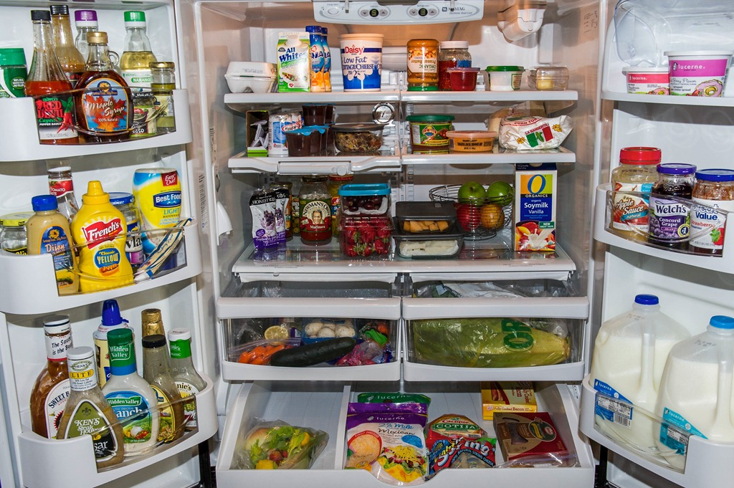❝To have another language is to possess a second soul.❞-Charlemagne
GOOD LUCK
AYHAN DUYGULUOĞLU

