KASTAMONU SCIENCE HIGH SCHOOLTHEME 3- CONTENT 2 WRITING TASK CLASSES 9-A-B-C

FREE TIME ACTIVITIES

THE INSTRUCTIONS

- Write a paragraph about yourself by answering each of the following questions.
- Use simple present tense to answer the questions.
- You can write more than one sentence for each of the questions.
- You should write one paragraph for each group of questions.

THE QUESTIONS TO BE ANSWERED

PARAGRAPH 1: QUESTIONS ABOUT YOUR FAMILY
- What is your name?
- How old are you?
- How many members are there in your family?
- What does your father do?
- What does your mother do?
- How do they get to work?
- Dou you have brothers or sisters?
- If you have, how old are they?

PARAGRAPH 2: QUESTIONS ABOUT YOU
- Dou you have a pet?
- Do you have a special room at home?
- How do you get to school?
- Do you sometimes go to school on foot?
- Do you have a computer in your room?

PARAGRAPH 3: QUESTIONS ABOUT FREE TIME ACTIVITIES
- What is your favorite sport?
- What do you want to be in the future?
- What do you do in your free time?
- What do you like doing most?
- What do you like watching on television?
- What do you like eating most?
- How often do you go to the cinema?
- How often do you play games with your friends?

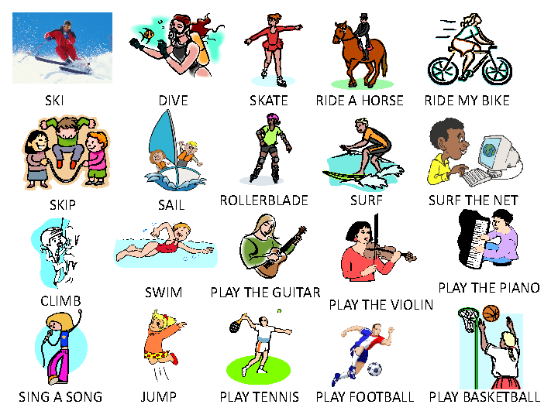
❝Those who know nothing of foreign languages know nothing of their own.❞
Johann Wolfgang von Goethe
GOOD LUCK
AYHAN DUYGULUOĞLU

