KASTAMONU SCIENCE HIGH SCHOOL THEME 3-CONTENT 2 WRITING TASK
CLASSES 9-A-B-C

TYPES OF MOVIES

THE INSTRUCTIONS

- Write a review about your favorite movie.

- Answer the following questions about your review;

PARAGRAPH 1
- What type of movie is it?
- Do you like this type of movies?
- What is the title of the movie?
- Who is the director?
- How old is the director?
- Where does he live?
- Is he or he married?
- Does he or she have daughters or sons?

PARAGRAPH 2
- Who are the main characters?
- Who is your favorite actor in the movie?
- Who is your favorite actress in the movie?
- What do they do?
- How do they look?
- How are their characters?
- Do you like their characters? Why or why not?
PARAGRAPH 3
- What is the plot of the film?
- How much is the budget of the film?
- When do the events take place?
- Where do the events take place?
- What happens at the beginning?
- How does the story end?
- Are the events exciting?
- What is the most important event in the story?
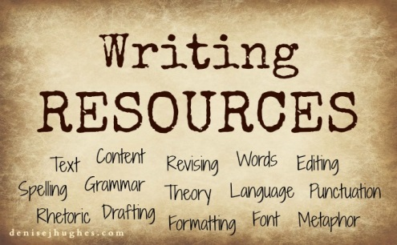
GOOD LUCK
AYHAN DUYGULUOĞLU



