KASTAMONU SCIENCE HIGH SCHOOL THEME 4 CONTENT 1 WRITING TASK CLASSES 9-A-B-C

DAILY ROUTINES

THE INSTRUCTIONS

- Write about your father’s job and his daily routine.
- Answer each of the following questions in your paragraph.

PARAGRAPH ONE

- What is your father’s name?
- How old is he?
- What does he do?
- Where does he work?
- How many hours a day does he work?
- How does he get to work?
- What time does he get up on weekdays?
- What time does he have breakfast?
- What time does he leave home?
- Does he come home for lunch?
- Where does he have lunch?
- When does he have lunch?
- What time does he leave work?
- What time does he arrive home?
- What time does he have dinner?
- Does he watch television in the evenings?
- Which programs does he watch?
- Do you play games with him in the evenings?
- What time does he go to bed?

PARAGRAPH TWO

- What is his favorite free time activity?
- What is his favorite sport?
- What does he do at weekends?
- In which month does he have holiday?
- Does he like spending time with his family?
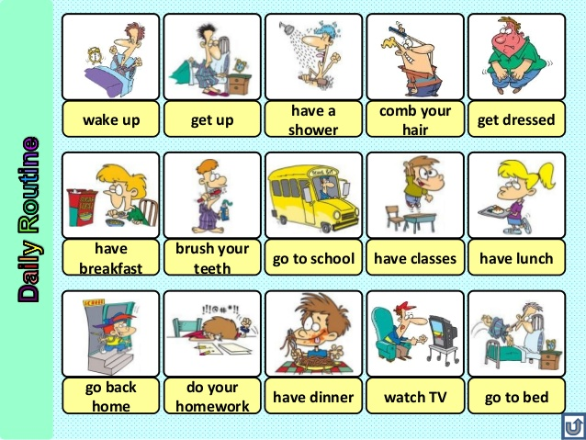
……………………………………………………………………………………………………………………………………………………………………………………………………………………………………………………………………………………………………………………………………………………………………………………………………………………………………………………………………………………………………………………………………………………………………………………………………………… “A different language is a different vision of life.”
Federico Fellini
“If we spoke a different language, we would perceive a somewhat different world.”
Ludwig Wittgenstein
GOOD LUCK
AYHAN DUYGULUOĞLU

