KASTAMONU SCIENCE HIGH SCHOOL THEME 4 CONTENT 2 WRITING TASK CLASSES 9-A-B-C

WILD LIFE

THE INSTRUCTIONS

- Write a paragraph about the wild animals.
- Use the comparative and superlative structures.
- For example, ‘An elephant is the biggest mammal living on land’.
- Also give information about where they live.
- Write about what they eat.
- Write about what your favorite wild animal and explain why.

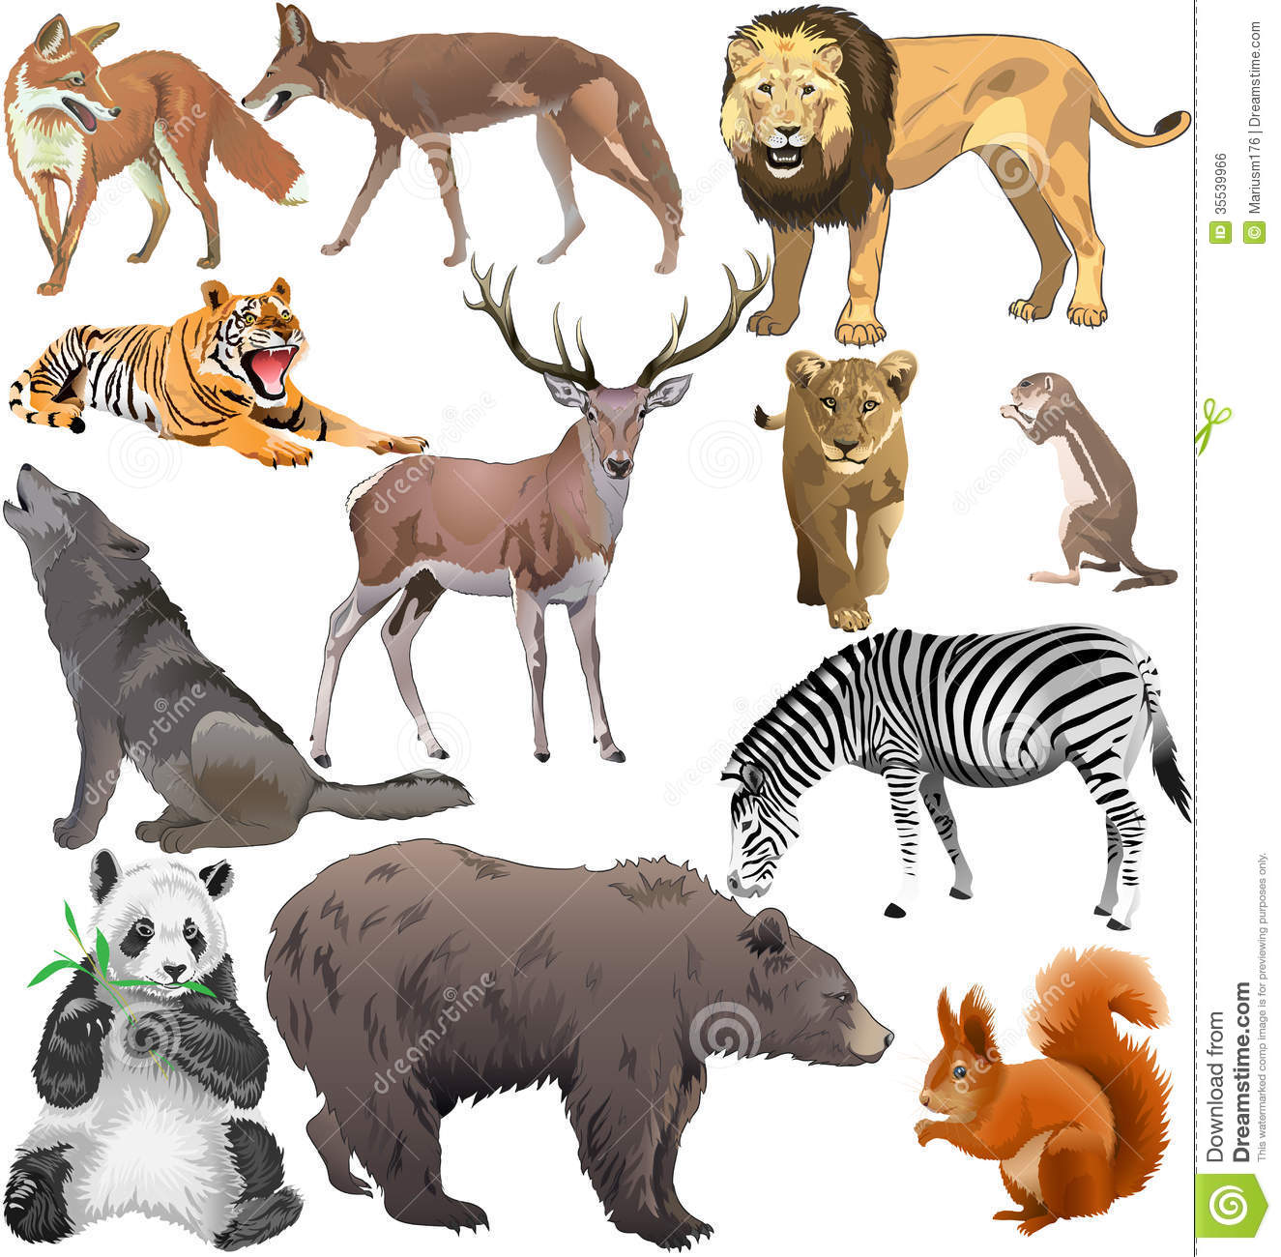
GOOD LUCK
AYHAN DUYGULUOĞLU

