KASTAMONU SCIENCE HIGH SCHOOL THEME 4-CONTENT 3 WRITING TASK
CLASSES 9-A-B-C

ABILITIES

THE INSTRUCTIONS

- Write a paragraph of at least 300 words for London.
- You should write about the following topics;
- Historical places to see
- Parks and entertainment places to see
- Meals to eat
- Things to do
- Places for shopping
- Good hotels to stay in
- Use the grammar structure ‘can’ for ability in your sentences.
You can visit the British Museum there etc…..
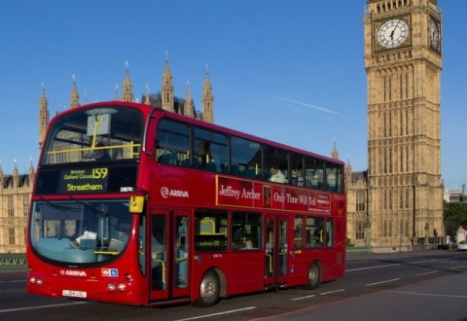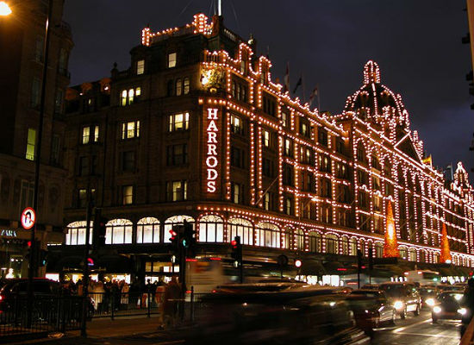
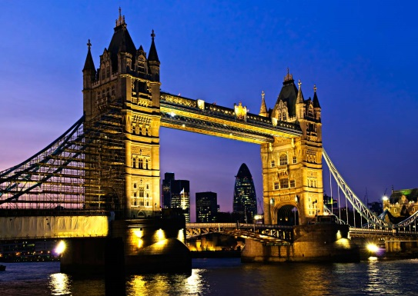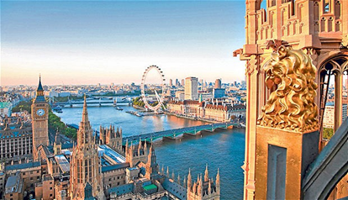


GOOD LUCK
AYHAN DUYGULUOĞLU

