KASTAMONU SCIENCE HIGH SCHOOL THEME 5-CONTENT 1 WRITING TASK
CLASSES 9-A-B-C

CLOTHES

THE INSTRUCTIONS

1) Write about what your family members generally wear.
2) Write about what you wear at weekends and explain why.
3) Write about what color clothes do you like wearing and explain why.
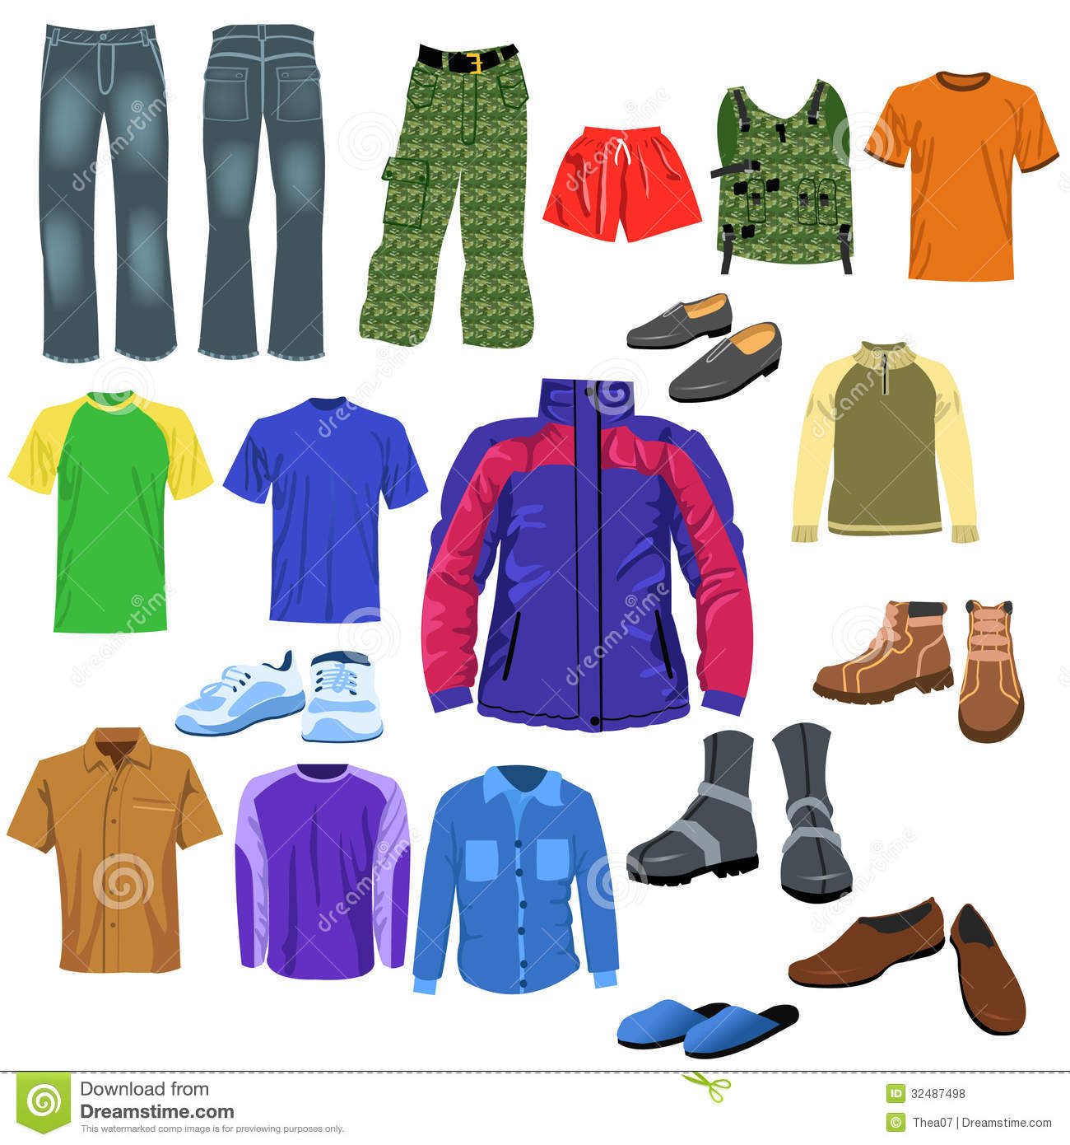


AYHAN DUYGULUOĞLU
THE TEACHER OF ENGLISH LANGUAGE

