KASTAMONU SCIENCE HIGH SCHOOL THEME 5-CONTENT 2 WRITING TASK
CLASSES 9-A-B-C

BODY-APPEARANCE-CHARACTER

THE INSTRUCTIONS

- Write a paragraph about the following topic;

- Friends are important, but everyone has a different opinion of what makes a good friend. Explain what, in your opinion makes a good friend..
- Write about your best friend.
- Describe his physical appearance.
- Write about his character.

- Use the adjectives personality and physical appearance in your writing.

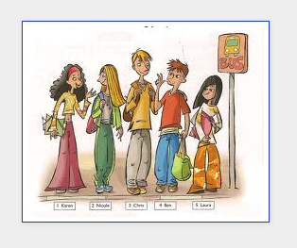
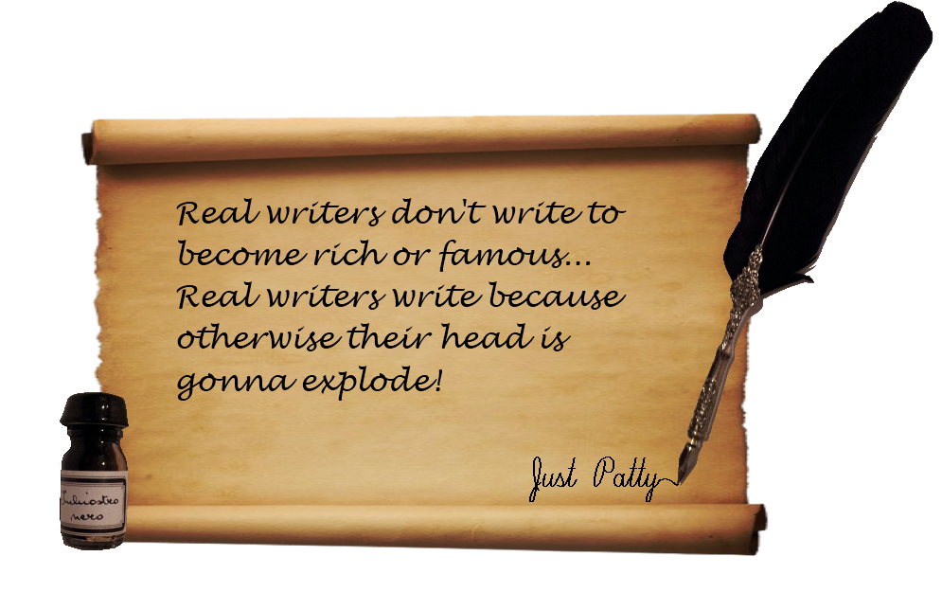
GOOD LUCK
AYHAN DUYGULUOĞLU

