KASTAMONU SCIENCE HIGH SCHOOL THEME 5-CONTENT 3 WRITING TASK CLASSES 9-A-B-C

CHARACTER

THE INSTRUCTIONS

- Write a short paragraph about your favorite movie.

- Use Simple Present Tense in your story.

- Answer the following questions in your story.

- Who stars in the movie?
- How many main characters in the movie?
- Where do the events take place?
- When do the events take place?
- What happens at the beginning of the film?
- What happens then?
- What happens at the end of the film?
- What do you like most about the film?
- Who is your favorite character in the movie?

- Use the following structures in the story;
First, second, then, at the end, finally.

- In one of the paragraphs, choose two of the characters and compare and contrast them. Use the following adjectives of personality.

undisciplined, disorganized, careless,
attentive, alert, observant, considerate;
aggressive, selfish, inconsiderate;
self-confident, shy, modest,
arrogant, stubborn, obstinate;
melancholic, self-conscious, touchy, sensitive;
humorous, amusing, funny, interesting, dull, boring;
generous, unselfish, kind,
economical, thrifty, stingy, greedy;
formal, official, informal, relaxed,
strange, odd, weird, eccentric, crazy.
good-tempered, easygoing;
bad-tempered, friendly, sociable, outgoing, unfriendly, hostile, unsociable;
tough, independent, mature, weak, immature;
dependable, reliable, trustworthy, honest, unreliable, dishonest;
reasonable, sensible, unreasonable,
ambitious, hard-working, energetic, lazy;
disciplined, organized, careful,

- Use the following adjectives of physical appearance;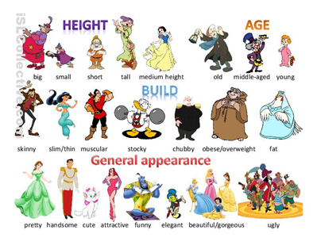
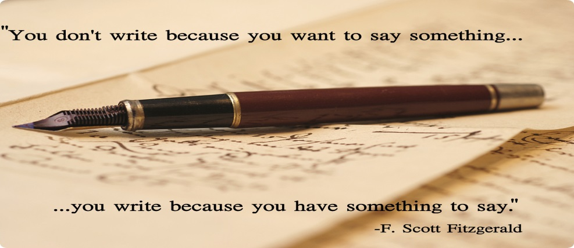
GOOD LUCK
AYHAN DUYGULUOĞLU

