KASTAMONU SCIENCE HIGH SCHOOL THEME 6-CONTENT 1 WRITING TASK
CLASSES 9-A-B-C

PLACES IN A CITY

THE INSTRUCTIONS

- Imagine that one of your friend abroad is going to visit Kastamonu next month to stay for five days but you will not be there. He wants to know what he should do there. Explain him the following;

- Which historical places he should visit
- Where he should do shopping for food
- Where he should do shopping for souvenirs
- Where and what he should eat
- Where he should go for fun

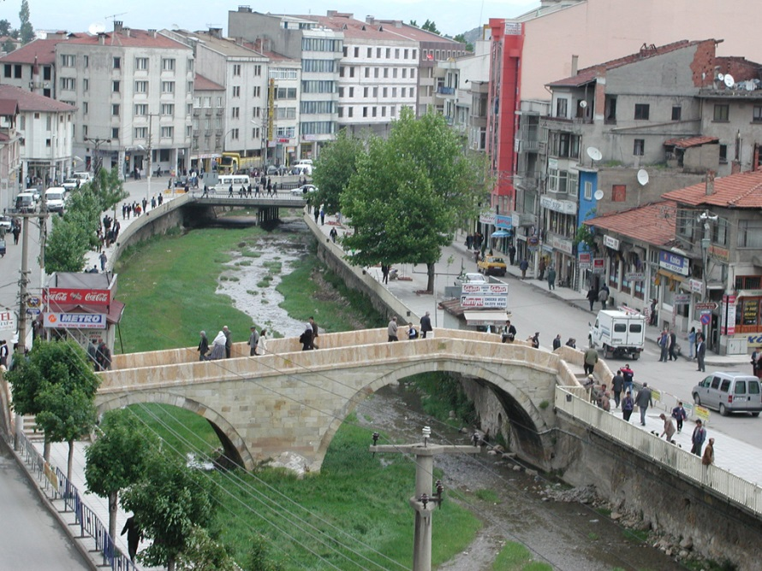
GOOD LUCK
AYHAN DUYGULUOĞLU

