KASTAMONU SCIENCE HIGH SCHOOL THEME 6 CONTENT 2 WRITING TASK
CLASSES 9-A-B-C

MEANS OF TRANSPORT

THE INSTRUCTIONS

- Imagine that you are a tourist guide and you want to write a CV for yourself to help visitors coming to visit Kastamonu. Write about yourself answering the following questions and try to inform the visitors about which type of transportation they should choose to come to Kastamonu by explaining the reasons;

- Where do you live?
- Which languages can you speak well?
- What is your favorite historical site in your hometown?
- What do you do in a typical work day?
- Do you like your job?
- Which countries would you like to visit in the future as a guide?
- Which city would you like to live in the future and why?
- Which is the most important historical site in Turkey and why?
- Which is the most important historical site in the world and why?
- Which kind of transportation do you prefer most and why?

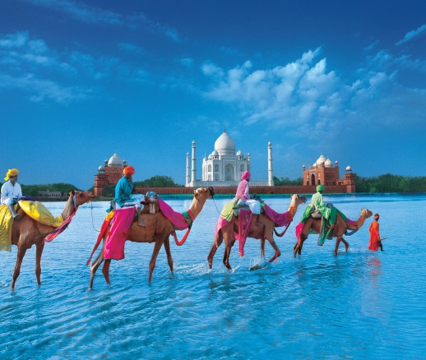
GOOD LUCK
AYHAN DUYGULUOĞLU

