KASTAMONU SCIENCE HIGH SCHOOL THEME 6- CONTENT 3 WRITING TASK
CLASSES 9-A-B-C

TRAVELLING

THE INSTRUCTIONS

- İmagine that you are going on holiday next to one of the following cities. Write about why you choose to go on holiday there. Describe it to one of your friends who does not know any of the places. Answer the following questions;

- When do you have your holidays?
- With whom do you go on holidays?
- Do you prefer to have a holiday near the sea or near the mountains?
- Where are you going on holiday this year?
- Why do you want to go there?
- What do you like most there?
- What do you generally do on holidays?

- Choose one of the following places as your favorite holiday place and describe it to your friend and explain why you go there for holiday;

ŞANGAY PARİS
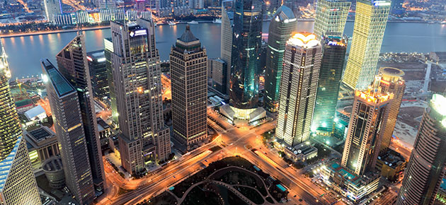

OXFORD MADRİD

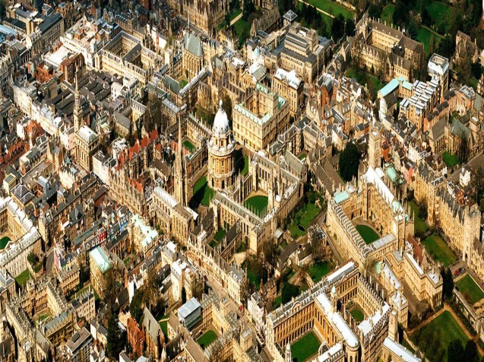

GOOD LUCK
AYHAN DUYGULUOĞLU

