KASTAMONU SCIENCE HIGH SCHOOL THEME 7 CONTENT 1 WRITING TASK

HISTORICAL MONUMENTS

THE INSTRUCTIONS

- Write about your best holiday. Answer the questions below;

- When did you go on that holiday?
- How old were you?
- Which school were you at when you went there?
- Where did you go for holiday?
- How many days did you stay there?
- With whom did you go on the holiday?
- What season was the holiday?
- How did you spend your days there?
- Which historical places did you visit?
- Which historical monument did you see?
- What did you generally do during the days?
- What did you generally do in the evenings?
- Did you attend any parties at nights?
- Did you visit any historical sites during the holiday?
- What attracted you most about the holiday resort?
- What was the name of the hotel you stayed in?
- How was the hotel?
- What facilities did it have?
- How did you feel when the holiday was over?
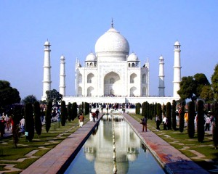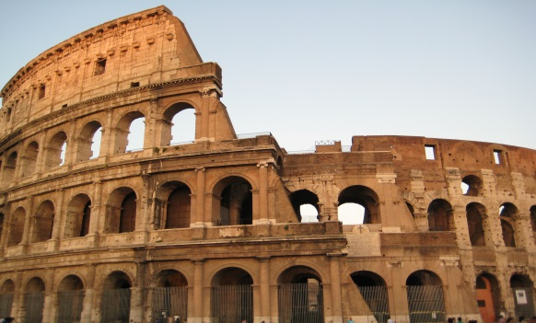
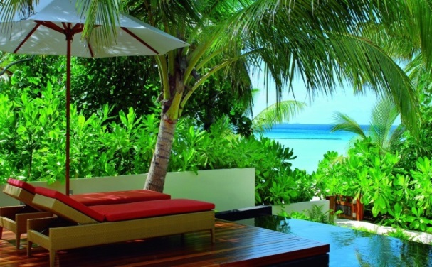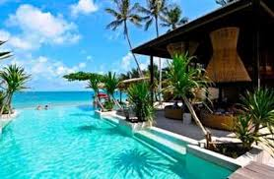
GOOD LUCK
AYHAN DUYGULUOĞLU

