KASTAMONU SCIENCE HIGH SCHOOL THEME 7 CONTENT 2 WRITING TASK CLASSES 9-A-B-C

PAST ACTIVITIES

THE INSTRUCTIONS

A) Write an autobiyography answering the following questions;
1) When were you born?
2) Where were you born?
3) Which cities did you live in before you attended primary school?
4) What age were you when you attended primary school?
5) What was the name of the primary school you attended?
6) What subjects did you like most at primary school?
7) What did you dream of being in the future when you were at primary school?
8) What was your favorite hobby when you were at primary school?
9) Which games did you play with friends when you were at primary school?
10) Who was your best friend?
11) Why was he or she your best friend?
12) What was your biggest problem when you were a child?
13) Who was your idol when you were a child?
14) What was your best memory about your childhood?
15) Where was your best holiday?
16) What was your favorite toy when you were a child and who bought it for you?
17) Which birthday party was the best for you and why?
18) Which secondary school did you attend after you graduated from the primary school?
19) What was your favorite subject there?
20) How was the school in general?
21) When did you graduate from the secondary school?
22) Why did you choose to attend Kastamonu Science High School?

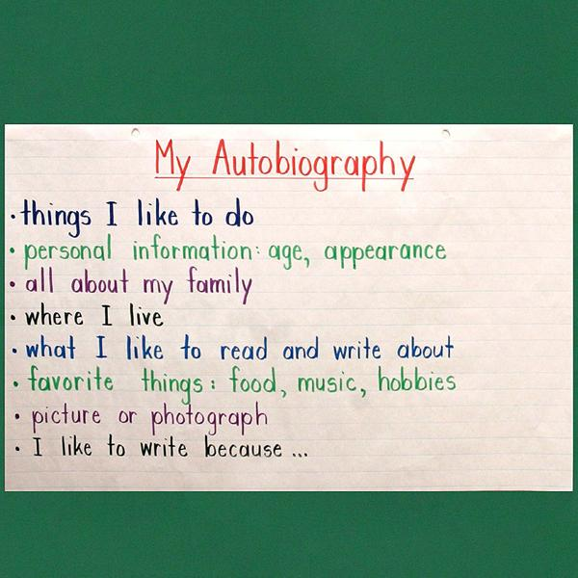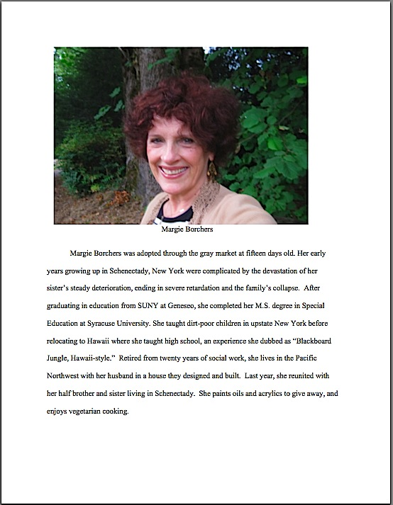
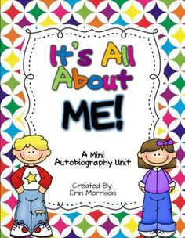

GOOD LUCK
AYHAN DUYGULUOĞLU

