KASTAMONU SCIENCE HIGH SCHOOL
THEME 8-CONTENT 2-WRITING TASK
HOSPITAL
INSTRUCTIONS

- Find a partner for yourself.
- Write a dialogue on the following topic;

- One of you is a doctor and one of you is a patient.
- The patient visit the doctor for an illness you can choose.
- The doctor listens to the patient and prescribes some medicine to him or her.
- He also gives him or her some advice.

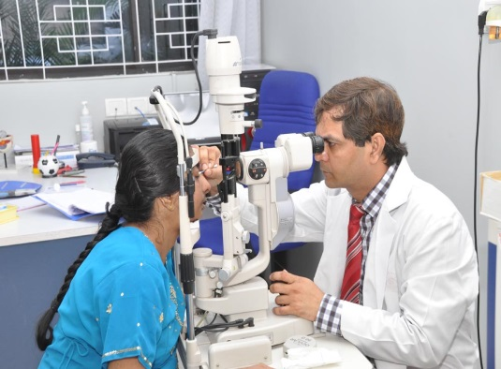



GOOD LUCK
AYHAN DUYGULUOĞLU

