KASTAMONU SCIENCE HIGH SCHOOL
THEME 8-CONTENT 3-WRITING TASK
FIRST AID KIT
INSTRUCTIONS
- Choose one of the following first aid situations and give advice to the people who witness such a situation. You can use the structure;

- When you see someone experiencing heart attack, you must…….or you must not…….

- Heart attack
- Drowning
- Bleeding
- Burn

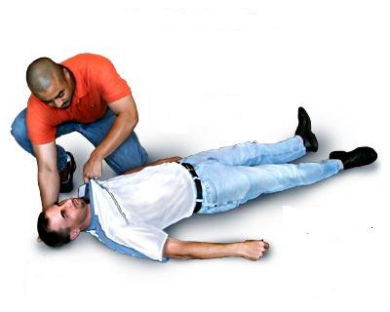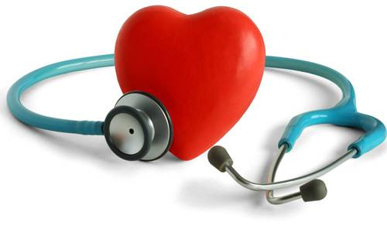

GOOD LUCK
AYHAN DUYGULUOĞLU

