KASTAMONU SCIENCE HIGH SCHOOL THEME 9-CONTENT 1 WRITING TASK
CLASSES 9-A-B-C

FUTURE PLANS

THE INSTRUCTIONS

1) Write about your future plans by using future tense. Your writing should be 3 different paragraphs, each paragraph should include at least five sentences. The topic of the each paragraph should be as follows;

THE FIRST PARAPRAPH: Your future plans about the university and the department you want to attend. You can answer the following questions in your paragraph.

- Which city are you going to attend the university in and why?
- Which university are you going to attend when you win the university exam and why?
- Which department are you going to attend in the future and why?
- Where are you going to stay when you are at university and why?
- Why do you want to/ don’t you want to attend a university in your hometown and why?

THE SECOND PARAGRAPH: Your future plans about your career. You can answer the following questions in your paragraph.

- Will you go on your education when you finish the university? If yes or no, please explain why.
- Where will you work after you finish the university?
- What will you do to improve yourself in your profession?
- Will you attend any education activity or seminar abroad? If yes or no, please explain why.
- Will you do any voluntary work about your profession?

THE THIRD PARAGRAPH: Your future plans about your personal life. You can answer the following questions in your paragraph.
- When will you get married?
- Will you live with your parents? Why or why not?
- Will you live in a city or in the countryside? Why or why not?
- What will you do when you get retired?
- Which profession do you hope your children will choose in the future?
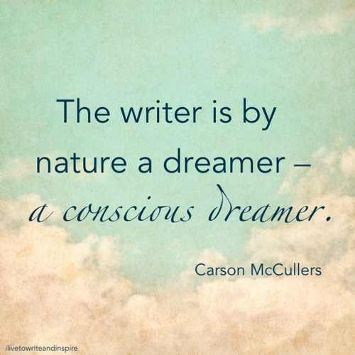
GOOD LUCK
AYHAN DUYKULUOĞLU

