KASTAMONU SCIENCE HIGH SCHOOL THEME 9 CONTENT 2 WRITING TASK CLASSES 9-A-B-C

SPECIAL OCCASIONS

THE INSTRUCTIONS

1) Imagine that as the classroom, you are going to organize a charity feast for a poor family in your town. Write about the preparations you will do by using the structure ‘going to’. Your writing should be three paragraphs each involving 5 sentences at least. You should write the following in the paragraphs;

THE FIRST PARAGRAPH:

- Preparations for the feast
- Where are you going to organize the feast?
- What are you going to sell?
- Who is going to bring what?
- When are you going to organize the feast?
- Who are you going to invite to the feats?
- Who is going to help you organize it?

THE SECOND PARAGRAPH

- The day of the feast.
- Who is going to sell the goods?
- Who is going to keep the money collected?
- What time is the feast going to start in the morning?
- What time is the feast going to finish in the evening?

THE THIRD PARAGRAPH

- When are you going to help the poor family?
- Who is going to do the shopping for the family?
- What are going to buy for the poor family?
- Where are you going to do the shopping for them?
- How are you going to take the goods to them?

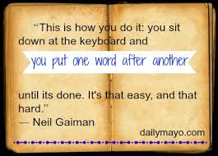
GOOD LUCK
AYHAN DUYGULUOĞLU

