KASTAMONU SCIENCE HIGH SCHOOL
THEME 9 CONTENT 3 WRITING TASK

PARTY

THE INSTRUCTIONS

- Imagine that you have attended a friend’s birthday party in İstanbul. After the party, you want to spend a day in İstanbul with your friends. Write about what you are going to do with your friends in İstanbul.

- Which places are you going to see?
- Which museums are you going to visit?
- What are you going to eat for lunch?
- Where are you going to go for shopping?
- What are you going to buy for your family as a gift?
- Which traditional drinks are you going to taste?
- Where are you going to have dinner and what are you going to have for dinner?
- Where are you going to spend the night?
- What kind of shows are you going to watch?
- What traditional games are you going to play?
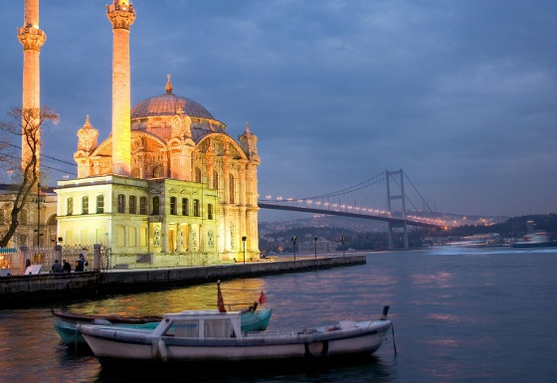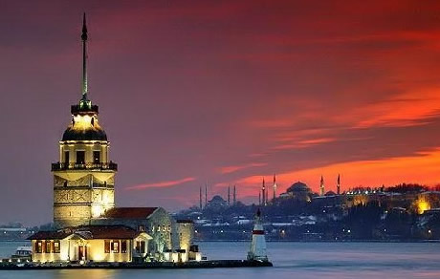

GOOD LUCK
AYHAN DUYGULUOĞLU

