References & snapshot

# References

* An Object that points to a location in your application (can create References to either Database and Storage in Firebase by pointing to a location)
* Allows you to read/write references
* Used to upload a file to the Storage and add data to the Database

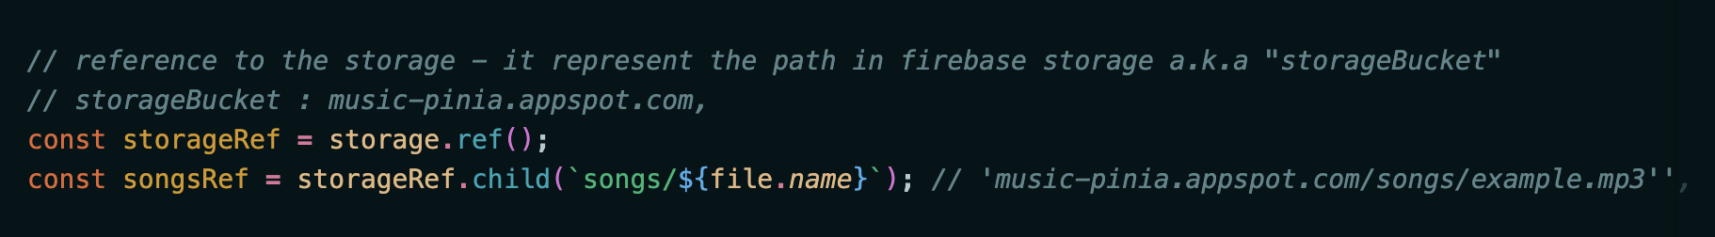

* References can create another references
* Can create root references (***storageRef***), the root references was used to create another references (***songsRef***) to the location where the file will be upload
* Best practice is create root reference and another for a specific location → allow to create more references

# Snapshot

* Snapshot are objects that are a copy of location in your application
* Can read-only
* Immutable (can not write) → can not be changed, changes wouldn’t be reflected in Firebase whenever we make change to the application

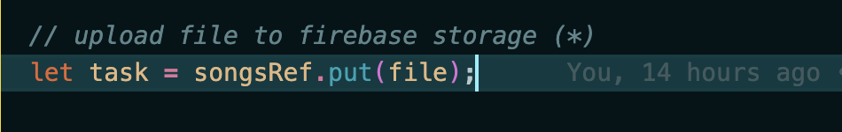

* It’s typical for Firebase to respond with a snapshot; one example of a snapshot was when initially did the upload to Firebase, we used snapshot to gather information about the upload in progress; even able to grab the reference
* Some snapshot come with a references
* ***Note***: Snapshot are usually returned whenever you listen to changes using a reference, you can not create snapshot directly (it‘s created during event)

***→ References and snapshots can read the data in the application. Snapshots are read-only but are memory efficient (tiết kiệm bộ nhớ)***