

**ONLINE GLASS SELLING STOREFRONT (GLASS KING)**

**Software Design Document**

**Table of Contents**

I. Overview **3**

1. Code Packages/Namespaces 3

Package descriptions & package class naming conventions 3

2. Database Design 4

Feedback 5

Order 6

Feedback_Replies 6

Product 7

Users 8

User Address 8

Notification 8

Cart 9

Ship 9

Order Detail 9

Ship Info 10

User Address 10

Category 11

Manufacturer 11

ProductStatus 11

Order Status 11

**II. Code Design** **12**

# I. Overview

## 1. Code Packages/Namespaces

## 

### 1.1 Package descriptions & package class naming conventions

| **No** | **Package** | **Description** |
| --- | --- | --- |
| *01* | *view (Web Pages)* | *Provide interaction with user, GUI*  *Java Class Naming Convention* |
| *02* | *controller* | *Control the data flow between view and dao, Control the logic of the system*  *Java Class Naming Convention* |
| *03* | *dao* | *Provide the connection to the Database, Extract data for the system* |
| *04* | *filter* | *Control the redirection between Pages in view and from view to controller*  *Java Class Naming Convention* |
| *05* | *entity* | *Define the logic of data extracted from Database*  *Java Class Naming Convention* |

## 2. Database Design

### 2.1 Database Schema

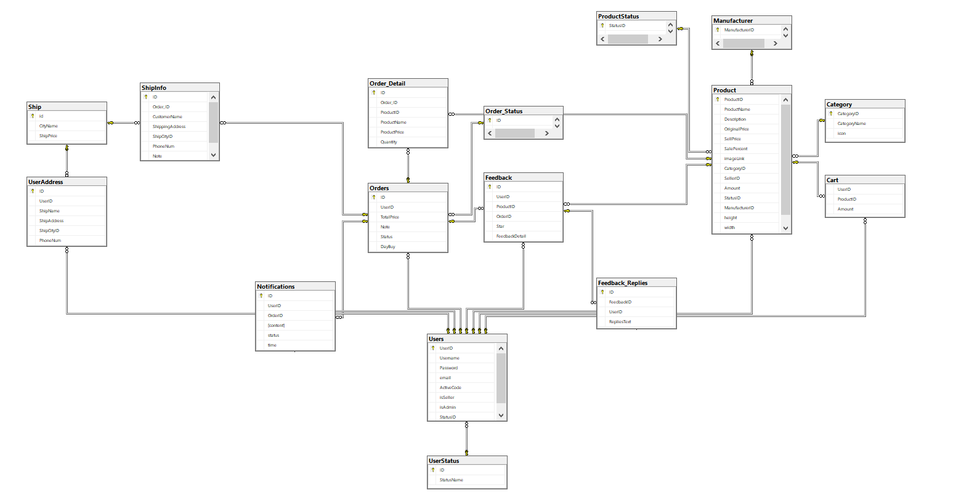

***Table descriptions & package class naming conventions are as below***

| **No** | **Table** | **Description** |
| --- | --- | --- |
| *01* | *User Status* | *Store the status of an Account* |
| *02* | *Users* | *Store the information of all users (including customers, sellers and admin)*  *- Primary keys: UserID*  *- Foreign keys: StatusID* |
| *03* | *Category* | *Store the information of Categories of products*  *- Primary keys: CategoryID* |
| *04* | *Product Status* | *Store the status of a Product (out of stock or not)*  *- Primary keys: StatusID* |
| *05* | *Manufacturer* | *Store the information of the Manufacturer of a Product*  *- Primary keys: ManufacturerID* |
| *06* | *Product* | *Store the information of all products*  *- Primary keys: ProductID*  *- Foreign keys: ManufacturerID, StatusID, SellerID, CategoryID* |
| *07* | *Information* | *Store some information of the shop* |
| *08* | *Cart* | *Store information of the Cart of each Customer*  *- Foreign keys: UserID, ProductID* |
| *09* | *Order_Status* | *Store the status of an Order*  *- Primary keys: ID* |
| *10* | *Orders* | *Store information of all orders*  *- Primary keys: ID*  *- Foreigns keys: UserID* |
| *11* | *Order_Detail* | *Store products information of all orders*  *- Primary keys: ID*  *- Foreigns keys: Order_ID, ProductID* |
| *12* | *Ship* | *Store the ship Price of each City*  *- Primary keys: ID* |
| *13* | *UserAddress* | *Store the Shipping Address of Customers*  *- Primary keys: ID*  *- Foreign keys: UserID, ShipCityID* |
| *14* | *ShipInfo* | *Store the ship info of all orders*  *- Primary keys: ID*  *- Foreign keys: UserID, ShipCityID* |
| *15* | *Notifications* | *Store the notifications of a Customer order*  *- Primary keys: ID*  *- Foreign keys: UserID, OrderID* |
| *16* | *Feedback* | *Store all information of Customer’s feedbacks on a Product*  *- Primary keys: ID*  *- Foreign keys: UserID, ProductID, OrderID* |
| *17* | *Feedback*  *_Replies* | *Store all replies of each feedback*  *- Primary keys: ID*  *- Foreign keys: UserID, FeedbackID* |

### 2.2 Database Table

#### 2.2.1 Feedback

| **#** | **Field name** | **Type** | **Size** | **Unique** | **Not Null** | **PK/FK** | **Notes** |
| --- | --- | --- | --- | --- | --- | --- | --- |
| 1 | ID | int |  | N | Y | PK | Auto increments |
| 2 | UserID | int |  | Y | N | FK | FK to table UserID |
| 3 | ProductID | int |  | Y | N | FK | FK to table Product |
| 4 | OrderID | int |  | Y | N | FK | FK to table Orders |
| 5 | Star | int | Star < 6 AND Star > 0 | Y | N |  | Star scale rating out of 5 |
| 6 | FeedbackDetail | nvarchar | 2000 | Y | N |  | Comment on other's products |

#### 2.2.2 Order

| **#** | **Field name** | **Type** | **Size** | **Unique** | **Not Null** | **PK/FK** | **Notes** |
| --- | --- | --- | --- | --- | --- | --- | --- |
| 1 | ID | int |  | N | Y | PK | Auto increments |
| 2 | UserID | int |  | Y | N | FK | FK to table User |
| 3 | TotalPrice | float |  | Y | N |  | price of the product |
| 4 | Note | nvarchar | 2000 | Y | N |  | note |
| 5 | Status | int |  | Y | N | FK | FK to table Order_Status |
| 6 | DayBuy | date time |  | Y | N |  | purchase date |

#### 2.2.3 Feedback_Replies

| **#** | **Field name** | **Type** | **Size** | **Unique** | **Not Null** | **PK/FK** | **Notes** |
| --- | --- | --- | --- | --- | --- | --- | --- |
| 1 | ID | int |  | N | Y | PK | Auto increments |
| 2 | FeedbackID | int |  | Y | N | FK | FK to table Feedback |
| 3 | UserID | float |  | Y | N | FK | FK to table Users |
| 4 | RepliesText | nvarchar | 2000 | Y | N | FK | Reply to customer |

#### 2.2.4 Product

| **#** | **Field name** | **Type** | **Size** | **Unique** | **Not Null** | **PK/FK** | **Notes** |
| --- | --- | --- | --- | --- | --- | --- | --- |
| 1 | ProductID | int |  | N | Y | PK | Auto increments |
| 2 | ProductName | nvarchar |  | Y | N | FK | FK to table Feedback |
| 3 | Description | nvarchar | 1000 | Y | N |  | description of the product |
| 4 | OriginalPrice | int | 2000 | Y | N |  | original price of the product |
| 5 | SellPrice | int |  | Y | N | FK | FK to table SellerID |
| 6 | SalePercent | int | >=0 AND <=100 | Y | N |  | discount percentage |
| 7 | imageLink | nvarchar | 1000 | Y | N |  | link of product photo |
| 8 | CategoryID | int |  | Y | N |  | to table Category |
| 9 | SellerID | int |  | Y | N | FK | FK to table StatusID |
| 10 | Amount | int |  | Y | N |  | the number of products |
| 11 | StatusID | int |  | Y | N |  | product status from table ProductStatus |
| 12 | ManufacturerID | int |  | Y | N | FK | FK to table ManufacturerID |
| 13 | height | float |  | Y | N |  | height of product |
| 14 | width | float |  | Y | N |  | width of product |
|  |  |  |  |  |  |  |  |

#### 2.2.5 Users

| **#** | **Field name** | **Type** | **Size** | **Unique** | **Not Null** | **PK/FK** | **Notes** |
| --- | --- | --- | --- | --- | --- | --- | --- |
| 1 | UserID | int |  | N | N | PK | Auto increments |
| 2 | Username | nvarchar | 500 | Y | N |  | user's login name |
| 3 | Password | nvarchar | 1000 | Y | N |  | user's password |
| 4 | email | nvarchar | 1000 | Y | N |  | user's email |
| 5 | ActiveCode | nvarchar | 11 | Y | N |  | code to unlock active |
| 6 | isSekker | int |  | Y | N |  | is a seller |
| 7 | isAdmin | int |  | Y | N |  | is a admin |
| 8 | StatusID | int |  | Y | N | FK | FK to table UserStatus |

#### 2.2.6 User Address

| **#** | **Field name** | **Type** | **Size** | **Unique** | **Not Null** | **PK/FK** | **Notes** |
| --- | --- | --- | --- | --- | --- | --- | --- |
| 1 | ID | int |  | N | Y | PK | Auto increments |
| 2 | UserID | int |  | Y | N | FK | FK to table User |
| 3 | ShipName | nvarchar | 500 | Y | N |  | product shipper's name |
| 4 | ShipAddress | nvarchar | 1000 | Y | N |  | address to ship |
| 5 | ShipCityID | int |  | Y | N | FK | FK to table Ship |
| 6 | PhoneNum | varcher | 20 | Y | N |  | customer phone number |

#### 2.2.7 Notification

| **#** | **Field name** | **Type** | **Size** | **Unique** | **Not Null** | **PK/FK** | **Notes** |
| --- | --- | --- | --- | --- | --- | --- | --- |
| 1 | ID | int |  | N | N | PK | Auto increments |
| 2 | UserID | int |  | Y | N | FK | FK to table User |
| 3 | OrderID | int |  | Y | N | FK | FK to table Order |
| 4 | content | char | 1000 | Y | N |  | main content |
| 5 | status | char | 30 | Y | N |  | status read or unread |
| 6 | time | char | 50 | Y | N |  | time check |

#### 2.2.8 Cart

| **#** | **Field name** | **Type** | **Size** | **Unique** | **Not Null** | **PK/FK** | **Notes** |
| --- | --- | --- | --- | --- | --- | --- | --- |
| 1 | UserID | int |  | Y | N | FK | FK to table Users |
| 2 | ProductID | int |  | Y | N | FK | FK to table Product |
| 3 | Amount | int |  | Y | N |  | the number of products |

#### 2.2.9 Ship

| **#** | **Field name** | **Type** | **Size** | **Unique** | **Not Null** | **PK/FK** | **Notes** |
| --- | --- | --- | --- | --- | --- | --- | --- |
| 1 | id | int |  | N | Y | PK | Auto increments |
| 2 | CityName | nvarchar | 1000 | Y | N |  | Name of city to ship |
| 3 | ShipPrice | int |  | Y | N |  | shipping price |

#### 2.2.10 Order Detail

| **#** | **Field name** | **Type** | **Size** | **Unique** | **Not Null** | **PK/FK** | **Notes** |
| --- | --- | --- | --- | --- | --- | --- | --- |
| 1 | ID | int |  | N | Y | PK | Auto increments |
| 2 | Order_ID | int |  | Y | Y | FK | FK to table Orders |
| 3 | ProductID | int |  | Y | Y | FK | FK to table Product |
| 4 | ProductName | nvarchar | 1000 | Y | Y |  | Product's name |
| 5 | ProductPrice | int |  | Y | Y |  | product price |
| 6 | Quantity | int |  | Y | Y |  | product quality |

#### 2.2.11 Ship Info

| **#** | **Field name** | **Type** | **Size** | **Unique** | **Not Null** | **PK/FK** | **Notes** |
| --- | --- | --- | --- | --- | --- | --- | --- |
| 1 | ID | int |  | N | Y | PK | Auto increments |
| 2 | Order_ID | int |  | Y | N | FK | FK to table Orders |
| 3 | CustomerName | nvarchar | 1000 | Y | N |  | CustomerName |
| 4 | ShippingAddress | nvarchar | 1000 | Y | N |  | ShippingAddress |
| 5 | ShipCityID | int |  | Y | N | FK | FK to table Ship |
| 6 | PhoneNum | varchar | 20 | Y | N |  | PhoneNum |
| 7 | Note | nvarchar | 1000 | Y | N |  | Note |

#### 2.2.12 User Address

| **#** | **Field name** | **Type** | **Size** | **Unique** | **Not Null** | **PK/FK** | **Notes** |
| --- | --- | --- | --- | --- | --- | --- | --- |
| 1 | ID | int |  | N | Y | PK | Auto increments |
| 2 | UserID | int |  | Y | N | FK | FK to table Orders |
| 3 | ShipName | nvarchar | 500 | Y | N |  | ShipName |
| 4 | ShippingAddress | nvarchar | 1000 | Y | N |  | ShippingAddress |
| 5 | ShipCityID | int |  | Y | N | FK | FK to table Ship |
| 6 | PhoneNum | varchar | 20 | Y | N |  | PhoneNum |

#### 2.2.13 Category

| **#** | **Field name** | **Type** | **Size** | **Unique** | **Not Null** | **PK/FK** | **Notes** |
| --- | --- | --- | --- | --- | --- | --- | --- |
| 1 | CategoryID | int |  | N | Y | PK | Auto increments |
| 2 | Categoryname | nvarchar | 1000 | Y | N |  | Categoryname |
| 3 | icon | nvarchar | 1000 | Y | N |  | icon |

#### 2.2.14 Manufacturer

| **#** | **Field name** | **Type** | **Size** | **Unique** | **Not Null** | **PK/FK** | **Notes** |
| --- | --- | --- | --- | --- | --- | --- | --- |
| 1 | ManufacturerID | int |  | N | Y | PK | Auto increments |
| 2 | ManufacturerName | nvarchar | 1000 | Y | N | FK | ManufacturerName |

#### 2.2.15 ProductStatus

| **#** | **Field name** | **Type** | **Size** | **Unique** | **Not Null** | **PK/FK** | **Notes** |
| --- | --- | --- | --- | --- | --- | --- | --- |
| 1 | StatusID | int |  | N | Y | PK | Auto increments |
| 2 | StatusName | nvarchar | 1000 | Y | N | FK | StatusName |

#### 2.2.16 Order Status

| **#** | **Field name** | **Type** | **Size** | **Unique** | **Not Null** | **PK/FK** | **Notes** |
| --- | --- | --- | --- | --- | --- | --- | --- |
| 1 | ID | int |  | N | Y | PK | ID |
| 2 | Name | nvarchar | 50 | Y | Y | FK | Name |

# II. Code Design