

**ONLINE GLASS SELLING STOREFRONT (GLASS KING)**

**Software Requirement Specification**

– Hanoi, September 2022 –

**Table of Contents**

I. Overview **3**

1. Introduction 3

2. System Functions 4

a. Screen Flow 4

b. Screen Details 6

c. User Authorization 8

d. Non-Screen Functions 9

3. Common Requirements 9

1.1 Operating Environment 9

1.2 Design and Implementation Constraints 9

1.3 Assumptions and Dependencies 9

1.4 Business rules 10

II. Functional Requirements **11**

Hung: 11

Minh: 14

HA: 16

Tuan: 21

Đức: 22

# I. Overview

## 1. Introduction

This document describes the requirements for glassking.com website, which provides services and supplies glasses-related products for customers. Types of reader this document is intended for: developers, project managers, testers, etc.   
  
This website will grant customers the ability to pick up their customized glasses, and order them from an online store front, then to be delivered to specified locations.

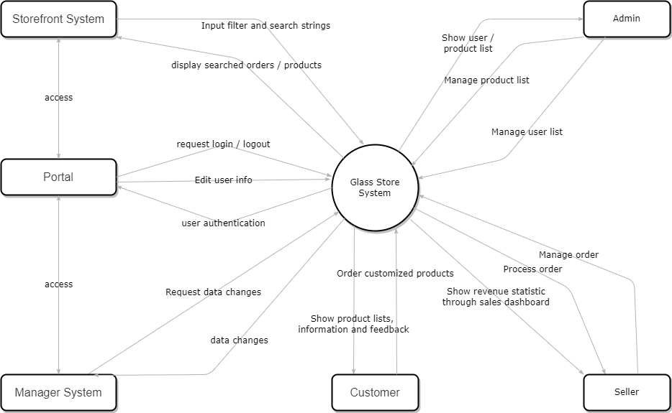

With the development of the storefront, this project will bring good experiences to group member who need to improve their coding skills. The group asks questions and help eachother in real-time via Google meet.

## 2. System Functions

#### a. Screen Flow

User: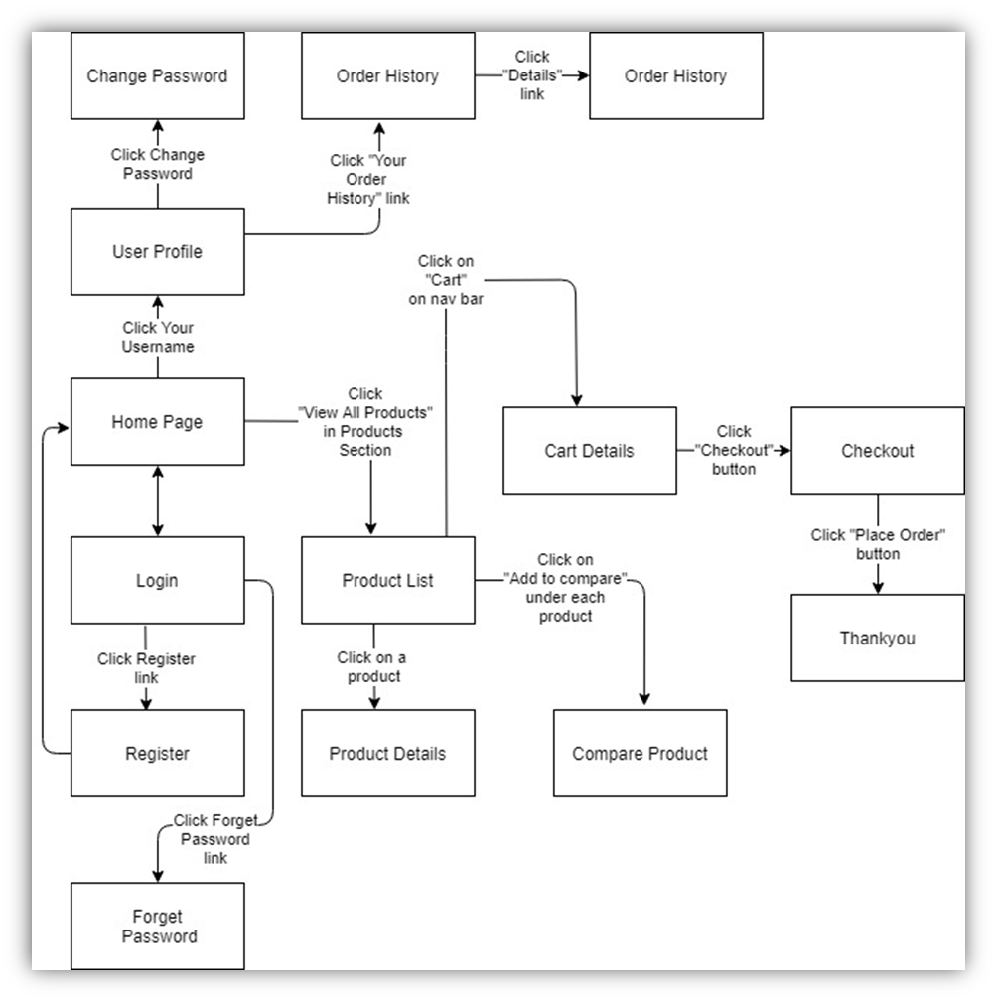

Figure 1-1: Screen Flow for User

Admin: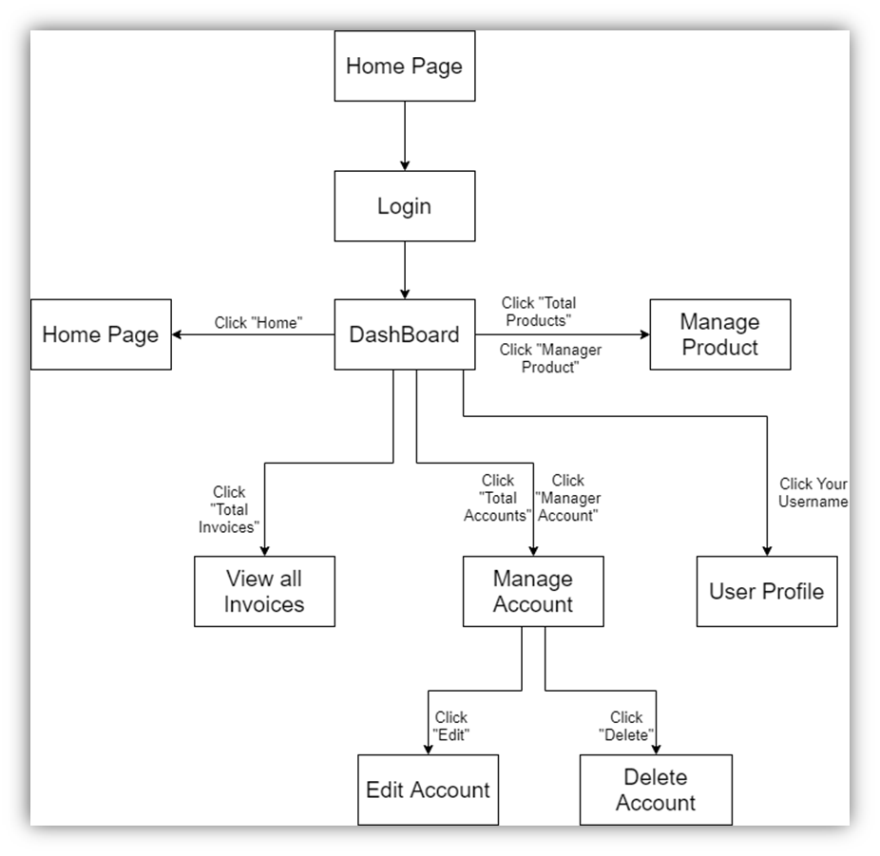

Figure 1-2: Screen Flow for Admin

Seller: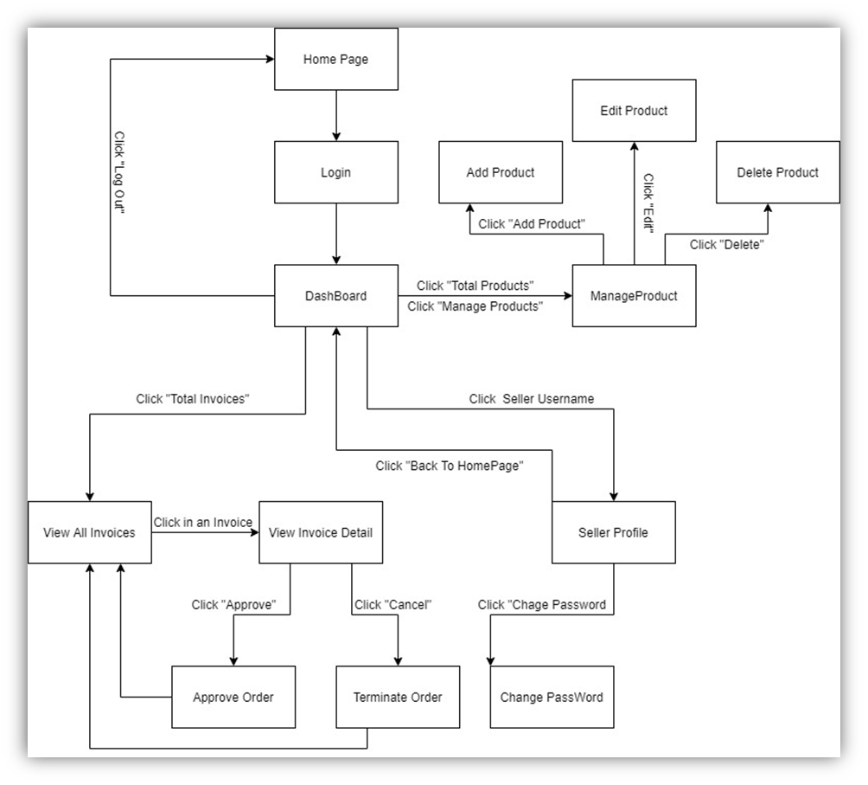

Figure 1-3: Screen Flow for Seller

#### b. Screen Details

| **#** | **Feature** | **Screen** | **Description** |
| --- | --- | --- | --- |
| 1 | Search & Filter Product | Home Page | Search for a Product by name or filter it by category |
| 2 | Interact with map | Home Page | Use the map to find the location of the shop |
| 3 | View Product Detail | Product Details | Display detail information of Product |
| 4 | Change Amount | Cart Details | Plus or Minus the Amount of a Product in Cart |
| 5 | Delete Product | Cart Details | Delete a Product in Cart |
| 6 | Delete Cart | Cart Details | Delete all the Product in Cart |
| 7 | Login | User Login | User Login to the System |
| 8 | Register | User Register | User Register for an account |
| 9 | Send Code | User Authorization | System send a Code via Email and User enter the code to pass Authorization |
| 10 | View User List | Users List [Admin] | Admin View the list of all Accounts in the System |
| 11 | Edit User | Users List [Admin] | Admin Edit information of an Account |
| 12 | Delete User | Users List [Admin] | Admin Delete an Account from the System |
| 13 | Add Ship Information | Cart Completion | User enter all shipping information for delivery |
| 14 | Change Ship Information | Cart Completion | User can change the existing shipping information for delivery |
| 15 | Reset Password | Reset Password | When user forget password, send a verification code through Email for user to reset password |
| 16 | Change Password | Change Password | Change user’s old password with new password |
| 17 | User Profile | User Profile | User views information about his account |
| 18 | My Orders | My Orders | User views the history of all orders he made |
| 19 | Order Information | Order Information | User views detail history of a specific order |
| 20 | View Product List | Products List [Sale] | Seller views all of Products that he sells |
| 21 | Sale Dashboard | Sale Dashboard [Sale] | Seller views Statistic of the sale of his products |
| 22 | Orders List | Orders List [Admin] | Admin views list of all of 2orders |
| 23 | Order Details | Order Details [Sale] | Seller views the detail of 1 of his orders |
| 24 | View Feedback | Feedback | Customer views all the Feedbacks about a Product |
| 25 | Send Feedback | Feedback | Customer writes and send a Feedback about a Product |
| 26 | View all Notification | Notification | User views the list of all Notifications |
| 27 | Mark as Read | Notification | User mark all the new Notification as read |
| 28 | Search to Compare | Compare Product | User searches for a Product to Compare with the Current Product |
| 29 | View Comparison | Compare Product | User views all the Compare information |
| 30 | Error | Error | Show in case there’s an Error occurs |

#### c. User Authorization

| **Screen** | **Guest** | **User** | **Seller** | **Admin** |
| --- | --- | --- | --- | --- |
| Home Page (HA) | x | x |  |  |
| Products List [Customers] | x | x |  |  |
| Product Details (HA) | x | x |  |  |
| View Feedback (Đức) | x | x |  |  |
| Compare Product (Đức) | x | x |  |  |
| Cart System |  | x |  |  |
| Cart Details (HA) |  | x |  |  |
| Cart Completion (HA) |  | x |  |  |
| Portal | x |  |  |  |
| User Login (DH) | x |  |  |  |
| User Sign up (DH) | x |  |  |  |
| User Authorization (DH) | x |  |  |  |
| My Orders (Minh) |  | x |  |  |
| Order Information (Tuấn) |  | x |  |  |
| Cancel Order |  | x |  |  |
| Give Feedback |  | x |  |  |
| User Profile (DH) |  | x | x | x |
| Change Password (DH) |  | x | x | x |
| Reset Password (DH) |  | x | x | x |
| Notification (Đức) |  | x | x | x |
| Sale Dashboard [Seller] (Tuấn) |  |  | x |  |
| Order Management [Seller] |  |  | x |  |
| Orders List [Seller] (Minh) |  |  | x |  |
| Order Details [Seller] (Minh) |  |  | x |  |
| Edit Order [Seller] |  |  | x |  |
| Management System [Admin] |  |  |  | x |
| Users List [Admin] (Minh) |  |  |  | x |
| Products List [Admin] (HA) |  |  |  | x |
| Error (Tuấn) | x | x | x | x |

In which:

* Guest: Customer who has not yet logged in to the site
* User: Customer who has an account an has logged in
* Seller: People who sell products in the shop
* Admin: People who manage the shop

#### d. Non-Screen Functions

| **#** | **Feature** | **System Function** | **Description** |
| --- | --- | --- | --- |
| 1 | Remember Me | Login | System store user’s login account and password in cookies for future re-login |
| 2 | Login with Facebook | Login | User logs in the system with his Facebook account |
| 3 | Add To Cart | Home Page & Product Detail | User Click “Add To Cart” to add this Product to Cart |

## 3. Common Requirements

#### 1.1 Operating Environment

The glassking.com website shall be compatible with standard web browsers on Windows, Mac, and Web-enabled smart phone platforms.

#### 1.2 Design and Implementation Constraints

CO-1: The administrator shall be able to maintain and modify the site without requiring any specialized technical knowledge.

CO-2: The backend web must be written in Java programming language.

CO-3: All HTML code shall conform to the HTML 5.0 standard

#### 1.3 Assumptions and Dependencies

Assumptions:

· Availability of external libraries are expected, and each imported modules/libraries are used in one of their fixed version.

Dependencies:

· The end user browser environment (must have basic javascript and html > version 4 installed)

· External libraries

#### 1.4 Business rules

| ID | Rule definition | Type of rule | Static or dynamic | Source |
| --- | --- | --- | --- | --- |
| BR-1 | Deliveries must be completed in 1 week after the order approved. After one week, customer can cancel order manually. | Constraint | Dynamic | Shop policy |
| BR-2 | All goods in a single order must be paid for by using the same payment method. | Constraint | Static | Shop manager |
| BR-3 | Order price is calculated as the sum of each order item price times the quantity of that order item ordered, plus shipping fee | Computation | Dynamic | Shop manager |

## 

# II. Functional Requirements

Website’s mockup screen:

### 1. Portal

Hung:

#### 1.1 Login:

· *Function trigger: This function is triggered when guests click Sign In in the navigation bar, or when admin/seller trying to access manager frontend while logged off.*

· *Function description: The screen shows a portal webpage with a login panel, filled with an username and a password textfield, remember me checkbox, login, signup and forgot my password button.*

· *Screen layout: Mockup prototype of the screen, sample below is for Login screen*

#### 

**Screen Definition**

| # | Field Name | Type | Mandatory | Max Length | Description |
| --- | --- | --- | --- | --- | --- |
| 1 | username | Textfield | Yes | 50 | Fill account’s username |
| 2 | password | Textfield | Yes | 50 | Fill account’s password |

· *Function Details: The screen shows a portal webpage with a login panel, filled with an username and a password textfield, remember me checkbox, login, signup and forgot my password button.*

Process flow

| # | Actor | Action description |
| --- | --- | --- |
| 1 | User | User fill in the following login fields   * username * password |
| 2 | System | System authorize users and redirect them to homepage given that username and password was correct and matched. |

Business rules

| # | Description |
| --- | --- |
| BR01 | Password must meet the site’s password requirements (contain at least 7 characters and up) |

#### 

#### *1.*2Sign up:

· *Function trigger: This function is triggered when guests click Sign Up in the Login panel.*

· *Function description: The screen shows a portal webpage with a sign up panel, filled with an username, a password textfield, a confirm password textfield, an email textfield, terms and condition checkbox, and sign up button.*

· *Screen layout: Mockup prototype of the screen, sample below is for Sign up screen*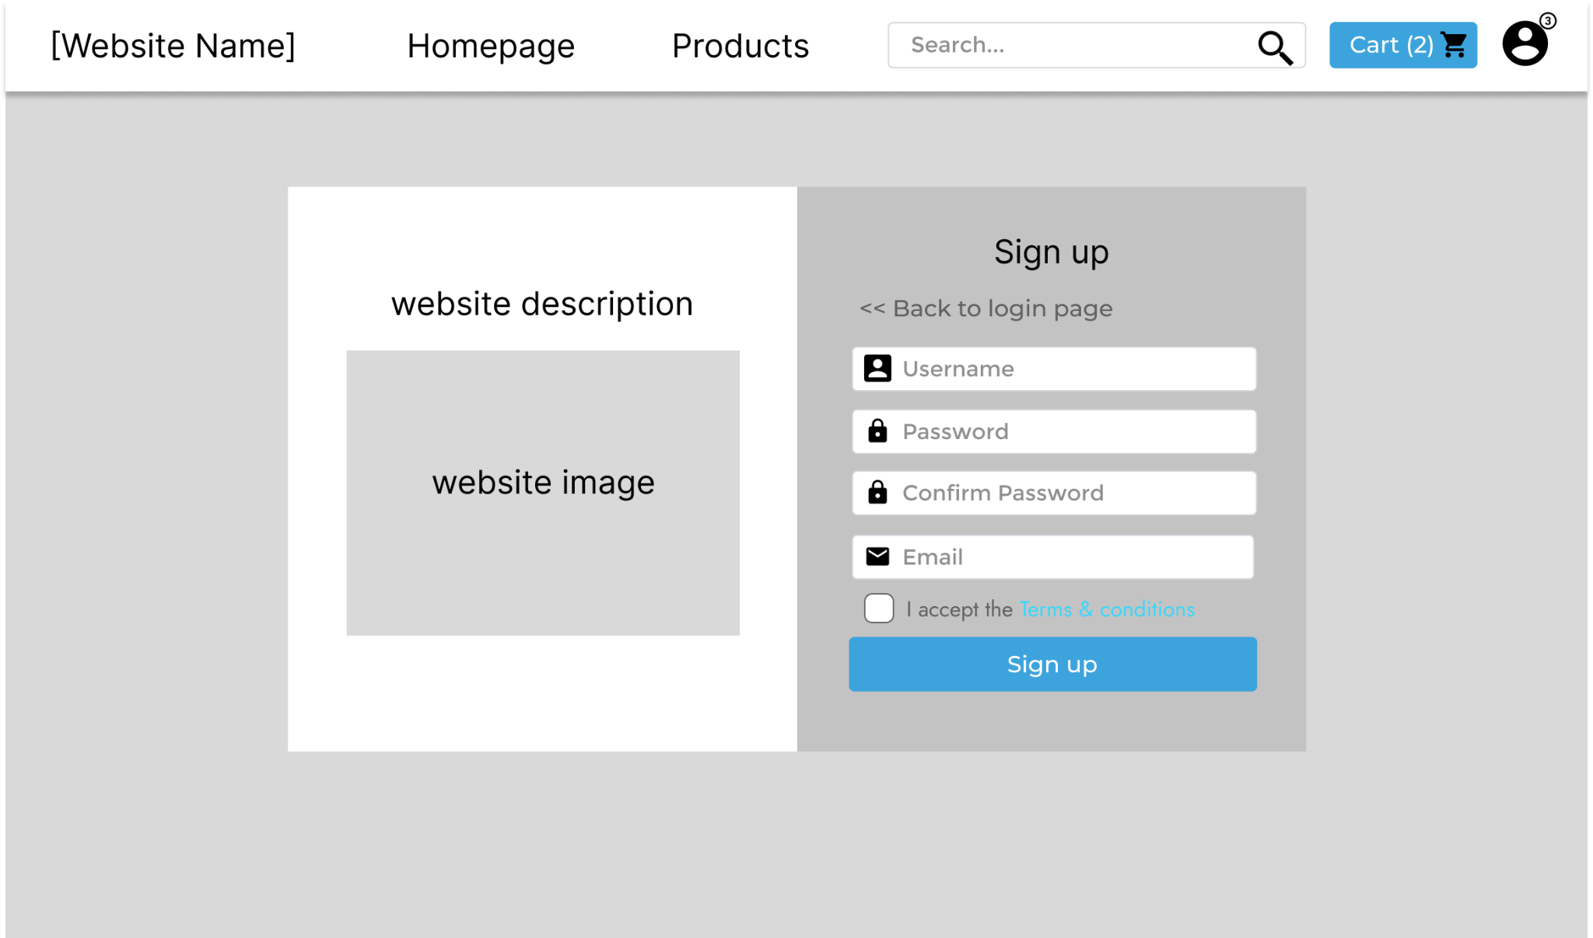

**Screen Definition**

| # | Field Name | Type | Mandatory | Max Length | Description |
| --- | --- | --- | --- | --- | --- |
| 1 | username | Textfield | Yes | 50 | Fill account’s username |
| 2 | password | Textfield | Yes | 50 | Fill account’s password |
| 3 | Confirm password | Textfield | Yes | 50 | Repeat inputted password |
| 4 | Email | Textfield | Yes | 50 | Fill account’s email |

· *Function Details: The screen shows a portal webpage with a sign up panel, filled with an username, a password textfield, a confirm password textfield, an email textfield, terms and condition checkbox, and sign up button.*

Process flow

| # | Actor | Action description |
| --- | --- | --- |
| 1 | User | User fill in the following register fields   * username * password * confirm password * email |
| 2 | System | System create a new user in the database (with default role which is “customer”), and authorize users, redirecting them to homepage with given user infos (automatically logging them in) |

Business rules

| # | Description |
| --- | --- |
| BR01 | Password must meet the site’s password requirements (contain at least 7 characters a  nd up) |
| BR02 | Confirm Password field must match the Password field. |
| BR03 | Email field must meet the site’s email requirements, and follow conventional email format (example: example@mail.com) |

### 2. User Profile

#### 2.1 Reset password:

· *Function trigger: This function is triggered when guests click “I forgot my password” label in the Login panel.*

· *Function description: The screen shows a portal webpage with a Reset your password panel, filled with an username, an email textfield, and confirm button.*

· *Screen layout: Mockup prototype of the screen, sample below is for Reset password screen*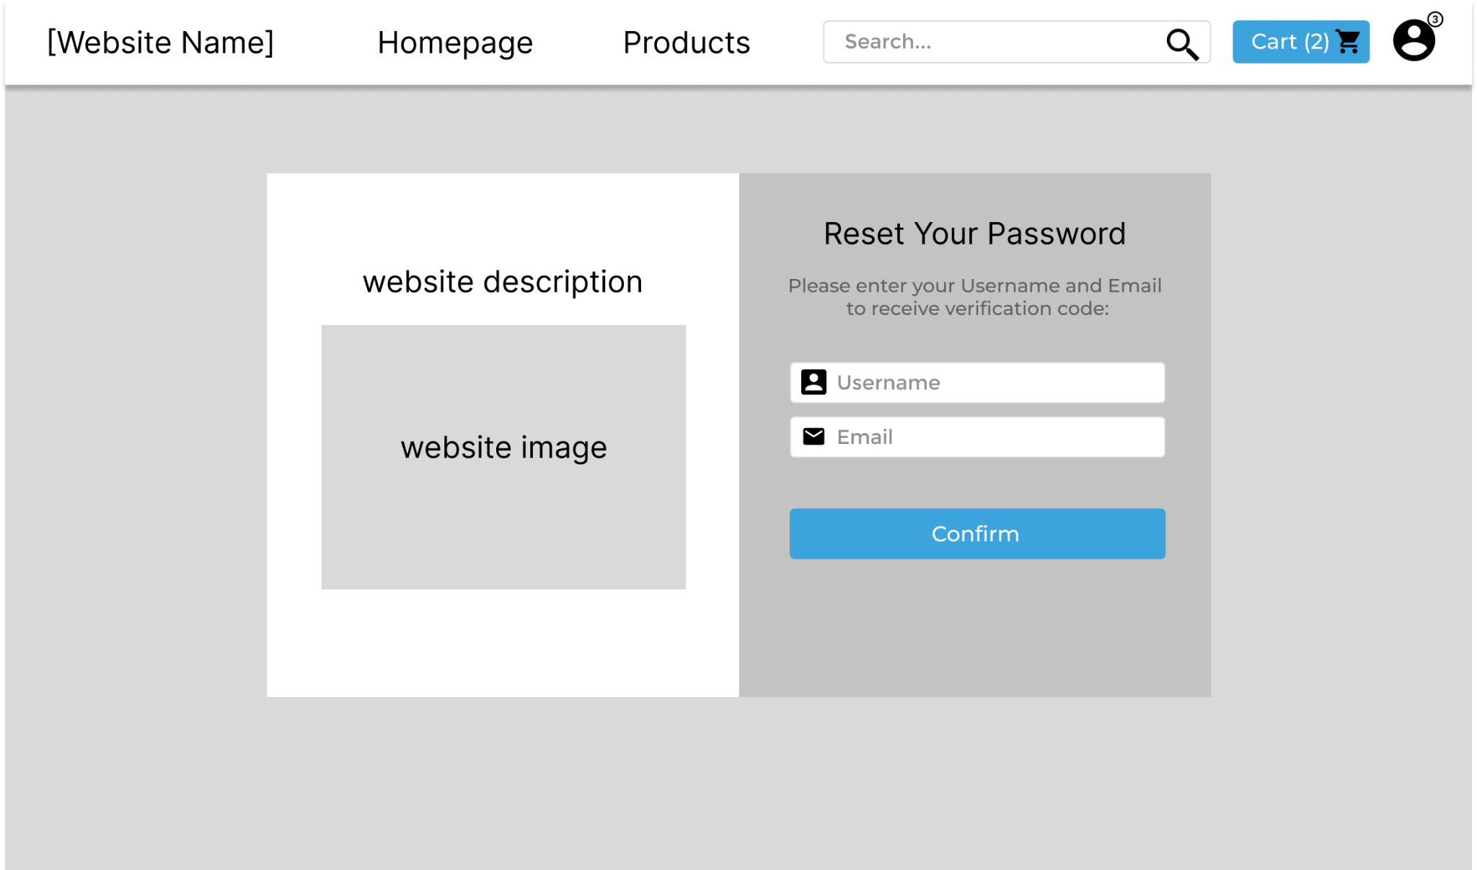

**Screen Definition**

| # | Field Name | Type | Mandatory | Max Length | Description |
| --- | --- | --- | --- | --- | --- |
| 1 | username | Textfield | Yes | 50 | Fill account’s username |
| 2 | Email | Textfield | Yes | 50 | Fill account’s email |

· *Function Details: The screen shows a portal webpage with a Reset your password panel, filled with an username, an email textfield, and confirm button.*

Process flow

| # | Actor | Action description |
| --- | --- | --- |
| 1 | User | User fill in the following fields   * username * email |
| 2 | System | System send a mail to the inputted email address containing verification link, after clicking that link it will redirect to the “Change Password” screen. |

Business rules

| # | Description |
| --- | --- |
| BR01 | Email field must meet the site’s email requirements, and follow conventional email format (example: example@mail.com) |

#### 

#### 2.2 Change password:

· *Function trigger: This function is triggered when user click on a redirect link to reset password through their email, or click on the button in the Profile panel.*

· *Function description: The screen shows a portal webpage with a Change password panel, filled with a password, a confirm password, and confirm button.*

· Screen layout: Mockup prototype of the screen, sample below is for Change password screen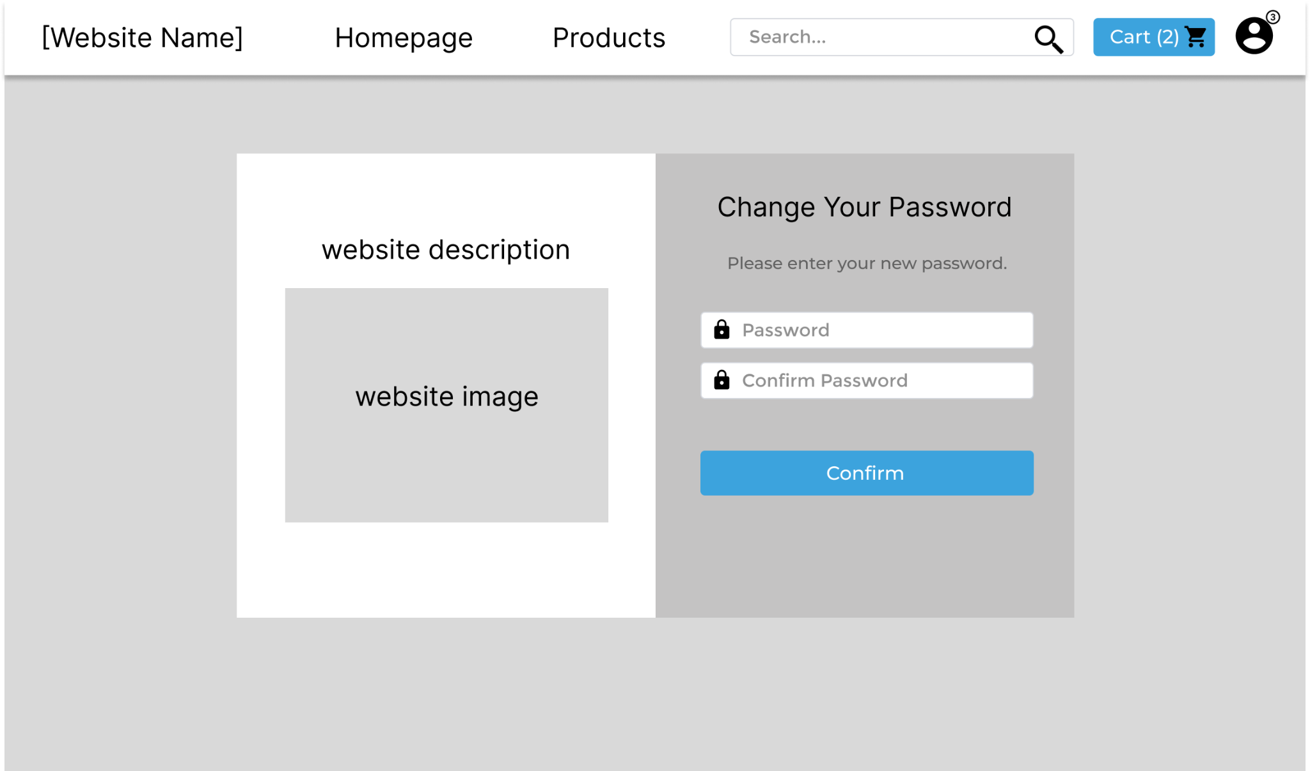

**Screen Definition**

| # | Field Name | Type | Mandatory | Max Length | Description |
| --- | --- | --- | --- | --- | --- |
| 1 | password | Textfield | Yes | 50 | Fill account’s password |
| 2 | Confirm password | Textfield | Yes | 50 | Repeat inputted password |

· *Function Details: The screen shows a portal webpage with a Change password panel, filled with a password, a confirm password, and confirm button.*

Process flow

| # | Actor | Action description |
| --- | --- | --- |
| 1 | User | User fill in the following fields   * password * confirm password |
| 2 | System | System send a request to change the user’s password, then redirect them to the login screen. |

Business rules

| # | Description |
| --- | --- |
| BR01 | Password must meet the site’s password requirements (contain at least 7 characters a  nd up) |
| BR02 | Confirm Password field must match the Password field. |

#### 

#### 2.3 Profile page:

· *Function trigger: This function is triggered when user click on their profile icon in the navigation bar when they logged in.*

· *Function description: The screen shows a portal webpage with a Your profile panel, containing user details, filled with a password field, a view orders button, and change password button.*

· Screen layout: Mockup prototype of the screen, sample below is for Profile page screen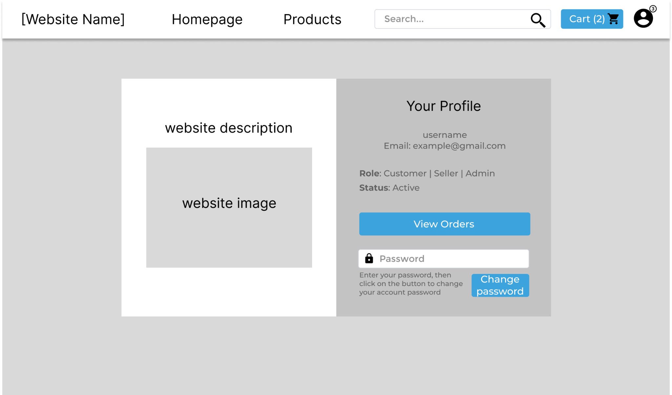

**Screen Definition**

| # | Field Name | Type | Mandatory | Max Length | Description |
| --- | --- | --- | --- | --- | --- |
| 1 | password | Textfield | Yes | 50 | Fill account’s password |

· *Function Details: The screen shows a portal webpage with a Your profile panel, containing user details, filled with a password field, a view orders button, and change password button.*

Process flow (change password)

| # | Actor | Action description |
| --- | --- | --- |
| 1 | User | User fill in the following fields   * password |
| 2 | System | System send a request to change the user’s password, then redirect them to the change password screen. |

Process flow (view orders)

| # | Actor | Action description |
| --- | --- | --- |
| 1 | User | User click the “view order” button |
| 2 | System | System redirect the user to the “my orders” screen. |

Business rules

| # | Description |
| --- | --- |
| BR01 | Password must meet the site’s password requirements (contain at least 7 characters a  nd up), and must match the user’s current password. |

#### 

Đức:

#### 2.4 Notification

·  *Function trigger: This function is triggered when guests click Notifications in the navigation bar*

· *Function description: The screen shows a portal web page with notifications, date and time for user*

· *Screen layout: Mockup prototype of the screen, sample below is for Notifications screen*

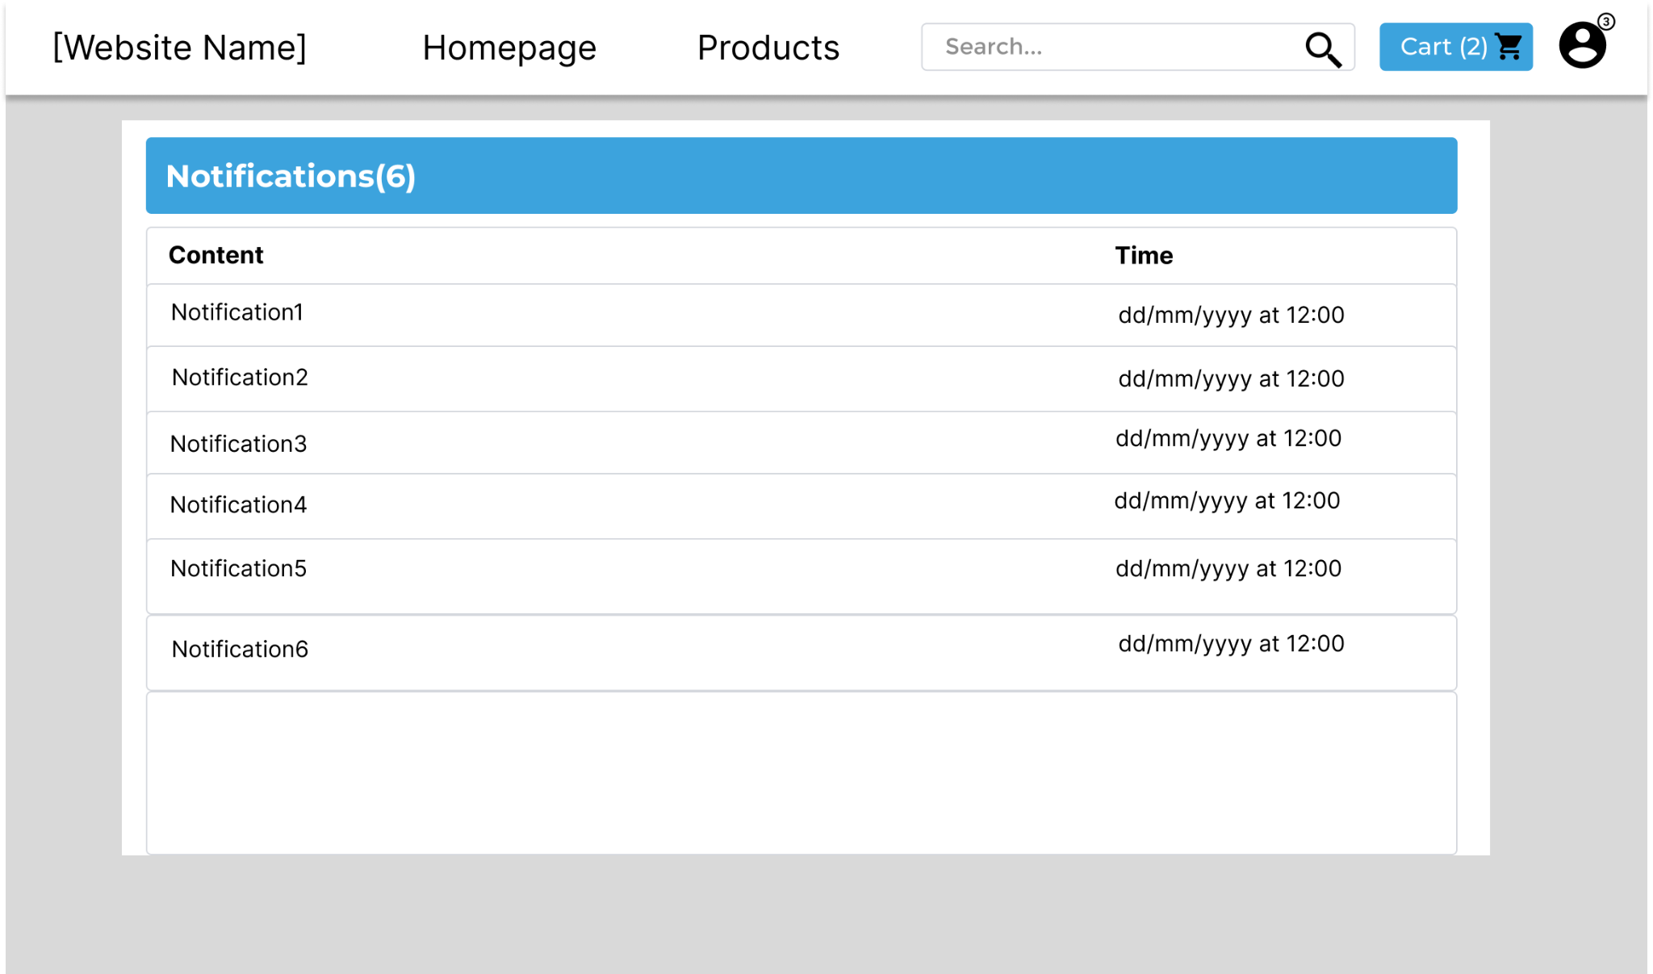

**Screen Definition**

| # | Field Name | Type | Mandatory | Max Length | Description |
| --- | --- | --- | --- | --- | --- |
| 1 | notification | String | Yes | 50 | Webpage notification |
| 2 | date | Date | Yes | 50 | Notification date |
|  | time | Time | Yes |  | Notification time |

· *Function Details: The screen shows a portal web page with notifications, date and time for user*

Process flow

| # | Actor | Action description |
| --- | --- | --- |
| 1 | User | User click notifications button |
| 2 | System | System allow user to see notifications, date and time |

Business rules

| # | Description |
| --- | --- |
| BR01 | Notification must have date and time |

#### 

#### 2.5 Feedback

· *Function trigger: This function is triggered when guests vote for the product by Star rating and fill the feedback and submit*

· *Function description: The screen shows a portal web page with Star rating button, filled with an user feedback text field and submit button.*

· *Screen layout: Mockup prototype of the screen, sample below is for Feedback screen*

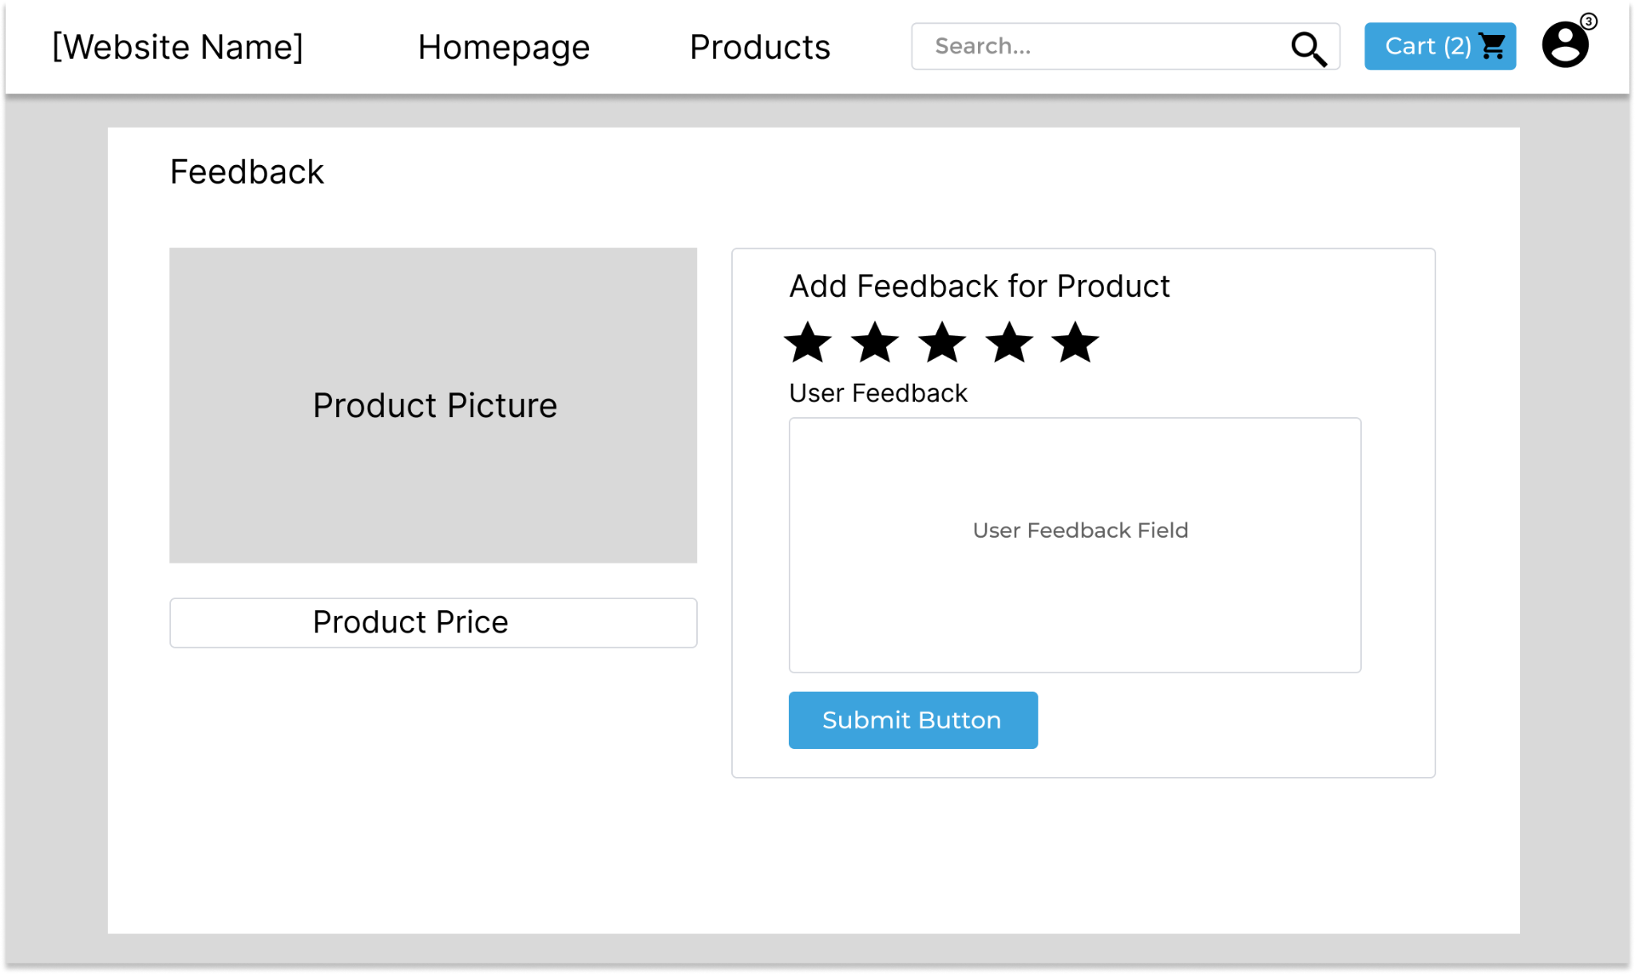

**Screen Definition**

| # | Field Name | Type | Mandatory | Max Length | Description |
| --- | --- | --- | --- | --- | --- |
| 1 | Star rating | Button | Yes | 5 | Click star rating |
| 2 | User feedback field | Textfield | Yes | 50 | Fill user feedback |
| 3 | Submit button | Button | Yes | 1 | Click submit button to submit |

· *Function Details: The screen shows a portal web page with a feedback star, filled with an user feedback textfield and click the submit button to submit feedback*

Process flow

| # | Actor | Action description |
| --- | --- | --- |
| 1 | User | User rate the feedback from star rating |
| 2 | User | User fill the feedback field |
| 3 | User | User click the submit button |
| 2 | System | System create a new feedback user in the database (with default role which is “customer”), and save the user feedback with star and text |

Business rules

| # | Description |
| --- | --- |
| BR01 | Star rating must be rated (at least 1 star) |
| BR02 | User feedback field must be filled (at least 1 letter) |

HA:

### 3. Cart System

#### 3.1 Cart Details:

*Function trigger: Login user and check cart.*

· *Function description:*

*Role : User*

*Purpose : Users can view and manage their shopping cart*

· *Screen layout:* 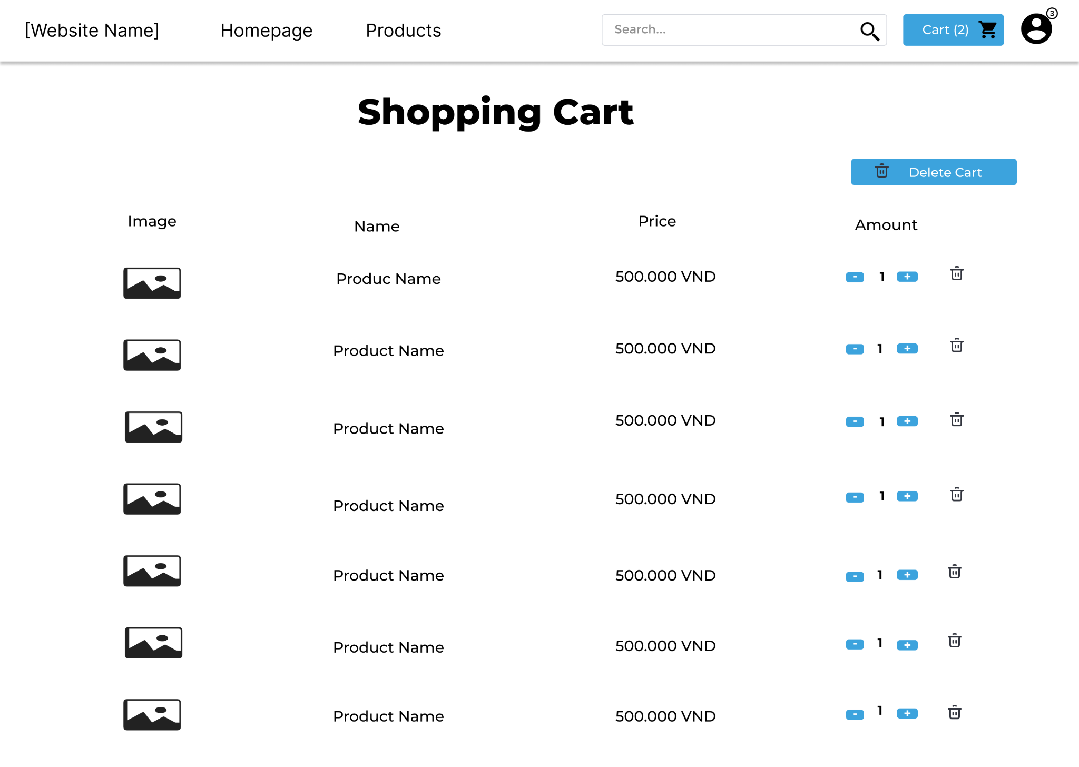

| # | Actor | Action description |
| --- | --- | --- |
| 1 | User | The user can enter the buttons   * Delete Cart * “+” or ”-” * Icon Delete |
| 2 | System | * Remove all products in cart * Products can be added or removed. If the number of products is 1 , the user presses “-” button, the system will delete that product * When the user presses delete, the system will remove the product from the cart |

#### 3.2 Cart Completion:

*Function trigger: User pays order*

· *Function description:*

*Role : User*

*Purpose : Show details of order information*

· *Screen layout:* 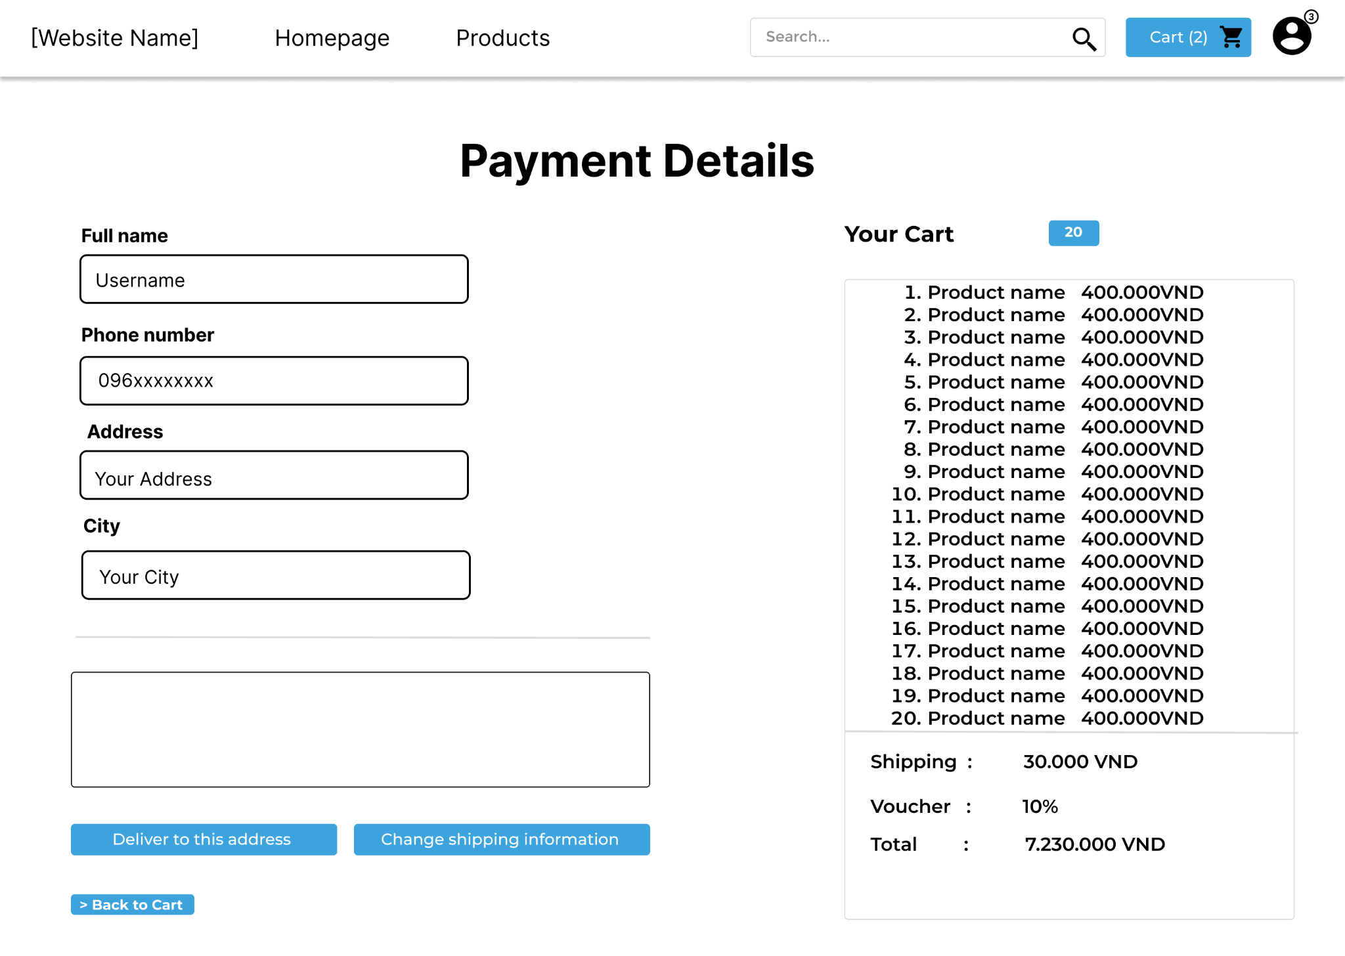

| # | Field Name | Type | Mandatory | Max Length | Description |
| --- | --- | --- | --- | --- | --- |
| 1 | username | Textfield | Yes | 50 | Fill account’s username |
| 2 | phone number | Textfield | Yes | 50 | Fill your phone number |
| 3 | Address | Textfield | Yes | 50 | Fill your address |
| 4 | City | Textfield | Yes | 50 | Fill tour city |

| # | Actor | Action description |
| --- | --- | --- |
| 1 | User | The user can enter the buttons   * Deliver to address * Change shipping information * Back to cart |
| 2 | System | * The system updates the delivery address entered by the customer * The system changes the delivery address requested by the customer * Return to customer's cart |

### 4. Home page

#### 4.1 Homepage:

*Function trigger: Login users and see an overview of all products*

· *Function description:*

*Role : User*

*Purpose : Users can view and choose a product*

· *Screen layout:* 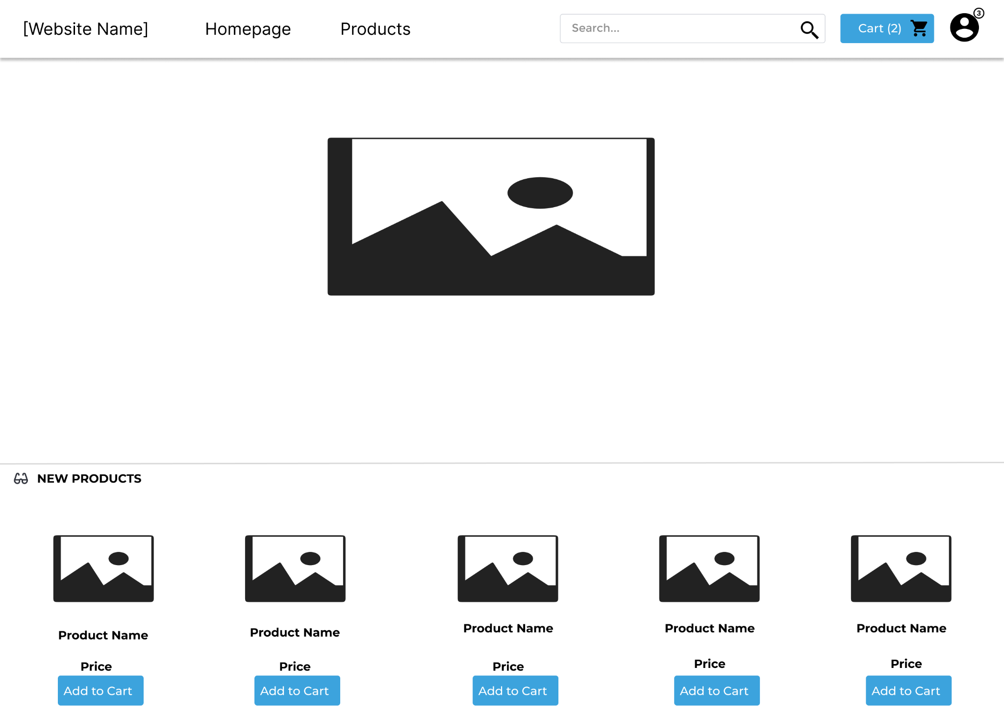

| # | Actor | Action description |
| --- | --- | --- |
| 1 | User | The user can enter the buttons   * Add to Cart |
| 2 | System | * The system will automatically add the product to the cart |

#### 4.2 Product List:

* **Function trigger: User accesses the website**
* **Function description:**
  + **Role: Guest, User**
  + **Purpose: Users Search for the Product they want**

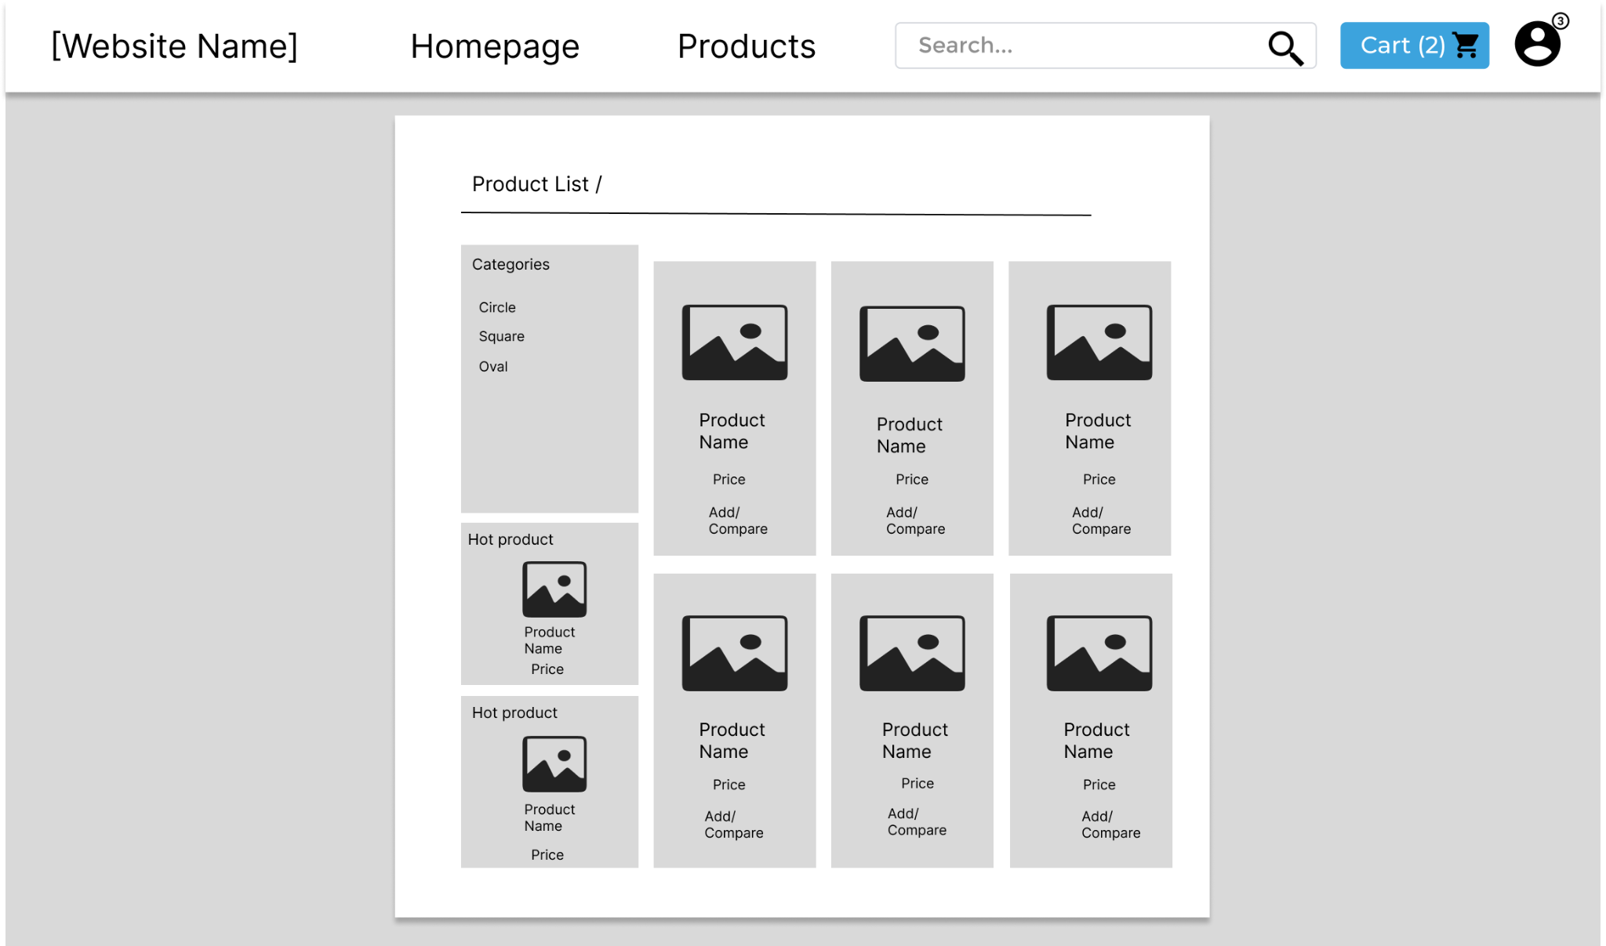

| # | Actor | Action description |
| --- | --- | --- |
| 1 | User | * User can add to cart or compare   with other products |
| 2 | System | * The system will put the product in the cart * If the user wants to compare with other products   then the system will choose the product to compare and compare it with the other product that you will choose |

#### 4.3 Product Compare:

*Function trigger: Users can compare products*

· *Function description:*

*Role : User*

*Purpose : Select products and compare details.*

· *Screen layout:* 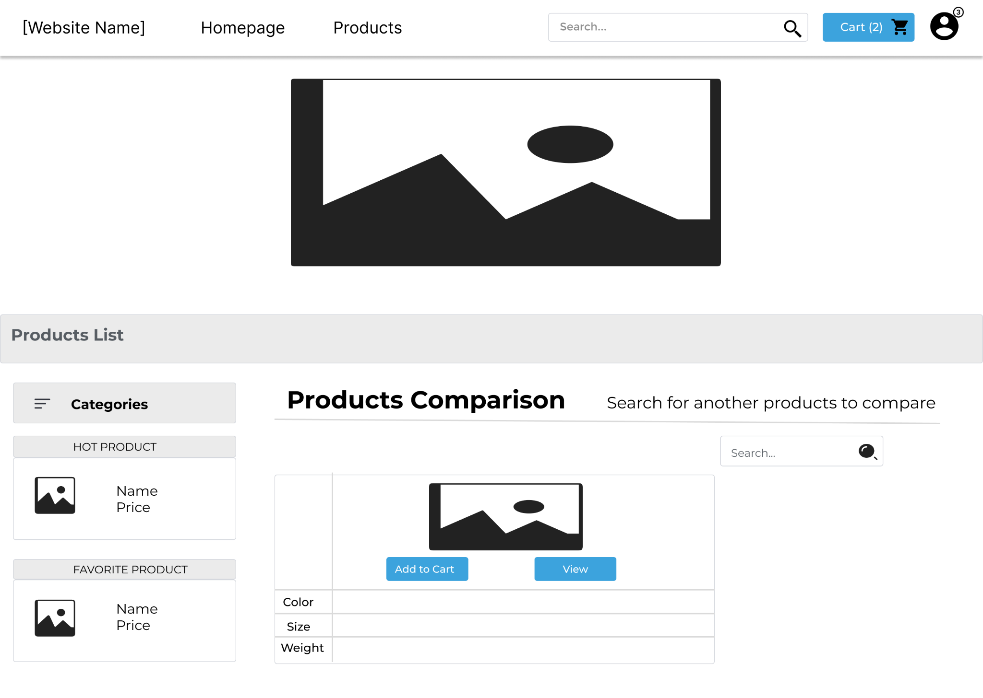

| # | Actor | Action description |
| --- | --- | --- |
| 1 | User | The user can enter the buttons   * Add to Cart * View   Users can search for products   * Search |
| 2 | System | * The system will automatically add the product to the cart * The system will provide information and photos about the product * The system will give the product that the customer is looking for |

#### 4.4 Product Details:

*Function trigger: User can add products to cart or buy now*

· *Function description:*

*Role : User*

*Purpose : Show details of products*

· *Screen layout:* 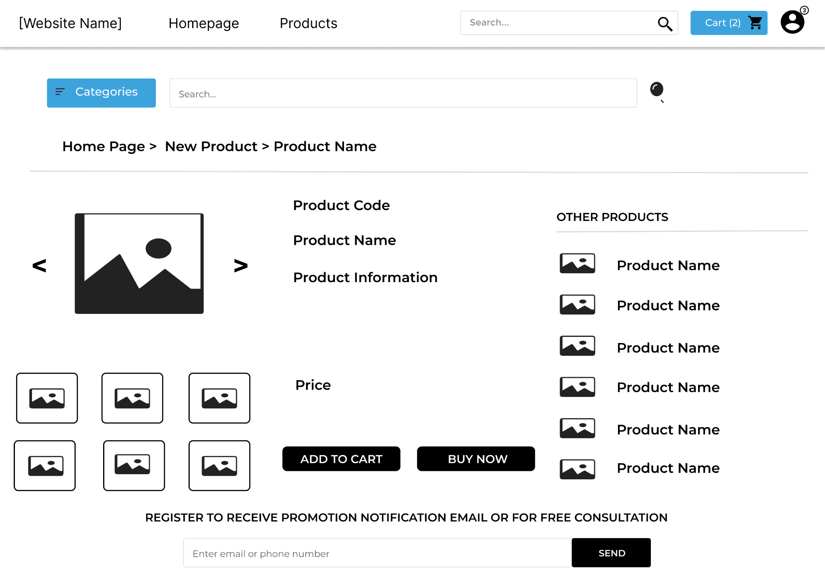

| # | Actor | Action description |
| --- | --- | --- |
| 1 | User | The user can enter the buttons   * Categories * Add to cart * Buy Now |
| 2 | System | * The system will display all categories of products * The system will automatically add the product to the cart * The system will display the order after the customer chooses to buy now |

| # | Actor | Action description |
| --- | --- | --- |
| 1 | User | The user can   * Search * Send email or phone number |
| 2 | System | * Provide details about the product the customer is looking for * The system will send product offers to customers via email or text message |

Tuan:

### 5. My Orders

#### 5.1 Order information:

* Function trigger: This function is used when the user has placed an order and the admin wants to see the information
* Function description: The screen displays detailed information of each user's order

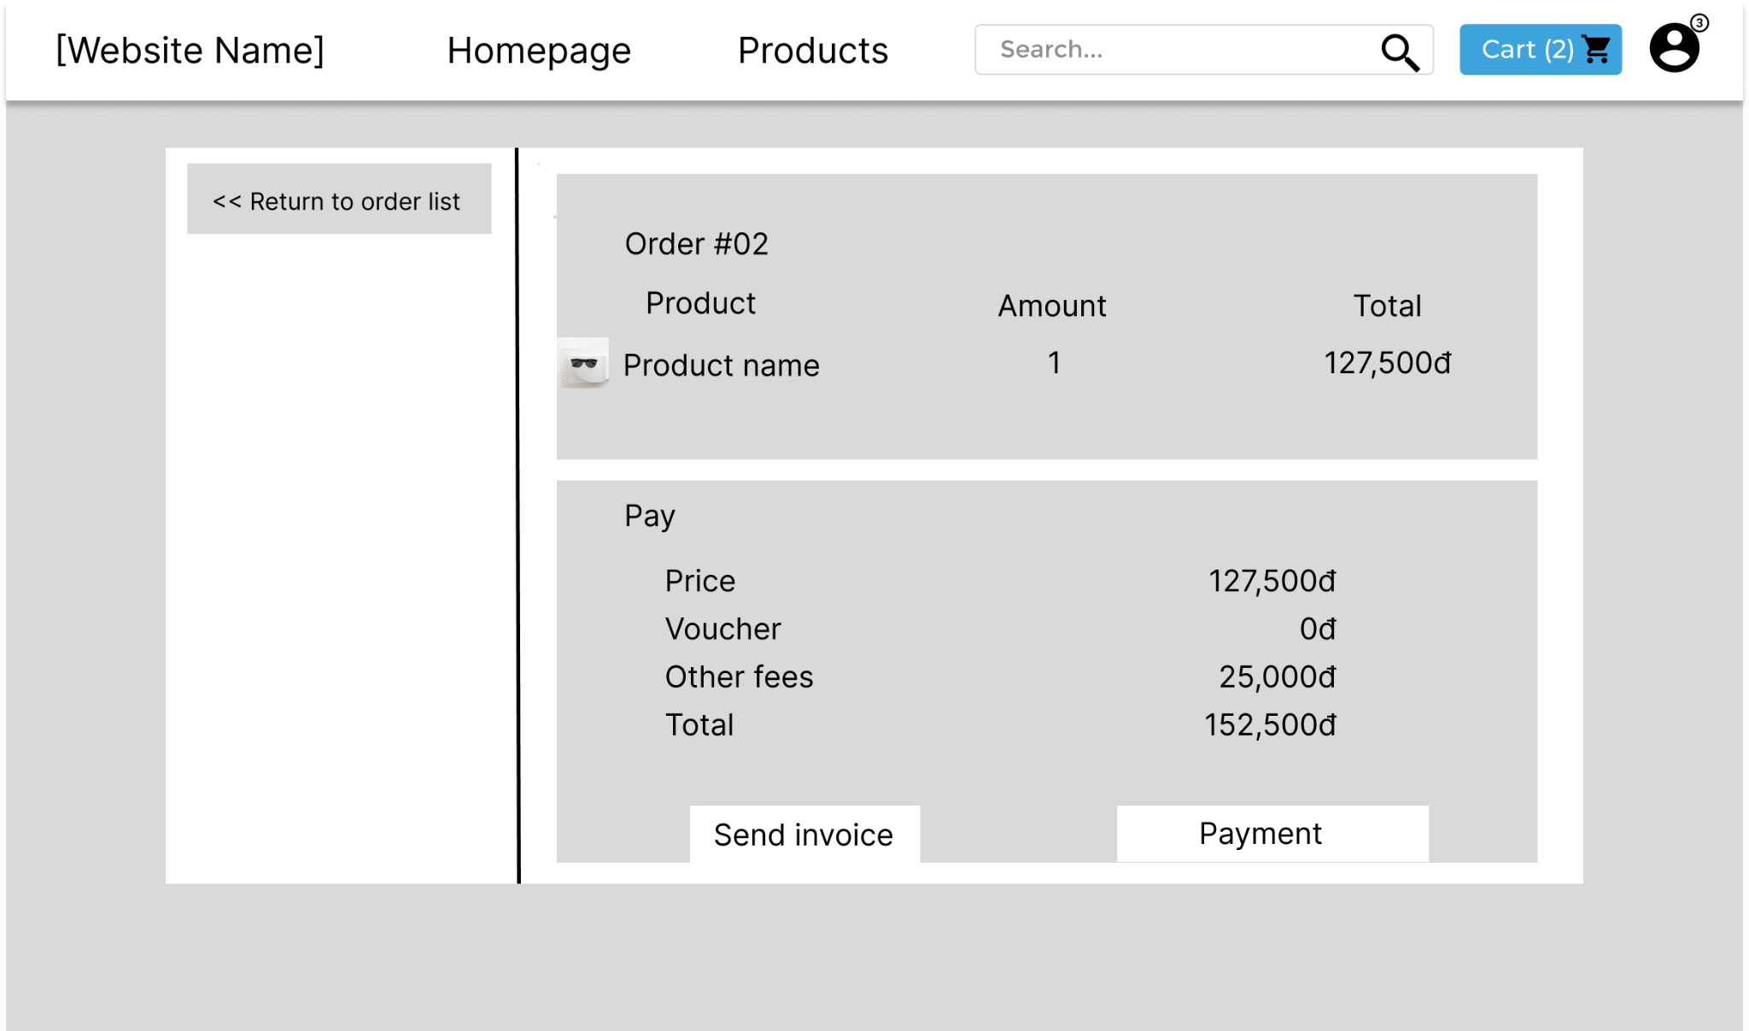

Process flow (view orders)

| # | Actor | Action description |
| --- | --- | --- |
| 1 | Admin | Admin can:  - View details of orders  - Send invoice  - Payment management |
| 2 | System | Provide detailed information of all user orders |

#### 5.2 My Order:

* Function trigger: Users log-in the website, access the profile page and click on My Orders button
* Function description:
  + Role: Buyers
  + Purpose: Users can see their shopping history
  + Screen layout:

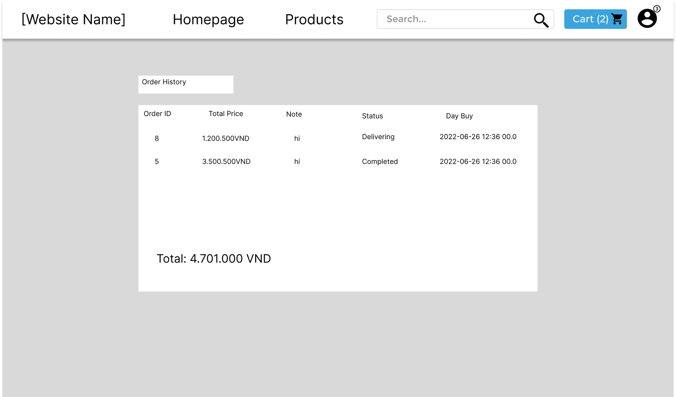

### 6. Management System:

#### 6.1 User List:

* Function trigger: Admin click “Edit” button next to an entry from user list.
* Function description:
  + Role: Admin.
  + Purpose: Edit information of an account.
* Screen layout:

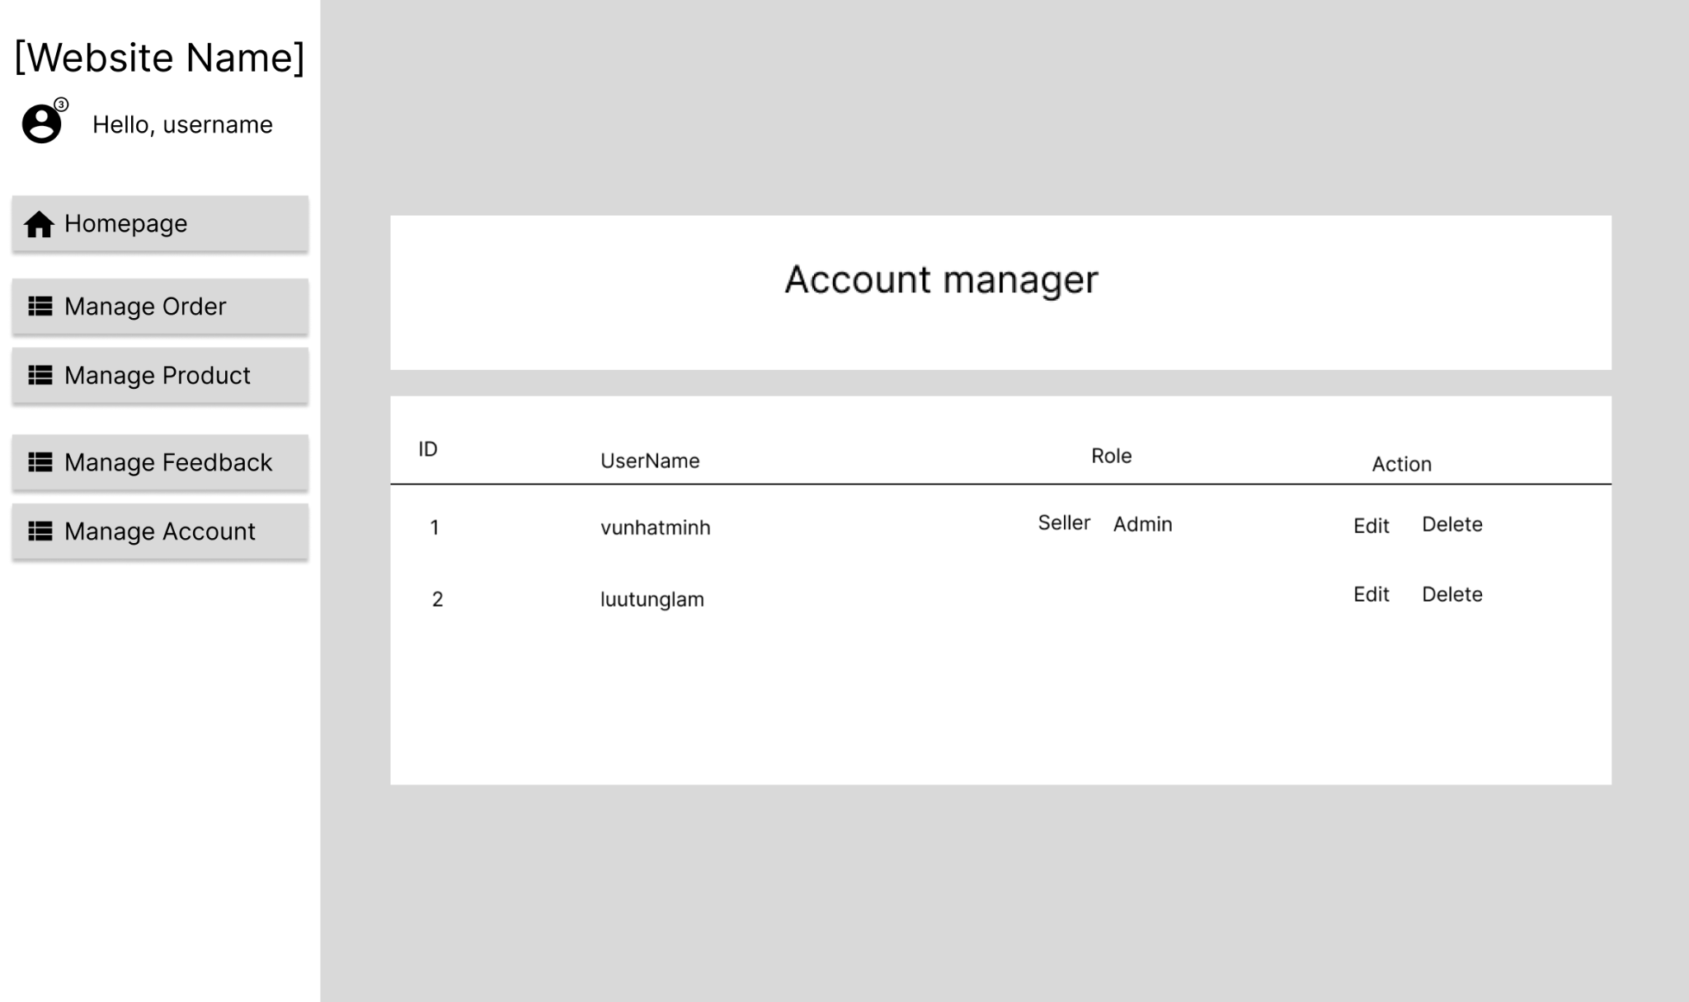

| # | Actor | Action description |
| --- | --- | --- |
| 1 | User | * Admin can edit or delete the account in the Action section |
| 2 | System | * User can change username, password and email * Press Delete can remove Account |

#### 6.2 Products List:

* Function trigger: Users login as admin and click on Manage Product button or Product List button
* Function description:
  + Role: Admin
  + Purpose: Admin can manage the products of the website (add, delete, edit…)

Screen layout: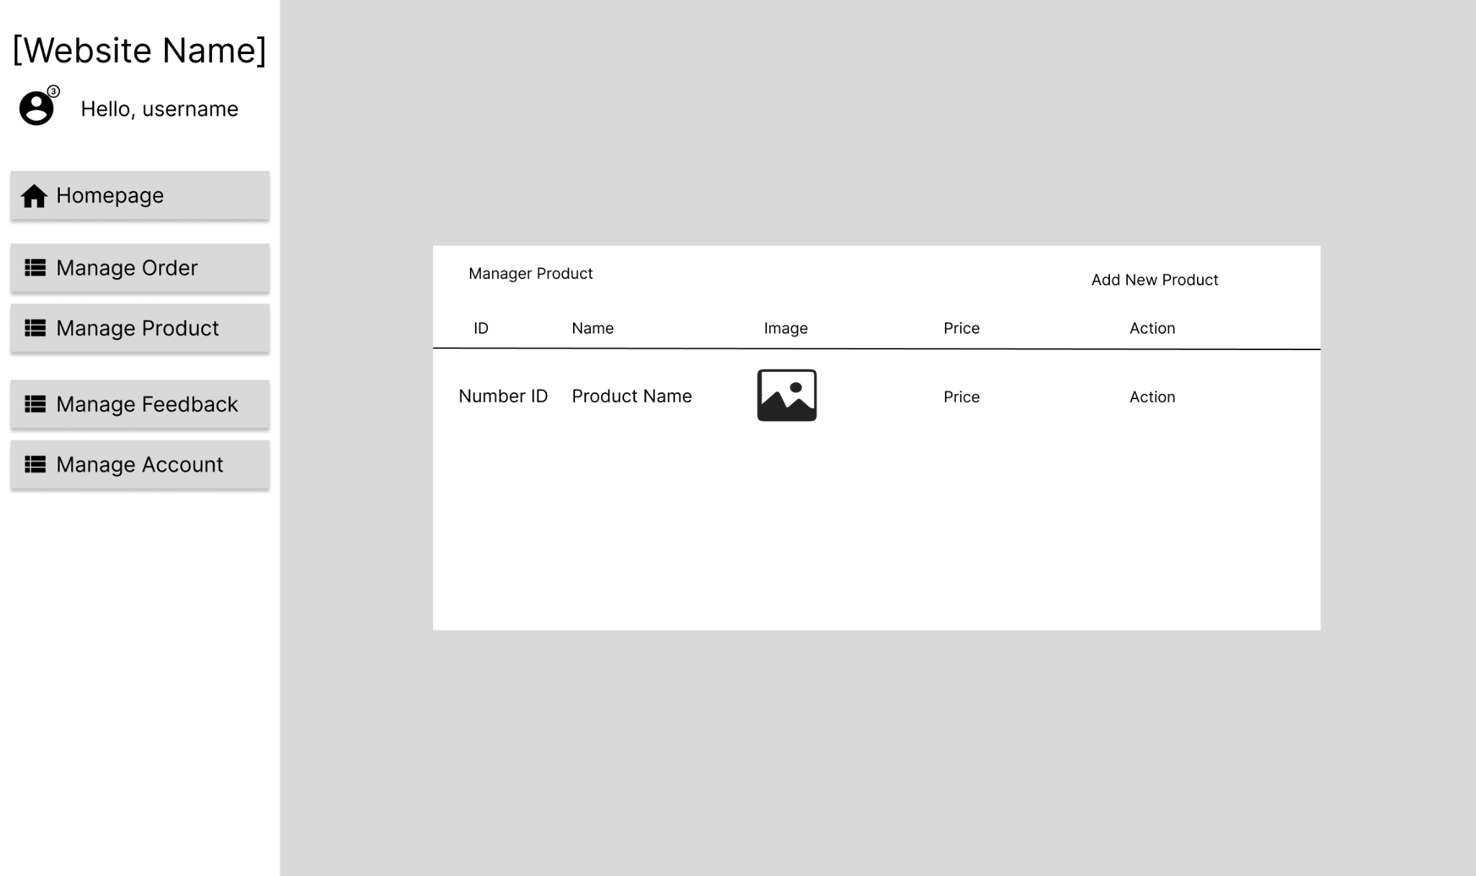

| # | Actor | Action description |
| --- | --- | --- |
| 1 | User | * Users can edit or delete the product in the Action section |
| 2 | System | * User can change Name, Description, Price, Image Link,   Category, Seller sand Amount   * Press Delete can remove Product |

#### 

### 7. Order Management:

#### 7.1 Order List:

Function trigger: Admin Login and click Total Invoices

Function description:

• Role: Admin

• Purpose: Admin views list of all of 2orders

Screen layout:

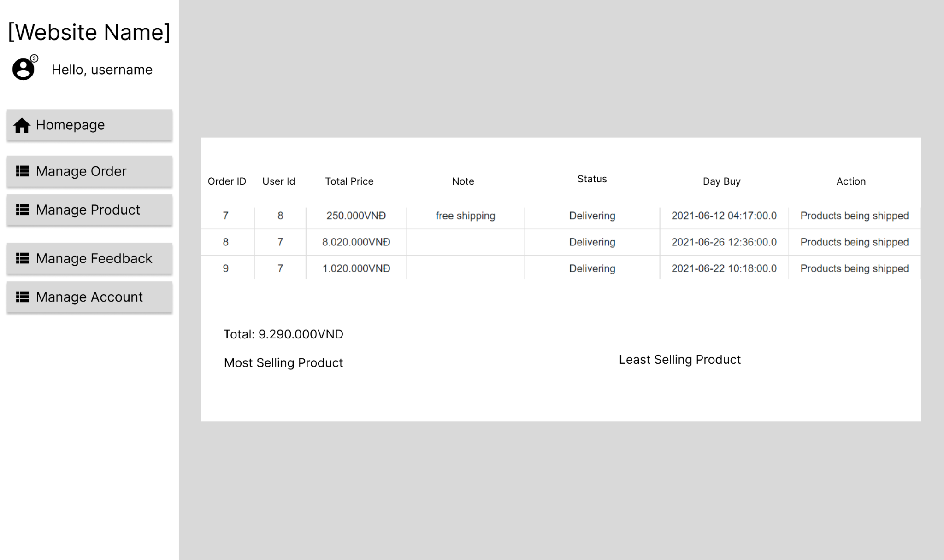

### 

### 8. Sale dashboard:

* Function trigger: This function is used when admin view sales statistics
* Function description: The screen will display a chart of monthly revenue statistics

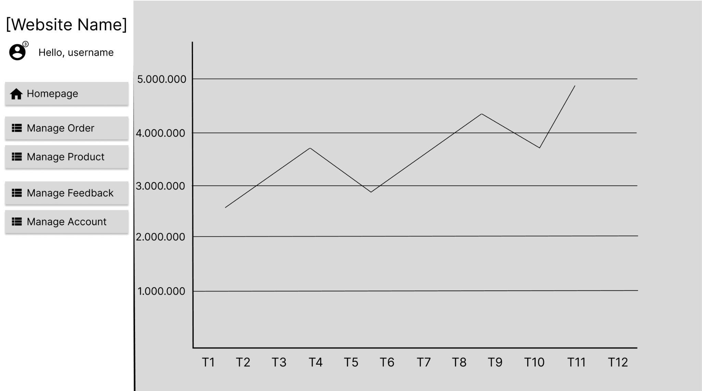

| # | Actor | Action description |
| --- | --- | --- |
| 1 | Admin | Admin can:  -View sales statistics by month |
| 2 | System | Display the sales statistics table of the sales website according to the chart |

### 9. Error:

* Function trigger: The function will occur when the user manipulates the error
* Function description: The screen will show an error not found

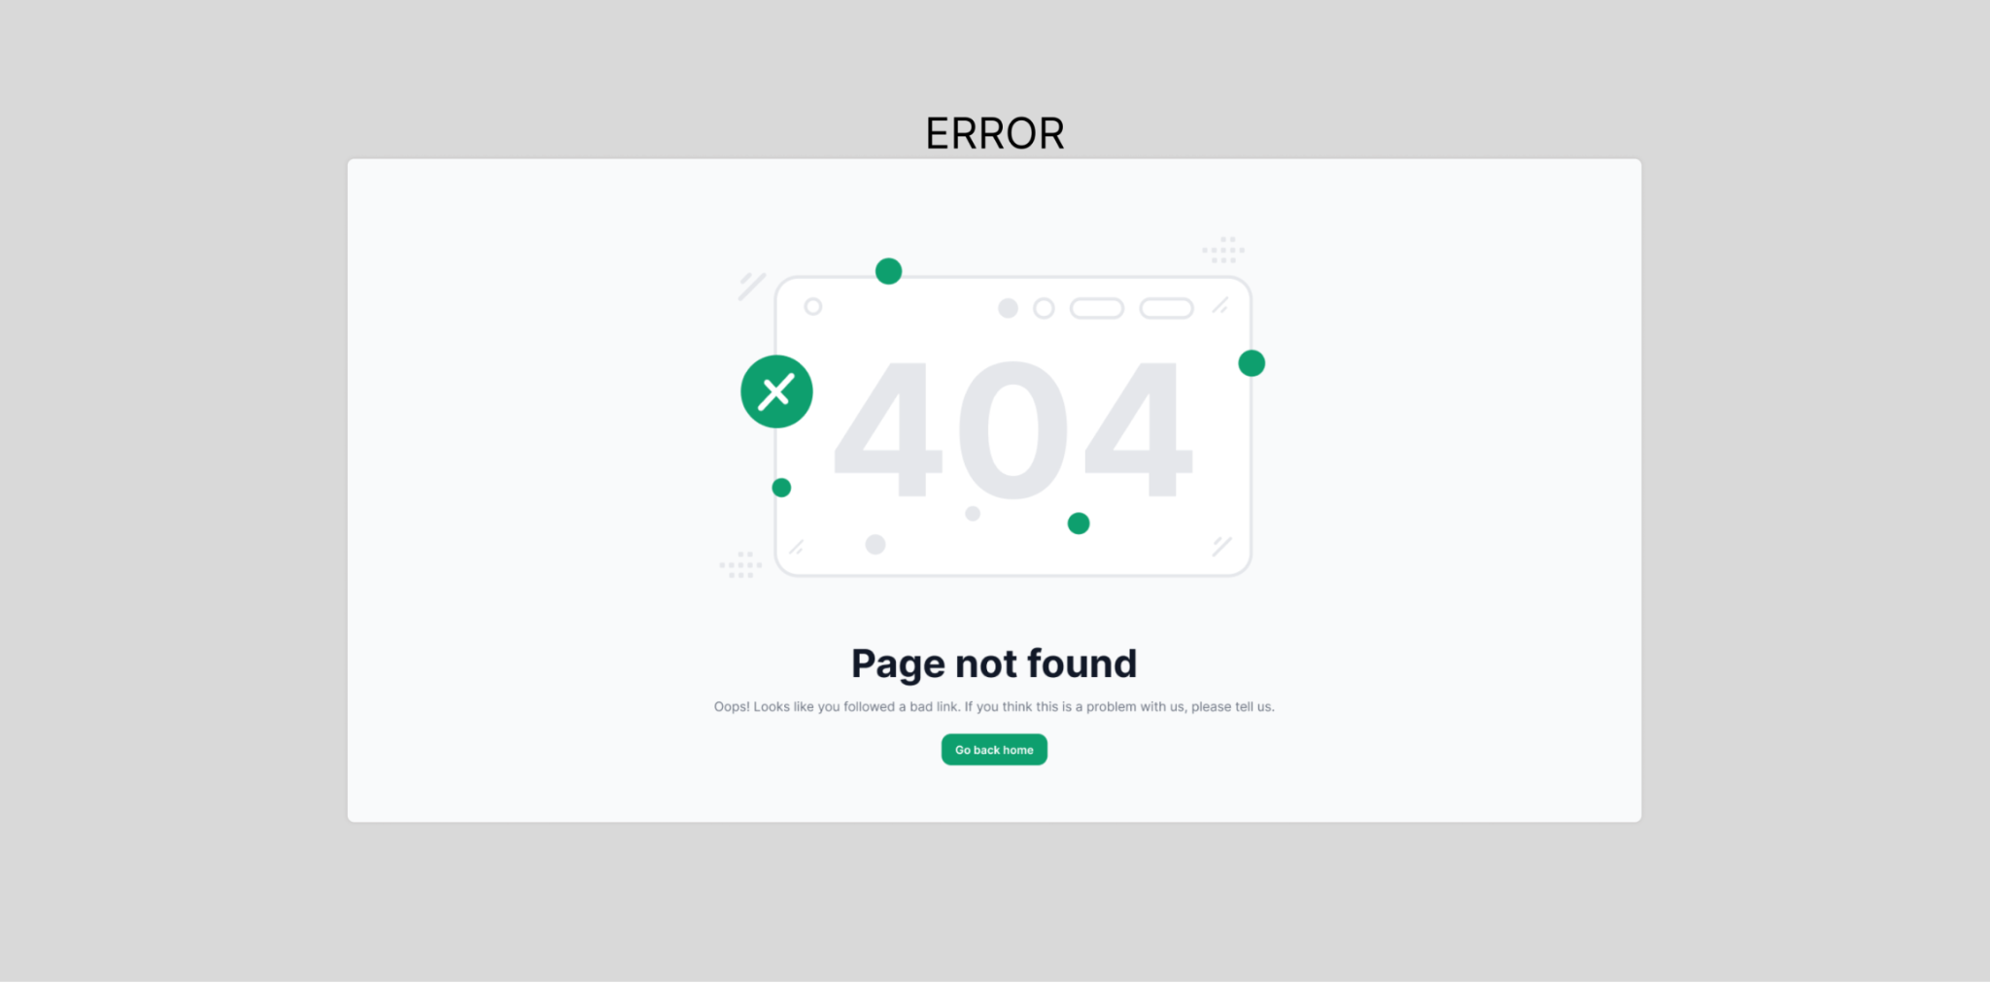

| # | Actor | Action description |
| --- | --- | --- |
| 1 | User | User can now the error when using the operation on the system |
| 2 | System | display the system's general error screen |

#### 