Customer Shopping Behavior Analysis

1. Project Overview
This project involves analyzing customer shopping behavior using transactional data from 3,900 purchases spanning multiple product categories. The objective is to generate actionable insights into spending patterns, customer segmentation, product preferences, and subscription trends to support data-driven strategic decision-making..

2. Dataset Summary
- Total Records: 3,900
- Total Features: 18
Key Variables:
- Customer Demographics: Age, Gender, Location, Subscription Status
- Purchase Details: Item Purchased, Category, Purchase Amount, Season, Size, Color
- Shopping Behavior: Discount Applied, Promo Code Used, Previous Purchases, Purchase Frequency, Review Rating, Shipping Type
Data Quality Notes:
- Missing Values: 37 missing entries in the Review Rating column

3. Exploratory Data Analysis using Python
We began with data preparation and cleaning in Python:
- Data Loading: Imported the dataset using pandas.
- Initial Exploration: Used df.info() to check structure and .describe() for summary statistics.
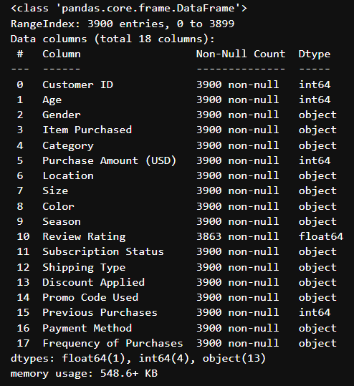
Summary statiistics
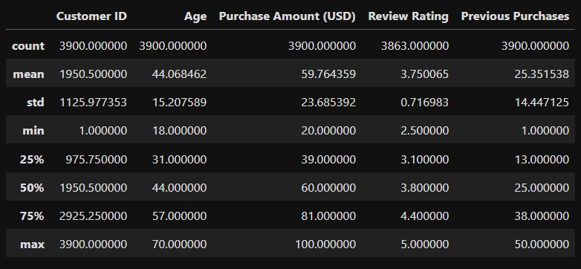
- Missing Data Handling: Identified null values and imputed missing entries in the review_rating column using the median rating within each product category.
- Column Standardization: Renamed all columns to follow snake_case format for improved readability and consistent documentation.
- Feature Engineering: Created an age_group variable by binning customer ages into defined ranges and derived a purchase_frequency_days feature based on customer purchase timestamps.
- Data Consistency Check: Assessed correlation between discount_applied and promo_code_used variables; determined redundancy and removed promo_code_used for cleaner analysis.
- Database Integration: Established a connection between the Python environment and a Microsoft SQL database, then loaded the cleaned DataFrame for subsequent SQL-based analysis.

4. Data Analysis using SQL (Business Transactions)
Structured SQL queries were executed in MSSQL to address key business questions and extract actionable insights from the transactional dataset.
- Revenue by Gender: Calculated and compared the total revenue generated by male and female customers to identify gender-based spending patterns and assess their contribution to overall sales performance.
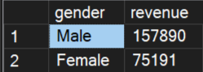
- High-Spending Discount Users: Identified customers who utilized discounts yet recorded purchase amounts exceeding the overall average transaction value. This analysis helped highlight high-value customers who remain responsive to promotional offers.
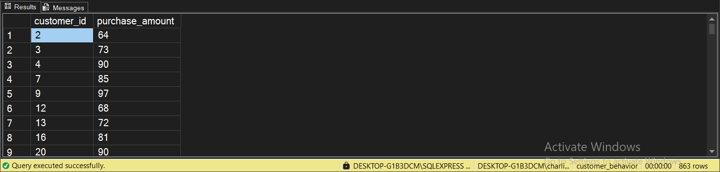
- Top 5 Products by Rating: Retrieved the five products with the highest average review_rating scores to identify top-performing items based on customer satisfaction and feedback.
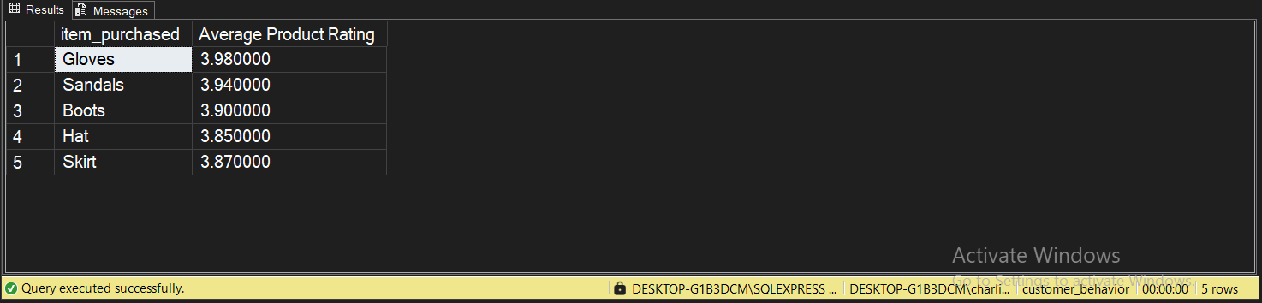
- Shipping Type Comparison: Compared the average purchase_amount between Standard and Express shipping methods to evaluate how shipping preferences correlate with customer spending behavior.
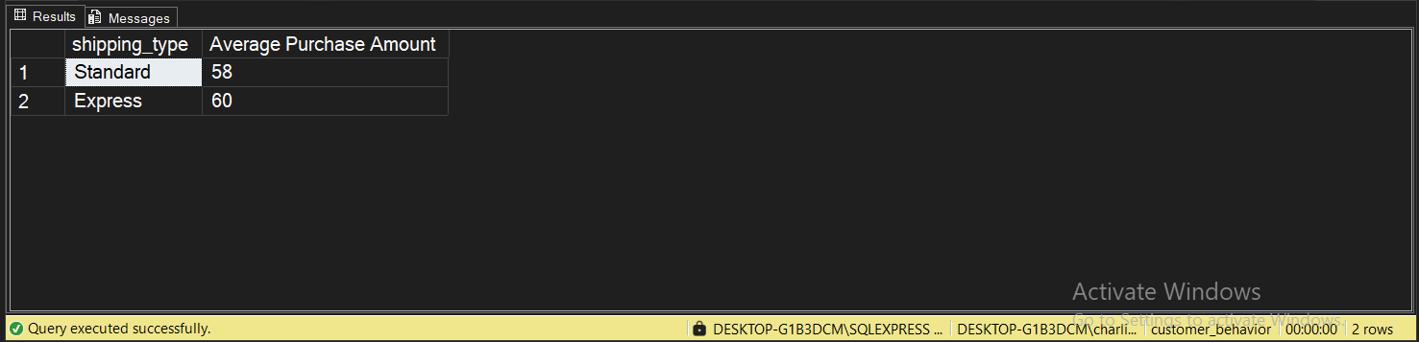
- Subscribers vs. Non-Subscribers:
Analyzed and compared both the average purchase amount and total revenue between subscribers and non-subscribers to assess the impact of subscription status on customer spending and overall revenue contribution.
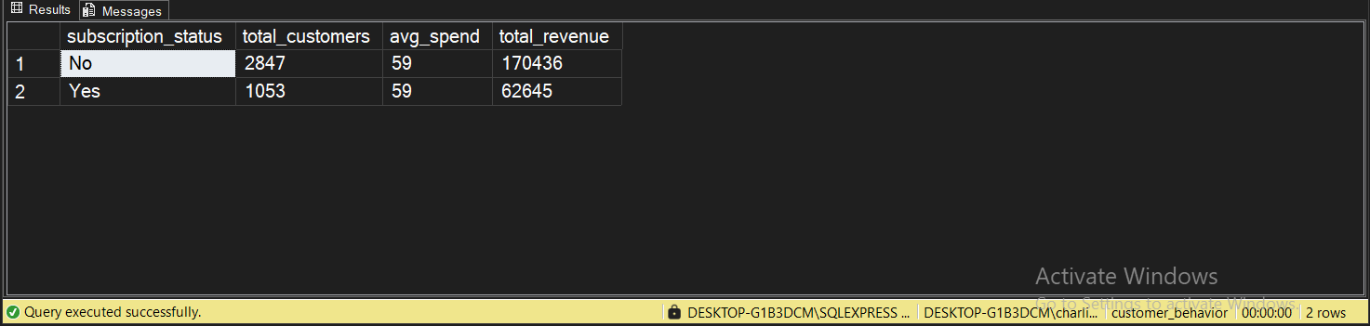
- Discount-Dependent Products:
Identified the top five products with the highest proportion of purchases made using discounts to determine which items are most reliant on promotional pricing for sales.
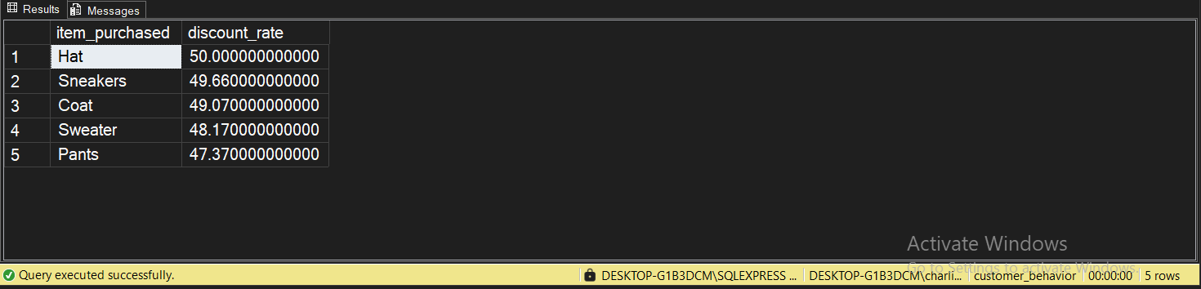
- Customer Segmentation: Segmented customers into New, Returning, and Loyal categories based on their purchase history
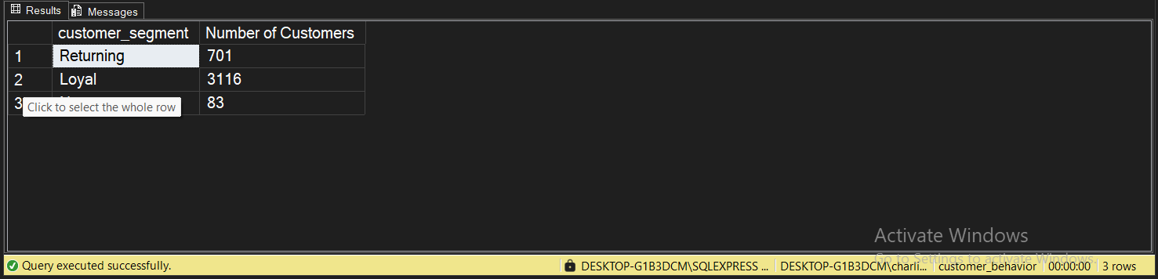
- Top 3 Products per Category: Identified the three most purchased products within each product category to highlight best-selling items and support inventory and merchandising decisions.
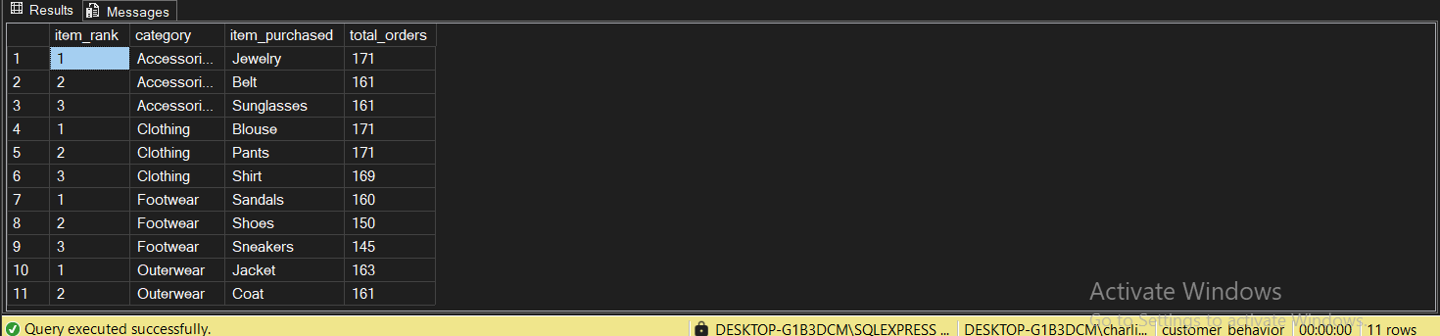
- Repeat Buyers & Subscriptions: Analyzed whether customers with more than five purchases are more likely to hold a subscription, examining the relationship between purchase frequency and subscription adoption.
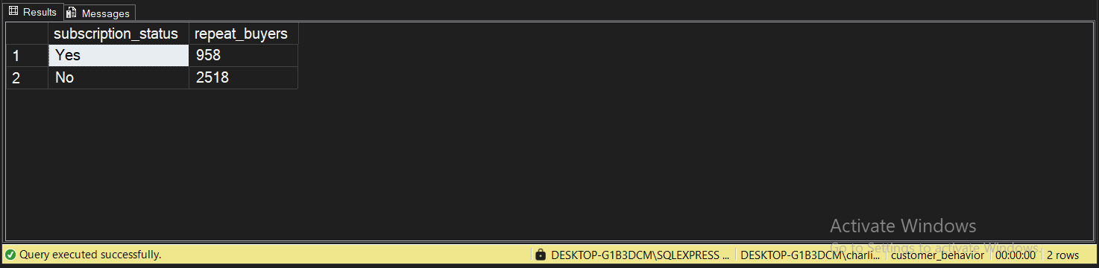
- Revenue by Age Group: Calculated the total revenue generated by each age_group to identify which customer age segments contribute most significantly to overall sales.
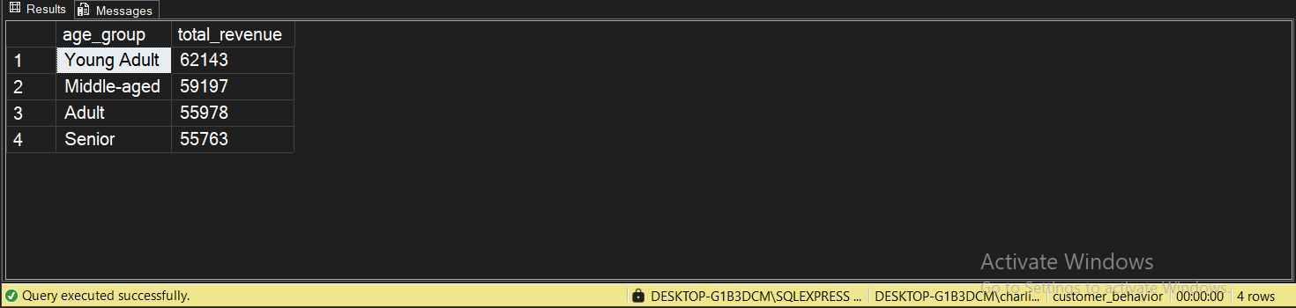

5. Dashboard in Power BI
Developed an interactive Power BI dashboard to visually present key insights from the analysis, enabling stakeholders to explore trends, customer behavior, and product performance through dynamic charts and filters.
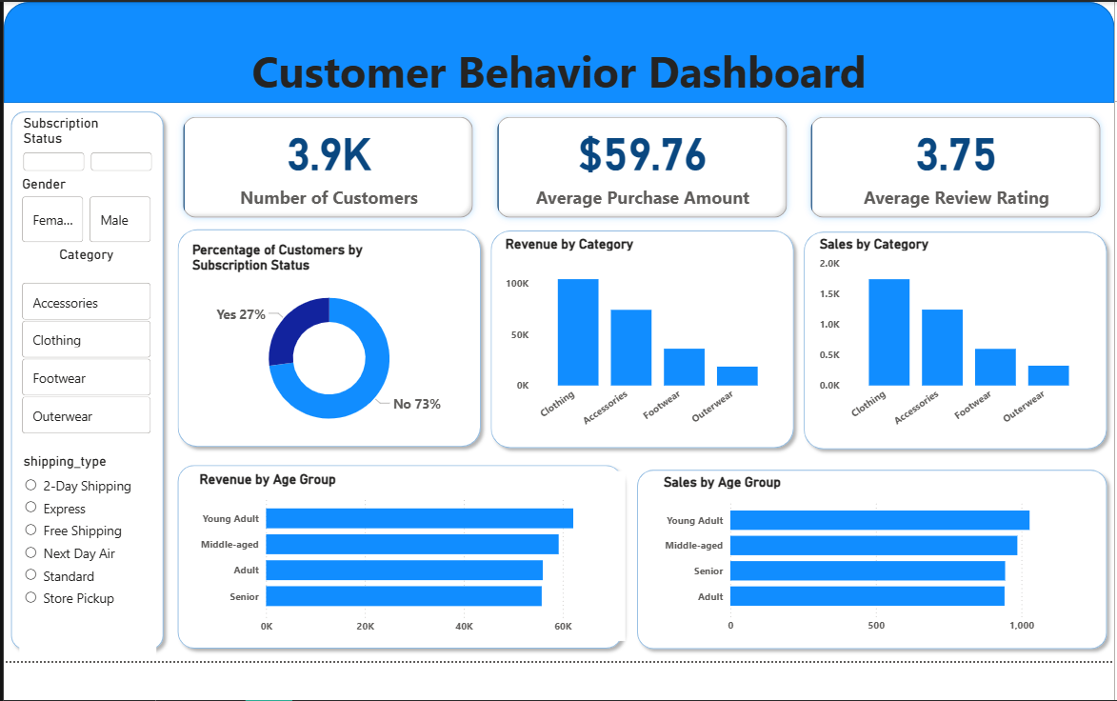

6. Business Recommendations
- Boost Subscriptions: Promote exclusive benefits and incentives to encourage more customers to subscribe.
- Customer Loyalty Programs: Reward repeat buyers to nurture them into the Loyal customer segment.
- Review Discount Policy: Optimize discount strategies to increase sales while maintaining healthy profit margins.
- Product Positioning: Emphasize top-rated and best-selling products in marketing campaigns to drive sales.
- Targeted Marketing: Focus marketing efforts on high-revenue age groups and customers who prefer Express shipping to maximize ROI.

