

|  |
| --- |
| TCV Web Django  2020 |
|  |
| March 30  Transcosmos Việt Nam  Authored by: Phạm Duy Khánh |



# Django Framework

Django is a high-level Python Web framework that encourages rapid development and clean, pragmatic design. Built by experienced developers, it takes care of much of the hassle of Web development, so you can focus on writing your app without needing to reinvent the wheel. It’s free and open source.

* Ridiculously fast.
  + Django was designed to help developers take applications from concept to completion as quickly as possible.
* Reassuringly secure.
  + Django takes security seriously and helps developers avoid many common security mistakes.
* Exceedingly scalable.
  + Some of the busiest sites on the Web leverage Django’s ability to quickly and flexibly scale.

1. Setting up your Raspberry Pi

## **Set up your SD card**

If you have an SD card that doesn’t have the Raspbian operating system on it yet, or if you want to reset your Raspberry Pi, you can easily install Raspbian yourself. To do so, you need a computer that has an SD card port — most laptop and desktop computers have one.

### The Raspbian operating system via the Raspberry Pi Imager

Using the Raspberry Pi Imager is the easiest way to install Raspbian on your SD card.

**Note:** more advanced users looking to install a particular operating system should use this guide to [installing operating system images](https://www.raspberrypi.org/documentation/installation/installing-images/README.md).

#### Download and launch the Raspberry Pi Imager

* Visit the [Raspberry Pi downloads page](https://www.raspberrypi.org/downloads).

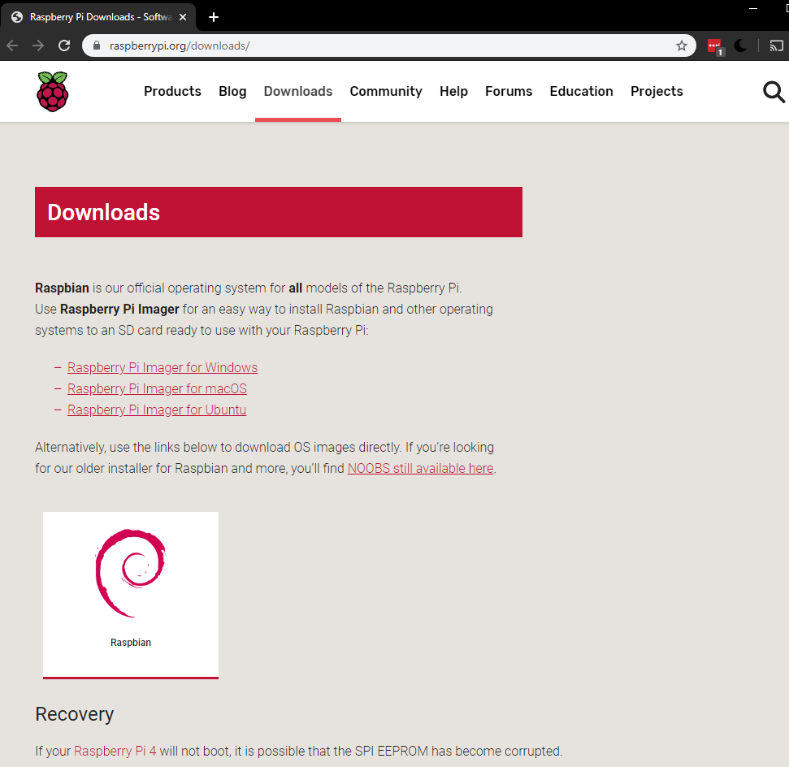

* Click on the link for the Raspberry Pi Imager that matches your operating system.

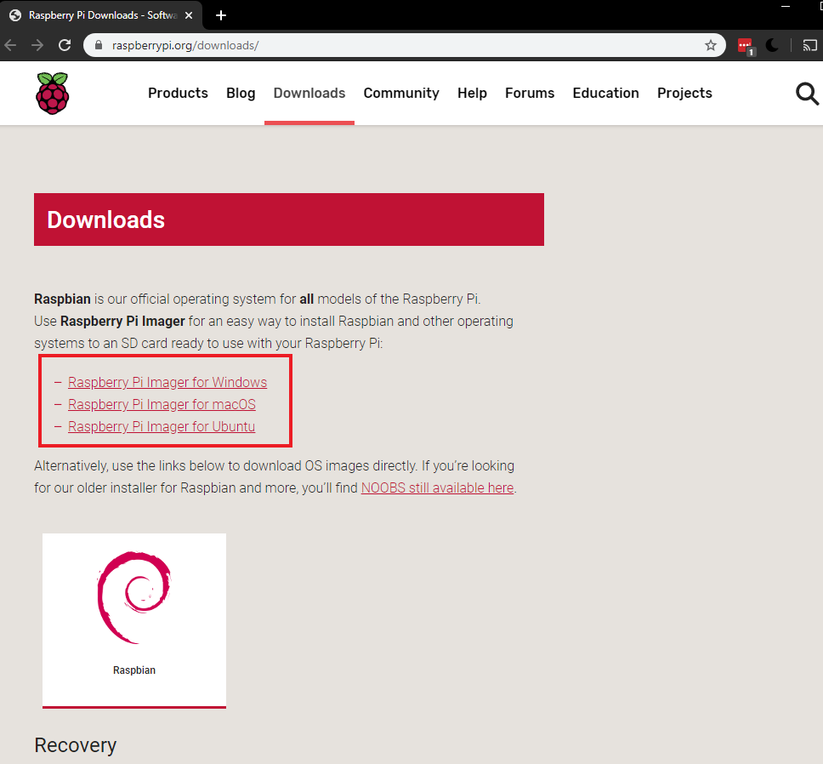

* When the download finishes, click it to launch the installer.

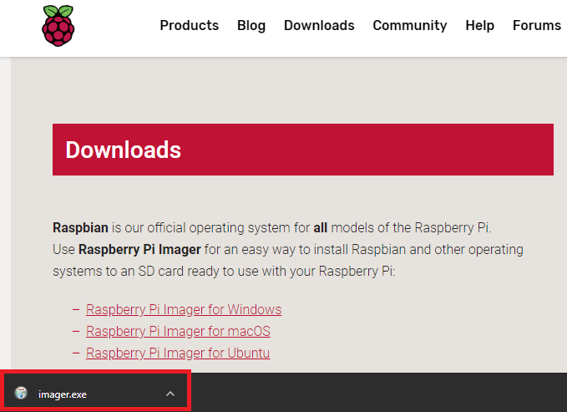

#### Using the Raspberry Pi Imager

Anything that’s stored on the SD card will be overwritten during formatting. So if the SD card on which you want to install Raspbian currently has any files on it, e.g. from an older version of Raspbian, you may wish to back these files up first to not lose them permanently.

When you launch the installer, your operating system may try to block you from running it. For example on Windows I get the following:

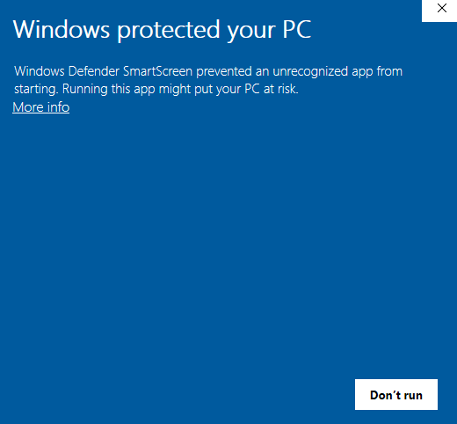

* If you get this, click on More info and then Run anyway.
* Follow the instructions to install and run the Raspberry Pi Imager.
* Insert your SD card into the computer or laptop’s SD card slot.
* In the Raspberry Pi Imager, select the OS that you want to install and the SD card you would like to install it on.

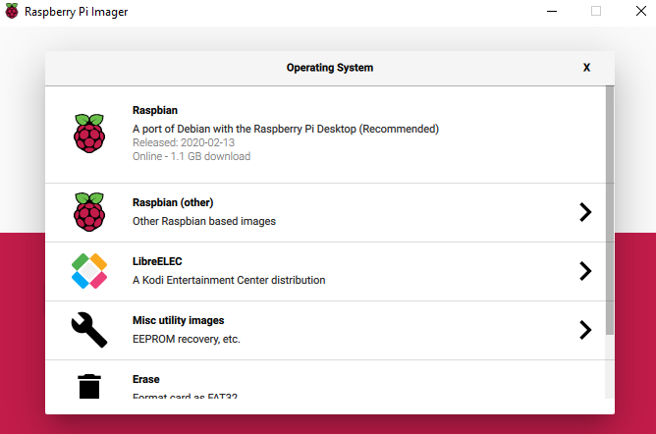

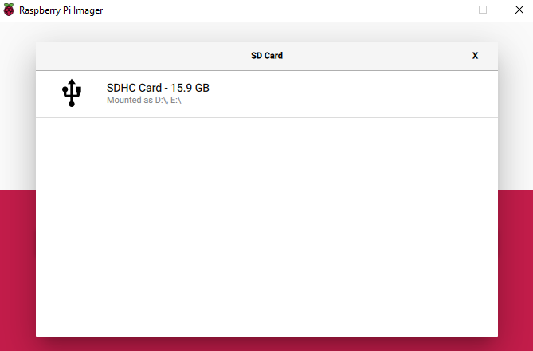

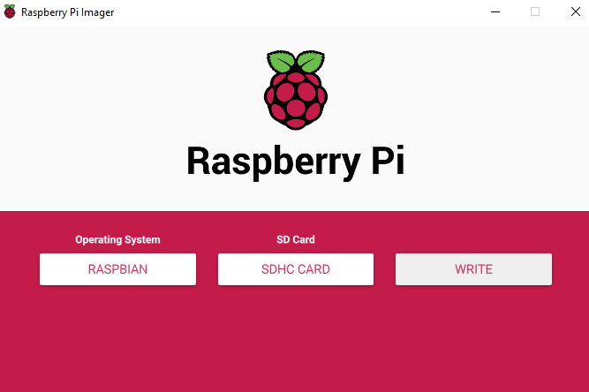

* Then simply click the WRITE button.
* Wait for the Raspberry Pi Imager to finsh writing.
* Once you get the following message, you can eject your SD card.

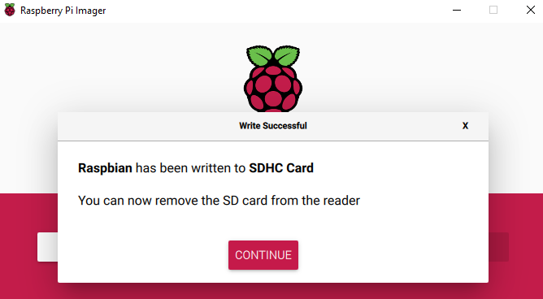

## **Connect your Raspberry Pi**

Now get everything connected to your Raspberry Pi. It’s important to do this in the right order, so that all your components are safe.

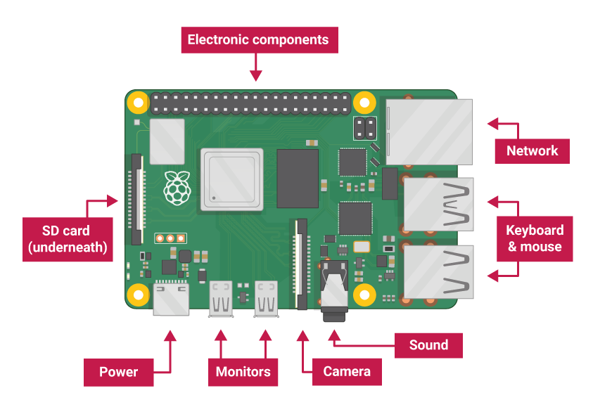

* Insert the SD card you’ve set up with Raspbian (via NOOBS) into the microSD card slot on the underside of your Raspberry Pi.

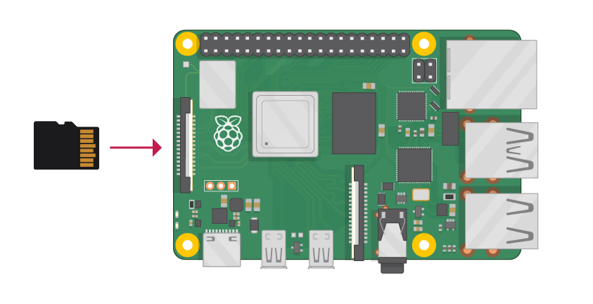

**Note:** Many microSD cards come inside a larger adapter — you can slide the smaller card out using the lip at the bottom.

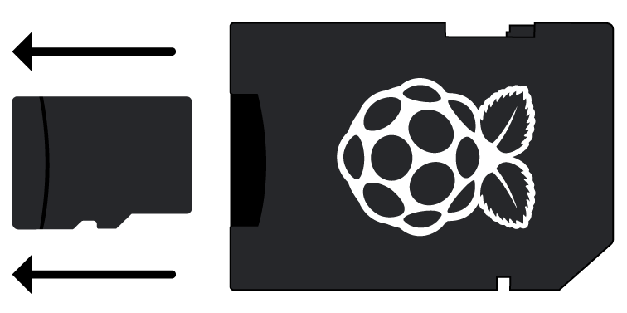

* Find the USB connector end of your mouse’s cable, and connect the mouse to a USB port on Raspberry Pi (it doesn’t matter which port you use).

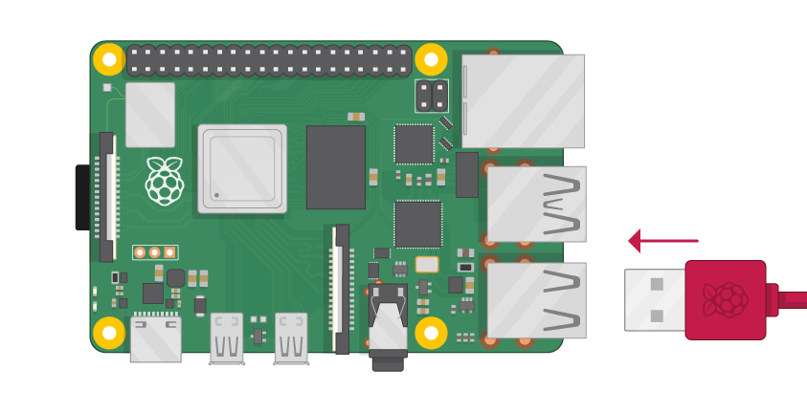

* Connect the keyboard in the same way.

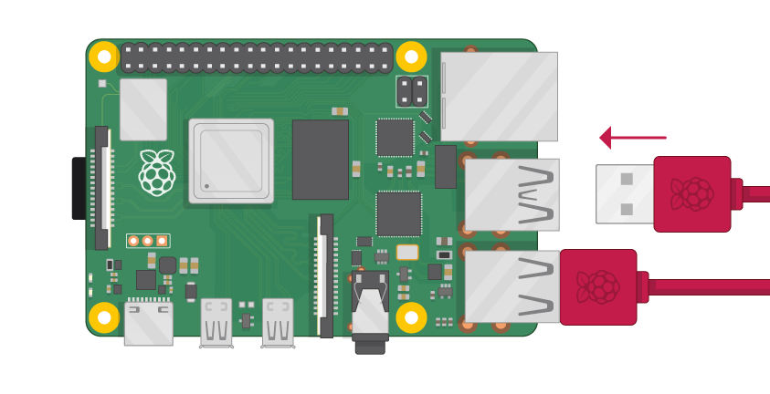

* Make sure your screen is plugged into a wall socket and switched on.
* Look at the HDMI port(s) on the Raspberry Pi — notice that they have a flat side on top.
* Use a cable to connect the screen to Raspberry Pi’s HDMI port — use an adapter if necessary.

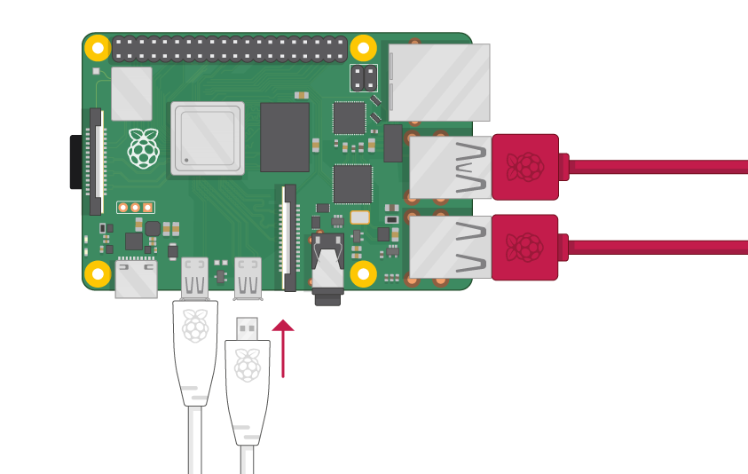

**Raspberry Pi 1, 2, 3**

Connect your screen to the single HDMI port.

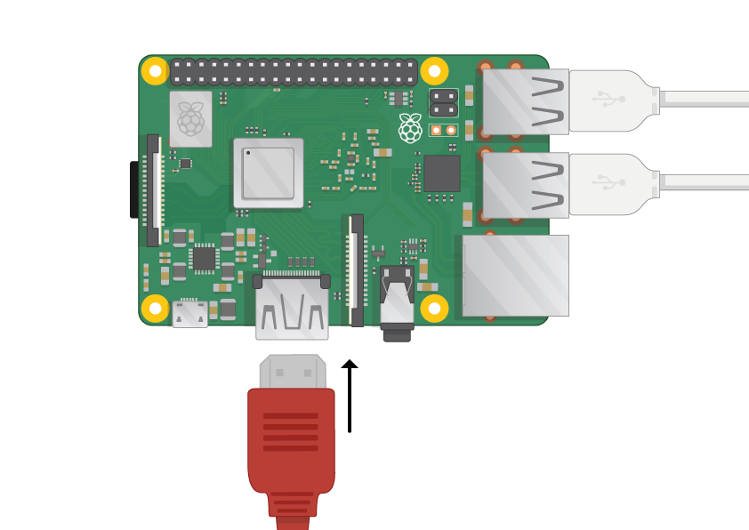

**Note:** nothing will display on the screen, because your Raspberry Pi is not running yet.

* If you want to connect your Raspberry Pi to the internet via Ethernet, use an Ethernet cable to connect the Ethernet port on Raspberry Pi to an Ethernet socket on the wall or on your internet router. You don’t need to do this if you want to use wireless connectivity, or if you don’t want to connect to the internet.

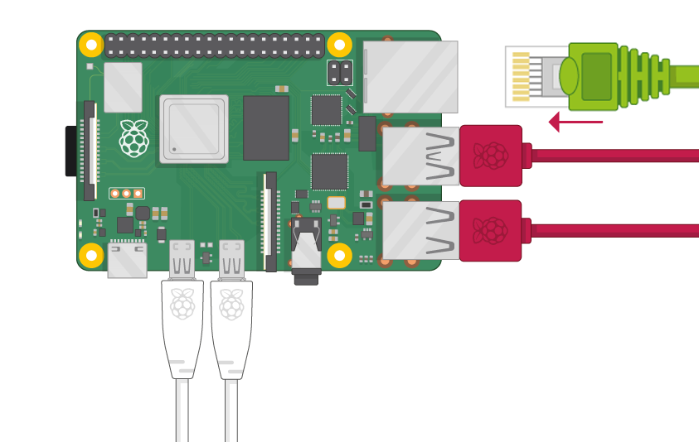

* If the screen you are using has speakers, sound will play through those. Alternatively, connect headphones or speakers to the audio port if you prefer.

## **Start up your Raspberry Pi**

Your Raspberry Pi doesn’t have a power switch: as soon as you connect it to a power outlet, it will turn on.

* Plug the USB power supply into a socket and connect it to your Raspberry Pi’s power port.

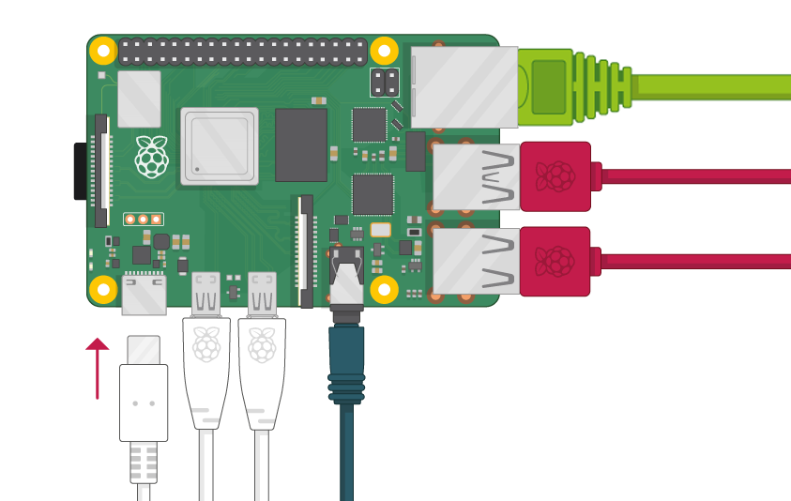

You should see a red LED light up on the Raspberry Pi, which indicates that Raspberry Pi is connected to power. As it starts up (this is also called **booting**), you will see raspberries appear in the top left-hand corner of your screen.

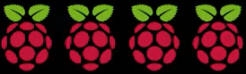

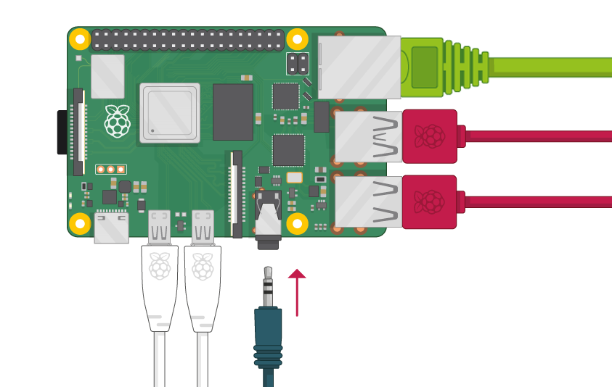



After a few seconds the Raspbian Desktop will appear.

raspbian desktop

## **Finish the setup**

When you start your Raspberry Pi for the first time, the **Welcome to Raspberry Pi** application will pop up and guide you through the initial setup.



* Click **Next** to start the setup.
* Set your **Country**, **Language**, and **Timezone**, then click **Next** again.

pi wizard country

* Enter a new password for your Raspberry Pi and click ****Next****.

pi wizard password

* Connect to your WiFi network by selecting its name, entering the password, and clicking ****Next****.

pi wizard wifi

**Note:** if your Raspberry Pi model doesn’t have wireless connectivity, you won’t see this screen.

* Click ****Next**** let the wizard check for updates to Raspbian and install them (this might take a little while).

pi wizard updating

* Click ****Done**** or ****Reboot**** to finish the setup.

**Note:** you will only need to reboot if that’s necessary to complete an update.

pi wizard complete

1. Install Django and related package.
2. Set up python3

# Installing Python 3.6 on Raspbian

As of January 2018, Raspbian does not yet include the latest Python release, Python 3.6. This means we will have to build it ourselves, and here is how to do it. There is also an ansible role attached that automates it all for you.

1. Install the required build-tools (some might already be installed on your system).
2. $ sudo apt-get update

$ sudo apt-get install build-essential tk-dev libncurses5-dev libncursesw5-dev libreadline6-dev libdb5.3-dev libgdbm-dev libsqlite3-dev libssl-dev libbz2-dev libexpat1-dev liblzma-dev zlib1g-dev

If one of the packages cannot be found, try a newer version number (e.g. libdb5.4-dev instead of libdb5.3-dev).

1. Download and install Python 3.6. When downloading the source code, select the most recent release of Python 3.6, available on the [official site](https://www.python.org/downloads/source/). Adjust the file names accordingly.
2. $ wget https://www.python.org/ftp/python/3.6.5/Python-3.6.5.tar.xz
3. $ tar xf Python-3.6.5.tar.xz
4. $ cd Python-3.6.5
5. $ ./configure
6. $ make

$ sudo make altinstall

1. Optionally: Delete the source code and uninstall the previously installed packages. When uninstalling the packages, make sure you only remove those that were not previously installed on your system. Also, remember to adjust version numbers if necesarry.
2. $ sudo rm -r Python-3.6.5
3. $ rm Python-3.6.5.tar.xz
4. $ sudo apt-get --purge remove build-essential tk-dev
5. $ sudo apt-get --purge remove libncurses5-dev libncursesw5-dev libreadline6-dev
6. $ sudo apt-get --purge remove libdb5.3-dev libgdbm-dev libsqlite3-dev libssl-dev
7. $ sudo apt-get --purge remove libbz2-dev libexpat1-dev liblzma-dev zlib1g-dev
8. $ sudo apt-get autoremove

$ sudo apt-get clean

1. Set up Django

Run command in terminal (Ctrl +T)

Update all resource and version package off raspberry pi

* Sudo apt-get update

Install django

* Pip install django

1. Create first project

Django-admin startproject

django-admin startproject home

To create a Django project, open Command Prompt (terminal) and navigate to the directory you want to create, then type the command above, above we create a project with the name mysite. The startproject command will create a directory named home, the structure inside the directory will look like this:

home/

manage.py

mysite/

__init__.py

settings.py

urls.py

wsgi.py