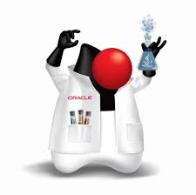
Java EE 7 tutorial

Developer.getImprovements()

Author: Guillaume Diaz
Copyright: Daxiongmao.eu®
Version: 1.0 – January 2014

Table of Contents
Requirements 3
Aims 3
Application architecture 4
Overall view 4
Software architecture – Backend (EJB project) 5
EJB content 5
Testing aspects 5
Software architecture – Frontend (WAR project) 6
WAR content 6
JSF introduction 6
How to create a Java EE 7 project 7
Creates Maven modules 8
Add Maven JavaEE 7 archetypes repository 8
Java EE 7 – Backend (EJB) 9
Project creation 9
Project facets 10
Java EE 7 web project – Frontend (WAR) 11
Project creation 11
Project facets 12
Add Maven dependency 12
Java EE 7 – Overall project (EAR) 13
Project creation 13
Project facets 13
Add Maven dependencies 14
Java EE 7 – Parent POM 15
Initialize projects 16
Backend initialization – EJB project 16
Persistence.xml – JPA and database setup 17
Manifest.MF 18
Beans.xml – EJBs detection / declaration 18
Frontend initialization – WAR project 19
Faces-config.xml – JSF configuration 19
Web.xml – Web configuration 20
Resources 22
Bibliography 23

Requirements

IDE | Eclipse 4.3 SR1  NetBeans 7.1
Application Server | Glassfish 4.0
Dependencies management | Apache Maven 3.1
Java | JDK 7 v45
Internet browser | It must be HTML5 comptabile

You need to know:
- Java programming
- HTML + CSS
- Key paradigms:
- Dependency Injection (IoC)
- N-Third software architecture
- MVC
- Object Relationship Management & Database architecture
- Event programming
- Java Naming Directory (JNDI)
- Convention over configuration

Aims
This tutorial explains how to build a simple application.
The application aims to provide:
- Application log-in using both JDBC (database) or J2EE security
  - Persistence layer is done using JPA v2.1
  - User Interface is done in JSF 2.2
- Responsive design through Twitter Bootstrap and HTLM5
- Log-in API using REST web-services
  - Data objects can be serialized using JAX-RS annotations
- Event programming
  - using JMS v2.0 to exchange messages: publish / subscribe
- Simple chat
  - using JMS v2.0 to exchange messages: with message routing
- Display / Edit / Add / Delete some content from database and | or import file

Application architecture

Overall view
You cannot build the application into a single Maven module. That means, you have to create at least 2 maven projects.
Java EE 7 requires you to separate the backend (EJB) from the frontend (WAR).
This limitation comes from the underline deployment descriptors that are used to deploy each application.

Therefore the application will have the following architecture:

Frontend
Backend
User Interface
HTML5 + JSF 2.2
MySQL database
JPA 2.1
Event bus
JMS v2.0
Application Server
Web services
JAX-RS / JAX-WS
As you can see on this diagram, thanks to the JSR specifications, the application server already provides a lot of underline technologies.

Only job: implement the frontend + backend.

From a Maven point of view:
- Backend = EJB project
- Frontend = WAR project
- The whole is an EAR project
Java Enterprise Archive (= application)

EAR = EJB (backend beans) + WAR (web application) + Deployment Descriptor

Software architecture – Backend (EJB project)

EJB content
The backend is where the application logic and data access is performed.
From a technical point of view, this is what the developer has to do:

Model
Data objects (JPA 2.1 + JAX-RS)
Services
DAO + Application logic (EJB 3.2)
Utils
Utilities classes
beans.xml
EJB beans configuration
persistence.xml
Database + JPA configuration
MANIFEST.MF
Application declaration
glassfish-ejb-jar.xml
Deployment descriptor
Java code
pom.xml

As you can see on the picture, an EJB project has 4 layers:
- Model = data objects. Use annotations to make them serializable and match the database
- Services / Utilities = Application core. Each EJB is like a Spring bean.
- Configuration = XML files for the application server. They describe how to use the application: database configuration, EJB beans auto-detection or specific set, etc.
- Deployment descriptor = how to deploy the application on a specific application server. This file content will change according to the server you are using (Glassfish, IBM WAS, ...)

The Model, Services / Utilities & Configuration layers do not depend on any application server.

The 4th layer (Deployment Descriptor) is tied to your specific infrastructure.

Testing aspects
- Unit tests
= Test a class using either mock or stub to isolate the target and ensure a specific behavior.
As they do not rely on the application server jUnit + Mockito is enough.
No changes compare to Java SE :-)
- Integration tests
= Test a component (set of classes / beans) running on the application server.
You have to use the same embedded server as your target platform + Arquillian.

Software architecture – Frontend (WAR project)

WAR content
Like any other web application based upon the MVC paradigm, a Java Server Faces (JSF) application is composed of different layers:
- View = web-pages and resources (languages files – i18n, images, videos, sounds, ...).
The web pages are written in HTML5 with some JSF 2.2 tags.
- Controller = JSF Backing Beans
Each controller acts as a bridge between backend, model and view.
In most case each page has it's own backing bean.
- Model
In JavaEE the Model is separated in 2 parts. Depending on the situation you can:
    - Re-use the backend model layer. Ex: This is useful to display database content
    - For each web form you have to create a specific model (in the frontend layer).
- Configuration

JSF introduction
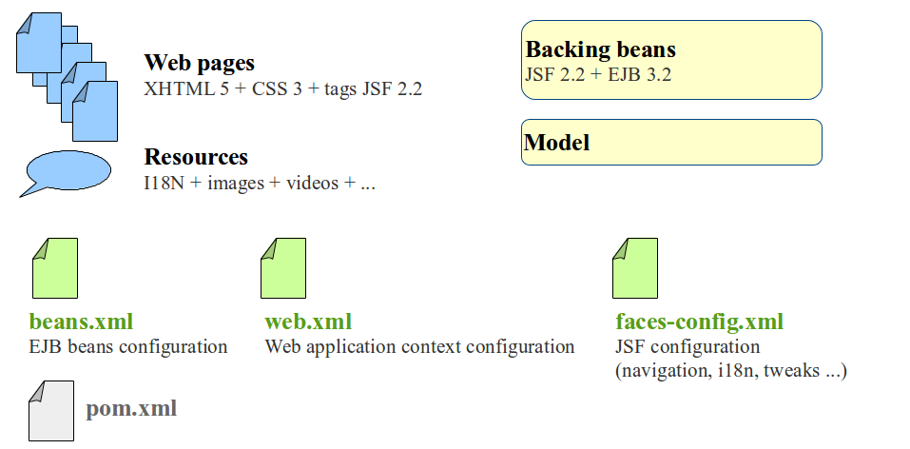
Java Server Faces (JSF) rely upon MVC paradigm, so it's architecture is quite common.
The JSF tags in the web-pages are derivated from JSP. That makes them easy to understand for any developer.
Tricky part is the JSF backing beans. In the controller, you can:
- Setup either statefull or stateless beans
- Manage sessions and parameters
- Check login and other attributes
You have to be careful on which annotation to use and when.

JSF is a server side technology. So, the result might change depending on your browser and operating system. To overcome this problem you can use HTML5 + CSS3 templates such as “bootstrap”. These templates will handle different set of browsers and hardware for you.

How to create a Java EE 7 project
This is the process to create a Java EE 7 application:
- Setup environment: database / MQ servers / Glassfish 4
- Setup server connections and datasource. Give them some name (JNDI)
- Create all Maven modules and parent project
- Implement the backend logic and test it. Use the server datasources through JNDI.
- Implement the frontend using backend calls + test the application

As you can deploy a WAR on Glassfish,
repeat number steps 2 and 3 until your application is done.

- Configure the EAR
- Deploy the EAR on Glassfish
Now you can deploy anywhere as long as the JNDI and datasources types matches!

Creates Maven modules
Either you create the projects by hand if you feel confident enough, or you can use the existing archetypes that the java community has created.
In this tutorial, I assume it's your first JavaEE 7 project = we will use the archetypes. :D

Add Maven JavaEE 7 archetypes repository
Eclipse > Windows > Preferences > Maven > Add remote catalog
- URL: http://repo1.maven.org/maven2/archetype-catalog.xml
- Description: Maven central
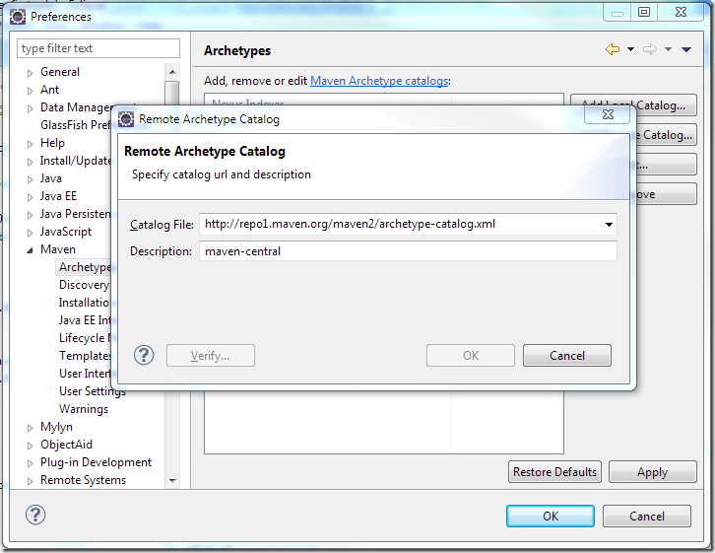

You can also browse the archetypes yourself to:
https://nexus.codehaus.org/content/repositories/ [alternative location]

Java EE 7 – Backend (EJB)

Project creation
Eclipse > File > New > Maven project...
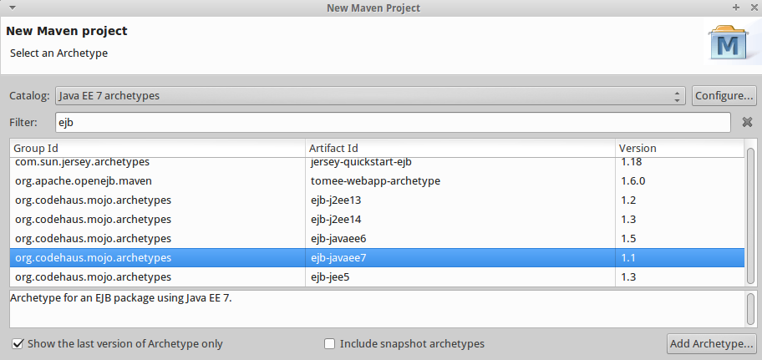
New repository
Maven artefact
ejb-javaee7

Then, you have to fill up the form:
- Group ID
- Artifact ID: backend
- Version: 1.0.0-SNAPSHOT

Project facets
Your favorite IDE (Eclipse, NetBeans, IntelliJ) can provides a lot of tools if you declare the project correctly. You have to set the project's facets.

Eclipse > Right click on the project name in Package Explorer view > Properties > Project Facets
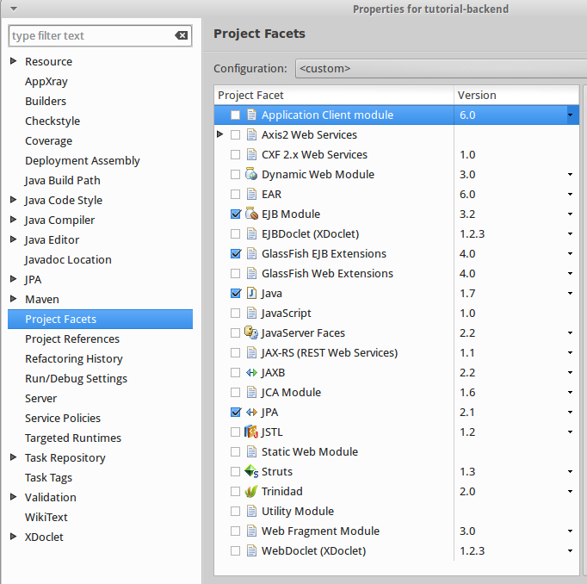

EJB Module 3.2

Glassfish EJB 4.0

Java 1.7

JPA 2.1

Java EE 7 web project – Frontend (WAR)

Project creation
Eclipse > File > New > Maven project...
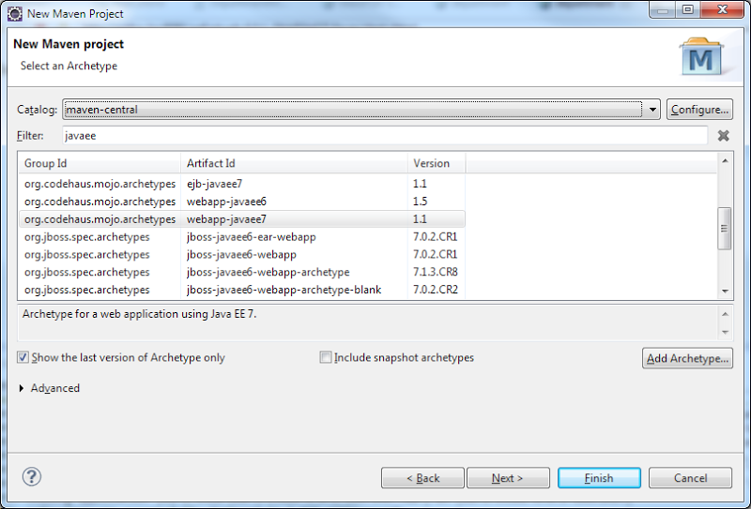
New repository
Maven artefact
webapp-javaee7

Then, you have to fill up the form:
- Group ID
- Artifact ID: frontend
- Version: 1.0.0-SNAPSHOT

Project facets
Eclipse > Right click on the project name in Package Explorer view > Properties > Project Facets
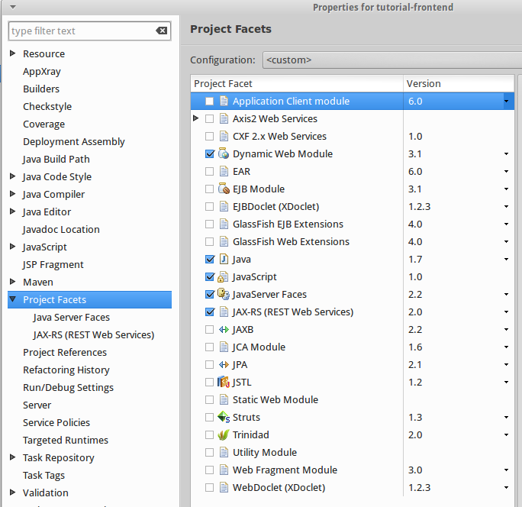

Web module 3.1

Glassfish Web 4.0
Java 1.7
JavaScript 1.0
JSF 2.2
JAX-RS 2.0

Add Maven dependency
- Edit the pom.xml file of the frontend project
- Add a dependency to the Backend project you've just created before

<!-- Backend project -->
<dependency>
<groupId>${project.parent.groupId}</groupId>
<artifactId>backend</artifactId>
<version>${project.parent.version}</version>
<type>ejb</type>
</dependency>

To get the best of JavaEE 7 you have to specify the dependency type for WAR and EJB libs

Java EE 7 – Overall project (EAR)

Project creation
Eclipse > File > New > Maven project...
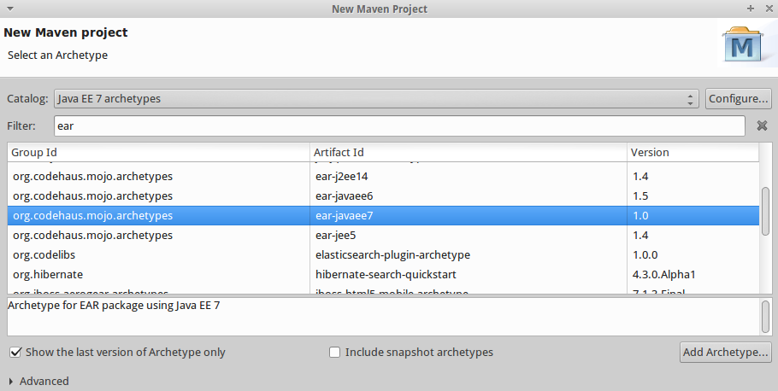
ear-javaee7

Then, you have to fill up the form:
- Group ID
- Artifact ID: deployment
- Version: 1.0.0-SNAPSHOT

Project facets
Eclipse > Right click on the project name in Package Explorer view > Properties > Project Facets
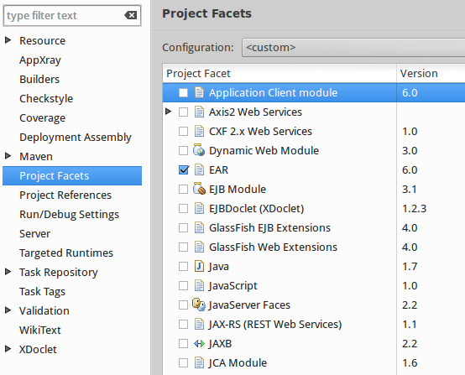

Just select ear v6.0

Add Maven dependencies
- Edit the pom.xml file of the deployment project
- Add dependencies to Backend + Frontend projects you've just created before

<!-- Backend project -->
<dependency>
<groupId>${project.parent.groupId}</groupId>
<artifactId>backend</artifactId>
<version>${project.parent.version}</version>
<type>ejb</type>
</dependency>

<!-- Frontend project -->
<dependency>
<groupId>${project.parent.groupId}</groupId>
<artifactId>frontend</artifactId>
<version>${project.parent.version}</version>
<type>war</type>
</dependency>

Java EE 7 – Parent POM
Now you have created 2 projects: backend + frontend.
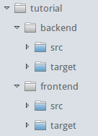
To improve the daily life, I strongly advise you to create a parent POM for these 2 artifacts.

The content of the parent POM can be deduced from both the EJB and WAR projects.

You can also check my example over here:
TODO: ADD LINK TO THE ROOT POM !

Initialize projects

Backend initialization – EJB project
Once you have create the EJB project, you have to:
- Create / declare some resources folders [maven setup]
- Create and populate some configuration files

You project should look like:
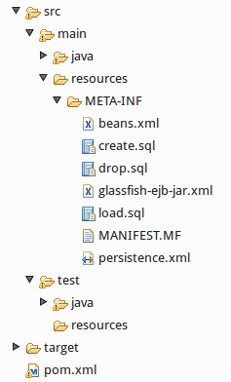
Mandatory files
Application server

You don't have to create any SQL files if you're using the automatic database creation.

Don't hesitate to declare the missing sources and resources folders, if any.

Persistence.xml – JPA and database setup
This is where you configure your database access and all the JPA options.
 This file is highly customizable. Don't hesitate to Google it !

Minimum content:

<?xml version="1.0" encoding="UTF-8"?>
<persistence version="2.1" xmlns="http://xmlns.jcp.org/xml/ns/persistence"
xmlns:xsi="http://www.w3.org/2001/XMLSchema-instance"
xsi:schemaLocation="http://xmlns.jcp.org/xml/ns/persistence
http://xmlns.jcp.org/xml/ns/persistence/persistence_2_1.xsd">

<!-- Datasource declaration and transaction type -->
<persistence-unit name="tutorialJeePU" transaction-type="JTA">
<jta-data-source>jdbc/tutorial</jta-data-source>

<properties>
<property name="javax.persistence.schema-generation.database.action"
value="drop-and-create"/>

<!-- Create / Drop tables using JPA annotations only (metadata) -->
<property name="javax.persistence.schema-generation.create-source"
value="metadata"/>
<property name="javax.persistence.schema-generation.drop-source"
value="metadata"/>

<!-- Populate the database with some default values using a SQL script -->
<property name="javax.persistence.sql-load-script-source"
value="META-INF/load.sql"/>

<!-- Advanced properties -->
<property name="eclipselink.logging.exceptions" value="true"/>
<property name="eclipselink.logging.level" value="FINE"/>
</properties>
</persistence-unit>
</persistence>

As you can see, this file is composed of 4 steps:
- Datasource declaration + transaction type
the JNDI jdbc/tutorial must match a server's datasource name.
- Database schema management (create / create-drop / update / do nothing) using either some SQL scripts or @nnotations
- Database content loading – to initialize some default values
- Logging

You can also add some specific stuff for a specific type of database.
 By careful: by doing so you break the contract “write once, run everywhere”.

Manifest.MF
You just need to initialize this file. Everything else is handled by the application server.
The content is just:
Manifest-Version: 1.0

Beans.xml – EJBs detection / declaration

As I'll use the @nnotations to declare my beans, the beans.xml content is pretty simple:
<?xml version="1.0" encoding="UTF-8"?>
<beans xmlns="http://xmlns.jcp.org/xml/ns/javaee"
xmlns:xsi="http://www.w3.org/2001/XMLSchema-instance"
xsi:schemaLocation="http://xmlns.jcp.org/xml/ns/javaee
http://xmlns.jcp.org/xml/ns/javaee/beans_1_1.xsd"
bean-discovery-mode="annotated">
</beans>

Frontend initialization – WAR project

Your project should look like this:
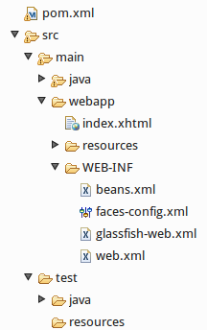

Don't hesitate to create this folder if missing !
Then, declare it as a resource folder

The glassifish-web.xml is not mandatory.
→ It depends on your application server.

The beans.xml file content is exactly the same as the EJB [see previous §]

Faces-config.xml – JSF configuration
This is where you'll defined all the navigation, actions and pages flows for JSF.
The minimal content to start is:

<?xml version="1.0"?>
<faces-config version="2.2" xmlns="http://xmlns.jcp.org/xml/ns/javaee"
xmlns:xsi="http://www.w3.org/2001/XMLSchema-instance"
xsi:schemaLocation="http://xmlns.jcp.org/xml/ns/javaee
http://xmlns.jcp.org/xml/ns/javaee/web-facesconfig_2_2.xsd" >

<application>
<locale-config>
<default-locale>en</default-locale>
<supported-locale>en</supported-locale>
</locale-config>
</application>

</faces-config>

This file content will evolve with your application.
It might become a big file: don't worry that's expected !

Web.xml – Web configuration
This is where your setup your web application.

<?xml version="1.0" encoding="UTF-8"?>
<web-app version="3.1" xmlns="http://xmlns.jcp.org/xml/ns/javaee"
xmlns:xsi="http://www.w3.org/2001/XMLSchema-instance"
xsi:schemaLocation="http://xmlns.jcp.org/xml/ns/javaee
http://xmlns.jcp.org/xml/ns/javaee/web-app_3_1.xsd" >

<display-name>tutorial</display-name>

<!-- Enable JSF for the current application -->
<servlet>
<servlet-name>Faces Servlet</servlet-name>
<servlet-class>javax.faces.webapp.FacesServlet</servlet-class>
<load-on-startup>1</load-on-startup>
</servlet>
<!-- JSF files and folders -->
<servlet-mapping>
<servlet-name>Faces Servlet</servlet-name>
<url-pattern>/faces/*</url-pattern>
<url-pattern>*.jsf</url-pattern>
<url-pattern>*.xhtml</url-pattern>
</servlet-mapping>

<!-- Welcome (start) page of the application -->
<welcome-file-list>
<welcome-file>index.xhtml</welcome-file>
</welcome-file-list>

<!-- Current project status -->
<context-param>
<param-name>javax.faces.PROJECT_STAGE</param-name>
<param-value>Development</param-value>
</context-param>

<!-- i18n settings. This is where the bundle files are available -->
<context-param>
<param-name>javax.faces.WEBAPP_RESOURCES_DIRECTORY</param-name>
<param-value>/resources</param-value>
</context-param>

<!-- JSF specific configuration and tweaks. -->
<context-param>
<param-name>javax.faces.SERIALIZE_SERVER_STATE</param-name>
<param-value>false</param-value>
</context-param>
<context-param>
<param-name>javax.faces.STATE_SAVING_METHOD</param-name>
<param-value>server</param-value>
</context-param>

</web-app>

TO BE FINISHED

Resources

Java EE 7 Maven archetypes | http://repo1.maven.org/maven2/archetype-catalog.xml

Bibliography

☺☺☺ | Ojitha Kumanayka – Java EE 7 enterprise application development tutorial  http://ojitha.blogspot.se/2013/07/java-enterprise-application-development.html
☺☺☺ | Java EE 7 hands-on lab. Official ORACLE & Glassfish community tutorial  http://glassfish.org/hol/javaee7-hol.pdf

 Responsive design The user interface will change and adapt itself to the current platform.
Only select Glassfish facet if you are actually using Glassfish Application Server. Otherwise select the facet for your own server: IBM WebSphere, Jboss, ...

