**DERIVATIVE**

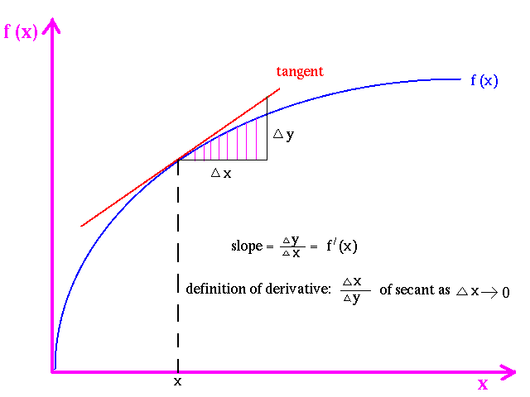

**Problem**

Given a [polynomial](https://en.wikipedia.org/wiki/Polynomial) over a variable x, your task is to calculate the value of its [derivative](https://en.wikipedia.org/wiki/Derivative) in the given point x

The polynomial is a combination of several (at least one) monomials. Each monomial is guaranteed to be in the format <coef>*x^<power>

* <coef> is an integer in the range [-1000, 1000]. If it is equal to 1, it may be omitted
* <power> is an integer in the range [0, 12]. If it is equal to 1, it may be omitted. If it is equal to 0, 'x' can also be omitted

The monomials are separated by a + or a - sign, surrounded by a single whitespace character

**Input**

The first line contains 1 integer T, which is the number of testcases ( 0 ≤ T ≤ 50 )

After this, there will be 2*T lines, each testcase has 2 lines:

+ the first line: a polynomial in the format described above

+ the second line: value of x

**Output**

For each testcase, output the value of the polynomial's derivative at x

**Notice**

- Guaranteed constraints:-1000 ≤ x ≤ 1000

**Example**

Input

2

3*x^2 - x^4 + 8

-2

5x

-1

Output

20

5

For polynomial = "3*x^2 - x^4 + 8" and x = -2, the output should be  
derivative(polynomial, x) = 20

The derivative of the polynomial is 6*x - 4*x^3. Its value at the point -2 is equal to 6 * (-2) - 4 * (-2)3 = -12 - 4 * (-8) = -12 + 32 = 20. Thus, the answer is 20

**Time limit**

500ms C/C++

3000ms Java

4000ms PHP, Python, Ruby