TCP_MSG
SERVER
using System;
using System.Collections.Generic;

using System.ComponentModel;

using System.Data;
using System.Drawing;

using System.Linq;

using System.Text;

using System.Windows.Forms;
using System.Net;

using System.Net.Sockets;

using System.Collections;
using System.Threading;

using System.IO;

namespace ServerTCP_

{

public partial class FormServer : Form

{

public FormServer()

{
InitializeComponent();

}

delegate void ShowMessage(String Message_);

public void Show(string Message_)
{

if (lstReceive.InvokeRequired)

{

ShowMessage message = new ShowMessage(Show); lstReceive.Invoke(message, new object[] {Message_}); return;

}
lstReceive.Items.Add(Message_);

}

public void ShowIP(string Message_)

{

if (txtIP.InvokeRequired)

{

ShowMessage message = new ShowMessage(ShowIP); txtIP.Invoke(message, new object[] { Message_ }); return;
}
txtIP.Text = Message_;

}

string returnString = "";

char[] s;

TcpListener listener;

TcpClient client;
Thread listenerThread;

bool isStart = false;

public void ListenMessage()
{

try

{
listener = new TcpListener(IPAddress.Any, int.Parse(txtPort.Text));

listener.Start();

isStart = true;

listenerThread = new Thread(new ThreadStart(WaitingConnect)); listenerThread.Start();

}

catch (Exception exc)
{

MessageBox.Show("Không thể khởi động máy chủ ! \n" + exc.ToString());

}

}

public void WaitingConnect()
{

while (isStart)
{

IPEndPoint remote = new IPEndPoint(IPAddress.Any, 0); client = listener.AcceptTcpClient();

StreamReader reader = new StreamReader(client.GetStream()); string data = reader.ReadLine(); if (data.Trim().Length > 0)
{
Show("Nhận thông điệp từ -> " + remote.Address.ToString() + " : " + data);

StreamWriter writer = new StreamWriter(client.GetStream());

writer.WriteLine(data);

writer.Flush();
}

}

}

private void btnStart_Click(object sender, EventArgs e)

{
lstReceive.Items.Clear();

new Thread(new ThreadStart(ListenMessage)).Start(); lstReceive.Items.Add("Đang lắng nghe ... ");
}

private void lstReceive_SelectedIndexChanged(object sender, EventArgs e)
{

if (lstReceive.SelectedItem != null)

txtResult.Text = lstReceive.SelectedItem.ToString();

}

private void Stop_Click(object sender, EventArgs e)

{
if (listener != null)

{

isStart = false;
listener.Stop();

}
}

}

}

CLIENT
using System;

using System.Collections.Generic;
using System.ComponentModel;

using System.Data;

using System.Drawing;
using System.Linq;

using System.Text;

using System.Windows.Forms;

using System.Net.Sockets;
using System.Net;

using System.IO;

using System.Threading;

namespace ClientTCP

{
public partial class FormClient : Form

{

public FormClient()

{
InitializeComponent();

}

public delegate void ShowMessage(string Message_);

public void Show(string Message_)

{
if (lstReceive.InvokeRequired)

{

ShowMessage message = new ShowMessage(Show); lstReceive.Invoke(message, new object[] { Message_ }); return;

}

lstReceive.Items.Add(Message_);
}

TcpClient tcpClient;

StreamReader reader;
StreamWriter writer;

private void btnSend_Click(object sender, EventArgs e)
{

tcpClient = new TcpClient(); tcpClient.Connect(txtIP.Text, int.Parse(txtPort.Text)); writer = new StreamWriter(tcpClient.GetStream()); writer.WriteLine(txtMessage.Text); writer.Flush();

new Thread(new ThreadStart(ReceiveMessage)).Start();

}

private void ReceiveMessage()

{

reader = new StreamReader(tcpClient.GetStream()); string strReturn = reader.ReadLine(); if (strReturn.Trim().Length > 0)

Show("Thông điệp từ Server : " + strReturn);

}

private void txtMessage_KeyPress(object sender, KeyPressEventArgs e)
{

if (e.KeyChar == (char)13)
btnSend_Click(sender, e);

}

private void lstReceive_SelectedIndexChanged(object sender, EventArgs e)

{

if (lstReceive.SelectedItem != null)

txtResult.Text = lstReceive.SelectedItem.ToString();
}

}

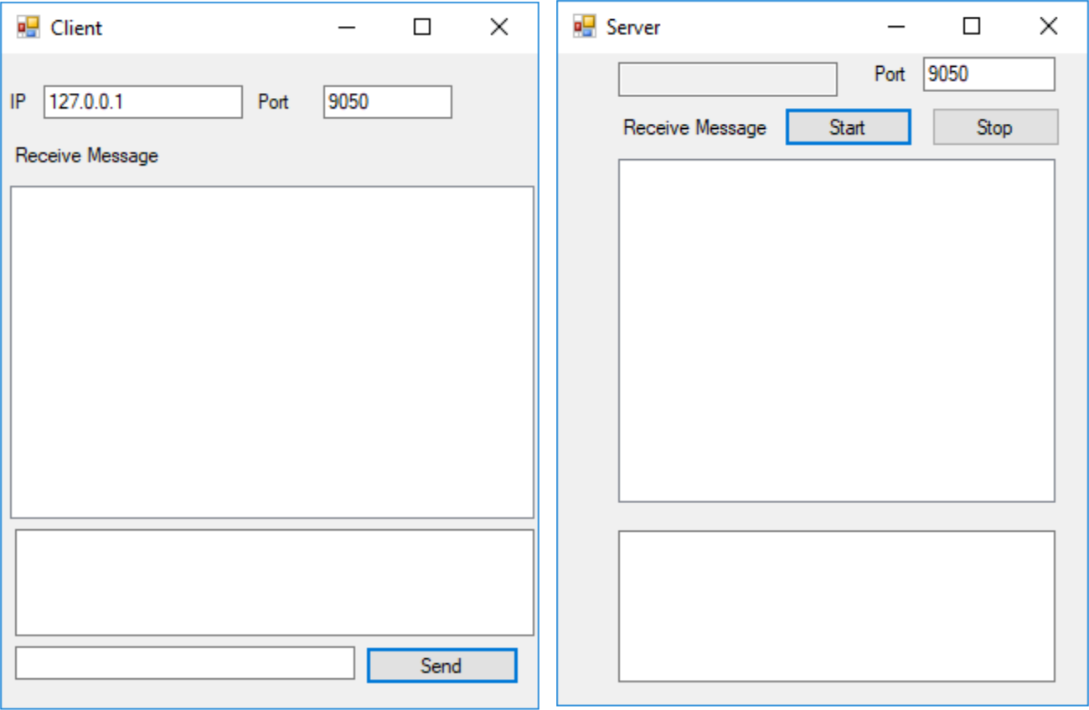
}
UDP_MSG
SERVER
using System;

using System.Collections.Generic; using System.ComponentModel; using System.Data; using System.Drawing;

using System.Linq;
using System.Text;
using System.Windows.Forms;
using System.Net.Sockets;
using System.Threading;
using System.Net;

namespace SrvUDPMSG

{
public partial class Form1 : Form
{
public Form1()
{
InitializeComponent();

}

delegate void ShowMessage(String Message);

public void Show(string Message)
{

if (lstReceive.InvokeRequired)
{

ShowMessage message = new ShowMessage(Show); lstReceive.Invoke(message, new object[]
{Message});
return;
}

lstReceive.Items.Add(Message);
}

public void ShowIP(string Message)

{
if (txtIP.InvokeRequired)
{

ShowMessage message = new ShowMessage(ShowIP); txtIP.Invoke(message, new object[] { Message }); return;

}
txtIP.Text = Message;

}

public string Process(string Message)
{

return Message.Trim();
}
public void ListenMessage()
{
try
{

- Khởi tạo UdpClient lắng nghe tại cổng chỉ định
- UdpClient udpClient = new

UdpClient(int.Parse(txtPort.Text));
while (true)
{
IPEndPoint remote = new

IPEndPoint(IPAddress.Any, 0); ShowIP(remote.Address.ToString());

Byte[] receiveBytes = udpClient.Receive(ref remote);
// Chuyển đổi mảng Byte thành chuỗi Unicode để xử lý
string data =

Encoding.Unicode.GetString(receiveBytes);
string msg = " Thông điệp nhận từ -> " +
remote.Address.ToString() + " : " + data.ToString();
Show(msg);
data = Process(data);
Byte[] sendBytes = Encoding.Unicode.GetBytes(data);

udpClient.Send(sendBytes, sendBytes.Length, remote);
msg = " Gởi tới -> " + remote.Address.ToString() + " : " + data.ToString();

Show(msg);

}
}
catch (Exception exc)
{

MessageBox.Show(" Không thể khởi động máy chủ ! \n" + exc.ToString());

}
}

private void btnStart_Click(object sender, EventArgs e)
{
lstReceive.Items.Clear();

new Thread(new ThreadStart(ListenMessage)).Start(); lstReceive.Items.Add("Đang lắng nghe ... ");

}
private void lstReceive_SelectedIndexChanged(object sender, EventArgs e)

{
if (lstReceive.SelectedItem != null)
txtResult.Text = lstReceive.SelectedItem.ToString();
}

}
}
CLIENT
using System;

using System.Collections.Generic; using System.ComponentModel; using System.Data; using System.Drawing;

using System.Linq;
using System.Text;
using System.Windows.Forms;
using System.Net.Sockets;
using System.Net;

namespace ClientUDPMSG

{
public partial class Form1 : Form
{
public Form1()
{
InitializeComponent();

}
public delegate void ShowMessage(string Message);

public void Show(string Message)
{
if (lstReceive.InvokeRequired)

{

ShowMessage message = new ShowMessage(Show); lstReceive.Invoke(message, new object[] { Message});
return;
}
lstReceive.Items.Add(Message);

}

private void btnSend_Click(object sender, EventArgs e)
{

if (txtIP.Text.Trim().Length == 0)
MessageBox.Show("Vui lòng nhập vào địa chỉ IP!");

else
{
UdpClient udpClient = new UdpClient();

udpClient.Connect(txtIP.Text, int.Parse(txtPort.Text));

if (txtMessage.Text.Trim().Length == 0) txtMessage.Text = "Bạn hãy nhập vào thôngđiệp ...";
else
{
Byte[] sendBytes =

Encoding.Unicode.GetBytes(txtMessage.Text); udpClient.Send(sendBytes, sendBytes.Length);
IPEndPoint remote = new

IPEndPoint(IPAddress.Parse(txtIP.Text), int.Parse(txtPort.Text));
Byte[] receivedBytes = udpClient.Receive(ref remote);
string message = Encoding.Unicode.GetString(receivedBytes);
Show("Nhận thông điệp từ -> " + remote.Address.ToString() + " : " + message);
txtMessage.Text = "";

}
}
}

private void txtMessage_KeyPress(object sender,KeyPressEventArgse)

{
if (e.KeyChar == (char)13)
btnSend_Click(sender, e);
}

private void lstReceive_SelectedIndexChanged(object sender,
EventArgs e)

{
if (lstReceive.SelectedItem != null)
txtResult.Text = lstReceive.SelectedItem.ToString();
}

}
}

CHƯƠNG 4
CHUONG4_bai1: TCPClientSample
using System;
using System.Net;
using System.Net.Sockets;
using System.Text;
class TcpClientSample

{
public static void Main()
{
byte[] data = new byte[1024];
string input, stringData;

TcpClient server;
try

{
server = new TcpClient("127.0.0.1", 9050);
} catch (SocketException)

{

Console.WriteLine("Unable to connect to server"); return;

}

NetworkStream ns = server.GetStream(); int recv = ns.Read(data, 0, data.Length);

stringData = Encoding.ASCII.GetString(data, 0, recv); Console.WriteLine(stringData);

while(true)
{

input = Console.ReadLine(); if (input == "exit")

break; ns.Write(Encoding.ASCII.GetBytes(input), 0, input.Length); ns.Flush();

data = new byte[1024];
recv = ns.Read(data, 0, data.Length);

stringData = Encoding.ASCII.GetString(data, 0, recv); Console.WriteLine(stringData);
}

Console.WriteLine("Disconnecting from server..."); ns.Close();

server.Close();
}
}

TCPListener_Sample(Server)
using System;
using System.Net;
using System.Net.Sockets;
using System.Text;
class TcpListenerSample

{
public static void Main()
{
int recv;
byte[] data = new byte[1024];

TcpListener newsock = new TcpListener(9050);
newsock.Start();

Console.WriteLine("Waiting for a client...");
TcpClient client = newsock.AcceptTcpClient();
NetworkStream ns = client.GetStream();

string welcome = "Welcome to my test server";
data = Encoding.ASCII.GetBytes(welcome);
ns.Write(data, 0, data.Length);
while(true)
{

data = new byte[1024];
recv = ns.Read(data, 0, data.Length);
if (recv == 0)
break;

Console.WriteLine(

Encoding.ASCII.GetString(data, 0, recv));

ns.Write(data, 0, recv);
}
ns.Close();

client.Close();
newsock.Stop();
}
}
Bai3 BinaryUDPServer
using System;
using System.Net;
using System.Net.Sockets;
using System.Text;
class BinaryUdpSrvr

{
public static void Main()
{
byte[] data = new byte[1024];
IPEndPoint ipep = new IPEndPoint(IPAddress.Any, 9050);

UdpClient newsock = new UdpClient(ipep);
Console.WriteLine("Waiting for a client...");

IPEndPoint sender = new IPEndPoint(IPAddress.Any, 0);
data = newsock.Receive(ref sender);

Console.WriteLine("Message received from {0}:", sender.ToString());

Console.WriteLine(Encoding.ASCII.GetString(data, 0, data.Length));

string welcome = "Welcome to my test server"; data = Encoding.ASCII.GetBytes(welcome); newsock.Send(data, data.Length, sender); byte[] data1 = newsock.Receive(ref sender); int test1 = BitConverter.ToInt32(data1, 0); Console.WriteLine("test1 = {0}", test1); byte[] data2 = newsock.Receive(ref sender); double test2 = BitConverter.ToDouble(data2, 0); Console.WriteLine("test2 = {0}", test2); byte[] data3 = newsock.Receive(ref sender); int test3 = BitConverter.ToInt32(data3, 0); Console.WriteLine("test3 = {0}", test3); byte[] data4 = newsock.Receive(ref sender); bool test4 = BitConverter.ToBoolean(data4, 0); Console.WriteLine("test4 = {0}", test4.ToString()); byte[] data5 = newsock.Receive(ref sender); string test5 = Encoding.ASCII.GetString(data5); Console.WriteLine("test5 = {0}", test5); newsock.Close();

}
}
BinaryUDPClient
using System;

using System.Net;
using System.Net.Sockets;
using System.Text;

class BinaryUdpClient
{
public static void Main()
{
byte[] data = new byte[1024];

string stringData;

UdpClient server = new UdpClient("127.0.0.1", 9050); IPEndPoint sender = new IPEndPoint(IPAddress.Any, 0);

string welcome = "Hello, are you there?"; data = Encoding.ASCII.GetBytes(welcome); server.Send(data, data.Length);
data = new byte[1024];
data = server.Receive(ref sender);

Console.WriteLine("Message received from {0}:", sender.ToString()); stringData = Encoding.ASCII.GetString(data, 0, data.Length); Console.WriteLine(stringData);

int test1 = 45;
double test2 = 3.14159;
int test3 = -1234567890;

bool test4 = false;
string test5 = "This is a test.";

byte[] data1 = BitConverter.GetBytes(test1); server.Send(data1, data1.Length);

byte[] data2 = BitConverter.GetBytes(test2); server.Send(data2, data2.Length);

byte[] data3 = BitConverter.GetBytes(test3); server.Send(data3, data3.Length);

byte[] data4 = BitConverter.GetBytes(test4); server.Send(data4, data4.Length);

byte[] data5 = Encoding.ASCII.GetBytes(test5); server.Send(data5, data5.Length); Console.WriteLine("Stopping client"); server.Close();
}

}

BinaryUDPDataTest

using System;
using System.Net;
using System.Text;
class BinaryDataTest
{
public static void Main()
{

int test1 = 45;
double test2 = 3.14159;
int test3 = -1234567890;
bool test4 = false;
byte[] data = new byte[1024];

string output;
data = BitConverter.GetBytes(test1);

output = BitConverter.ToString(data);
Console.WriteLine("test1 = {0}, string = {1}", test1, output);
data = BitConverter.GetBytes(test2);

output = BitConverter.ToString(data);

Console.WriteLine("test2 = {0}, string = {1}", test2, output); data = BitConverter.GetBytes(test3);
output = BitConverter.ToString(data);

Console.WriteLine("test3 = {0}, string = {1}", test3, output); data = BitConverter.GetBytes(test4);
output = BitConverter.ToString(data);

Console.WriteLine("test4 = {0}, string = {1}", test4, output);
}

}

Bai BinaryNetworkByteOrder

using System;
using System.Net;
using System.Text;
class BinaryNetworkByteOrder
{

public static void Main()
{
short test1 = 45;
int test2 = 314159;
long test3 = -123456789033452;

byte[] data = new byte[1024];
string output;

data = BitConverter.GetBytes(test1);
output = BitConverter.ToString(data);

Console.WriteLine("test1 = {0}, string = {1}", test1, output);

data = BitConverter.GetBytes(test2);
output = BitConverter.ToString(data);

Console.WriteLine("test2 = {0}, string = {1}", test2, output); data = BitConverter.GetBytes(test3); output = BitConverter.ToString(data);

Console.WriteLine("test3 = {0}, string = {1}", test3, output); short test1b = IPAddress.HostToNetworkOrder(test1);

data = BitConverter.GetBytes(test1b); output = BitConverter.ToString(data); Console.WriteLine("test1 = {0}, nbo = {1}", test1b, output); int test2b = IPAddress.HostToNetworkOrder(test2);

data = BitConverter.GetBytes(test2b); output = BitConverter.ToString(data); Console.WriteLine("test2 = {0}, nbo = {1}", test2b, output); long test3b = IPAddress.HostToNetworkOrder(test3);

data = BitConverter.GetBytes(test3b); output = BitConverter.ToString(data); Console.WriteLine("test3 = {0}, nbo = {1}", test3b, output);
}
}

NetworkOrderClient

using System;

using System.Net;
using System.Net.Sockets;
using System.Text;
class NetworkOrderClient
{

public static void Main()
{
byte[] data = new byte[1024];
string stringData;
TcpClient server;

try
{

server = new TcpClient("127.0.0.1", 9050);
} catch (SocketException)
{

Console.WriteLine("Unable to connect to server"); return;

}

NetworkStream ns = server.GetStream(); int recv = ns.Read(data, 0, data.Length);

stringData = Encoding.ASCII.GetString(data, 0, recv); Console.WriteLine(stringData);

short test1 = 45; int test2 = 314159;
long test3 = -123456789033452;

short test1b = IPAddress.HostToNetworkOrder(test1); data = BitConverter.GetBytes(test1b); Console.WriteLine("sending test1 = {0}", test1); ns.Write(data, 0, data.Length);
ns.Flush();

int test2b = IPAddress.HostToNetworkOrder(test2); data = BitConverter.GetBytes(test2b); Console.WriteLine("sending test2 = {0}", test2); ns.Write(data, 0, data.Length);
ns.Flush();

long test3b = IPAddress.HostToNetworkOrder(test3); data = BitConverter.GetBytes(test3b); Console.WriteLine("sending test3 = {0}", test3); ns.Write(data, 0, data.Length);
ns.Flush();
ns.Close();
server.Close();
}
}

NetworkOrderSrvr

using System;

using System.Net;
using System.Net.Sockets;
using System.Text;

class NetworkOrderSrvr
{
public static void Main()
{
int recv;

byte[] data = new byte[1024];
TcpListener server = new TcpListener(9050);

server.Start();
Console.WriteLine("waiting for a client...");
TcpClient client = server.AcceptTcpClient();

NetworkStream ns = client.GetStream();
string welcome = "Welcome to my test server";
data = Encoding.ASCII.GetBytes(welcome);
ns.Write(data, 0, data.Length);
ns.Flush();

data = new byte[2];
recv = ns.Read(data, 0, data.Length);

short test1t = BitConverter.ToInt16(data, 0);

short test1 = IPAddress.NetworkToHostOrder(test1t); Console.WriteLine("received test1 = {0}", test1); data = new byte[4];
recv = ns.Read(data, 0, data.Length);
int test2t = BitConverter.ToInt32(data, 0);

int test2 = IPAddress.NetworkToHostOrder(test2t); Console.WriteLine("received test2 = {0}", test2); data = new byte[8];
recv = ns.Read(data, 0, data.Length);
long test3t = BitConverter.ToInt64(data, 0);
long test3 = IPAddress.NetworkToHostOrder(test3t);

Console.WriteLine("received test3 = {0}", test3);
ns.Close();
client.Close();
server.Stop();
}

}

Control_Server

using System;
using System.Collections.Generic;

using System.ComponentModel;

using System.Data;
using System.Drawing;

using System.Linq;

using System.Text;

using System.Windows.Forms;
using System.Net;

using System.Net.Sockets;

using System.Threading;
using System.IO;

namespace ControlSrv

{
public partial class Form1 : Form

{

const int PORT = 9050;

const int BUFF = 10000;
TcpClient client;

TcpListener listener;

Thread listenThread;
byte[] readbuff = new byte[BUFF];

public Form1()

{
InitializeComponent();

}

void SendData(string data)

{

lock (client.GetStream())

{

StreamWriter sw = new StreamWriter(client.GetStream()); sw.Write(data + (char)13 + (char)10); sw.Flush();
}

}

void ProcessList(string Flag)
{

string list = "";

System.Diagnostics.Process[] pr;

pr = System.Diagnostics.Process.GetProcesses(); foreach (System.Diagnostics.Process p in pr) {

if (p.MainWindowTitle.Length > 0)
list += " -" + p.MainWindowTitle + (char)13;

}

SendData("THONGBAO+" + Flag + "+" + list);
}

private void ProcessCommand(string data)

{

string[] DataArr;
DataArr = data.Split('+');

switch (DataArr[0])

{
case "SHUTDOWN":

{

if (DataArr[1] == "YES")
{

if (DataArr[2].Trim('\0') == "OK")
{

System.Diagnostics.Process.Start("shutdown", "-s -f -t0");
break;

}

ProcessList("SHUTDOWN-F");

break;
}

else

{
if (DataArr[2].Trim('\0') == "OK")

{

System.Diagnostics.Process.Start("shutdown", "-s -t 0"); break;

}

ProcessList("SHUTDOWN");

break;
}

}

case "LOCK":

{

if (DataArr[2].Trim('\0') == "OK")
{

System.Diagnostics.Process.Start(@"C:\Windows\System32\rundll32.exe", "user32.dll,LockWorkStation");

break;

}

ProcessList("LOCK");
break;

}
}

}
void DoRead(IAsyncResult ar)

{

int byteRead;

string message;
try

{

lock (client.GetStream())
{

byteRead = client.GetStream().EndRead(ar);

}

message = Encoding.ASCII.GetString(readbuff, 0, byteRead - 1); ProcessCommand(message);

lock (client.GetStream())

{

client.GetStream().BeginRead(readbuff, 0, BUFF,
new AsyncCallback(DoRead),null);

}
}

catch (Exception e)

{

}
}

void DoListen()

{

listener = new TcpListener(IPAddress.Any, PORT); listener.Start();

client = listener.AcceptTcpClient();

this.Invoke((MethodInvoker)delegate()
{

lbStatus.Text = "Client Connected!";

});

client.GetStream().BeginRead(readbuff, 0, BUFF, new AsyncCallback(DoRead),

null);

}

private void btListen_Click(object sender, EventArgs e)

{

listenThread = new Thread(DoListen);
listenThread.Start();

lbStatus.Text = "Waiting for client to connect!"; btListen.Enabled = false;
}

}

}
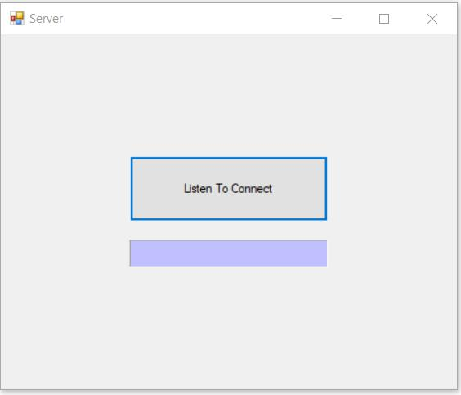

Control_Client
using System;

using System.Collections.Generic;
using System.ComponentModel;

using System.Data;

using System.Drawing;
using System.Linq;

using System.Text;

using System.Windows.Forms;

using System.Net;

using System.Net.Sockets;

using System.IO;
namespace ControlClient

{

public partial class Form1 : Form
{

const int PORT = 9050;

const int BUFF = 10000;
TcpClient client;

byte[] readbuff = new byte[BUFF];

public Form1()
{

InitializeComponent();

}

void SendData(string data)

{
lock (client.GetStream())

{

StreamWriter sw = new StreamWriter(client.GetStream());

sw.Write(data + (char)13);
sw.Flush();

}

}

private void ProcessCommand(string message)

{
string[] DataArr;

DataArr = message.Split('+');

switch (DataArr[0])
{

case "THONGBAO":

{

if (MessageBox.Show("Programs : \r" + DataArr[2] + "is running on server. Continue ?", "Warning", MessageBoxButtons.YesNo, MessageBoxIcon.Question) != DialogResult.No)

{
if (DataArr[1] == "SHUTDOWN-F")

SendData("SHUTDOWN+YES+OK");

if (DataArr[1] == "SHUTDOWN")
SendData("SHUTDOWN+NO+OK");

if (DataArr[1] == "RESTART-F")

SendData("RESTART+YES+OK");

if (DataArr[1] == "RESTART")
SendData("RESTART+NO+OK");

if (DataArr[1] == "LOCK")

SendData("LOCK+NO+OK");
if (DataArr[1] == "LOGOFF")

SendData("LOGOFF+NO+OK");

}
break;

}

}
}

void DoRead(IAsyncResult ar)

{

int byteRead;
string message;

try

{
byteRead = client.GetStream().EndRead(ar);

if (byteRead < 1)

{

return;
}

message = Encoding.ASCII.GetString(readbuff, 0, byteRead - 2);

ProcessCommand(message);
client.GetStream().BeginRead(readbuff, 0, BUFF,
new AsyncCallback(DoRead), null);

}
catch (Exception e)

{

}

}

private void btConnect_Click(object sender, EventArgs e)

{
if (txtIP.Text == "")

{

MessageBox.Show("Input IP Address Please");
return;

}

try
{

client = new TcpClient(txtIP.Text, PORT); client.GetStream().BeginRead(readbuff, 0, BUFF,
new AsyncCallback(DoRead), null);
MessageBox.Show("Sucessful!");

btConnect.Enabled = false;

}
catch

{

MessageBox.Show("Can not connect to server!"); this.Dispose();

}

}

private void btLock_Click(object sender, EventArgs e)

{

if (client == null)
{

MessageBox.Show("First, connect to server!");

}
else

SendData("LOCK+YES+");

}

private void btLogoff_Click(object sender, EventArgs e)

{

if (client == null)
{

MessageBox.Show("First, connect to server !");

}
else

SendData("LOGOFF+YES+");

}

private void btRestart_Click(object sender, EventArgs e)

{
if (client == null)

{
MessageBox.Show("First, connect to server");

}
else

{

if (checkBox1.Checked == true)
{

SendData("RESTART+YES+");

}

else
{

SendData("RESTART+NO+");

}
}

}

private void btShutdown_Click(object sender, EventArgs e)

{

if (client == null)
{

MessageBox.Show("First, connect to server!");

}

else
{

if (checkBox1.Checked == true)

{
SendData("SHUTDOWN+YES+");

}

else
{

SendData("SHUTDOWN+NO+");

}

}
}

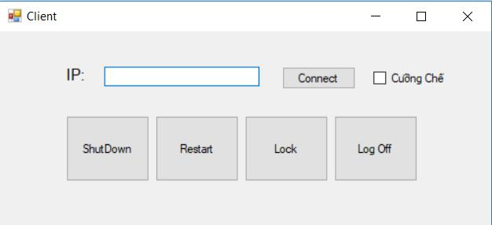
}

CHƯƠNG 5: TCP_Async

Server

using System;

using System.Net;

using System.Net.Sockets;

using System.Collections.Generic;

using System.ComponentModel;

using System.Data;

using System.Drawing;

using System.Linq;

using System.Text;

using System.Windows.Forms;

namespace AcSyncTcpSrv

{

public partial class Form1 : Form

{

private byte[] data = new byte[1024];

private int size = 1024;

private Socket server;

public Form1()

{

InitializeComponent();

server = new Socket(AddressFamily.InterNetwork, SocketType.Stream, ProtocolType.Tcp);

IPEndPoint iep = new IPEndPoint(IPAddress.Any, 9050);
server.Bind(iep);

server.Listen(5);

server.BeginAccept(new AsyncCallback(AcceptConn), server);

}

private void btnStop_Click(object sender, EventArgs e)

{

Close();

}

void AcceptConn(IAsyncResult iar)

{

Socket oldserver = (Socket)iar.AsyncState;

Socket client = oldserver.EndAccept(iar);

conStatus.Text = "Connected to: " + client.RemoteEndPoint.ToString(); string stringData = "Welcome to my server";

byte[] message1 = Encoding.ASCII.GetBytes(stringData); client.BeginSend(message1, 0, message1.Length, SocketFlags.None,

new AsyncCallback(SendData), client);

}

void SendData(IAsyncResult iar)

{

Socket client = (Socket)iar.AsyncState; int sent = client.EndSend(iar); client.BeginReceive(data, 0, size, SocketFlags.None,

new AsyncCallback(ReceiveData), client);
}

void ReceiveData(IAsyncResult iar)

{

Socket client = (Socket)iar.AsyncState;

int recv = client.EndReceive(iar);

if (recv == 0)

{

client.Close();

conStatus.Text = "Waiting for client..."; server.BeginAccept(new AsyncCallback(AcceptConn), server); return;

}

string receivedData = Encoding.ASCII.GetString(data, 0, recv); results.Items.Add(receivedData);

byte[] message2 = Encoding.ASCII.GetBytes(receivedData); client.BeginSend(message2, 0, message2.Length, SocketFlags.None,

new AsyncCallback(SendData), client);

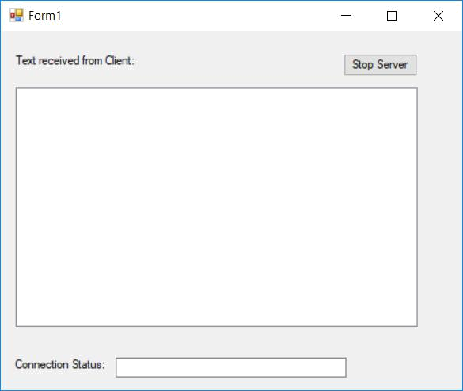
}

}

}

CLIENT

using System;

using System.Collections.Generic;

using System.ComponentModel;

using System.Data;

using System.Drawing;

using System.Linq;

using System.Text;

using System.Windows.Forms;

using System.Net.Sockets;

using System.Net;

namespace AcsyncTcpClients

{

public partial class Form1 : Form

{

private Socket client;

private byte[] data = new byte[1024];

private int size = 1024;

public Form1()

{

InitializeComponent();

}

private void btnConnect_Click(object sender, EventArgs e)

{

conStatus.Text = "Connecting...";

Socket newsock = new Socket(AddressFamily.InterNetwork, SocketType.Stream, ProtocolType.Tcp);

IPEndPoint iep = new IPEndPoint(IPAddress.Parse("127.0.0.1"), 9050); newsock.BeginConnect(iep, new AsyncCallback(Connected), newsock);
}

private void btnSend_Click(object sender, EventArgs e)

{

byte[] message = Encoding.ASCII.GetBytes(newText.Text); newText.Clear();

client.BeginSend(message, 0, message.Length, SocketFlags.None, new AsyncCallback(SendData), client);
}

private void btnDisconnect_Click(object sender, EventArgs e)

{

client.Close();

conStatus.Text = "Disconnected";

}

void Connected(IAsyncResult iar)

{

client = (Socket)iar.AsyncState;

try

{

client.EndConnect(iar);

conStatus.Text = "Connected to: " + client.RemoteEndPoint.ToString(); client.BeginReceive(data, 0, size, SocketFlags.None,
new AsyncCallback(ReceiveData), client);

}

catch (SocketException)

{

MessageBox.Show("Không thể kết nối đến Server"); conStatus.Text = "Error connecting";
}

}

void ReceiveData(IAsyncResult iar)

{

Socket remote = (Socket)iar.AsyncState;

int recv = remote.EndReceive(iar);

string stringData = Encoding.ASCII.GetString(data, 0, recv); results.Items.Add(stringData);

}

void SendData(IAsyncResult iar)

{

Socket remote = (Socket)iar.AsyncState; int sent = remote.EndSend(iar); remote.BeginReceive(data, 0, size, SocketFlags.None,

new AsyncCallback(ReceiveData), remote);

}

}

}

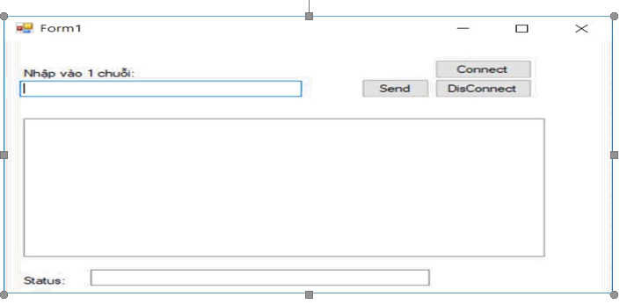

BAI : ThreadTCP

- Bài tập 1 – Chương 5

using System;

using System.Net;

using System.Net.Sockets;

using System.Text;

using System.Threading;

class ThreadedTcpSrvr

{

private TcpListener client;

public ThreadedTcpSrvr()

{

client = new TcpListener(9050);

client.Start();

Console.WriteLine("Waiting for clients...");

while(true)

{

while (!client.Pending())

{

Thread.Sleep(1000);

}

ConnectionThread newconnection = new ConnectionThread(); newconnection.threadListener = this.client;

Thread newthread = new Thread(new ThreadStart(newconnection.HandleConnection));

newthread.Start();

}

}
public static void Main()

{

ThreadedTcpSrvr server = new ThreadedTcpSrvr();

}

}

class ConnectionThread

{

public TcpListener threadListener;

private static int connections = 0;

public void HandleConnection()

{

int recv;

byte[] data = new byte[1024];

TcpClient client = threadListener.AcceptTcpClient(); NetworkStream ns = client.GetStream(); connections++;

Console.WriteLine("New client accepted: {0} active connections", connections);

string welcome = "Welcome to my test server"; data = Encoding.ASCII.GetBytes(welcome); ns.Write(data, 0, data.Length); while(true)

{

data = new byte[1024];

recv = ns.Read(data, 0, data.Length);

if (recv == 0)

break;

ns.Write(data, 0, recv);

}

ns.Close();

client.Close();

connections--;

Console.WriteLine("Client disconnected: {0} active connections",

connections);

}

}

Client:

using System;

using System.Collections.Generic;

using System.ComponentModel;

using System.Data;

using System.Drawing;

using System.Linq;

using System.Text;

using System.Windows.Forms;

using System.Net;

using System.Net.Sockets;

using System.Threading;

namespace _9._7TCPChat

{

public partial class TcpChat : Form

{

private static Socket client;

private static byte[] data = new byte[1024];

public TcpChat()

{
InitializeComponent();

}

private void ButtonConnect_Click(object sender, EventArgs e)

{

results.Items.Add("Connecting...");

client = new Socket(AddressFamily.InterNetwork, SocketType.Stream, ProtocolType.Tcp);

IPEndPoint iep = new IPEndPoint(IPAddress.Parse("127.0.0.1"), 9050); client.BeginConnect(iep, new AsyncCallback(Connected), client);
}

private void ButtonListen_Click(object sender, EventArgs e)

{

results.Items.Add("Listening for a client...");

Socket newsock = new Socket(AddressFamily.InterNetwork, SocketType.Stream, ProtocolType.Tcp);

IPEndPoint iep = new IPEndPoint(IPAddress.Any, 9050);

newsock.Bind(iep);

newsock.Listen(5);
newsock.BeginAccept(new AsyncCallback(AcceptConn), newsock);
}

private void ButtonSend_Click(object sender, EventArgs e)

{

byte[] message = Encoding.ASCII.GetBytes(newText.Text); newText.Clear();

client.BeginSend(message, 0, message.Length, 0, new AsyncCallback(SendData), client);

}

void SendData(IAsyncResult iar)

{

Socket remote = (Socket)iar.AsyncState;

int sent = remote.EndSend(iar);

}

void AcceptConn(IAsyncResult iar)

{

Socket oldserver = (Socket)iar.AsyncState;

client = oldserver.EndAccept(iar);

results.Items.Add("Connection from: " + client.RemoteEndPoint.ToString()); Thread receiver = new Thread(new ThreadStart(ReceiveData)); receiver.Start();

}

void Connected(IAsyncResult iar)

{

try

{

client.EndConnect(iar);

results.Items.Add("Connected to: " + client.RemoteEndPoint.ToString()); Thread receiver = new Thread(new ThreadStart(ReceiveData)); receiver.Start();

}

catch (SocketException)

{

results.Items.Add("Error connecting");

}

}

void ReceiveData()

{

int recv;

string stringData;

while (true)

{

recv = client.Receive(data);

stringData = Encoding.ASCII.GetString(data, 0, recv); if (stringData == "bye")

break;

results.Items.Add(stringData);

}

stringData = "bye";

byte[] message = Encoding.ASCII.GetBytes(stringData);

client.Send(message);

client.Close();

results.Items.Add("Connection stopped");

return;

}

private void TCPChat_KeyPress(object sender, KeyPressEventArgs e)

{

if (e.KeyChar == 13)

ButtonSend_Click(sender, e);

}

}
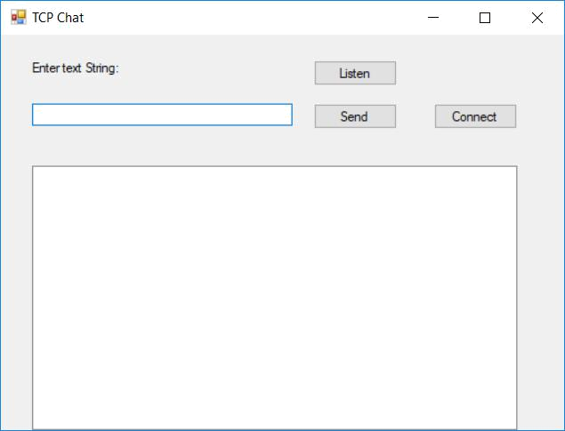
}

BAI: NETWORK_STREAM

using System;

using System.Collections.Generic; using System.Linq; using System.Text;

using System.IO;
using System.Net;
using System.Net.Sockets;

class StreamTcpSrvr
{

public static void Main()
{

string data;

IPEndPoint ipep = new IPEndPoint(IPAddress.Any, 9050); Socket newsock = new Socket(AddressFamily.InterNetwork,

SocketType.Stream, ProtocolType.Tcp);
newsock.Bind(ipep);

newsock.Listen(10);
Console.WriteLine("Waiting for a client...");
Socket client = newsock.Accept();

IPEndPoint newclient = (IPEndPoint)client.RemoteEndPoint; Console.WriteLine("Connected with {0} at port {1}",
newclient.Address, newclient.Port);

NetworkStream ns = new NetworkStream(client);
StreamReader sr = new StreamReader(ns);
StreamWriter sw = new StreamWriter(ns);
string welcome = "Welcome to my test server";
sw.WriteLine(welcome);
sw.Flush();
while (true)

{
try
{
data = sr.ReadLine();

}
catch (IOException)
{

break;
}

Console.WriteLine(data);
sw.WriteLine(data);

sw.Flush();
}

Console.WriteLine("Disconnected from {0}", newclient.Address);

sw.Close();
sr.Close();
ns.Close();
}
}
Client
using System;

using System.Collections.Generic; using System.Linq; using System.Text;

using System.IO;
using System.Net;
using System.Net.Sockets;

class StreamTcpClient
{
public static void Main()

{
string data;

string input;
IPEndPoint ipep = new
IPEndPoint(IPAddress.Parse("127.0.0.1"), 9050);

Socket server = new Socket(AddressFamily.InterNetwork, SocketType.Stream, ProtocolType.Tcp);

try
{
server.Connect(ipep);
}
catch (SocketException e)
{

Console.WriteLine("Unable to connect to server."); Console.WriteLine(e.ToString());

return;
}

NetworkStream ns = new NetworkStream(server); StreamReader sr = new StreamReader(ns); StreamWriter sw = new StreamWriter(ns); data = sr.ReadLine();

Console.WriteLine(data);
while (true)
{
input = Console.ReadLine();

if (input == "exit")
break;
sw.WriteLine(input);
sw.Flush();
data = sr.ReadLine();
Console.WriteLine(data);

}
Console.WriteLine("Disconnecting from server...");

sr.Close();
sw.Close();
ns.Close();

server.Shutdown(SocketShutdown.Both); server.Close();

}
}

BAI: ServerFile (Không có form)
using System;

using System.Collections.Generic; using System.ComponentModel; using System.Data; using System.Drawing;

using System.Linq;
using System.Text;
using System.Windows.Forms;
using System.Net;
using System.Net.Sockets;
using System.IO;

using System.Collections;

namespace Server
{
public partial class WindowServer : Form
{

private byte[] data = new byte[1024*1024];
private int size = 1024*1024;
private Socket server;

private int count=0;

public WindowServer()
{

InitializeComponent();
}
private void WindowServer_Load(object sender, EventArgs e)
{

}
private void cbChoose_CheckedChanged(object sender, EventArgs e)

{
if (cbChoose.CheckState == CheckState.Checked)
{

txtIP.Enabled = false;
txtPort.Enabled = false;
}
else

{

txtIP.Enabled = true;
txtPort.Enabled = true;
}
}

//Sự kiện nhấn nút Start Listening
private void btConn_Click(object sender, EventArgs e)
{

server = new Socket(AddressFamily.InterNetwork, SocketType.Stream, ProtocolType.Tcp);

if (cbChoose.Checked)

{
IPEndPoint iep = new IPEndPoint(IPAddress.Any, 9050); server.Bind(iep);

}
else

{
if (txtIP.Text == "" || txtPort.Text == "")
MessageBox.Show("Input your address first!");
else
{

IPAddress ip = IPAddress.Parse(txtIP.Text);

IPEndPoint iep = new IPEndPoint(ip, Convert.ToInt32(txtPort.Text));

erver.Bind(iep);
}
}
txtStatus.Text = "Waiting for client..."; server.Listen(5);

server.BeginAccept(new AsyncCallback(AcceptConn), server); //Bắt đầu việc chấp nhận kết nối từ client

}
void AcceptConn(IAsyncResult iar)

{
lbCount.Text = "";
Socket oldserver = (Socket)iar.AsyncState;

Socket client = oldserver.EndAccept(iar); //Kết thúc việc kết nối

count++;

server.BeginAccept(new AsyncCallback(AcceptConn), oldserver);
//Chấp nhận kết nối nếu có thêm client yêu cầu

lbCount.Text = Convert.ToString(count); txtStatus.Text = "Server is connecting to client...";
string stringData = "Welcome to my server";
byte[] message1 = Encoding.ASCII.GetBytes(stringData);

client.BeginSend(message1, 0, message1.Length, SocketFlags.None,

new AsyncCallback(SendData), client); //Gửi thông điệp chào mừng tới client

}
//Hàm gửi dữ liệu
void SendData(IAsyncResult iar)
{

Socket client = (Socket)iar.AsyncState;
int sent = client.EndSend(iar); //Kết thúc việc gửi dữ liệu

client.BeginReceive(data, 0, size, SocketFlags.None, new AsyncCallback(ReceiveData), client);
//Bắt đầu nhận dữ liệu từ socket

}
//Hàm nhận dữ liệu từ client gửi đến
void ReceiveData(IAsyncResult iar)
{
Socket client = (Socket)iar.AsyncState;
int recv = client.EndReceive(iar); //Kết thúc nhận dữ liệu
if (recv == 0)

{
client.Close();
count--;

if (count <= 0)
{
txtStatus.Text = "Waiting for client...";
}

lbCount.Text= Convert.ToString(count);
server.BeginAccept(new AsyncCallback(AcceptConn), server); //Chấp nhận kết nối mới đến server
return;

}
string receivedData = (Encoding.ASCII.GetString(data, 0, recv));

string recvData = receivedData.Replace(" ", "");
if (File.Exists(recvData) && recvData != "")
{
StreamReader SRD = new StreamReader(recvData);
string mess = SRD.ReadToEnd(); //Đọc tất cả nội dung trong file mà client yêu cầu
byte[] message2 = Encoding.ASCII.GetBytes(mess); client.BeginSend(message2, 0,message2.Length, SocketFlags.None,new AsyncCallback(SendData), client); //Bắt đầu việc gửi nội dung văn bản sang client

}
else
{

string mess = "Your path was wrong!\r\n Please re-send your path.";

byte[] message2 =
Encoding.ASCII.GetBytes(mess);
client.BeginSend(message2, 0, message2.Length, SocketFlags.None,
new AsyncCallback(SendData), client);
//Gửi thông điệp yêu cầu client nhập lại đường dẫn

}
}
private void btClose_Click(object sender, EventArgs e)

{
Close();
}

}
}

CLIENT

using System;

using System.Collections.Generic; using System.ComponentModel; using System.Data; using System.Drawing;

using System.Linq;
using System.Text;
using System.Windows.Forms;
using System.Net;
using System.Net.Sockets;
using System.IO;

namespace Client
{
public partial class WindowClient : Form
{
private Socket client;

private const int size =1024*1024; private byte[] data = new byte[size]; public WindowClient() {

InitializeComponent();
}

private void btConnect_Click(object sender, EventArgs e)
{
if (client == null)
{

Socket newsock = new Socket(AddressFamily.InterNetwor,

SocketType.Stream, ProtocolType.Tcp);
if (txtIP.Text == "" || txtPort.Text == "")

MessageBox.Show("Input your address first!");
else
{
IPEndPoint iep = new

IPEndPoint(IPAddress.Parse(txtIP.Text), Convert.ToInt32(txtPort.Text));

newsock.BeginConnect(iep, new

AsyncCallback(Connected), newsock);
//Bắt đầu việc kết nối từ server

}

}
else
{
MessageBox.Show("You are on connection");

}
}
//Hàm kết nối client với server
void Connected(IAsyncResult iar)
{
try

{

client = (Socket)iar.AsyncState; client.EndConnect(iar);
//Kết thúc việc kết nối
txtStatus.Text = "Connected to: " +

client.RemoteEndPoint.ToString(); client.BeginReceive(data, 0, size, SocketFlags.None,

new AsyncCallback(ReceiveData), client); //Bắt đầu nhận dữ liệu từ socket

}
catch (SocketException se)
{
string str;

str = "\nConnection failed, is the server running?\n" + se.Message;

MessageBox.Show(str);
}
}

//Hàm nhận dữ liệu được gửi qua từ server
void ReceiveData(IAsyncResult iar) {

Socket remote = (Socket)iar.AsyncState;

int recv = remote.EndReceive(iar);
//Kết thúc việc nhận dữ liệu
string stringData = Encoding.ASCII.GetString(data, 0,recv);
txtShow.Text = stringData;
//Hiển thị dữ liệu nhận được
}
private void btDisconn_Click(object sender, EventArgs e)

{

if (client != null)
{

client.Close();
client = null;
txtStatus.Text = "no connection";
}
else
{

string noti = "Connect first!";

MessageBox.Show(noti); //Thông báo khi client
được kết nối
}
}

private void btSendStr_Click(object sender, EventArgs e)
{
if (client != null)
{
if (txtDir.Text != "")
{
byte[] message =

Encoding.ASCII.GetBytes(txtDir.Text);
txtDir.Clear();
client.BeginSend(message, 0, message.Length,SocketFlags.None,

new AsyncCallback(SendData), client);
//Bắt đầu gửi dữ liệu từ socket
}
else
{

string noti = "Input your path first."; MessageBox.Show(noti);

}
}

else
{
string noti = "Connect first!";
MessageBox.Show(noti);
}

}

//Hàm gửi dữ liệu đi
void SendData(IAsyncResult iar)

{
try
{
txtShow.Clear();
Socket remote = (Socket)iar.AsyncState;
int sent = remote.EndSend(iar); //EndSend()

remote.BeginReceive(data, 0, size,

SocketFlags.None,

new AsyncCallback(ReceiveData), remote);
//Bắt đầu nhận dữ liệu từ socket

}
catch (SocketException se)
{

MessageBox.Show(se.ToString());
}
}

private void btClose_Click(object sender, EventArgs e)
{

if (client == null)
{
Close();
}
else
{

string noti = "Disconnect first."; MessageBox.Show(noti);

}
}

}

Chương 6-7
- GetProc

using System;
using System.Diagnostics;
class GetProc {
public static void Main()
{
Process thisProc = Process.GetCurrentProcess();
string procName = thisProc.ProcessName;
DateTime started = thisProc.StartTime;
int procID = thisProc.Id;
int memory = thisProc.VirtualMemorySize;
int priMemory = thisProc.PrivateMemorySize;
int physMemory = thisProc.WorkingSet;
int priority = thisProc.BasePriority;
ProcessPriorityClass priClass = thisProc.PriorityClass;
TimeSpan cpuTime = thisProc.TotalProcessorTime;
Console.WriteLine("Process: {0}, ID: {1}", procName, procID);
Console.WriteLine(" started: {0}", started.ToString());
Console.WriteLine(" CPU time: {0}", cpuTime.ToString());
Console.WriteLine( " priority class: {0} priority: {1}", priClass, priority);
Console.WriteLine(" virtual memory: {0}", memory);
Console.WriteLine(" private memory: {0}", priMemory);
Console.WriteLine(" physical memory: {0}", physMemory);
Console.WriteLine("\n trying to change priority...");
thisProc.PriorityClass = ProcessPriorityClass.High; priClass = thisProc.PriorityClass; Console.WriteLine(" new priority class: {0}", priClass); } }

2.ListProc

using System;
using System.Diagnostics;
class ListProcs {
public static void Main() {
int totMemory = 0; Console.WriteLine("Info for all processes:");
Process[] allProcs = Process.GetProcesses();
foreach(Process thisProc in allProcs) {
string procName = thisProc.ProcessName;
DateTime started = thisProc.StartTime;
int procID = thisProc.Id;
int memory = thisProc.VirtualMemorySize;
int priMemory = thisProc.PrivateMemorySize;
int physMemory = thisProc.WorkingSet;
totMemory += physMemory; int priority = thisProc.BasePriority;
TimeSpan cpuTime = thisProc.TotalProcessorTime; Console.WriteLine("Process: {0}, ID: {1}", procName, procID);
Console.WriteLine(" started: {0}", started.ToString());
Console.WriteLine(" CPU time: {0}", cpuTime.ToString());
Console.WriteLine(" virtual memory: {0}", memory); Console.WriteLine(" private memory: {0}", priMemory);
Console.WriteLine(" physical memory: {0}", physMemory); }
Console.WriteLine("\nTotal physical memory used: {0}", totMemory); } }

3.GetThreads

using System;
using System.Diagnostics;
class GetThreads {
public static void Main() {
Process thisProc = Process.GetCurrentProcess();
ProcessThreadCollection myThreads = thisProc.Threads;
foreach(ProcessThread pt in myThreads) {
DateTime startTime = pt.StartTime;
TimeSpan cpuTime = pt.TotalProcessorTime;
int priority = pt.BasePriority; ThreadState ts = pt.ThreadState;
Console.WriteLine("thread: {0}", pt.Id); Console.WriteLine(" started: {0}", startTime.ToString()); Console.WriteLine(" CPU time: {0}", cpuTime); Console.WriteLine(" priority: {0}", priority); Console.WriteLine(" thread state: {0}", ts.ToString()); } } }

4.ListThreads

using System;
using System.Diagnostics;
class ListThreads {
public static void Main() {
Process[] allProcs = Process.GetProcesses();
foreach(Process proc in allProcs) {
ProcessThreadCollection myThreads = proc.Threads;
Console.WriteLine("process: {0}, id: {1}", proc.ProcessName, proc.Id);
foreach(ProcessThread pt in myThreads) {
DateTime startTime = pt.StartTime;
TimeSpan cpuTime = pt.TotalProcessorTime;
int priority = pt.BasePriority;
ThreadState ts = pt.ThreadState;
Console.WriteLine(" thread: {0}", pt.Id); Console.WriteLine(" started: {0}", startTime.ToString()); Console.WriteLine(" CPU time: {0}", cpuTime); Console.WriteLine(" priority: {0}", priority); Console.WriteLine(" thread state: {0}", ts.ToString()); } } }}

5. DelegateEx

using System;
using System.Collections.Generic;
using System.Linq;
using System.Text;
namespace DelegateEx {
public delegate int Calculation(int a, int b);
class Program {
static int Add(int a, int b)
{
return a + b;
}
static int Sub(int a, int b) {
return a - b;
}
static int Calculate(int a, int b, Calculation cal) {
return cal(a, b);
}
static void Main(string[] args) {
int c = Calculate(9, 4, Add);
Console.WriteLine(c);
int d = Calculate(9, 4, Sub);
Console.WriteLine(d);
Console.ReadLine(); } } }

6. DelegateExample2

using System;
using System.Collections.Generic;
using System.Linq; using System.Text;
namespace DelegateExample2 {
public delegate int delCalculation(int So1, int So2);
class Calculation {
public int Cong(int So1, int So2) {
return So1 + So2;
}
public int Tru(int So1, int So2) {
return So1 - So2;
}
static void Main(string[] args) {
Calculation objTinhToan = new Calculation();
delCalculation objDelCong = objTinhToan.Cong;
int KQ_Cong = objDelCong(10, 5);
Console.WriteLine("Cong KQ = {0}", KQ_Cong); delCalculation objDelTru = objTinhToan.Tru;
int KQ_Tru = objDelTru(10, 5);
Console.WriteLine("Tru KQ = {0}", KQ_Tru); Console.ReadKey(); } }}

- ThreadedTcp Server

using System;
using System.Net;
using System.Net.Sockets;
using System.Text;
using System.Threading;
class ThreadedTcpSrvr {
private TcpListener client;
public ThreadedTcpSrvr() {
client = new TcpListener(9050);
client.Start();
Console.WriteLine("Waiting for clients...");
while(true) {
while (!client.Pending()) { Thread.Sleep(1000); }
ConnectionThread newconnection = new ConnectionThread();
newconnection.threadListener = this.client;
Thread newthread = new Thread(new ThreadStart(newconnection.HandleConnection)); newthread.Start();
} }
public static void Main() {
ThreadedTcpSrvr server = new ThreadedTcpSrvr(); } }
class ConnectionThread {
public TcpListener threadListener;
private static int connections = 0;
public void HandleConnection() {
int recv;
byte[] data = new byte[1024];
TcpClient client = threadListener.AcceptTcpClient();
NetworkStream ns = client.GetStream();
connections++; Console.WriteLine("New client accepted: {0} active connections", connections); string welcome = "Welcome to my test server";
data = Encoding.ASCII.GetBytes(welcome);
ns.Write(data, 0, data.Length);
while(true) { data = new byte[1024];
recv = ns.Read(data, 0, data.Length);
if (recv == 0) break;
ns.Write(data, 0, recv);
}
ns.Close();
client.Close();
connections—;
Console.WriteLine("Client disconnected: {0} active connections", connections); } }

8.TCP Chat
using System;
using System.Drawing;
using System.Net;
using System.Net.Sockets; using System.Text;
using System.Threading;
using System.Windows.Forms;
class TcpChatForm {
private static Socket client;
private static byte[] data = new byte[1024];
public TcpChatForm () {
InitializeComponent();
}
void ButtonListenOnClick(object obj, EventArgs ea) {
results.Items.Add("Listening for a client...");
Socket newsock = new Socket(AddressFamily.InterNetwork, SocketType.Stream, ProtocolType.Tcp);
IPEndPoint iep = new IPEndPoint(IPAddress.Any, 9050);
newsock.Bind(iep);
newsock.Listen(5);
newsock.BeginAccept(new AsyncCallback(AcceptConn), newsock);
}
void ButtonConnectOnClick(object obj, EventArgs ea) {
results.Items.Add("Connecting...");
client = new Socket(AddressFamily.InterNetwork, SocketType.Stream, ProtocolType.Tcp); IPEndPoint iep = new IPEndPoint(IPAddress.Parse("127.0.0.1"), 9050);
client.BeginConnect(iep, new AsyncCallback(Connected), client);
}
void ButtonSendOnClick(object obj, EventArgs ea) {
byte[] message = Encoding.ASCII.GetBytes(newText.Text);
newText.Clear();
client.BeginSend(message, 0, message.Length, 0, new AsyncCallback(SendData), client);
}
void AcceptConn(IAsyncResult iar) {
Socket oldserver = (Socket)iar.AsyncState; client = oldserver.EndAccept(iar); results.Items.Add("Connection from: " + client.RemoteEndPoint.ToString());
Thread receiver = new Thread(new ThreadStart(ReceiveData));
receiver.Start();
} void Connected(IAsyncResult iar) {
try {
client.EndConnect(iar);
results.Items.Add("Connected to: " + client.RemoteEndPoint.ToString());
Thread receiver = new Thread(new ThreadStart(ReceiveData));
receiver.Start();
} catch (SocketException) { results.Items.Add("Error connecting"); } }
void SendData(IAsyncResult iar) {
Socket remote = (Socket)iar.AsyncState; int sent = remote.EndSend(iar);
}
void ReceiveData() { int recv; string stringData; while (true) {
recv = client.Receive(data); stringData = Encoding.ASCII.GetString(data, 0, recv);
if (stringData == "bye") break; results.Items.Add(stringData);
}
stringData = "bye";
byte[] message = Encoding.ASCII.GetBytes(stringData);
client.Send(message);
client.Close();
results.Items.Add("Connection stopped");
return; } }
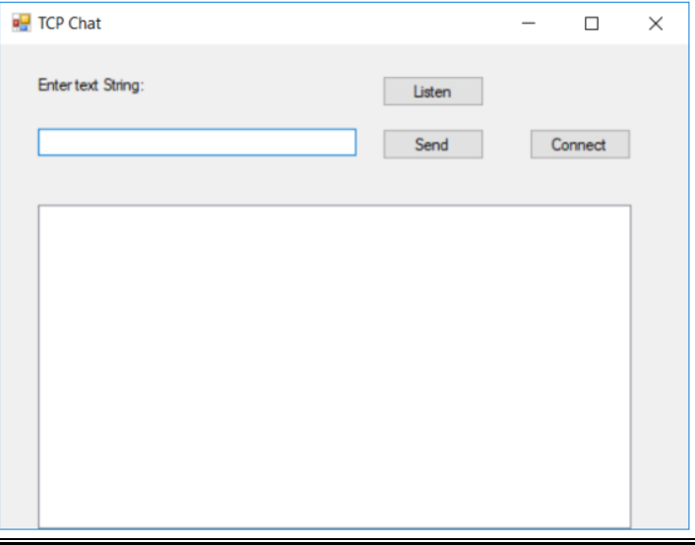
- ThreadPoolSample:

using System;
using System.Threading;
class ThreadPoolSample {
public static void Main() {
ThreadPoolSample tps = new ThreadPoolSample();
} public ThreadPoolSample() {
int i;
ThreadPool.QueueUserWorkItem(new WaitCallback(Counter)); ThreadPool.QueueUserWorkItem(new WaitCallback(Counter2));
for(i = 0; i < 10; i++)
{
Console.WriteLine("main: {0}", i);
Thread.Sleep(1000); } }
void Counter(object state) {
int i;
for (i = 0; i < 10; i++) {
Console.WriteLine(" thread: {0}", i); Thread.Sleep(2000);
} }
void Counter2(object state) {
int i;
for (i = 0; i < 10; i++) {
Console.WriteLine(" thread2: {0}", i); Thread.Sleep(3000); } } }

- ThreadPoolTcpSrvr:
using System;
using System.Net; using System.Net.Sockets;
using System.Text;
using System.Threading;
class ThreadPoolTcpSrvr {
private TcpListener client;
public ThreadPoolTcpSrvr() { client = new TcpListener(9050);
client.Start();
Console.WriteLine("Waiting for clients...");
while(true) {
while (!client.Pending()) {
Thread.Sleep(1000);
}
ConnectionThread newconnection = new ConnectionThread();
newconnection.threadListener = this.client;
ThreadPool.QueueUserWorkItem(new WaitCallback(newconnection.HandleConnection));
} }
public static void Main() {
ThreadPoolTcpSrvr tpts = new ThreadPoolTcpSrvr();
} }
class ConnectionThread {
public TcpListener threadListener;
private static int connections = 0;
public void HandleConnection(object state) {
int recv;
byte[] data = new byte[1024];
TcpClient client = threadListener.AcceptTcpClient();
NetworkStream ns = client.GetStream();
connections++;
Console.WriteLine("New client accepted: {0} active connections", connections);
string welcome = "Welcome to my test server"; data = Encoding.ASCII.GetBytes(welcome); ns.Write(data, 0, data.Length);
while(true) { data = new byte[1024];
recv = ns.Read(data, 0, data.Length);
if (recv == 0) break;
ns.Write(data, 0, recv);
}
ns.Close();
client.Close();
connections—;
Console.WriteLine("Client disconnected: {0} active connections", connections); }}

