**Final Project**

**Web Programming - Group D.M.A.F**

**Lecturer : PhD.Nguyen Duc Khoan**

**Course : Web Programming**

**Group’s member:**

|  |  |
| --- | --- |
| **Name** | **ID** |
| Nguyễn Hữu Quyền | 17110071 |
| Trần Ngọc Minh Quân | 17110068 |
| Mai Ngọc Anh Duy | 17110013 |

1. **Introduction**
   1. **Thank you note**

The success of a student more or less always accompanies a lecturer. We would like to express our sincere thanks to Mr. Nguyen Duc Khoan, who have teach us web programming the whole semester as well as provide tips to help us make the best project. Thanks to his instructions, help our team understand the knowledge to do, the presentation as well as the implementation of the example project so we can completed the course and gain our wisdom of this aspect. Again, our team would like to thank the lecturer.

Projects are made in about 4 weeks. However, due to many new knowledge as well as the time we do through each week is not optimal, the project will have many errors and not really completed, that is inevitable. We are looking forward to receiving all the comments of our teachers to help our limited knowledge better.

Sincerely thanks.

* 1. **Overview**

The project is a application for a university to manage their event that they organize. In the system will have 3 main role: Teacher(Sadmin), Monitor(Admin), Student(User). This project also let you know:

* How to create a basic Web application using MVC ASP.NET
* HTML, CSS, JS
* Validation
* The Create/Read/Update/Delete method (CRUD)
* How client and server work? How to deploy IIS to server?
  1. **Required Tools**

|  |  |
| --- | --- |
| Framework | Jquery, Bootstrap |
| Languages | C#, HTML, CSS, JS |
| Cross-flatform | ASP.NET |

1. **Usecase**

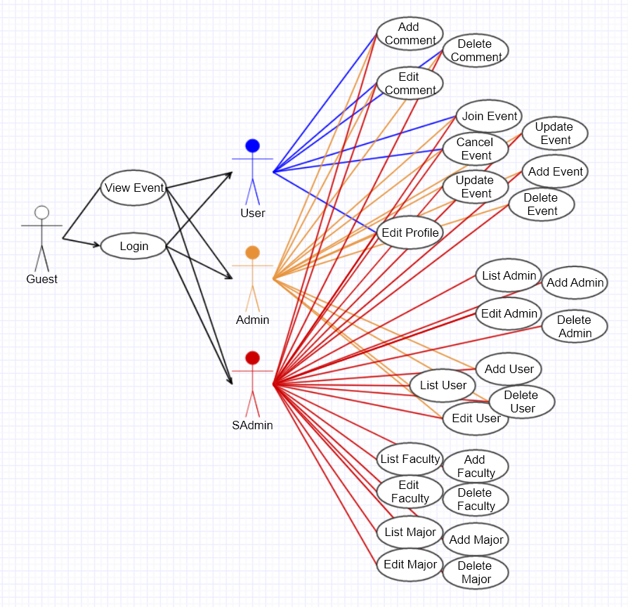

|  |  |  |  |
| --- | --- | --- | --- |
| **Use case name** | **Sign in** | | |
| Description | Allows user to access the software application | | |
| Actor | User, Admin, SAdmin | | |
| Business event | No. | Agent | System response |
|  | 1 | Click Login button |  |
|  | 2 |  | Give login interface |
|  | 3 | Click “Signin” button |  |
| Preconditions | System already has internet connection. | | |
| Condition affecting termination outcome | Login successfully 🡪 return to dahboard page  Login fail 🡪 show error | | |

|  |  |  |  |
| --- | --- | --- | --- |
| **Use case name** | **List** | | |
| Description | Allows user to list information in the database for each different situation | | |
| Actor | User, Admin, SAdmin | | |
| Business event | No. | Agent | System response |
|  | 1 | Click object link |  |
|  | 2 |  | Give list interface – generate by MVC |
| Preconditions | System already has internet connection. | | |
| Condition affecting termination outcome | List successfully 🡪 render to list page  Create fail 🡪 show error | | |

|  |  |  |  |
| --- | --- | --- | --- |
| **Use case name** | **Create** | | |
| Description | Allows user to create new information for each different situation | | |
| Actor | User, Admin, SAdmin | | |
| Business event | No. | Agent | System response |
|  | 1 | Click Create link |  |
|  | 2 |  | Give create interface – generate by MVC |
|  | 3 | Input data in to the model |  |
|  | 4 | Click Create |  |
| Preconditions | System already has internet connection. | | |
| Condition affecting termination outcome | Create successfully 🡪 return to list page  Create fail 🡪 show error | | |

|  |  |  |  |
| --- | --- | --- | --- |
| **Use case name** | **Edit** | | |
| Description | Allows user to change old information to a new one for each different situation | | |
| Actor | User, Admin, SAdmin | | |
| Business event | No. | Agent | System response |
|  | 1 | Click object link |  |
|  | 2 |  | Give edit interface – generate by MVC |
|  | 3 | Input data in to the model |  |
|  | 4 | Click Save |  |
| Preconditions | System already has internet connection. | | |
| Condition affecting termination outcome | Save successfully 🡪 return to list page  Save fail 🡪 show error | | |

|  |  |  |  |
| --- | --- | --- | --- |
| **Use case name** | **Details** | | |
| Description | Allows user to view specific information for each different situation | | |
| Actor | User, Admin, SAdmin | | |
| Business event | No. | Agent | System response |
|  | 1 | Click object link |  |
| Preconditions | System already has internet connection. | | |
| Condition affecting termination outcome | View successfully 🡪 Give detail interface  View fail 🡪 show error | | |

|  |  |  |  |
| --- | --- | --- | --- |
| **Use case name** | **Delete** | | |
| Description | Allows user to delete specific information for each different situation | | |
| Actor | User, Admin, SAdmin | | |
| Business event | No. | Agent | System response |
|  | 1 | Click object link |  |
|  | 2 |  | Give delete interface – generate by MVC |
| Preconditions | System already has internet connection. | | |
| Condition affecting termination outcome | Delete successfully 🡪 Return to list interface  View fail 🡪 show error | | |

1. **Class diagram**

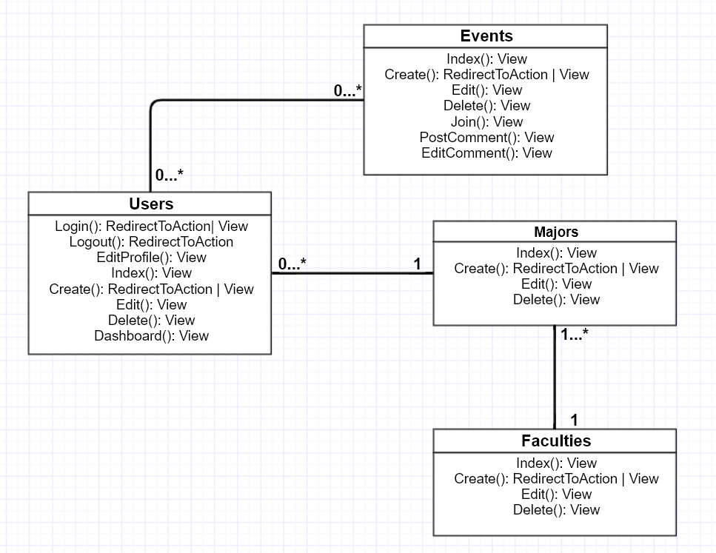

1. **ERD & Database diagram**
   1. **ERD diagram**

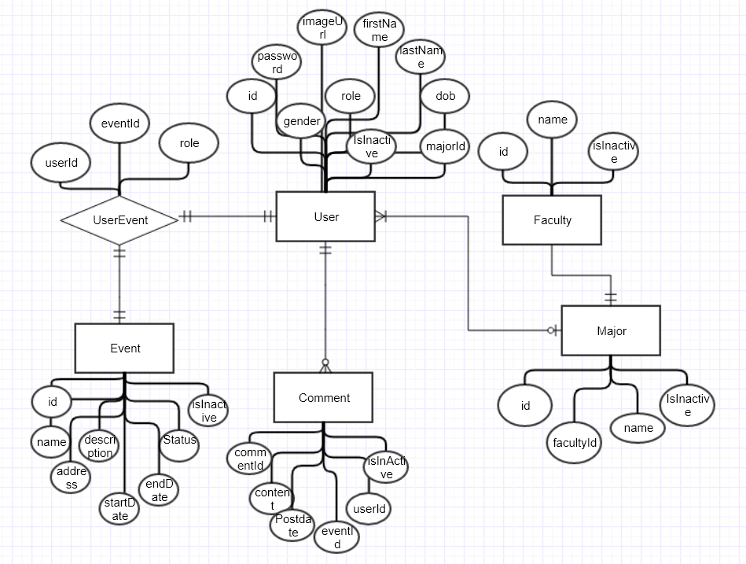

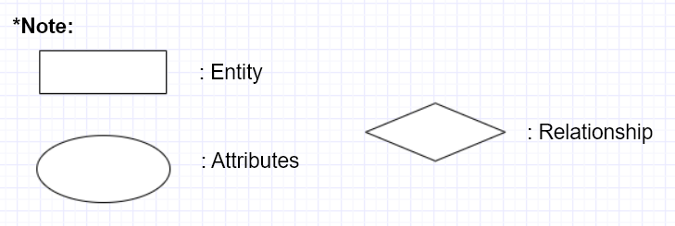

* 1. **Database diagram**

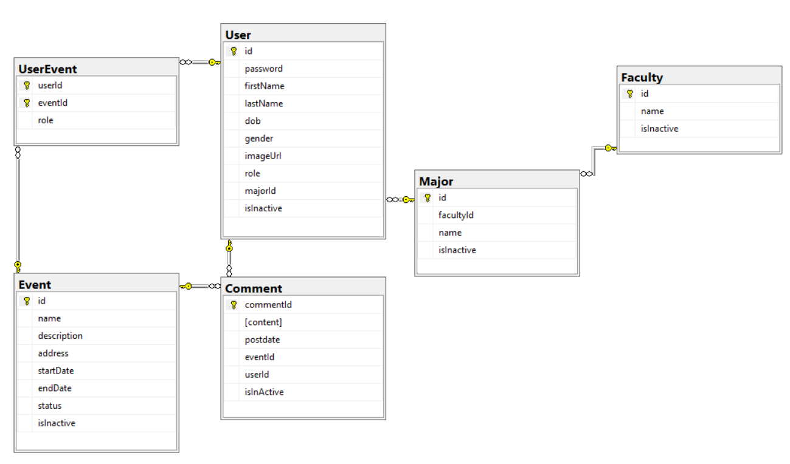

1. **Application View**

**Dashboard**

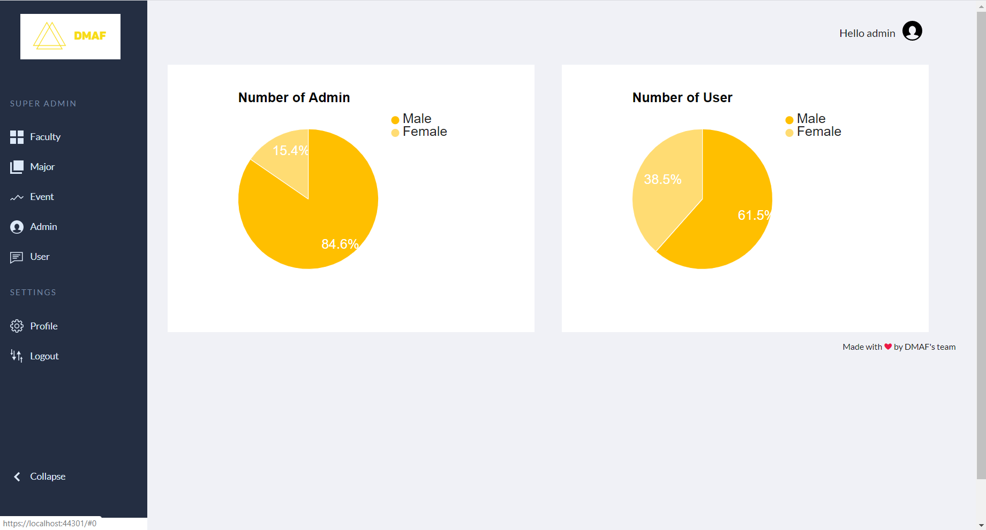

**Login**

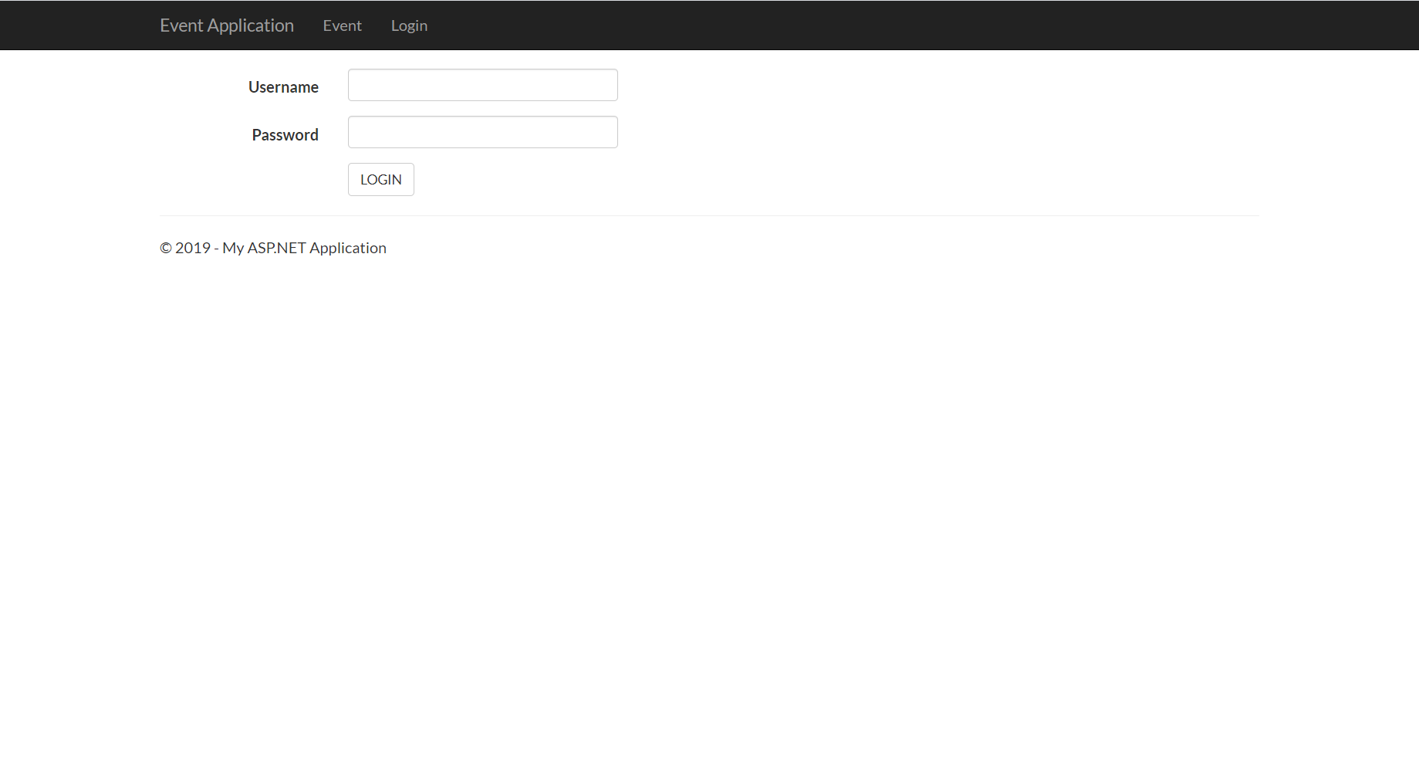

**User Management**

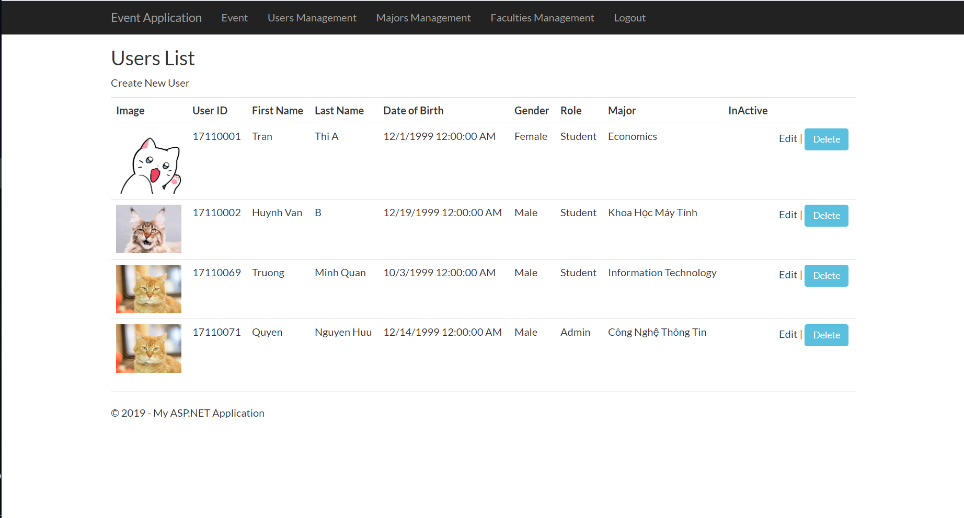

**Event Management**

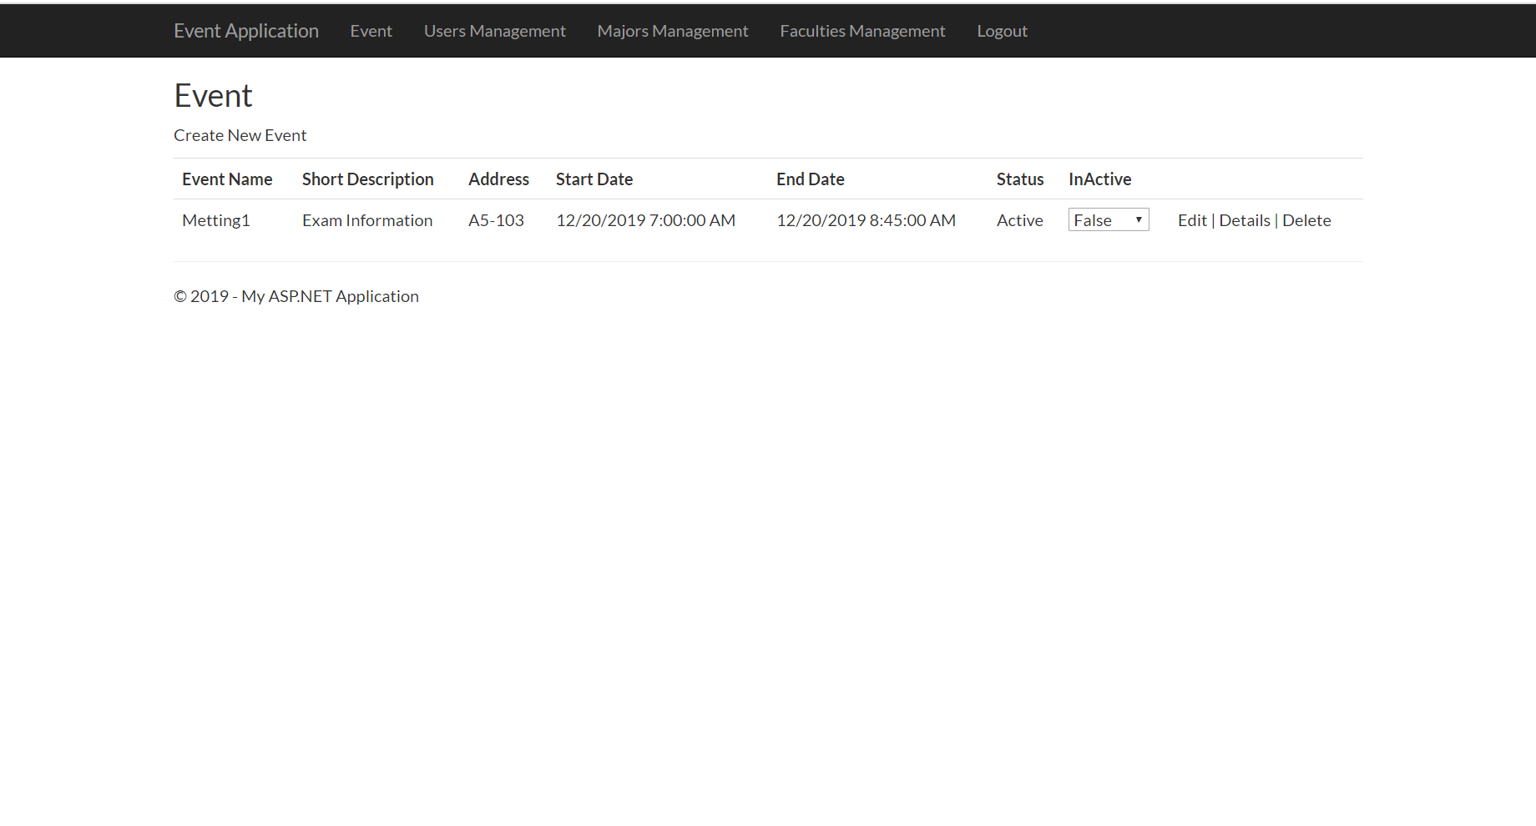

**Faculty Management** 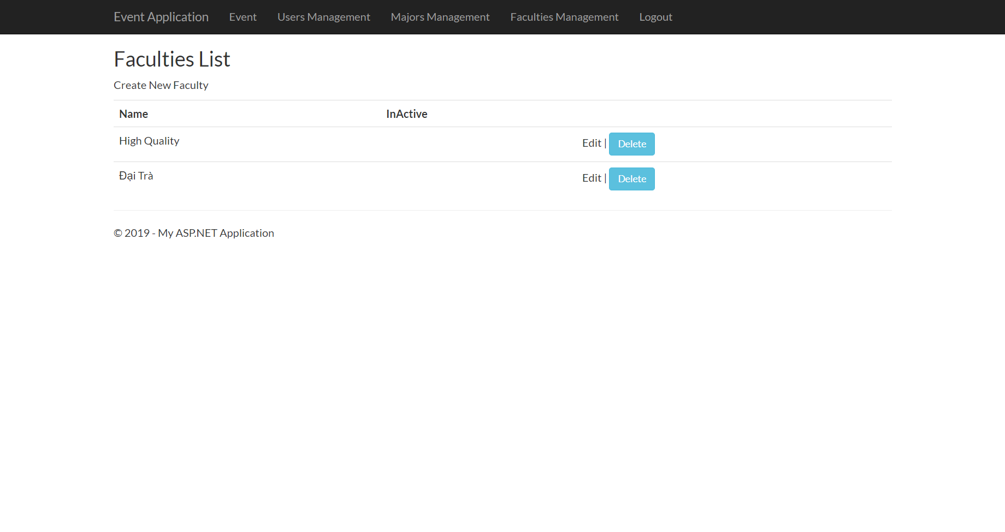

**Major Management** 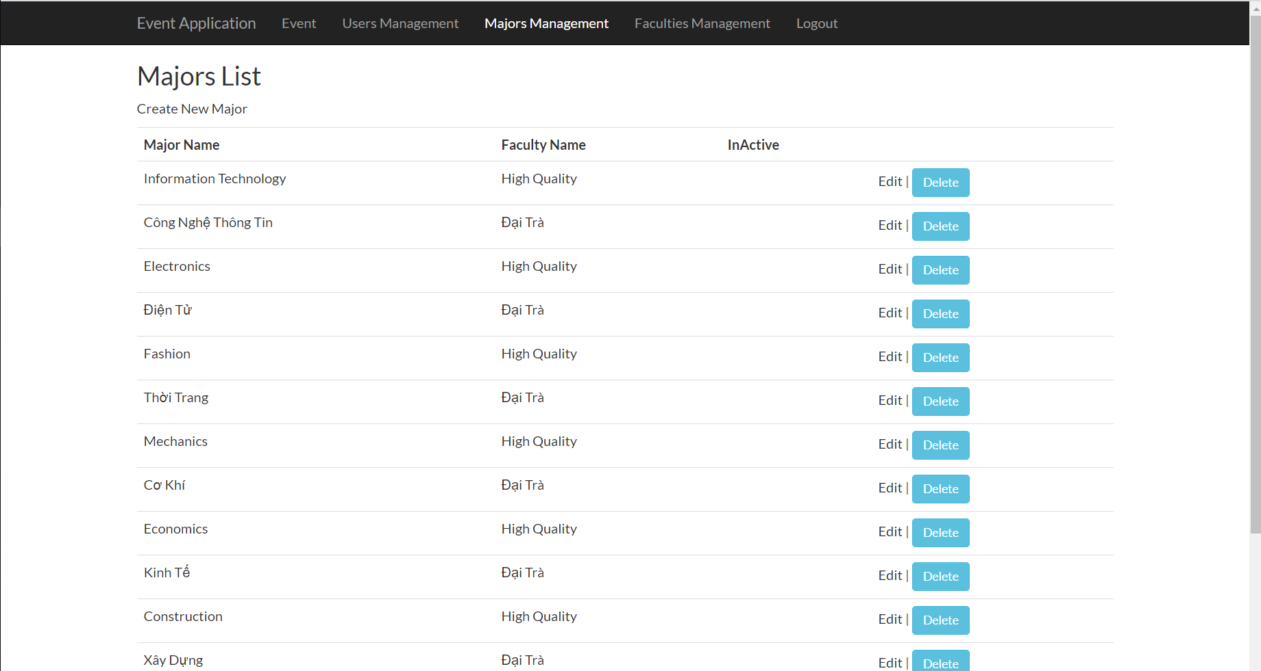

**Edit Profile**

1. **Work assignment**

|  |  |
| --- | --- |
| **Name** | **Assignment** |
| Nguyễn Hữu Quyền | * Dashboard page, writing report, make video. * Create a management page: Event: Create, Edit, View details, Delete Event. |
| Trần Ngọc Minh Quân | * Create management page: User:Create, Edit, View Details, Delete User, Faculty: Create, Edit, View detail, Delete Faculty, Major: Create, Edit, View Details, Delete Major * Login function, page |
| Mai Ngọc Anh Duy | * Edit Profile * Page for User and Admin: Edit profile, CRUD Event, CRUD User |