Step 1: Load data



Step 2: Configure the clustering algorithm settings

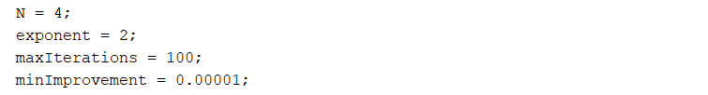

Specify whether to display the objective function value after each iteration.



Create an option vector for the Fuzzy c-means function using these settings.



Step 3: Cluster the data into N clusters.



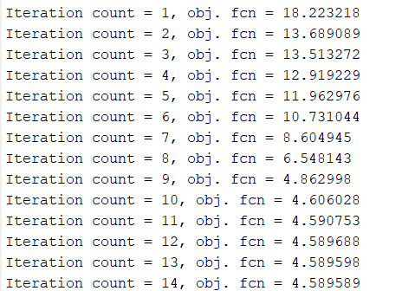

C contains the computed centers for each cluster. U contains the computed fuzzy partition matrix, which indicates the degree of membership of each data point within each cluster.

C:

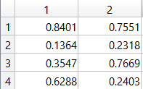

Classify each data point into the cluster for which it has the highest degree of membership.

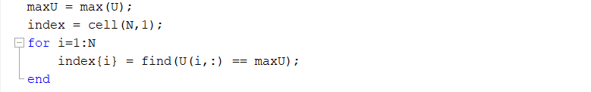

Step 4: Plot the clustering results.

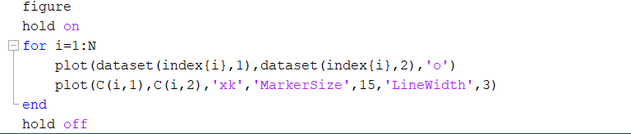

Result:

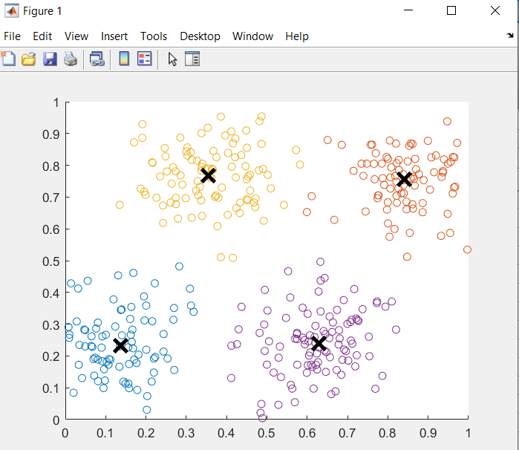

The data points in each cluster are shown in a different color. The center for each cluster is shown as a black X.

Step 5: Plot Data Point Membership Values

