Part 1: Testing Knowledge
- Challenges of Mobile Application Testing
- Correct way is testing mobile application on physical device but problem is we have thousands mobile device. It will made testing expensive .
- Use emulator and simulator also a way user for testing but there are some issue which emulator or simulator can’t cover (performance, security ….)
- Network and region also a challenges of mobile testing , Application is used everywhere in the world and we can’t handle it.
- Our last challenges is Automation Script for Mobile Testing , because too many device , script must be work stable for all device
- Defect report
- Defect number : 001
- Priority : High
- Testcase number : TS-001
- Testdata :
  - Input 1 : 2 , 2
  - Input 2 : 3 , 3
- Pre-condition : Program has been opened already
- Action :
  - Input 2 and 2 to program
  - Input 3 and 3 to program
- Expected :
  - Program return 4
  - Program return 6
- Actual :
  - Program return 3
  - Program return 5
- Description
  - We got problem if parameter 1 = parameter 2 and greater 1
- Screen shot
- Automation Framework
- Object : Framework which support many kind of project (Web , Applet, GUI testing , Winfrom….)
- Technique :
  - Selenium use for Web application (both webdriver and Selenium RC)
  - Selenium GRID for Cross Browser Testing and Parallels
  - Sivernium use for SilverLight Object
  - Sikuli use for GUI object
  - AutoIT use for Winfrom
  - SWING library use for Applet
  - Maven use for integrated with CI Server
- Language : Java
- Framework structure :
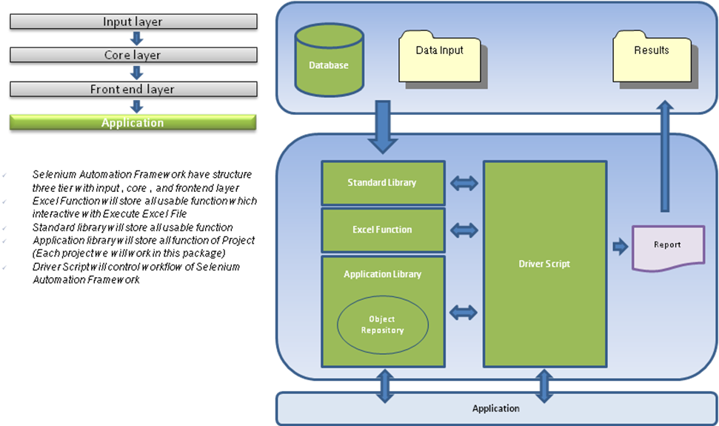
- Framework workflow :
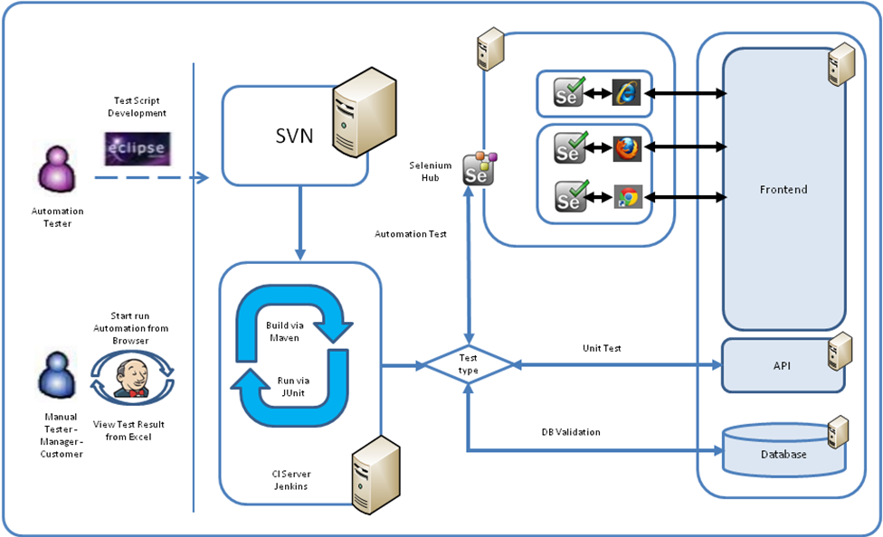
- Automation required : We can finish completed this requirement
  - Nightly Build :
    - Use schedule feature from Jenkins
  - Install App
    - User install from bat file
  - Execute Testcase
    - Create Job in Jenkins for project
    - Use maven to start build Job from excel testcase file
  - Send report
    - Send email to client include link to Excel result file
- Testcase for Triangle :
- Use decision table technique for writing testcase : Please get list testcase in Excel file TestCase Triangle.xls

Part 2 : Java Developer
- Describe the difference between classes such as Vector and ArrayList, and Hashtable and HashMap.
  - Arraylist is not synchronized while vector is. Arraylist has no default size while vector has a default size of 10.
  - HashMap is unsynchronized and Hashtable is synchronized. HashMap allows null values as key and value whereas Hashtable doesnt allow.
- What are the difference between Nested Class and Inner Class?
  - Inner class is
    - non-static class within another class
    - must be created using Outer class object
    - holds the reference of Outer class object that has created it
  - Neseted class is
    - static class within another class
    - created without using Outer class object
    - do not hold reference of Outer class object
- What are the differences between sleep() and wait()?
The main difference is if we need the thread wants to block particular period of time we just choose sleep() and when the thread called wait() means it will blocked untill we will call notify(),notifyAll();
- In what situations will there be memory leaks in Java? Describe one of them you know?
A “memory leak” is when an application holds references to objects which are no longer needed. Dead-lock, static field, JDBC not closed, a thread and if you hold onto it too long it can mean you have a “memory leak”.
- What is the output and why?
  - Output : MisfitTest.myclass@9304b1
  - Reason : All class will go inside and call function toString
public String toString() {
return getClass().getName() + "@" + Integer.toHexString(hashCode());
}
Part 3 : Data Structure and Algorithm
You can use maven for compile and run :
- Go to project which have POM file
- Mvn compiler
- Mvn exec:java -Dexec.mainClass="com.test.[filename]"
- Part3Question1.java
- Part3Question2.java
- Finf Loop
- bool findLoop(Node *head)
- {
- Node *slower, * faster;
- slower = head;
- faster = head;
- while(true) {

- if( !faster || !faster->next)
- return false;
- else if (faster == slower || faster->next == slower)
- return true;
- else{
- slower = slower->next;
- faster = faster->next->next;
- }
- }
- }

