Functional Requirements
Document (FRD)
Project/Initiative: Cinevie+ Online Ticketing
Date: March 2026
Version: 1.02
Contents
1. Document Revisions 3
2. Approvals 4
3. Introduction 5
3.1. Project Summary 5
3.2. Project Scope 6
3.3. Project Timeline 7
3.4. Key Stakeholders 7
4. Business Requirements 8
4.1. Functional Requirements 8
4.2. Non-Functional Requirements 9
5. Appendices 10
5.1. List of Acronyms 10
5.2. Glossary 10
5.3. Related Documents 10

Introduction

Purpose
This document describes the functional requirements of the CineVie+ system, a web-based movie ticket booking platform that supports both customer-facing booking activities and administrative management operations.

Project Summary

Background

Scope
The CineVie+ system consists of two main application areas:
- Customer Website:
- Allows users to browse movies, search and filter movies, select showtimes, book tickets, purchase food and beverages, and complete payments. Registered users can manage their bookings and personal information.
- Management System:
- Allows staff and administrators to manage movies, showtimes, promotions, and user accounts.

Actors
Actor | Desciption
Guest | Can browse movies, showtime, promotion without logging in
User | Can book tickets, foods and beverages
Admin/Staff | Can manage system data via management website

Overall Desciption

System Overview
CineVie+ is a movie ticket booking system that provides a unified login mechanism and role-based access.
After login:
- Customer accounts are redirected to the booking website
- Staff/Admin accounts are redirected to the management system
The system separates user-facing activities and administrative operations to ensure usability and control.

Business Flow

Booking Flow

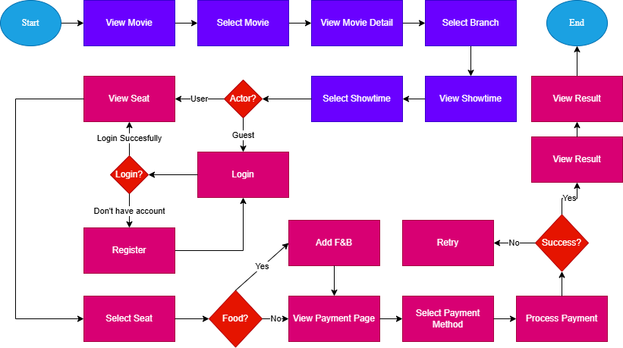

Payment Flow

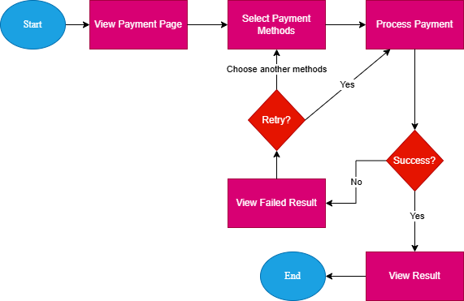

Business Rules

General
- Users must log in before booking
- Role-based access control

Business Rules
- BR-01: A selected seat shall be locked for 5 minutes during booking
- BR-02: If payment is not completed within the time limit, the seat shall be released
- BR-03: A user must log in before proceeding to payment
- BR-04: A seat cannot be booked by multiple users at the same time
- BR-05: Promotions are applied only if conditions are met
- BR-06: Payment failure shall not generate a ticket

Booking
- Seats cannot be double-booked
- Seats are temporarily locked during booking
- Booking expires if payment not completed

Payment
- Payment must be completed before ticket issuance
- Failed payment does not create ticket

Account
- Email must be unique
- Email must be verified
- Password must meet security requirements

Functional Requirements

Authentication Module
- FR-001: Register Account
REF | FR-001 | Actor | Guest
Name | Register Account
Description | The system allows users to register a new account.
Pre-condition | User is not logged in
Main Flow | 1.Guest accesses registration page  2.Guest enters required information (name, email, password, confirmation password, full name, gender, date of birth, number)  3.System validates input data  4.Guest clicks register button  5.System creates new user account  6.System sends verification email
Alternative Flow | 3.System shows error when guest enters invalid data or email exists
Business Rules | - Email must be unique  - Password must meet minimum security requirements  - Account must be verified before login
Output | System sends verification mail
s
- FR-002: Verify Email
REF | FR-002 | Actor | Guest
Name | Verify Email
Description | The system allows users to register a new account.
Pre-condition | User is not logged in
Main Flow | 1.Guest accesses registration page  2.Guest enters required information (name, email, password, confirmation password, full name, gender, date of birth, number)  3.System validates input data  4.Guest clicks register button  5.System creates new user account  6.System sends verification email
Alternative Flow | 3.System shows error when guest enters invalid data or email exists
Business Rules | - Email must be unique  - Password must meet minimum security requirements  - Account must be verified before login
Output | System sends verification mail

- FR-003: User Login
REF | FR-003 | Actor | Guest
Name | User Login
Description | The system allows registered users to log in.
Pre-condition | Guest has a registered account
Main Flow | 1.Guest enters email and password  2.Guest clicks login button  3.System validates credentials  4.System authenticates user  5.System redirects user to homepage
Alternative Flow | 5..System messeges error when guest enters invalid data or email not exists
Business Rules | - Only verified accounts can log in  - Maximum login attempts limit applied (5 times)
Output | System redirects user to homepage

- FR-004: Forgot Password
REF | FR-004 | Actor | User
Name | Forgot Password
Description | The system allows registered users who forget password to use data to get back password
Pre-condition | Guest has a registered account
Main Flow | 1.User clicks Forgot password  2.System displays the requirement data form (registered Email)  3.User enters Registered Email and clicks Send verification mail to Email  4.System send verification mail  5.User clicks verify in Email  6.System displays set password page  7.User enters new password and comfirmation new password  8.User clicks Change Password  9.System redirects user to login page
Alternative Flow | 4.System messeges error when Email not registered  9.System messeges error when user enters invalid password or matched the old password
Business Rules | - The verification mail is valid for a specific period of time  - Password must meet minimum security requirements
Output | System redirects user to login page

Movie Browsing Module
- FR-005: View Movie List
REF | FR-005 | Actor | User
Name | View Movie List
Description | The system displays list of now showing and coming soon movie
Pre-condition | Guest clicks on Movie button
Main Flow | 1.Guest enters to website  2.Guest clicks on Movie button  3.The system displays the list of movie depend on selected catagories
Alternative Flow | 3.The system displays error messeges when lost connection
Business Rules
Output | System redirects guest to movie page show the list of movie

- FR-006: View Movie Detail
REF | FR-006 | Actor | Guest
Name | View Movie Detail
Description | The system displays movie informations
Pre-condition | Guest clicks on Movie want to view
Main Flow | 1.Guest enters to website  2.Guest clicks on Movie button  3.Guest clicks on Movie want to view information  4.System displays the information of selected movie
Alternative Flow | 4.System displays error messeges when lost connection
Business Rules | Showtimes must be formatted in hh:mm format  Release date must be formatted in dd/mm/yyyy format
Output | System displays movie information page

- FR-007: Search Movie
REF | FR-007 | Actor | Guest
Name | Search Movie
Description | The system allows guest to search movie by enter characters
Pre-condition
Main Flow | 1.Guest enters to website  2.Guest clicks on Search box  3.Guest enters characters to search box  4.Guest clicks enter or click on search button  5.System displays the searching result on screen
Alternative Flow | 5.System display error messeges when lost connection or not matched value
Business Rules
Output | System displays list of movie based on searching data

- FR-008: Filter Movie
REF | FR-008 | Actor | Guest
Name | Filter Movie
Description | This feature allows users to refine movie lists based on preferences, enhancing the browsing experience.
Pre-condition | Guest enter to movie page
Main Flow | 1.Guest enters to website  2.Guest clicks on Movie button  3.Guest clicks on Filter tool (genre, status)  4.Guest chooses movie catagories  5.System displays movie base on selected category
Alternative Flow | 5.System displays blank list when have not matched value
Business Rules
Output | System displays list of movie based on selected category

Booking Ticket, Food & Beverage Module
- FR-009: Select Cinema
REF | FR-009 | Actor | Guest
Name | Select Cinema
Description | This feature allows system update showtime data based on selected cinema
Pre-condition | Guest enters the detail page of selected movie
Main Flow | 1.Guest enters to website  2.Guest clicks on Movie button  3.Guest clicks on Filter tool (genre, status)  4.Guest chooses movie catagories  5.System displays movie base on selected category
Alternative Flow | 5.System displays error messeges or blank list when lost connection or have not matched data
Business Rules | System only displays cinema that have showtime for that movie
Output | System displays list of showtime based on selected cinema

- FR-010: Select Showtime
REF | FR-010 | Actor | User
Name | Select Showtime
Description | This feature allows user selects movie want to book
Pre-condition | User is logged in  User enters movie detail page
Main Flow | 1.User selects cinema  2.System displays list of showtime of selected cinema  3.User chooses showtime want to book  4.System add showtime information to order  5.System redirects user to view seat page
Alternative Flow | 5.System redirects to login page if user is not logged in
Business Rules | System only displays cinema that have showtime for that movie  Showtimes must be formatted by hh:mm format  Users can only select a showtime after logging in
Output | System redirects user to seat page

- FR-011: View Seat Map
REF | FR-011 | Actor | User
Name | View Seat Map
Description | This feature allows user view seat map of selected showtime
Pre-condition | User selected movie showtime
Main Flow | 1.System redirects user to seat page  2.System displays the seat map of showtime
Alternative Flow | 2.System displays error messeges when lost connection
Business Rules | Seats must be formatted as a two-character code, where the first character (A–H) represents the row, and the second character (1–12) represents the seat number within that row.  System must display order information and update the data when user select seats  System displays the layout of a cinema auditorium, including seats, aisles, emergency exits, and the screen.
Output | System displays the seat map of showtime

- FR-012: Select Seat
REF | FR-012 | Actor | User
Name | Select Seat
Description | This feature allows user select seat of showtime
Pre-condition | User selected movie showtime
Main Flow | 1.System redirects user to seat page  2.User chooses seats want to book  3.System adds seat informations to order board  4.System highlights next button when adds seat informations to order board succesfully  5.System allows user continous next stage
Alternative Flow | 4.system doesn’t allow user to continous next stage when have errors
Business Rules | Seat Status include: Booked (Gray), Available (White), Selected (Blue)  System highlights the selected seats by Blue  System allows user to continue next step when at least one seat has been selected
Output | System displays the seat map of showtime

- FR-013: View Food & Beverage
REF | FR-013 | Actor | User
Name | View Food & Beverage
Description | This feature allows user view food & beverage after choosing seats
Pre-condition | User selected seats of showtime
Main Flow | 1.System redirects user to food & beverage page  2.System displays the view of food & beverage page
Alternative Flow | 2.System displays ereror messeges when lost connection
Business Rules | System only displays food & beverage that are in stock or ready to be served  System must display order information and update the data when user select items  System allows user to skip this step if it is not needed
Output | System displays the menu of food & beverage

Payment Module
- FR-014: View Payment Page
REF | FR-014 | Actor | User
Name | View Payment Page
Description | This feature allows user view payment page
Pre-condition | User completes food & beverage step
Main Flow | 1.System redirects user to payment page  2.System displays the view of payment page
Alternative Flow | 2.System displays ereror messeges when lost connection
Business Rules | System only displays food & beverages that are in stock or ready to be served  System must display order information and update the data when user select items  System allows user to skip this step if it is not needed
Output | System displays the menu of food & beverage

- FR-015: Select Payment Method
REF | FR-015 | Actor | User
Name | Select Payment Method
Description | This feature allows user select payment method (Momo, Banking,etc…)
Pre-condition | User enters payment page
Main Flow | 1.System displays the view of payment page  2.system displays available payment methods (VNPay, Momo,…)  3.User selects one payment method  4.System highlights the selected payment method  5.User clicks next to proceed payment
Alternative Flow | 4.System doesn’t highlight the selected payment method when error
Business Rules | System requires a payment method to be selected before proceeding  System highlights the selected payment method  System allows user to proceed to payment after selecting a method (Cannot proceed to the next step if no option is selected)
Output | System displays the menu of food & beverage

- FR-016: Process Payment
- Display food items.
- FR-017: View Payment Result
- Display success/failure result.

Ticket Management
- FR-019: View My Tickets
- Display booked tickets.
- FR-020: Cancel Booking
- Allow cancellation under conditions.

User Profile
- FR-021: Update Profile
- Allow updating name and phone.
- FR-022: Change Password
- Allow password update.
- FR-023: Update Email
- Allow email update with verification.

Promotion & Support
- FR-024: View Promotion
- Display promotions.
- FR-025: View Support Info
- Display hotline/contact.
- FR-026: View Policy
- Display refund/exchange policy.

Management System (Admin/Staff)
- FR-027: Manage Movies
- Create/update/delete movies.
- FR-028: Manage Showtimes
- Manage showtimes.
- FR-029: Manage Promotions
- Manage promotions.
- FR-030: Manage Users
- Manage user accounts.
- FR-031: View Reports
- View business reports.

Non-Functional Requirements

Security
- NFR-SEC-01: Authentication
- The system shall require authentication for all booking and account-related actions.
- The system shall enforce role-based access control (Customer vs Admin/Staff).
- NFR-SEC-02: Data Protection
- The system shall protect sensitive user data (password, email, payment info).
- Passwords shall be stored in encrypted/hashed format.
- NFR-SEC-03: Payment Security
- The system shall ensure all payment transactions are processed via secure external payment gateways.
- The system shall not store sensitive payment details (e.g., card numbers).
- NFR-SEC-04: Session Management
- The system shall automatically log out users after a period of inactivity (e.g., 15–30 minutes).
- The system shall prevent simultaneous conflicting booking actions for the same seat.

Performance
- NFR-PER-01: Response Time
- The system shall respond to user actions within ≤ 3 seconds under normal conditions.
- NFR-PER-02: Concurrent Users
- The system shall support at least 500–1000 concurrent users during peak hours.
- NFR-PER-03: Seat Availability Update
- The system shall update seat availability in near real-time (≤ 2 seconds delay).
- NFR-PER-04: Payment Processing Time
- Payment processing response shall be returned within ≤ 10 seconds (depending on external provider).

Availability
- NFR-AVA-01: System Uptime
- The system shall maintain ≥ 99% uptime excluding scheduled maintenance.
- NFR-AVA-02: Maintenance
- The system shall allow scheduled maintenance outside peak hours.

Scalability
- NFR-SCA-01: Traffic Growth
- The system shall scale to handle increased user traffic during peak events (e.g., movie releases).
- NFR-SCA-02: Data Growth
- The system shall support increasing data volume (movies, users, bookings) without performance degradation.

Usability
- NFR-USE-01: Ease of Use
- The system shall provide a clear and intuitive booking process.
- NFR-USE-02: Navigation
- Users shall be able to complete booking within ≤ 5–7 steps.
- NFR-USE-03: Error Feedback
- The system shall display clear and user-friendly error messages.

Maintainability
- NFR-MAI-01: System Updates
- The system shall allow updates without affecting core functionalities.
- NFR-MAI-02: Logging & Monitoring
- The system shall log critical events (login, booking, payment).

Non-Functional Requirements
Priority Scale
Level | Definition
1 | Critical
2 | High
3 | Medium
4 | Low
5 | Future

Functional Requirements
Module 1: User Management
Req# | Priority | Description
FR-001 | 1 | The system shall allow users to register an account
FR-002 | 1 | The system shall allow users to log in
FR-003 | 2 | The system shall allow users to update profile information
FR-004 | 2 | The system shall allow users to view profile information
FR-005 | 2 | The system shall allow users to view My Tickets

Module 2: Movie, Showtime, Food and Beverage Management
Req# | Priority | Description
FR-006 | 2 | The system shall display available movies
FR-007 | 2 | The system shall display movie details
FR-008 | 1 | The system shall allow users to select showtimes
FR-009 | 1 | The system shall display real-time seat availability
FR-010 | 3 | The system shall allow user to search movie quickly by enter keywords
FR-011 | 3 | The system shall allow user to define movie lists based on preferences
FR-012 | 1 | The system shall update showtime list based on selected branch
FR-013 | 1 | The system shall display showtime based on user selected branch
FR-014 | 3 | The system shall display food and beverage menu
FR-015 | 3 | The system shall allow user to optionally add food and beverage to their order

Module 3: Booking & Payment & Promotion
Req# | Priority | Description
FR-016 | 1 | The system shall allow users to select seats
FR-017 | 1 | The system shall display the seat layout of selected showtime, including seats, aisles, emergency exits, and the screen, allowing users to view and select suitable seats
FR-018 | 1 | The system shall display payment page and let user choose payment method
FR-019 | 1 | The system shall generate QR-code based on their selected payment method
FR-020 | 2 | The system shall allow ticket cancellation under defined conditions
FR-021 | 1 | The system allow display payment result
FR-022 | 3 | The system shall display promotion list
FR-023 | 3 | The system shall display promotion details

Module 4: Admin & Reporting
Req# | Priority | Description
FR-024 | 1 | The system shall allow administrators to manage movies and showtimes
FR-025 | 1 | The system shall provide a revenue dashboard
FR-026 | 2 | The system shall export revenue reports (daily/monthly)
FR-027 | 2 | The system shall manage F&B combos

Non-Functional Requirements

ID | Requirement
NFR-001 | System uptime ≥ 99.5%
NFR-002 | Page load time ≤ 3 seconds
NFR-003 | Support 50–100 transactions per second
NFR-004 | Compliance with Vietnamese data protection regulations
NFR-005 | Daily automated backup
NFR-006 | Data must not be stored outside Vietnam
NFR-007 | Core Web Vitals ≥ 90% (Good level)

Appendices

List of Acronyms

Term | Meaning
BRD | Business Requirements Document
SRS | Software Requirements Specification
KPI | Key Performance Indicator
UI | User Interface
UX | User Experience
F&B | Food & Beverage

Glossary
- QR Code: Electronic ticket verification code
- Overbooking: Selling the same seat more than once
- MVP: Minimum Viable Product

Related Documents
- FRD Document
- User story Document

