|  |  |  |
| --- | --- | --- |
|  | | **MINISTRY OF EDUCATION AND TRAINING** |
|  | |  |
| Capstone Project | | |
| Mobile Based Language Learning Application | | |
|  | | |
| **Group 4** | | |
| **Group Members** | Nguyễn Phước Thành  Vũ Khánh Hưng  Nguyễn Cao Duy  Trần Quang Phúc | |
| **Supervisor** | Mr. Nguyễn Huy Hùng | |
| **Ext. Supervisor** | N/A | |
| **Project Code** | MOLA | |

# Contents

Capstone Project 1

Mobile Based Language Learning Application 1

Contents 2

Report 1 Introduction 4

I. Project Information 4

II. Introduction 4

III. Current Situation 4

IV. Problem Definition 5

V. Proposed Solution 5

Feature functions 5

Advantages and disadvantages 6

VI. Function Requirement 6

VII. Role and Responsibility 7

Report 2 Software Project Management Plan 8

I. Problem Definition 8

Name of this Capstone Project 8

Problem Abstract 8

Project Overview 8

II. Project Organization 8

Software Process Model 8

Roles and responsibilities 9

Tools and Techniques 9

III. Project Management Plan 9

Software development life cycle 9

Phrase Detail 9

All Meeting Minutes 9

IV. Coding Convention 9

Report 3 Software Requirement Specification 9

I. User Requirement Specification 10

Teacher Requirement 10

Learner Requirement 10

II. System Requirement Specification 10

External Interface Requirement 10

System Overview Use Case 10

List of Use Case 10

III. Software System Attribute 10

Usability. 10

Reliability. 11

Availability. 11

Security. 11

Maintainability. 12

Portability. 12

Performance. 12

# Report 1 Introduction

## Project Information

Project name: Mobile Based Language Learning Application

Project code: MOLA

Product type: Mobile Application

Start Date: September 2016

End Date: December 2016

## Introduction

The prevalence of mobile technology in today’s society and the wave of technological innovation pose new ways to teach and learn foreign language. We can teach and learn foreign language anytime and anywhere using our mobiles. However, finding a teacher or another learner to practice with in order to improve your speaking skill is very difficult, especially a native speaker.

With that in mind, Mobile Based Language Learning Application (MOLA) was built to fill those needs. MOLA serves as a place to improve your speaking skill and as a bridge to connect those who want to teach and those who want to learn. Furthermore, MOLA also offers several tools such as Course tool or Dictionary to support the learning and teaching process.

## Current Situation

Knowing and doing are totally difference. Knowing a language, the grammar is one kind of knowledge but using a language, being able to speak fluently, speaking without transaction is the different kind of knowledge. So focus on practicing listening and speaking especially speak to native speakers is become a global trends and a popular demand today.

Currently, there are three common ways to practice speaking and listening skill with native speakers:

1. For popular language such as English, Chinese, Japanese... students can go to Language Center. Wealthier resident can hire tutor for their children.
2. For uncommon language, wealthier resident can study abroad.
3. For people who is busy or who cannot afford to go abroad can go online. They can make friend with native speaker, listen and speak to them. They also can take online course.

Native speakers who want to become a foreign language teacher they have to obtain a bachelor’s degree and often have to travel to country they want to work.

## Problem Definition

1. Study abroad is the best way to learn not only about language, but also about the culture. Unfortunately, not everybody have enough time or money or skills to do this.
2. So go to Language Center become the second best choice for many people but it has its own problem:
3. Timing is the first issue, Almost all student must follow a fixed schedule so people who is busy with there job or who want to study in their spare time cannot do this.
4. Student-teacher ratio is the second problem, usually there are 10 to 20 students in a class with one teacher so it is hard for teacher to find enough time to practice with all student. Hiring a tutor can solve this problem but it require a lot of money.
5. Native Teacher shortage.
6. About the disadvantages of online method:
7. Usually, there is no warranty, no certificate when study online.
8. Sometime it’s boring when follow the same course structure everyday, reading the text, listening to the audio, watching the video and taking the test.
9. It require personal computer connected to the internet.
10. Additionally, there is a demand from teacher who want to make more money with their skill in their spare time but currently there is no way to do this.

## Proposed Solution

Base on the current situation and the defined problems, our proposed solution is to build a mobile app named “MOLA” to connect students and teachers around the world.

### Feature functions

1. Teacher Component
2. Register time slots: users who want to teach can register his/her available time slots so that other users can register to learn.
3. Course Tool: a simple tool should be supported so that teachers can compose a course structure.
4. Effective score: each teacher can have effective score which indicates how effective he/she has been teaching. The effective score is calculated based on many factors: punctuality (i.e. online at the registered time slots), rating from learners…
5. Learner Component
6. Supported learning tools: while practicing speaking with teachers, learners can be supported with tools such as dictionary, pronunciation supports…
7. Learner Ranking: each learner will have a ranking score which indicates the progress he/she has made.
8. Privacy control: users should be able to control his/her camera viewing from other.
9. Suggestion: learners should be able to view suggested teachers and learners

### Advantages and disadvantages

1. Advantages
2. Flexible price. Teacher will set the price of the course. Price charge per minute.
3. Flexible schedule. Teacher is free to register his/her available time to teach and learners is free to register to learn any course in this slot. System doesn’t require certain topic for certain slot.
4. Focus on practicing. There is only one student per slot so teachers can focus on practice his/her skill.
5. Choose the best teacher. Learner can vote for a teacher and view suggested teachers base on other vote.
6. Can learn/teach anywhere with internet connected.
7. Disadvantages
8. Hard to verify language skill of all teachers.
9. Require mobile device with internet connection.

## Function Requirement

1. Learner
2. Enroll courses.
3. Register slots.
4. Look up dictionary.
5. Vote teachers.
6. Control privacy
7. View report
8. Teacher
9. Create courses.
10. Register time frame
11. View enrolled leaner in a course.
12. View registered slots.
13. View learn progress.
14. Admin
15. Manage account
16. System
17. Suggest teachers and learners.
18. Tracking learning progress.

## Role and Responsibility

|  |  |  |  |  |
| --- | --- | --- | --- | --- |
| No. | Full Name | Role | Position | Contact |
| 1 | Nguyễn Huy Hùng | Product Owner,  Scrum Master | Supervisor | HungNH  @fpt.edu.vn |
| 2 | Nguyễn Phước Thành | Developer | Leader | ThanhNPse61563  @fpt.edu.vn |
| 3 | Vũ Khánh Hưng | Developer | Member | HungVKse61404  @fpt.edu.vn |
| 4 | Nguyễn Cao Duy | Developer | Member | DuyNCse61032  @fpt.edu.vn |
| 5 | Trần Quang Phúc | Developer | Member | PhucTQse60993@fpt.edu.vn |

Table 1 Role and Responsibility

# Report 2 Software Project Management Plan

## Problem Definition

### Name of this Capstone Project

### Problem Abstract

### Project Overview

1. Current Situation
2. Proposed System
3. Website
4. Mobile Application
5. Boundaries of the System
6. Future Plans
7. Development Environment
8. Hardware requirements
9. Software Requirements

## Project Organization

### Software Process Model

The project is developed under Scrum Model.

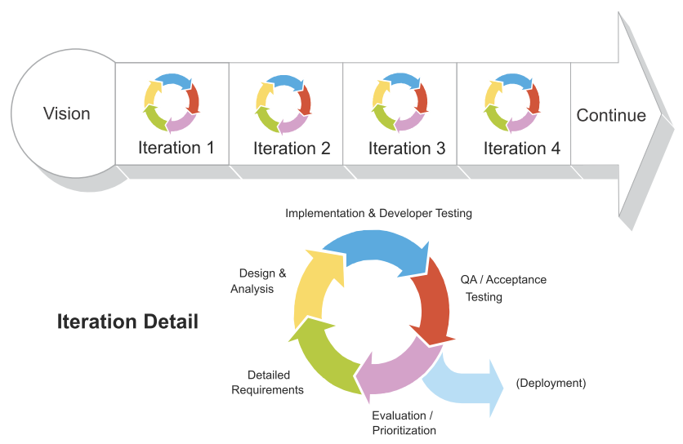

### Roles and responsibilities

### Tools and Techniques

## Project Management Plan

### Software development life cycle

### Phrase Detail

### All Meeting Minutes

## Coding Convention

# Report 3 Software Requirement Specification

## User Requirement Specification

### Teacher Requirement

### Learner Requirement

## System Requirement Specification

### External Interface Requirement

1. User Interface
2. Hardware Interface
3. Software Interface
4. Communication Protocol

### System Overview Use Case

### List of Use Case

<Teacher> Overview Use Case

<Learner> Overview Use Case

## Software System Attribute

The primary purpose of this system is to facilitate the meeting between teachers and learners. The key requirements of such system are usability, performance, and maintainability.

### Usability.

1. Graphic User Interface.
2. The system shall support multiple languages: Vietnamese, English, French, Spanish, Chinese, Japanese, and Korean. Therefore, the system shall detect the current culture and show the appropriate language.
3. The system shall have consistent GUI all over the system.
4. The system shall provide navigation buttons on each page.
5. The GUI shall provide user with access to all relevant use-case with the fewest number of clicks and key strokes.
6. Usability.
7. Online help manual shall be available for user in order to become more productive and use the full set of the features provided by the system.
8. Teachers and learner need less than five minutes to be familiar with the mobile app.
9. Installation.
10. The system shall be easy to deploy. Customer can deploy successfully and learn to configure, maintain the system within one day of training.
11. The manual guide should be clear. Mobile app installation can be done by normal user.

### Reliability.

1. Mean Time Between Failures (MTBF).
2. The Mean Time Between Failures shall exceed 480 hours.
3. Mean Time to Repair.
4. The Mean Time to Repair shall not exceed 8 hours.
5. Maximum bug rate.
6. The bug rate shall not exceed 1 bug/KLOC.
7. Failures Tolerance.
8. The system shall validate user input.
9. The system shall log every error.
10. The system shall be able to restore to previous state when failures occur.

### Availability.

1. This system shall be available and operational 24 hours a day, seven days a week.
2. There shall be a minimum down time of 6 % (~22 days/year) due to system maintenance.
3. The system shall provide a contractual agreement with an internet service provider who can provide 99.999% availability through their network facilities onto the internet.

### Security.

1. Data Transfer.
2. The system shall use secure sockets such as HTTPS in all transactions that include any confidential user information.
3. The system shall demand secure code suck as CAPTCHA when log-in.
4. After several time log-in fail, system shall lock the account.
5. The system shall automatically log out all users after a period of inactivity.
6. The system shall not leave any cookies on the user’s computer containing the user’s password.
7. Data Storage.
8. The mobile app shall never display a customer’s password. It shall always be echoed with special characters representing typed characters.
9. The mobile app shall never display a customer’s credit card number after retrieving from the database. It shall always be shown with just the last 4 digits of the credit card number.
10. The system’s back-end servers shall never display a user’s password. The user’s password may be reset but never shown.
11. The system’s back-end servers shall only be accessible to authenticated administrators.
12. The system’s back-end databases shall be encrypted.
13. Data shall be recorded in such a way that it can be audited for integrity requirements.

### Maintainability.

1. The system architecture shall be designed using fine-grain, self-contained components that may readily be changed.

### Portability.

1. The system shall be able to deployed into many type of servers those have Tomcat server.
2. The mobile app shall be able to install in any android device which version 4.4.4 Kitkat or newer.

### Performance.

1. Response Time.
2. The system shall have a fast response time allowing 90% of all response within 300ms.
3. Capacity.
4. The system shall be able to process tens of thousands request concurrency.