A logistic regression model was developed to predict whether a prospective donor would respond to the fundraising mailing using the available demographic and behavioral variables.
The initial model used the default classification threshold of 0.5, which resulted in very high accuracy (~95%). However, further analysis revealed that the model predicted nearly all donors as non-responders. This occurred due to class imbalance, where only a small percentage of donors actually responded to the campaign. As a result, accuracy alone was misleading and not an appropriate measure of model performance.
To address this issue, the classification threshold was lowered to 0.05. This adjustment allowed the model to identify a substantially larger number of potential responders, improving the model’s practical usefulness for marketing purposes. After lowering the threshold, the model successfully detected many responding donors, though overall accuracy decreased to approximately 56.8%. This decline is expected when working with imbalanced datasets because the model becomes more sensitive to the minority class.
The model achieved an AUC of approximately 0.60, indicating that it performs slightly better than random guessing but has limited predictive strength. This suggests that while logistic regression provides some ability to distinguish responders from non-responders, the available predictors may not strongly explain donor behavior.
Overall, logistic regression served as a solid baseline model. The analysis also highlights the importance of selecting appropriate evaluation metrics—such as AUC and sensitivity—rather than relying solely on accuracy when dealing with rare-event prediction problems like donor response.
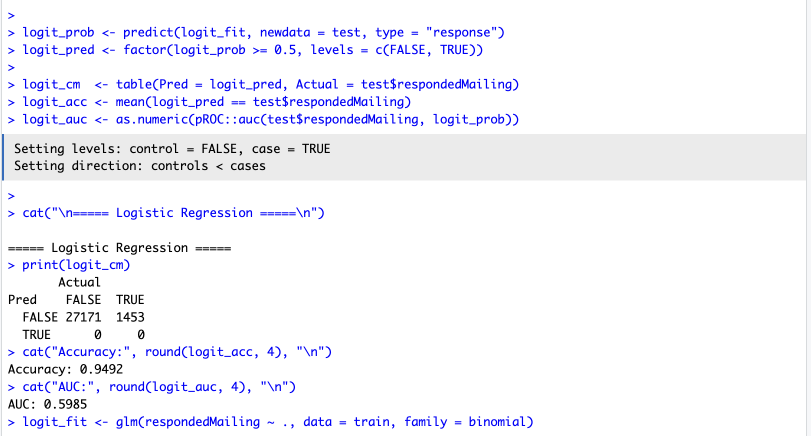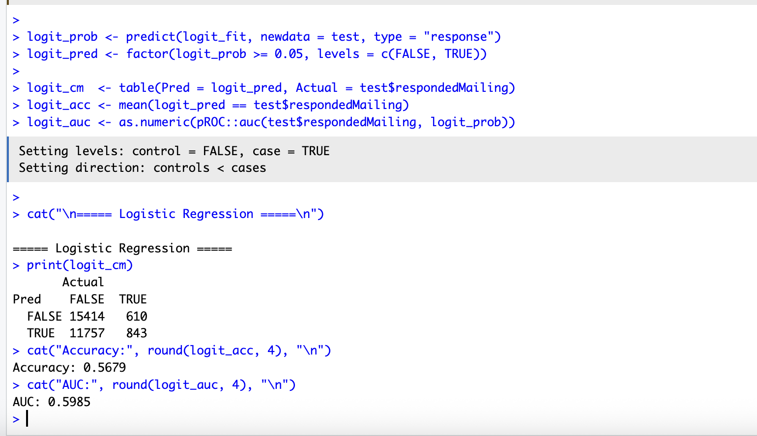

“LDA was fit to classify donor response. The model produced an AUC of ~0.596, indicating only weak ability to distinguish responders from non-responders. Using the default classification rule, LDA predicted almost all observations as non-responders, yielding high accuracy (~0.949) due to class imbalance rather than strong predictive power. This result suggests that, for this dataset, LDA provides limited improvement over logistic regression and is sensitive to predictor structure (e.g., collinearity among donation variables and dummy-coded categorical variables).”

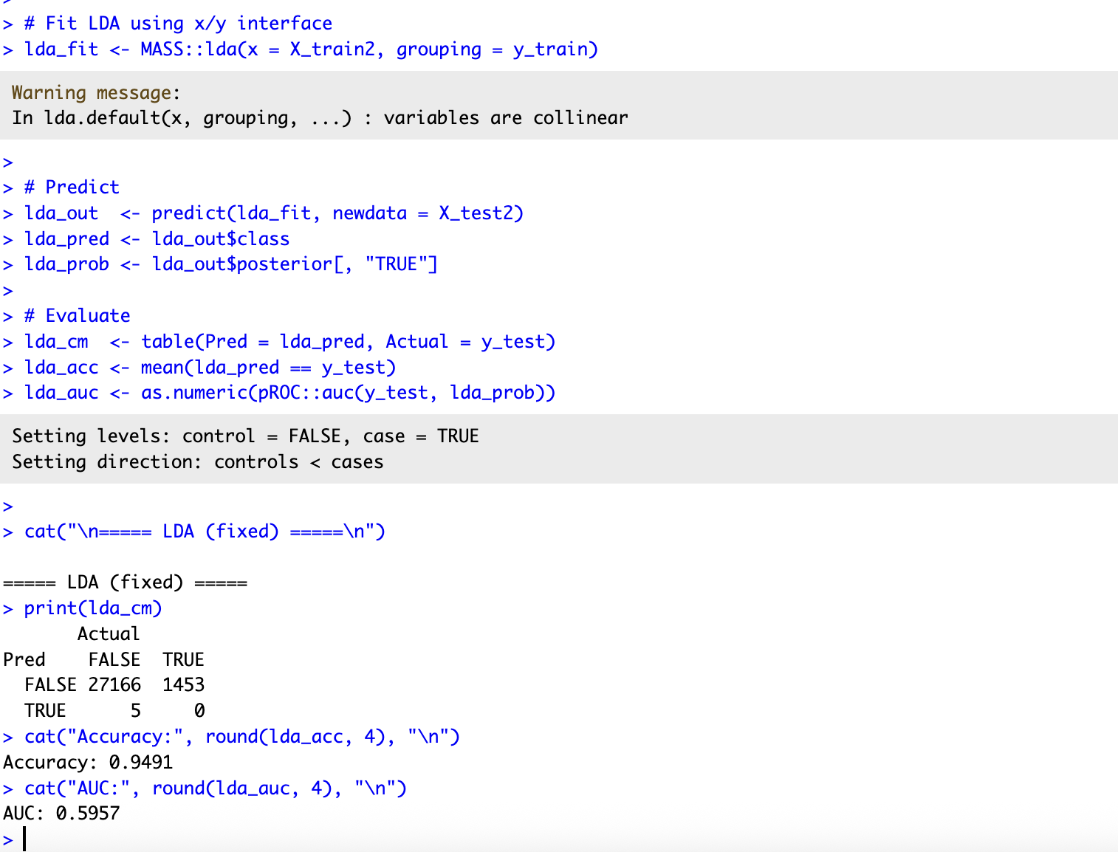
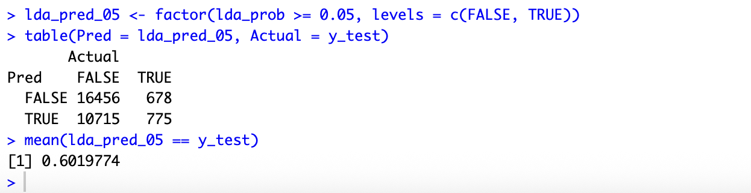
A Linear Discriminant Analysis (LDA) model was developed to predict whether prospective donors would respond to the fundraising campaign. Initially, when using the default classification rule, the model predicted nearly all donors as non-responders. Although this produced a high accuracy of approximately 94.9%, the result was misleading due to the severe class imbalance in the dataset, where the majority of donors did not respond.
To address this issue, the classification threshold was lowered to 0.05, allowing the model to identify donors with even a small probability of responding. After adjusting the threshold, the model successfully detected a substantially larger number of responders (775 true positives), demonstrating improved sensitivity. However, this came at the cost of reduced overall accuracy (≈60.2%), which is expected when working with imbalanced datasets because the model begins to classify more observations as potential responders.
Despite this adjustment, the model achieved an AUC of approximately 0.596, indicating only weak discriminative ability and suggesting that LDA struggles to effectively separate responders from non-responders. Additionally, warnings related to collinearity among predictors imply that some variables contain redundant information, which may further limit the model’s performance.
Overall, while lowering the threshold improved the model’s practical usefulness by capturing more likely responders, LDA demonstrated limited predictive strength for this dataset. These results suggest that the assumptions underlying LDA—particularly linear separability and shared covariance structure—may not hold well for donor behavior data.
Consequently, LDA serves primarily as a baseline comparison model rather than the optimal predictive approach for this problem.
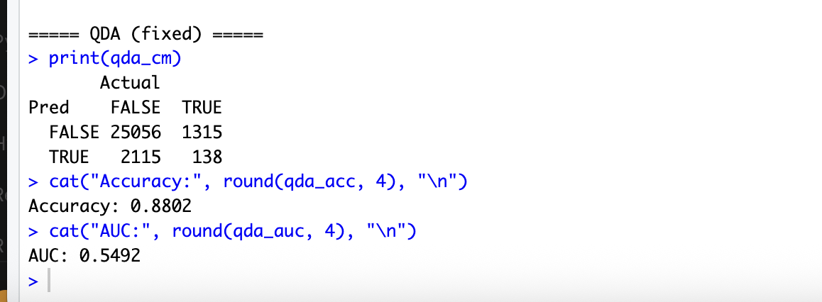
Quadratic Discriminant Analysis (QDA) was implemented to predict donor response while allowing for nonlinear decision boundaries between classes. After addressing multicollinearity and rank deficiency issues, the model was successfully estimated.
The QDA model achieved an overall accuracy of approximately 88.0%; however, this metric was inflated due to the significant class imbalance present in the dataset. More importantly, the model produced an AUC of 0.549, indicating weak discriminative ability and only marginal improvement over random guessing.
Additionally, the model demonstrated very low sensitivity, correctly identifying fewer than 10% of responding donors. This suggests that QDA struggled to capture meaningful patterns associated with donor behavior.
Compared to Logistic Regression and LDA, QDA delivered inferior predictive performance, likely due to its sensitivity to multicollinearity and the high dimensionality created by dummy-coded categorical variables.
Overall, the results indicate that QDA is not well suited for this donor prediction task and should not be recommended as the primary modeling approach.
The findings reinforce that more flexible models do not necessarily yield better predictive performance, particularly when model assumptions are violated.

