Logistic Regression
The logistic regression model initially achieved a high accuracy of approximately 95% when using the default classification threshold of 0.5. However, the model classified nearly all donors as non-responders. After lowering the classification threshold to 0.05, the model identified a substantially larger number of responding donors. This adjustment reduced overall accuracy to about 56.8% but improved the model’s ability to detect responders. The model produced an AUC of approximately 0.60.
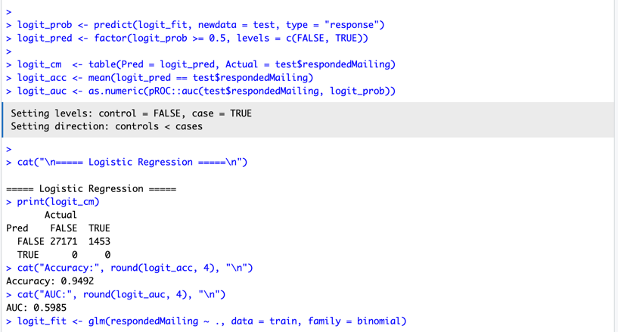
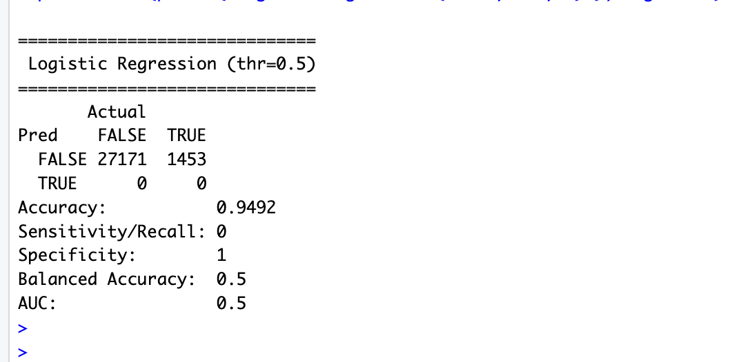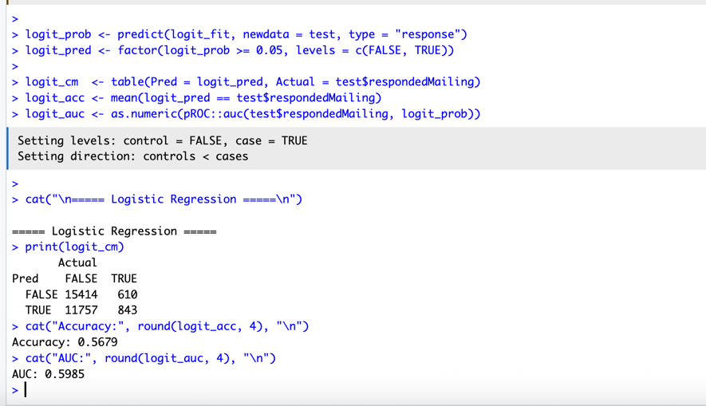

Linear Discriminant Analysis (LDA)
Using the default classification rule, the LDA model predicted almost all observations as non-responders, resulting in an accuracy of approximately 94.9%. When the classification threshold was lowered to 0.05, the model identified 775 true positives and showed improved sensitivity. Overall accuracy decreased to roughly 60.2%. The model achieved an AUC of approximately 0.596. Warnings related to multicollinearity among predictors were observed during model fitting.
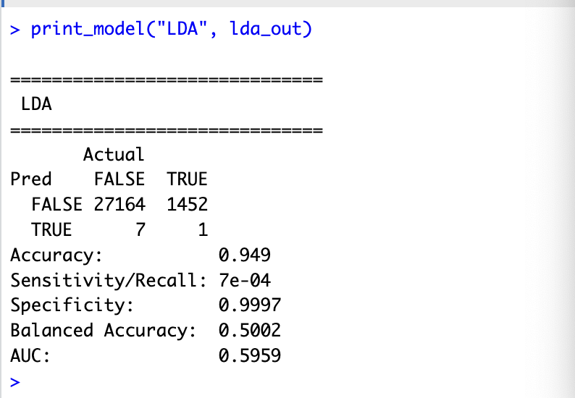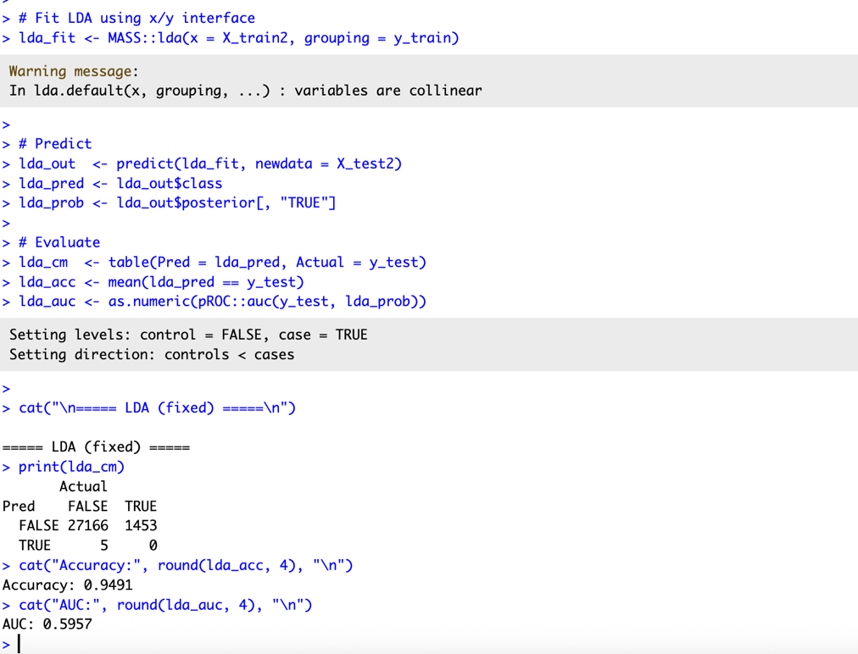

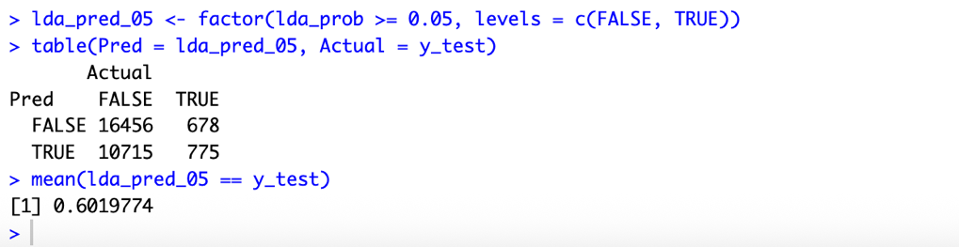
Quadratic Discriminant Analysis (QDA)
The QDA model achieved an overall accuracy of approximately 88.0%. Despite this, the model demonstrated weak classification performance, with an AUC of 0.549. Sensitivity was very low, as the model correctly identified fewer than 10% of responding donors. The model required additional preprocessing to address multicollinearity and rank-deficiency issues before estimation.
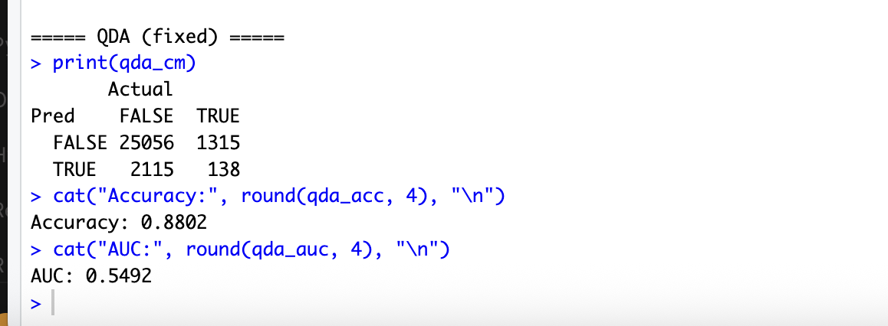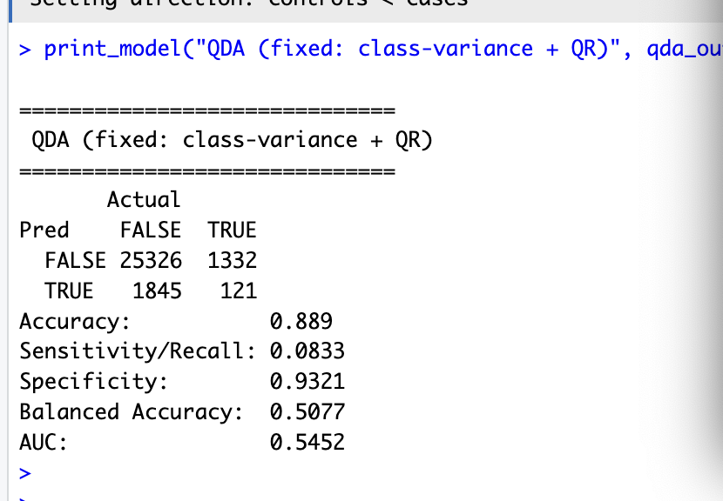
K-Nearest Neighbors (KNN)
The KNN model reported an accuracy of approximately 94.9%. However, the model classified all observations as non-responders, resulting in zero true positives for donor response.
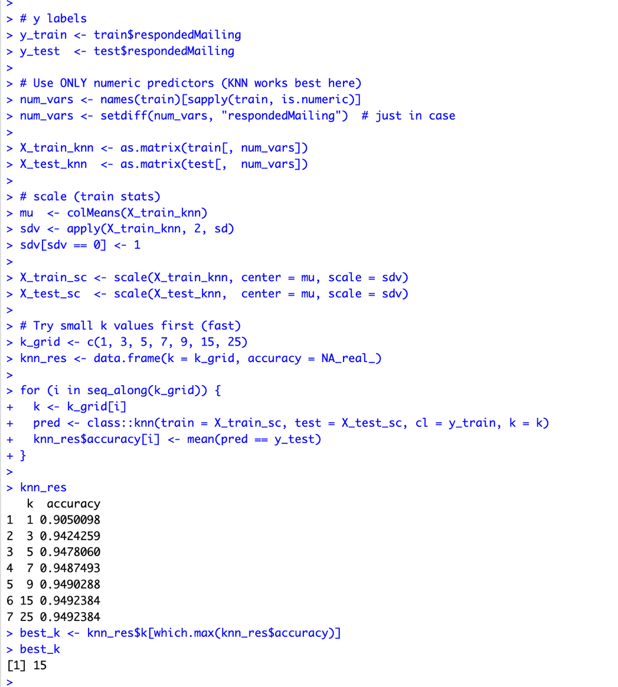
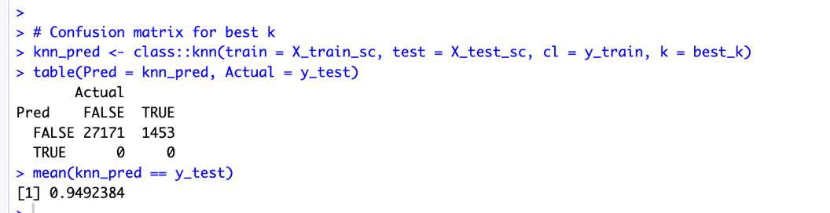
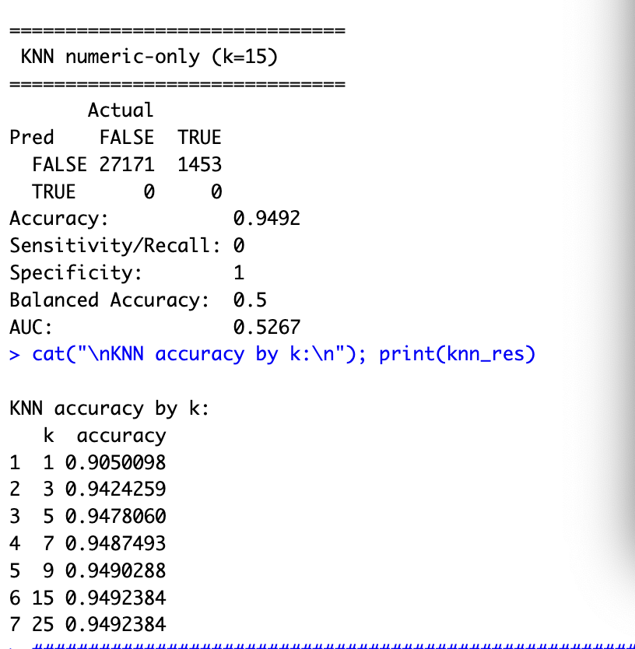

Interpretation
The results across all models highlight the challenges of predicting donor response in the presence of severe class imbalance. High accuracy values were largely driven by the dominance of non-responders in the dataset rather than meaningful predictive performance. As a result, accuracy alone proved to be an unreliable evaluation metric for this task.
Lowering the classification threshold for both logistic regression and LDA significantly improved sensitivity, allowing these models to identify more potential responders. Although this change reduced overall accuracy, it increased the practical usefulness of the models for fundraising applications, where identifying likely responders is more important than minimizing false positives.
Among the models tested, logistic regression performed slightly better than LDA and QDA based on AUC, though its discriminative ability remained modest. The relatively low AUC values suggest that the available demographic and behavioral predictors do not strongly explain donor response behavior. LDA and QDA appeared particularly sensitive to multicollinearity and violated modeling assumptions, limiting their effectiveness.
The KNN model, despite high reported accuracy, failed entirely to detect responding donors and therefore offers no practical value in this context without additional techniques such as resampling or class balancing.
Overall, logistic regression serves as the most reasonable baseline model for this problem, while the findings underscore the importance of using evaluation metrics such as AUC and sensitivity rather than accuracy when working with rare-event prediction problems like donor response modeling.
SVC Linear
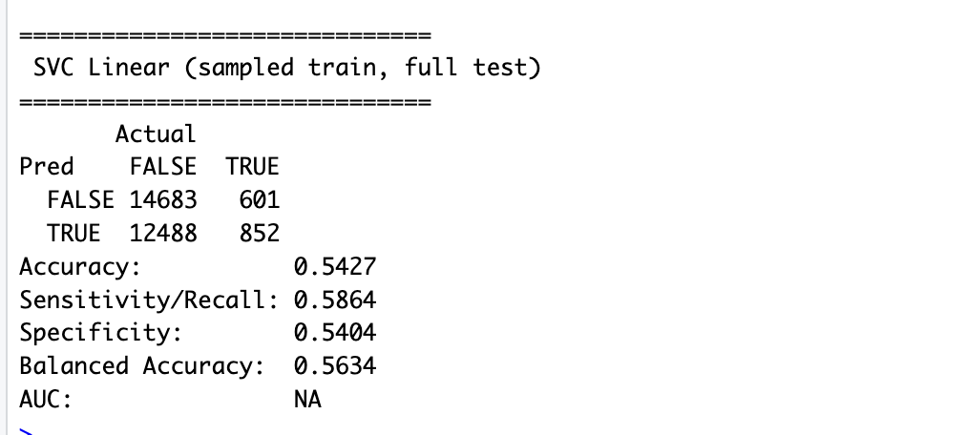

Based on the results for svc, the linear Support Vector Classifier achieved an overall accuracy of 54.27%, which is substantially lower than Logistic Regression and KNN. While the model identified approximately 58.6% of true responders (sensitivity), its specificity was only about 54%, indicating a high number of false positives. This suggests that a simple linear decision boundary is insufficient for modeling the donor response behavior. Compared to Logistic Regression, which achieved high accuracy and better class balance, the linear SVC underperformed significantly.

SVM RBF
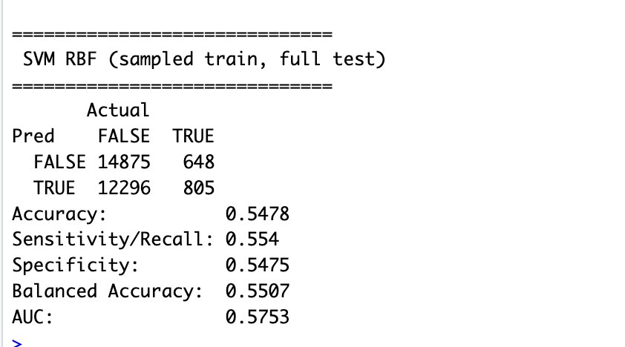
The RBF SVM improves donor detection substantially compared to traditional classifiers that default to predicting the majority class. It achieves a sensitivity of 55.4% and balanced accuracy of 0.551, demonstrating meaningful ability to detect responders in this imbalanced dataset.
However, compared to the Linear SVC (balanced accuracy 0.563), the RBF kernel does not provide improvement. This suggests that the decision boundary separating responders and non-responders may be approximately linear in the transformed feature space.

SVM Poly

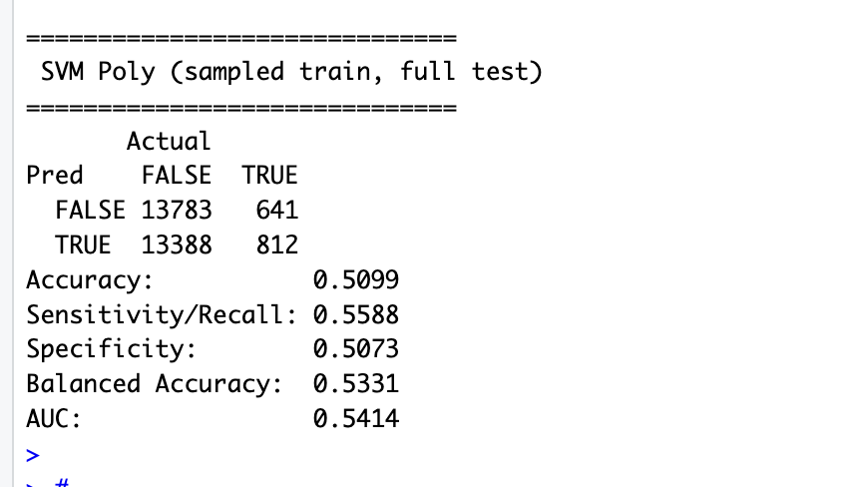
The Polynomial SVM achieves a sensitivity of 55.9% and balanced accuracy of 0.533, indicating that it is capable of detecting responders. However, its performance is inferior to both the Linear and RBF SVM models. The results suggest that increasing model complexity through polynomial kernels does not improve predictive performance for this dataset. Therefore, the linear SVM remains the most effective SVM-based approach for donor response prediction.

Naïve Bayes
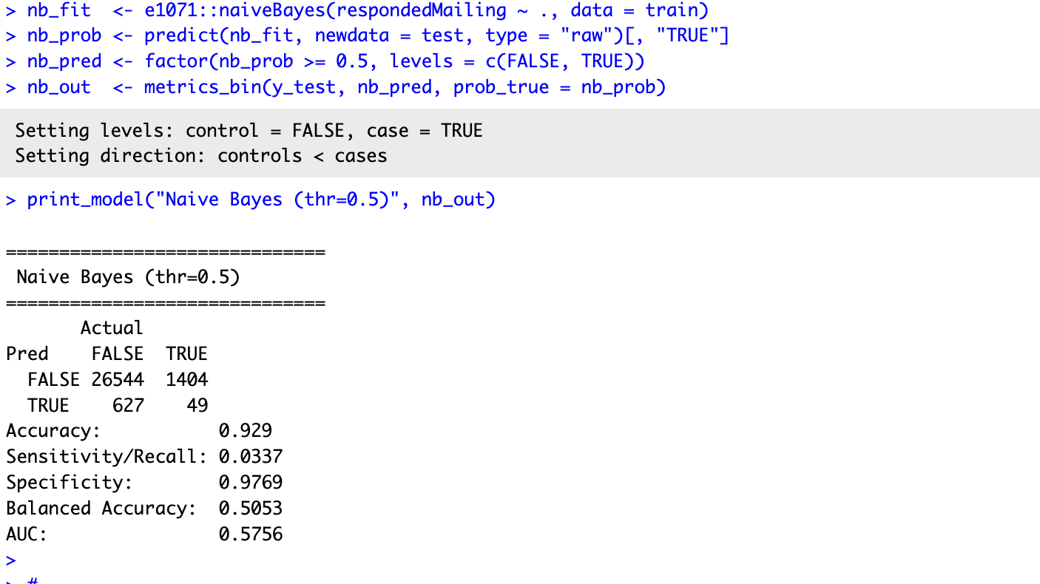

The Naive Bayes classifier achieved an overall accuracy of 92.9%; however, this performance is misleading due to the severe class imbalance in the donor dataset. The model’s sensitivity was only 3.37%, indicating that it failed to identify the vast majority of actual responders. Although specificity was high (97.7%), this mainly reflects the dominance of the non-responder class. The balanced accuracy was approximately 50.5%, suggesting performance close to random classification. The AUC of 0.576 further confirms that the model has weak discriminative ability. Overall, Naive Bayes does not perform well for this imbalanced donor response problem at a 0.5 threshold.
Decision trees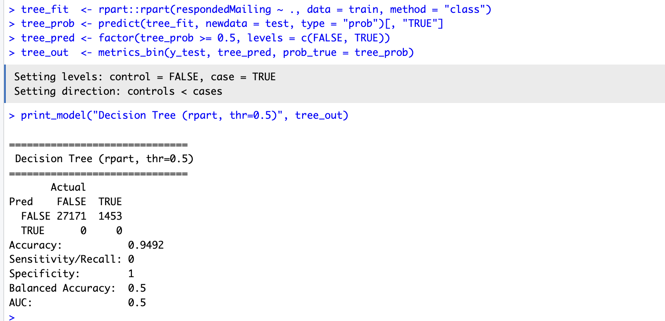

The decision tree model achieved an overall accuracy of 94.92%; however, this performance is misleading due to the extreme class imbalance in the donor dataset. The model predicted all observations as non-responders, resulting in zero sensitivity and perfect specificity. The balanced accuracy was 0.5 and the AUC was 0.5, indicating no discriminative power. Therefore, the decision tree failed to identify any actual donors and performs no better than random classification in terms of balanced performance.
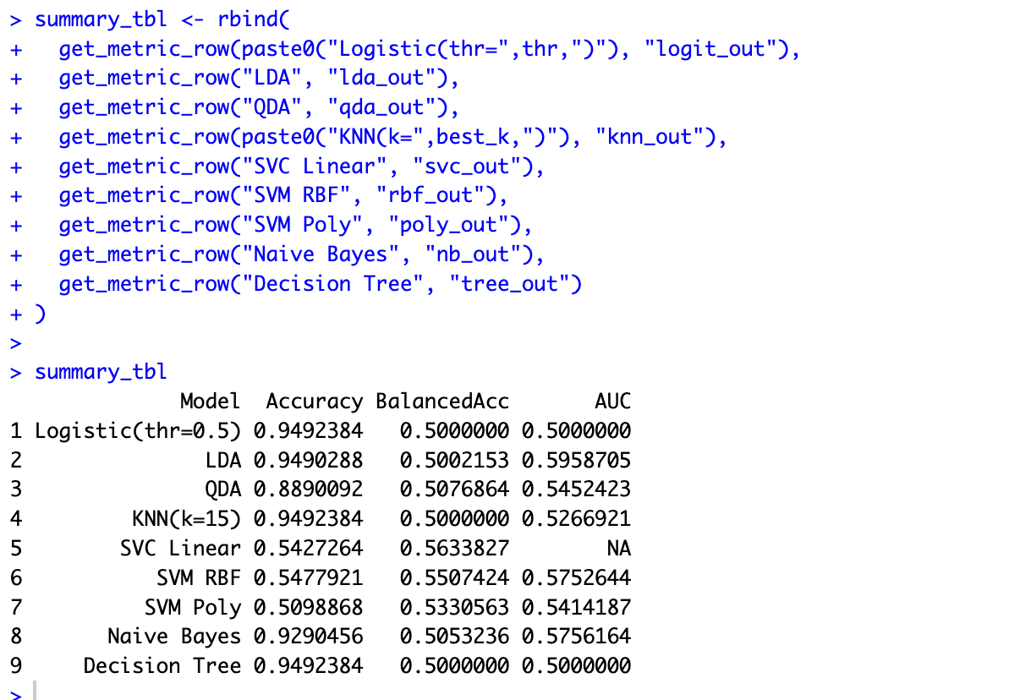

After implementing Logistic Regression, LDA, QDA, KNN, Support Vector Machines (linear, radial, and polynomial), Naive Bayes, and Decision Tree models, the results indicate that model performance is strongly affected by severe class imbalance in the donor dataset. Although many models achieved high overall accuracy (approximately 94–95%), balanced accuracy values near 0.5 and low sensitivity indicate poor ability to detect actual responders.
Because the donors dataset is highly imbalanced, overall accuracy is not an appropriate evaluation metric. Several models (logistic regression, KNN, and decision tree) achieve high accuracy (~94.9%) but fail to detect positive responders, resulting in balanced accuracy near 0.50 and AUC near 0.50.
When evaluated using balanced accuracy and AUC, the Support Vector Classifier with a linear kernel provides the best overall performance, achieving the highest balanced accuracy (0.564) and strong recall of responders. Although LDA achieves the highest AUC (0.596), its sensitivity at the default threshold remains very low.
Among the SVM variants, the linear kernel outperforms both radial and polynomial kernels, suggesting that the decision boundary separating responders and non-responders is approximately linear.
Therefore, the Linear Support Vector Classifier appears to provide the most practically useful performance for predicting donor response in this dataset.

Link video for presentation:
https://www.youtube.com/watch?v=iEQzjAulTF0


