B?O C?O CHI TI?T D? ?N DATA SCIENCE
Restaurant Review Sentiment Analysis
Ph?n lo?i c?m x?c ??nh gi? nh? h?ng b?ng TF-IDF v? Multinomial Naive Bayes

Th?ng tin | N?i dung
Nh?m th?c hi?n | Nh?m 5
B?i to?n | Ph?n lo?i review th?nh Negative, Neutral, Positive
Ng?n ng? d? li?u | Ti?ng Anh
C?ng ngh? ch?nh | Python, pandas, scikit-learn, matplotlib, seaborn, joblib
Ng?y l?p b?o c?o | 22/05/2026

M?c l?c
1. T?m t?t d? ?n
2. M?c ti?u v? ph?m vi
3. C?u tr?c project
4. M? t? d? li?u
5. Quy tr?nh ti?n x? l?
6. Ph?n t?ch kh?m ph? d? li?u
7. X?y d?ng m? h?nh
8. ??nh gi? k?t qu?
9. Script d? ?o?n v? c?ch ch?y
10. H?n ch? v? h??ng ph?t tri?n
11. K?t lu?n

1. T?m t?t d? ?n
D? ?n Restaurant Review Sentiment Analysis x?y d?ng m?t pipeline Data Science nh?m ph?n lo?i c?m x?c c?a review nh? h?ng. ??u v?o c?a h? th?ng l? n?i dung review ti?ng Anh, ??u ra l? m?t trong ba nh?n c?m x?c: Negative, Neutral ho?c Positive. Nh?n m?c ti?u ???c sinh t? c?t Rating theo quy t?c 1-2 sao l? Negative, 3 sao l? Neutral, 4-5 sao l? Positive.
Sau ti?n x? l?, t?p d? li?u c?n 9,219 d?ng v? 4 c?t. M? h?nh baseline s? d?ng TF-IDF k?t h?p Multinomial Naive Bayes, ??t accuracy 0.8221 tr?n t?p test 1,844 m?u. K?t qu? cho th?y m? h?nh nh?n di?n t?t l?p Positive v? Negative, nh?ng l?p Neutral c?n y?u do s? l??ng m?u ?t h?n v? ranh gi?i ng? ngh?a gi?a Neutral v?i hai l?p c?n l?i kh?ng r? r?ng.

2. M?c ti?u v? ph?m vi

2.1. M?c ti?u
- Kh?o s?t d? li?u review nh? h?ng, ki?m tra missing value, rating kh?ng h?p l? v? review tr?ng l?p.
- L?m s?ch v?n b?n review v? t?o nh?n sentiment t? rating.
- Ph?n t?ch ph?n b? rating, sentiment v? ?? d?i review ?? hi?u ??c ?i?m d? li?u.
- Hu?n luy?n m? h?nh baseline ph?c v? ph?n lo?i c?m x?c review.
- L?u artifact m? h?nh, vectorizer, bi?u ?? v? b?o c?o ??nh gi? ?? t?i s? d?ng.
- Cung c?p script d?ng l?nh ?? d? ?o?n sentiment cho review m?i.

2.2. Ph?m vi
Project t?p trung v?o b?i to?n supervised learning ? m?c baseline. D? li?u ??u v?o l? review ti?ng Anh; pipeline hi?n t?i ch?a x? l? ?a ng?n ng?, ch?a d?ng m? h?nh deep learning v? ch?a tri?n khai th?nh API ho?c web app.

3. C?u tr?c project
Th?nh ph?n | Vai tr?
data/raw/restaurant_reviews.csv | D? li?u g?c g?m th?ng tin nh? h?ng, reviewer, review, rating v? m?t s? metadata.
data/processed/clean_reviews.csv | D? li?u sau ti?n x? l? g?m Review, Rating, review_clean v? sentiment.
notebooks/01_data_overview.ipynb | Kh?o s?t d? li?u g?c v? hai c?t ch?nh Review, Rating.
notebooks/02_preprocessing.ipynb | L?m s?ch d? li?u, chu?n h?a rating, x?a tr?ng l?p, t?o review_clean v? sentiment.
notebooks/03_eda.ipynb | Ph?n t?ch ph?n b? rating, sentiment v? ?? d?i review; xu?t bi?u ??.
notebooks/04_train_naive_bayes.ipynb | Hu?n luy?n TF-IDF + Multinomial Naive Bayes v? ??nh gi? m? h?nh.
src/predict.py | Script d? ?o?n sentiment cho review m?i b?ng model ?? l?u.
figures/ | Ch?a c?c bi?u ?? EDA v? confusion matrix.
models/ | Ch?a naive_bayes_model.joblib v? tfidf_vectorizer.joblib.
reports/classification_report.csv | B?ng precision, recall, F1-score v? support.

4. M? t? d? li?u
D? li?u g?c c? 10,000 d?ng v? 8 c?t: Restaurant, Reviewer, Review, Rating, Metadata, Time, Pictures, 7514. Trong pipeline m? h?nh, project ch? s? d?ng hai c?t Review v? Rating v? ??y l? hai tr??ng tr?c ti?p ph?c v? b?i to?n ph?n lo?i c?m x?c.
C?t d? li?u g?c | S? gi? tr? thi?u
Restaurant | 0
Reviewer | 38
Review | 45
Rating | 38
Metadata | 38
Time | 38
Pictures | 0
7514 | 9999

T?p raw c? 635 review tr?ng l?p theo c?t Review. C?c b?n ghi thi?u Review ho?c Rating, rating kh?ng chuy?n ???c sang s?, rating ngo?i kho?ng 1-5 v? review tr?ng ???c lo?i b? trong b??c ti?n x? l?.
Ch? ti?u | Gi? tr?
S? d?ng sau ti?n x? l? | 9,219
S? c?t sau ti?n x? l? | 4
C?c c?t | Review, Rating, review_clean, sentiment
S? review_clean r?ng/thi?u | 11

5. Quy tr?nh ti?n x? l?
Quy tr?nh ti?n x? l? ???c th?c hi?n trong notebook 02_preprocessing.ipynb v?i c?c b??c ch?nh sau:
- Ch? gi? hai c?t c?n thi?t l? Review v? Rating ?? gi?m nhi?u t? c?c metadata kh?ng d?ng cho m? h?nh.
- X?a c?c d?ng thi?u Review ho?c Rating.
- Chuy?n Rating sang ki?u s? b?ng pd.to_numeric(errors="coerce"), sau ?? lo?i c?c gi? tr? kh?ng h?p l?.
- Ch? gi? rating nguy?n t? 1 ??n 5.
- X?a c?c review tr?ng l?p theo n?i dung Review.
- L?m s?ch text: chuy?n ch? th??ng, x?a URL, lo?i k? t? kh?ng ph?i ch? c?i ti?ng Anh, chu?n h?a kho?ng tr?ng.
- T?o nh?n sentiment: 1-2 sao l? Negative, 3 sao l? Neutral, 4-5 sao l? Positive.
- L?u d? li?u s?ch ra data/processed/clean_reviews.csv.
Rating | Sentiment
1, 2 | Negative
3 | Neutral
4, 5 | Positive

6. Ph?n t?ch kh?m ph? d? li?u

6.1. Ph?n b? rating
Rating | S? l??ng | T? l?
1 | 1,710 | 18.55%
2 | 675 | 7.32%
3 | 1,163 | 12.62%
4 | 2,297 | 24.92%
5 | 3,374 | 36.60%

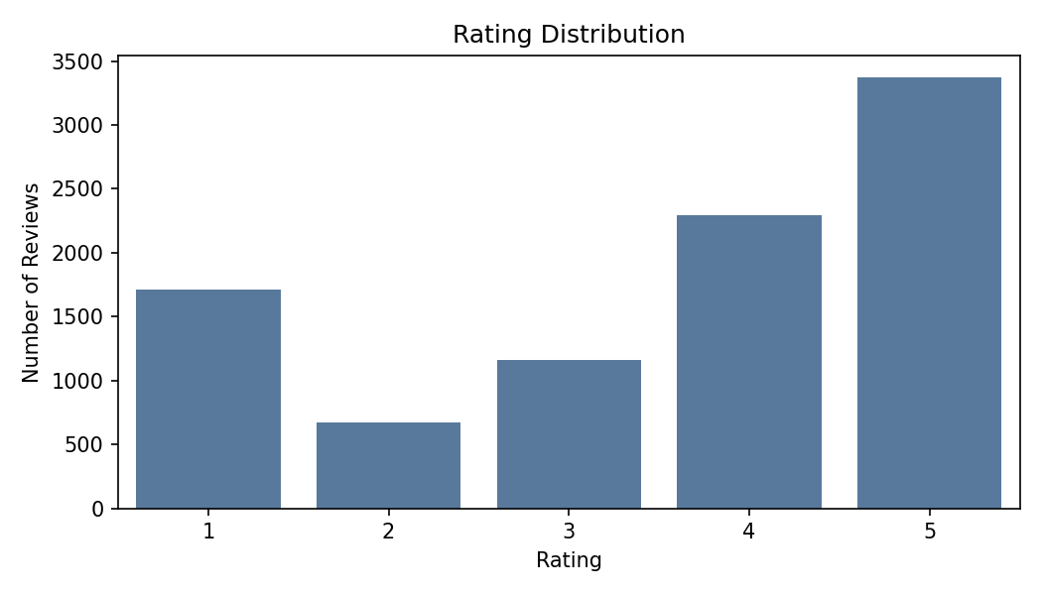
H?nh 1. Ph?n b? rating sau ti?n x? l?
D? li?u thi?n v? ??nh gi? t?ch c?c: rating 4 v? 5 chi?m ph?n l?n, ??c bi?t rating 5 chi?m t? l? cao nh?t. ?i?u n?y ph?n ?nh s? m?t c?n b?ng t? nhi?n c?a t?p d? li?u v? ?nh h??ng tr?c ti?p ??n ph?n b? sentiment.

6.2. Ph?n b? sentiment
Sentiment | S? l??ng | T? l?
Negative | 2,385 | 25.87%
Neutral | 1,163 | 12.62%
Positive | 5,671 | 61.51%

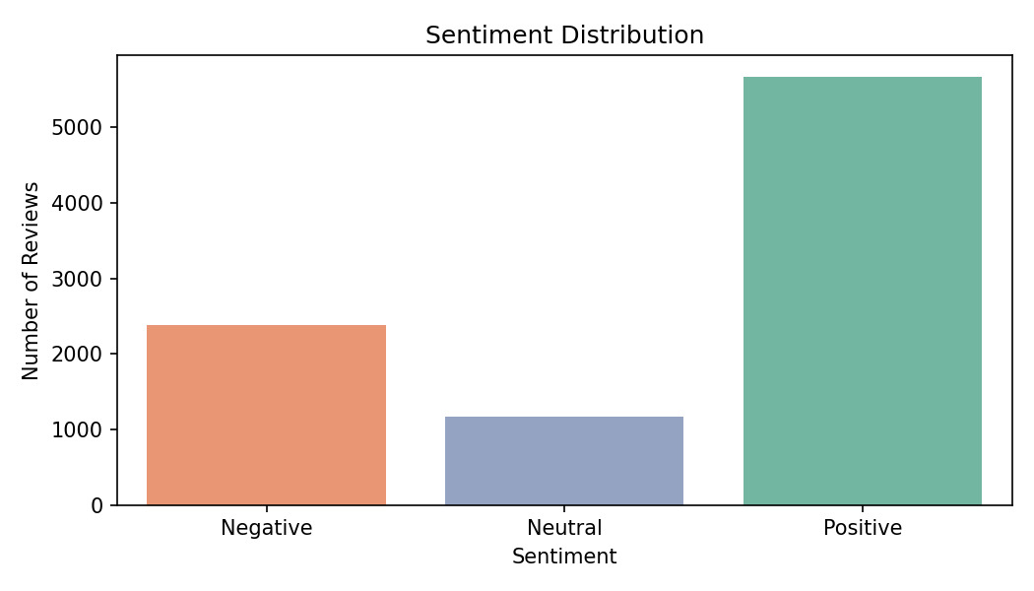
H?nh 2. Ph?n b? sentiment
L?p Positive c? 5,671 m?u, chi?m 61.51% d? li?u. L?p Neutral ch? c? 1,163 m?u, chi?m 12.62%, l? l?p nh? nh?t v? c?ng l? l?p kh? h?c nh?t trong m? h?nh hi?n t?i.

6.3. ?? d?i review
Th?ng k? | Gi? tr?
S? review | 9,219
Trung b?nh | 52.76 t?
?? l?ch chu?n | 60.87 t?
Nh? nh?t | 1 t?
Trung v? | 36 t?
L?n nh?t | 969 t?

Sentiment | ?? d?i TB | Trung v? | D?i nh?t
Negative | 49.02 | 35 | 617
Neutral | 58.02 | 41 | 695
Positive | 53.25 | 35 | 969

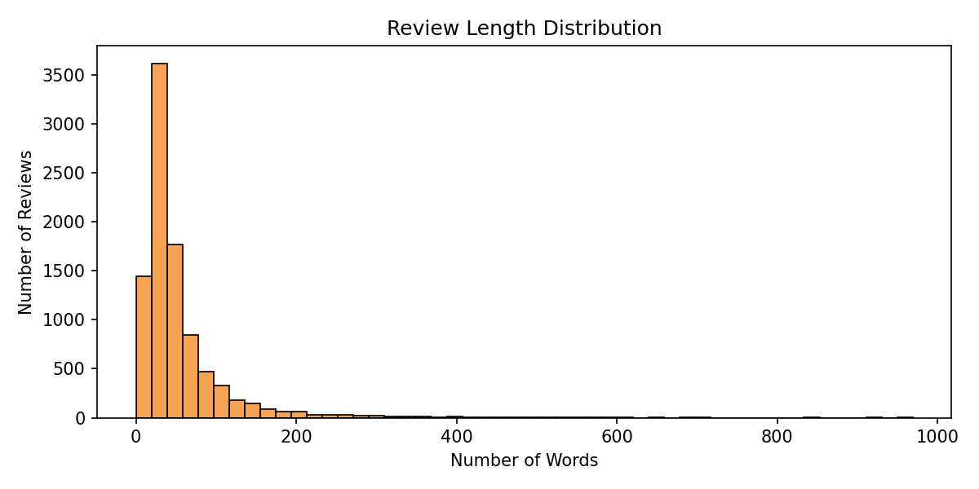
H?nh 3. Ph?n b? ?? d?i review
?a s? review c? ?? d?i v?a ph?i, trung v? kho?ng 36 t?. Tuy nhi?n v?n t?n t?i c?c review r?t d?i, l?n t?i 969 t?. ?? d?i review c?a ba l?p kh?ng ch?nh l?ch qu? l?n, n?n ??c tr?ng n?i dung t? v?ng quan tr?ng h?n ?? d?i ??n thu?n.

7. X?y d?ng m? h?nh

7.1. Chia t?p train/test
Sentiment | Train | Test
Negative | 1,908 | 477
Neutral | 930 | 233
Positive | 4,537 | 1,134

D? li?u ???c chia theo t? l? 80/20 v?i random_state=42 v? stratify=y. T?p train c? 7,375 m?u, t?p test c? 1,844 m?u. Stratify gi?p t? l? c?c l?p trong train v? test g?n gi?ng ph?n b? g?c.

7.2. Vector h?a v?n b?n b?ng TF-IDF
Tham s? TF-IDF | Gi? tr?
max_features | 5000
min_df | 2
max_df | 0.9
ngram_range | (1, 2)
use_idf | True
norm | l2
K?ch th??c vocabulary sau fit | 5,000

TF-IDF bi?n review ?? l?m s?ch th?nh vector s? d?a tr?n m?c ?? quan tr?ng c?a t? ho?c c?m t?. Vi?c d?ng ngram_range=(1, 2) cho ph?p m? h?nh h?c c? unigram v? bigram, v? d? c?c c?m nh? good food ho?c bad service.

7.3. Multinomial Naive Bayes
Th?ng tin m? h?nh | Gi? tr?
Lo?i m? h?nh | MultinomialNB
alpha | 1.0
fit_prior | True
class_prior | None
classes_ | Negative, Neutral, Positive

Multinomial Naive Bayes ph? h?p v?i d? li?u v?n b?n d?ng t?n su?t ho?c TF-IDF, hu?n luy?n nhanh v? l? l?a ch?n baseline h?p l? cho b?i to?n sentiment classification.

8. ??nh gi? k?t qu?

8.1. Classification report
L?p/Ch? s? | Precision | Recall | F1-score | Support
Negative | 0.8031 | 0.8553 | 0.8284 | 477.0000
Neutral | 0.5556 | 0.0215 | 0.0413 | 233.0000
Positive | 0.8312 | 0.9727 | 0.8964 | 1134.0000
accuracy | 0.8221 | 0.8221 | 0.8221 | 0.8221
macro avg | 0.7300 | 0.6165 | 0.5887 | 1844.0000
weighted avg | 0.7891 | 0.8221 | 0.7708 | 1844.0000

Accuracy ??t 0.8221. Weighted F1-score ??t 0.7708, trong khi macro F1-score ch? ??t 0.5887. Kho?ng c?ch n?y cho th?y k?t qu? t?ng th? b? ?nh h??ng b?i vi?c l?p Positive chi?m t? tr?ng l?n.

8.2. Confusion matrix
Th?c t? / D? ?o?n | Negative | Neutral | Positive
Negative | 408 | 3 | 66
Neutral | 70 | 5 | 158
Positive | 30 | 1 | 1103

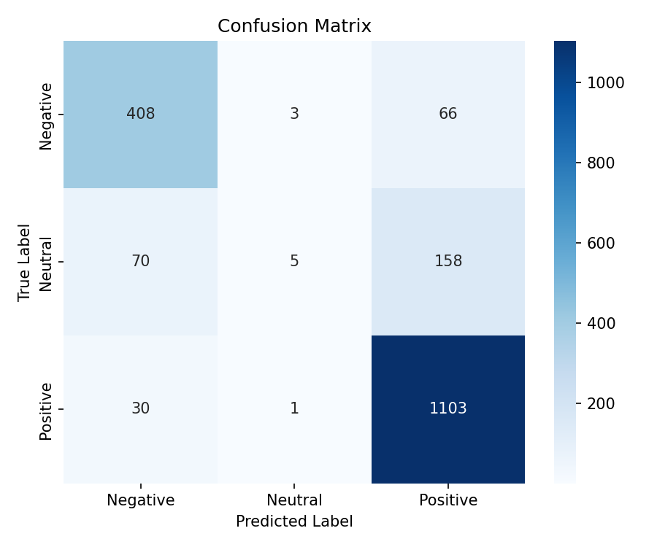
H?nh 4. Confusion matrix tr?n t?p test
M? h?nh d? ?o?n ??ng 1,103/1,134 m?u Positive v? 408/477 m?u Negative. ??i v?i Neutral, m? h?nh ch? d? ?o?n ??ng 5/233 m?u, ph?n l?n b? nh?m sang Positive ho?c Negative. Nguy?n nh?n ch?nh l? l?p Neutral ?t d? li?u, n?i dung review trung t?nh th??ng ch?a c? t?n hi?u t?ch c?c v? ti?u c?c, ??ng th?i nh?n Neutral ???c suy ra t? rating 3 n?n c? th? nhi?u.

8.3. Nh?n x?t theo t?ng l?p
- Positive: F1-score 0.8964, recall r?t cao 0.9727; m? h?nh nh?n di?n t?t review t?ch c?c.
- Negative: F1-score 0.8284, k?t qu? kh? ?n v? c?n b?ng h?n so v?i Neutral.
- Neutral: F1-score 0.0413; ??y l? ?i?m y?u r? nh?t c?a m? h?nh baseline.

9. Script d? ?o?n v? c?ch ch?y
File src/predict.py cung c?p ch?c n?ng d? ?o?n sentiment cho review m?i. Script t?i model v? vectorizer t? th? m?c models/, l?m s?ch review ??u v?o b?ng c?ng logic clean_text, vector h?a b?ng TF-IDF r?i d? ?o?n b?ng Multinomial Naive Bayes. N?u m? h?nh h? tr? predict_proba, script in th?m x?c su?t t?ng l?p.
B??c | L?nh/N?i dung
C?i th? vi?n | pip install -r requirements.txt
Ch?y notebook | Ch?y l?n l??t notebooks/01 ??n notebooks/04
D? ?o?n review m?i | python src/predict.py "The food was amazing and the staff were very friendly."

Review m?u | D? ?o?n
The food was amazing and the staff were very friendly. | Positive
The restaurant was okay, not bad but not special. | Neutral
The food was cold and the service was terrible. | Negative

10. H?n ch? v? h??ng ph?t tri?n

10.1. H?n ch?
- Nh?n sentiment ???c suy ra t? rating, kh?ng ph?i nh?n c?m x?c do con ng??i g?n tr?c ti?p, n?n c? th? t?n t?i nhi?u nh?n.
- D? li?u m?t c?n b?ng, l?p Neutral ?t h?n nhi?u so v?i Positive, d?n ??n recall v? F1-score c?a Neutral r?t th?p.
- Ti?n x? l? hi?n ch? gi? ch? c?i a-z n?n ch?a ph? h?p n?u d? li?u c? nhi?u k? t? ??c bi?t, emoji ho?c review ?a ng?n ng?.
- M? h?nh Naive Bayes gi? ??nh ??c l?p ?i?u ki?n gi?a c?c ??c tr?ng, kh? n?m b?t ng? c?nh ph?c t?p, ph? ??nh ho?c s?c th?i m?a mai.
- Project hi?n m?i ? m?c notebook/script, ch?a c? API, giao di?n ng??i d?ng ho?c pipeline t? ??ng h?a ??y ??.

10.2. H??ng ph?t tri?n
- Th? nghi?m c?n b?ng d? li?u b?ng class weighting, oversampling ho?c thu th?p th?m m?u Neutral.
- So s?nh th?m Logistic Regression, Linear SVM, Random Forest ho?c c?c m? h?nh transformer nh? BERT/RoBERTa.
- B? sung b??c x? l? stopword, lemmatization/stemming v? ki?m tra t?c ??ng l?n t?ng l?p.
- T?i ?u tham s? TF-IDF v? m? h?nh b?ng GridSearchCV ho?c RandomizedSearchCV.
- ??nh gi? th?m b?ng cross-validation v? ki?m th? tr?n m?t t?p d? li?u ngo?i.
- Tri?n khai th?nh API ho?c web app ?? nh?p review v? nh?n k?t qu? d? ?o?n tr?c ti?p.
- B? sung logging, ki?m th? t? ??ng v? h??ng d?n t?i hu?n luy?n m? h?nh.

11. K?t lu?n
Project ?? ho?n th?nh ??y ?? m?t pipeline Data Science c? b?n: kh?o s?t d? li?u, ti?n x? l?, EDA, hu?n luy?n m? h?nh, ??nh gi?, l?u artifact v? vi?t script d? ?o?n. Baseline TF-IDF + Multinomial Naive Bayes ??t accuracy t?t ? m?c 0.8221 v? ho?t ??ng hi?u qu? v?i hai l?p Positive/Negative. Tuy nhi?n, hi?u qu? v?i l?p Neutral c?n th?p, v? v?y h??ng c?i thi?n quan tr?ng nh?t l? x? l? m?t c?n b?ng d? li?u v? th? c?c m? h?nh c? kh? n?ng bi?u di?n ng? c?nh t?t h?n.

C?c file ??u ra ch?nh:
- models/naive_bayes_model.joblib
- models/tfidf_vectorizer.joblib
- reports/classification_report.csv
- figures/confusion_matrix.png
- src/predict.py

