**Report Lab 05: GUI Programming**

# Swing components

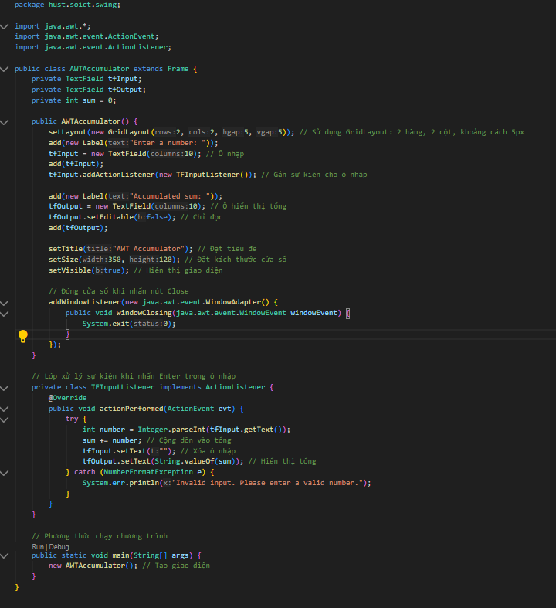

# Organizing Swing components with Layout Managers

# JavaFX API

