
Software Design Specification
VinaStay System
– Hanoi, November 2026 –
Record of changeS
Date | A*  M, D | In charge | Change Description
*A - Added M - Modified D - Deleted

Table of Contents
I. Overview 4
1. Code Packages 4
2. Database Design 4
a. Database Schema 4
b. Table Description 4
II. Code Designs 5
1. <Feature/Function Name1> 5
a. Class Diagram 5
b. Class Specifications 5
c. Sequence Diagram(s) 5
d. Database queries 6
2. <Feature/Function Name2> 6

I. Overview

1. System Architecture
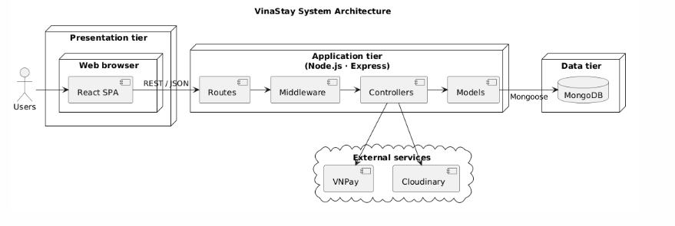

Component descriptions
No | Component | Description
01 | Presentation tier | A single-page web application built with React that runs in the user’s browser. It provides the user interface for Guests, Customers, Hotel Partners, Operations Managers and Admins, and calls the REST API of the application tier.
02 | Application tier | A Node.js/Express server that exposes the REST API of the system. It authenticates users with JSON Web Tokens, enforces role-based access, applies the business rules and accesses the data tier.
03 | Data tier | A MongoDB database that stores users, hotels, room types, bookings, payments, reviews and the other application data.
04 | VNPay | An external payment gateway that processes the online payments of bookings.
05 | Cloudinary | An external cloud storage service that stores and serves hotel and room images.

2. Code Packages
2.1 Backend
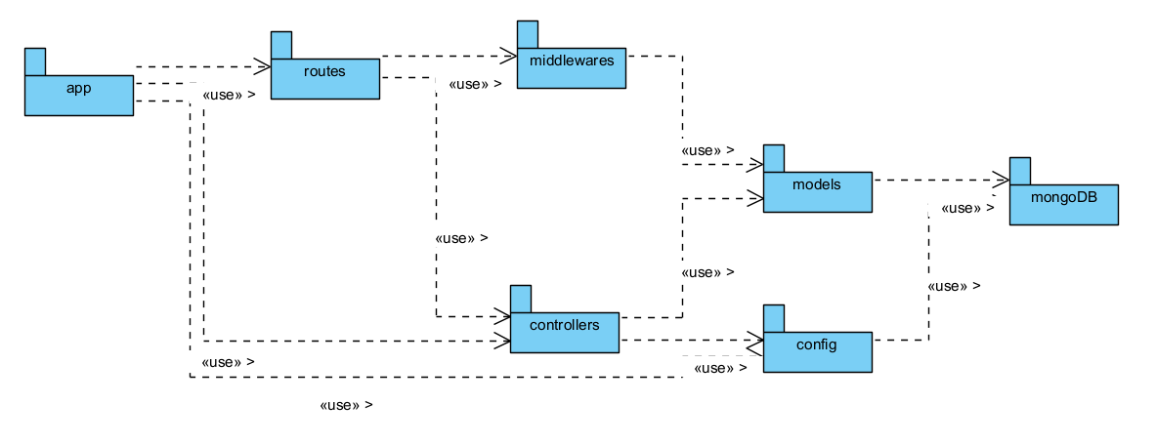
Package descriptions

No | Package | Description
01 | app | Main entry point of the backend application that initializes the server, loads configurations, and registers API routes.
02 | routes | Defines API endpoints and maps incoming HTTP requests to their corresponding middleware and controllers.
03 | middlewares | Provides request processing functions for authentication, authorization, validation, and error handling before reaching controllers.
04 | controllers | Contains the core business logic, handling HTTP request processing, interacting with models, and returning responses.
05 | models | Defines data structures, schemas, and ORM/ODM mappings for database entities.
06 | config | Manages environment variables, database connection settings, and system configurations.
07 | mongoDB | External database system storing application data, accessed via models and database connections.
2.2 Frontend
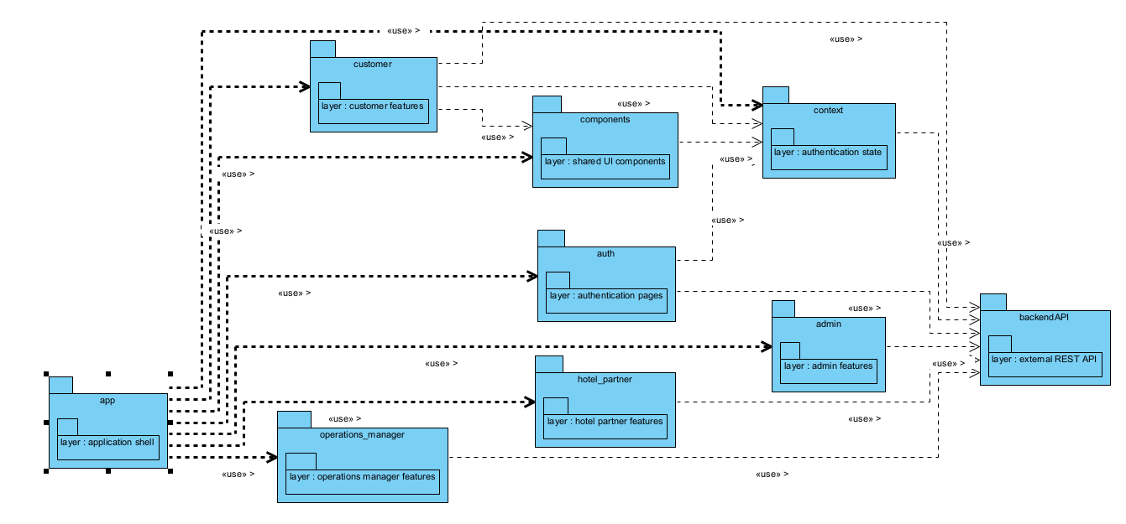
Package descriptions
No | Package | Description
01 | app (layer: application shell) | Main application shell and root routing/layout structure.
02 | customer (layer: customer features) | Contains pages and features for customer-facing flows (search, booking, history, reviews).
03 | components (layer: shared UI components) | Reusable UI components shared across different features.
04 | context (layer: authentication state) | Manages global states such as user authentication state and session data.
05 | auth (layer: authentication pages) | Contains login, registration, and other authentication-related pages.
06 | admin (layer: admin features) | Contains management and administrative features for system administrators.
07 | hotel_partner (layer: hotel partner features) | Contains features and dashboards for hotel partners/owners.
08 | operations_manager (layer: operations manager features) | Contains operational management features for staff/managers.
09 | backendAPI (layer: external REST API) | Handles communication and HTTP requests to the backend REST API.

3. Database Design

a. Database Schema
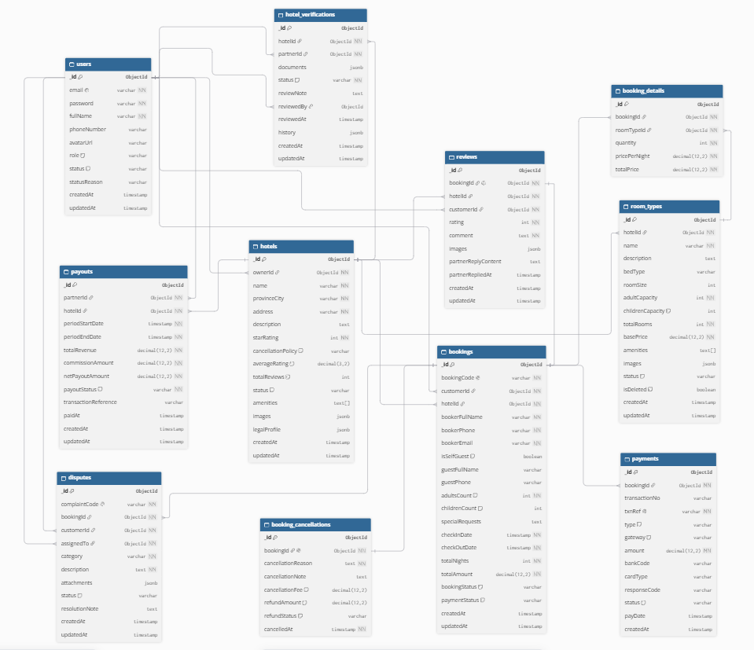

b. Table Description

No | Table | Description
01 | users | Stores user information in the system (customers, hotel partners, administrators), including account details, credentials, roles, and status.
02 | hotel_verifications | Tracks verification requests and review history for hotel registrations submitted by hotel partners, including reviewer notes and document references.
03 | payouts | Manages financial payout transactions and calculations to hotel partners, tracking revenue, commission, net payout amounts, and transaction status.
04 | complaints | Manages customer complaints related to bookings or hotels, assigned handlers, attachment links, and resolution status.
05 | booking_cancellations | Stores cancellation records for bookings, including cancellation reasons, fee calculations, refund amounts, and processing status.
06 | hotels | Stores detailed information about hotels, address, cancellation policy, average rating, amenities, legal profile, and images owned by partners.
07 | reviews | Stores reviews, ratings, comments, images, and responses from hotel partners after customers complete their stay.
08 | bookings | Stores customer room bookings, booking status, payment status, check-in/out dates, guest counts, and booker/guest information.
09 | booking_details | Stores line-item details for each booking, mapping reserved room types, quantities, nightly rates, and total prices.
10 | room_types | Manages room types for each hotel, including capacity, bed type, base price, total number of rooms, room size, and amenities.
11 | payments | Stores payment transactions related to bookings, including payment gateway, amount, transaction type, card details, and gateway responses.

II. Code Designs

1. Authentication

a. Class Diagram
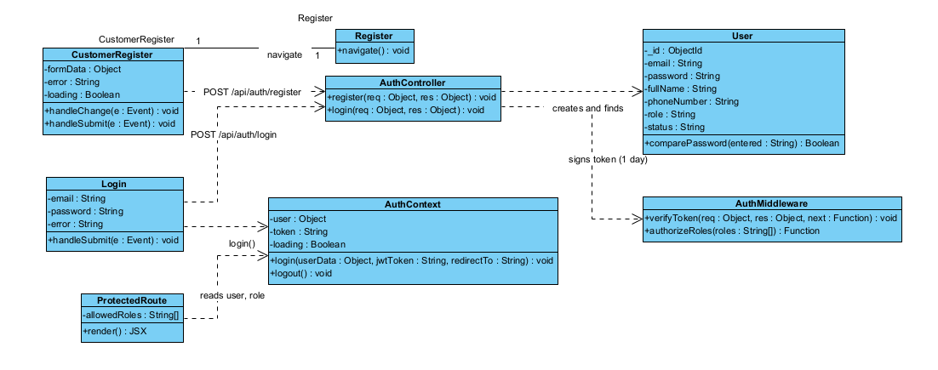

b. Sequence Diagram(s)
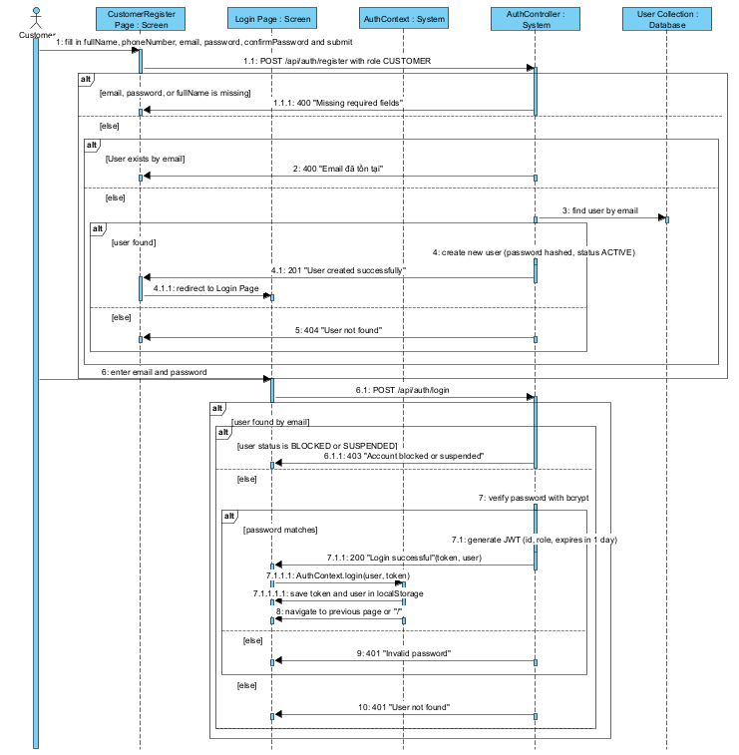

2. Book room & Payment

a. Class Diagram
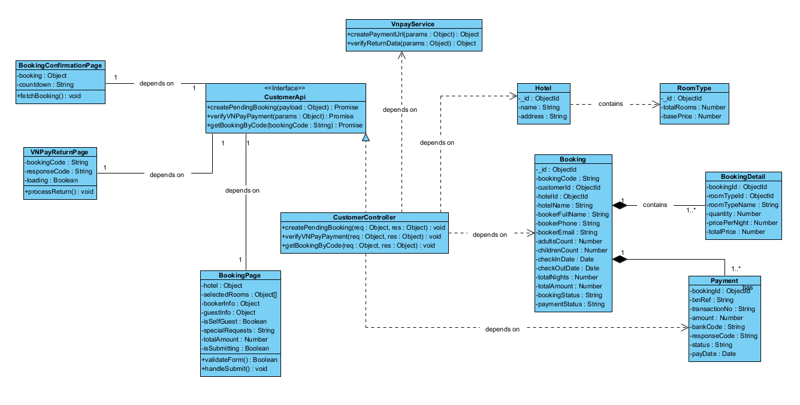

b. Sequence Diagram(s)
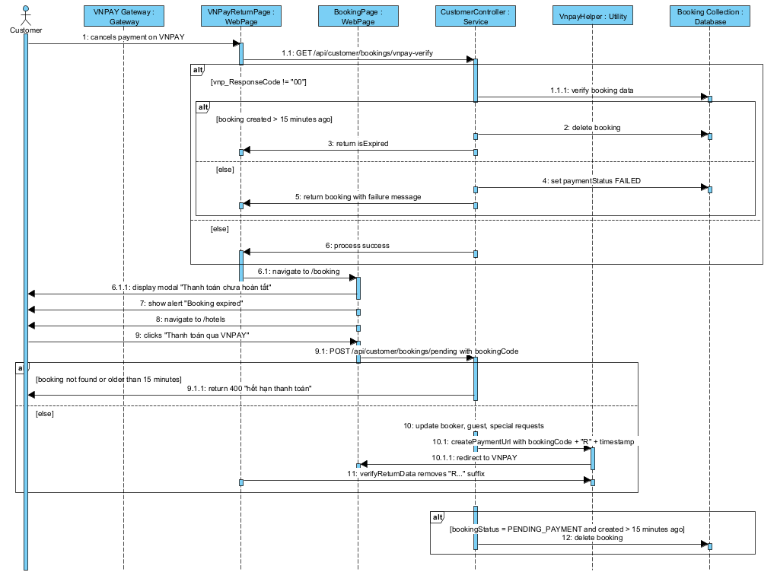

3. Cancel booking & Refund

a. Class Diagram
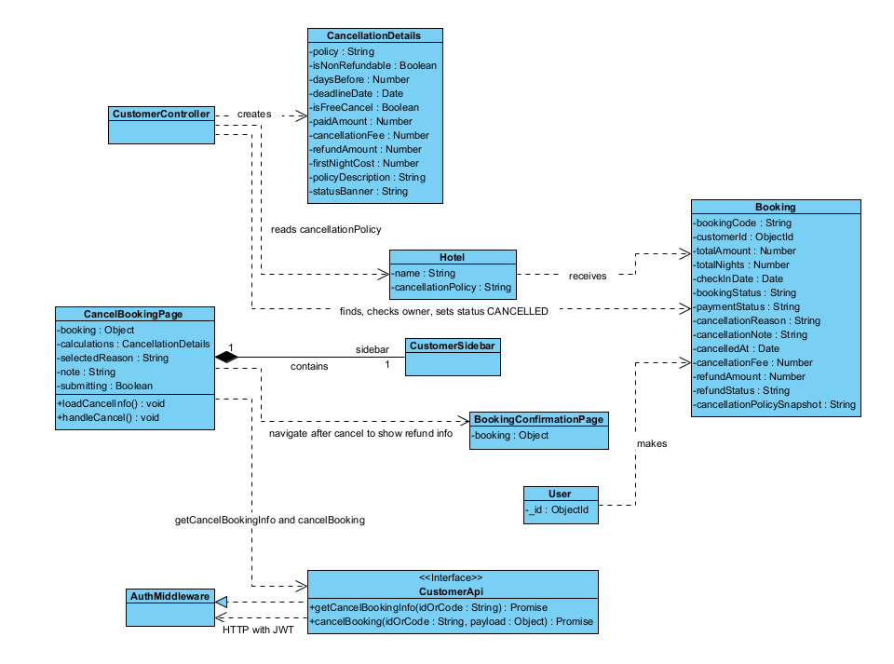

b. Sequence Diagram(s)
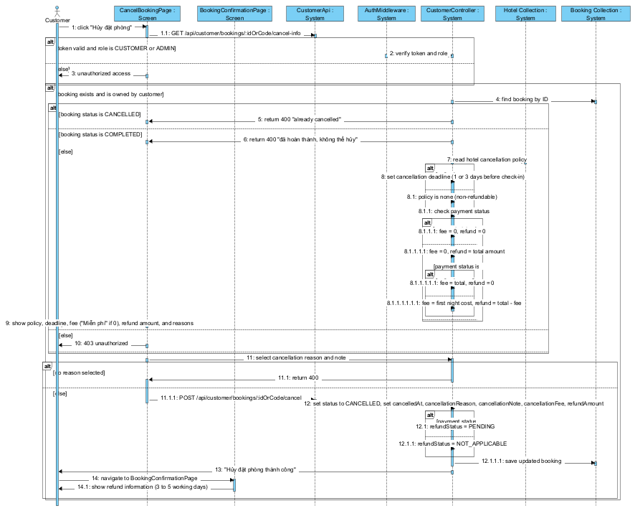

4. Search and Filter Hotels

a. Class Diagram
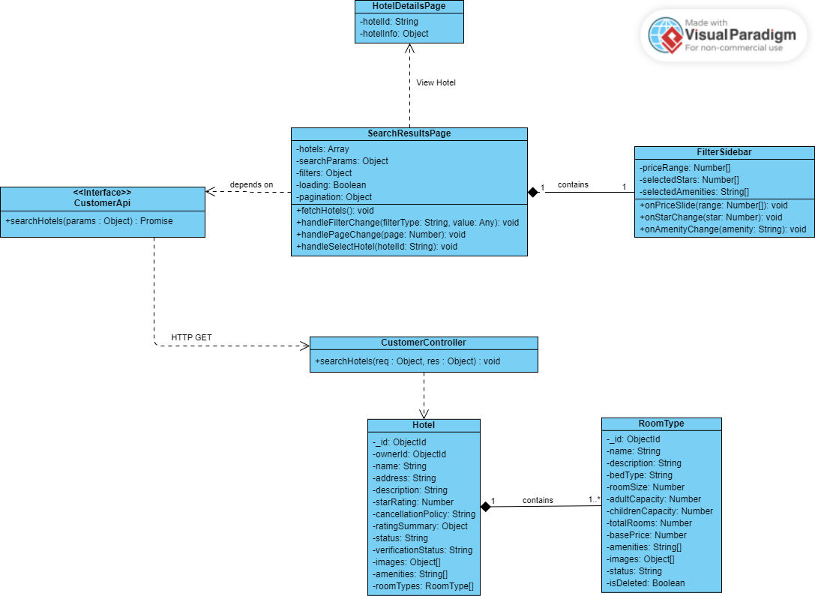

b. Sequence Diagram(s)
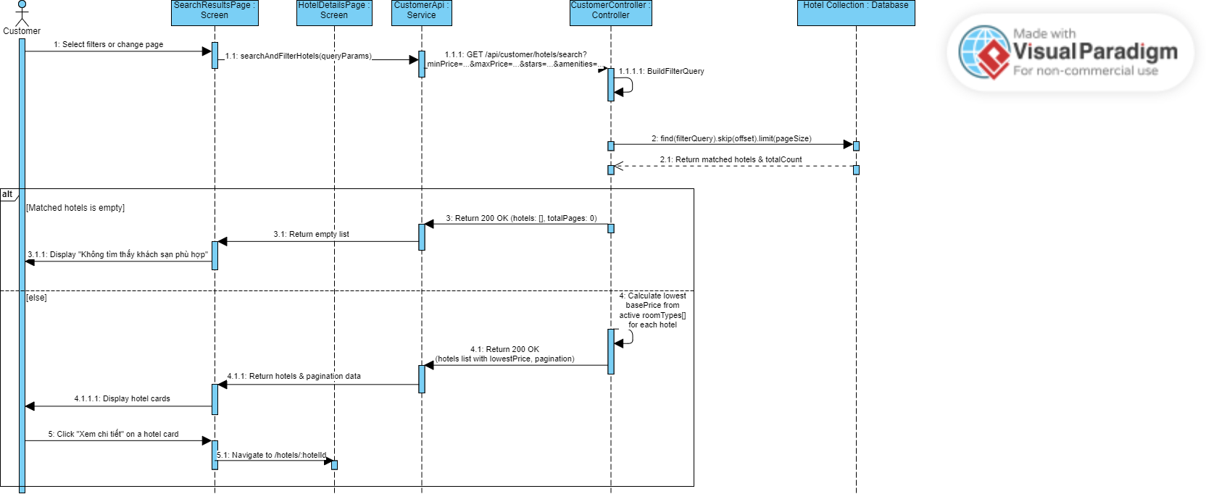

5. View Hotel Detail and Check room available

a. Class Diagram
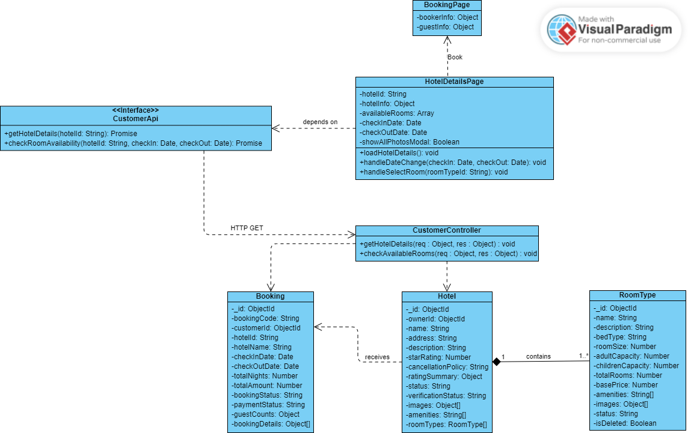

b. Sequence Diagram(s)
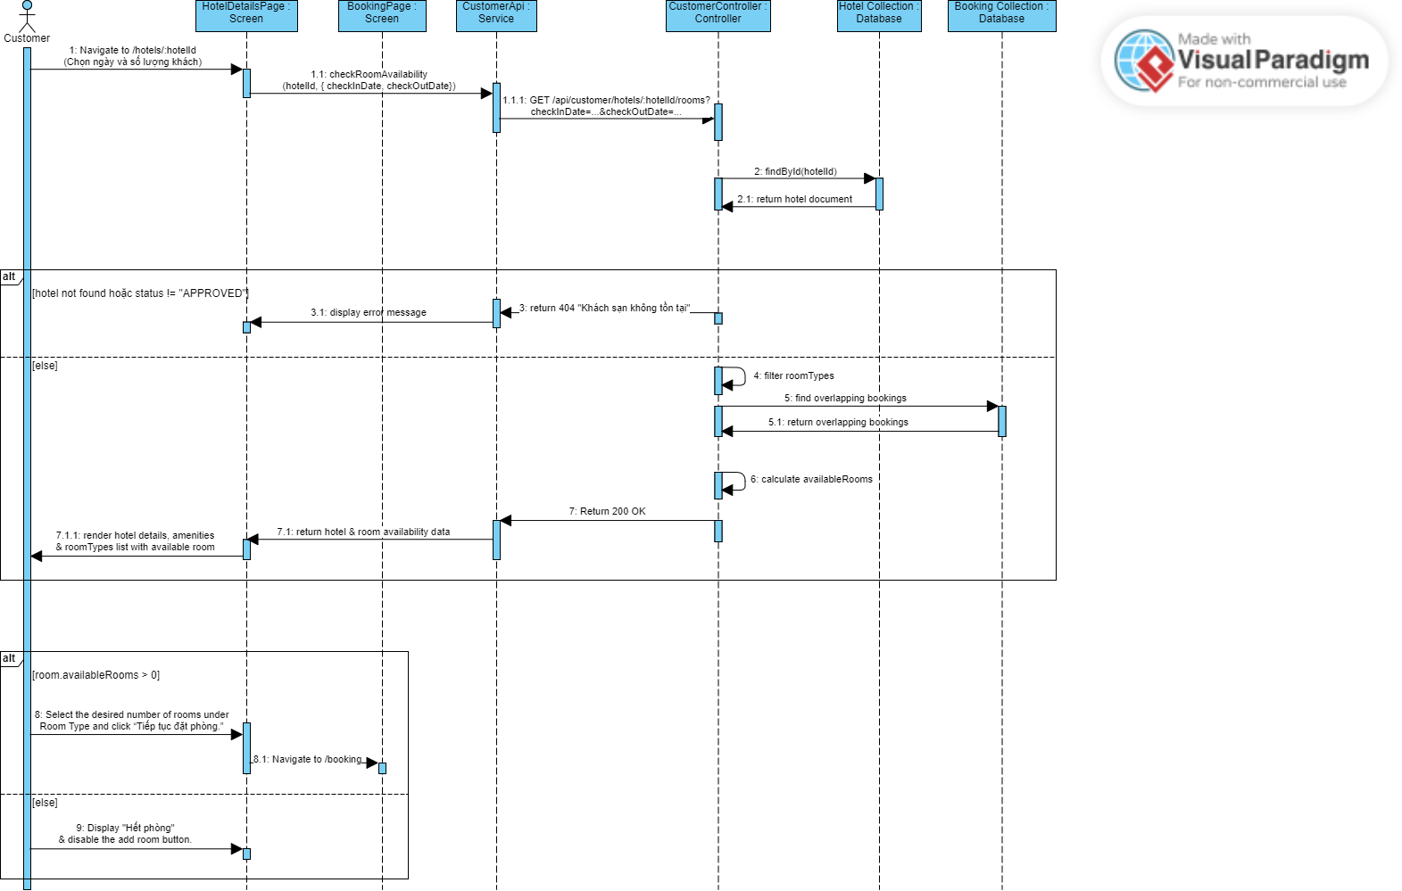

6. Submit Review & Rating

a. Class Diagram

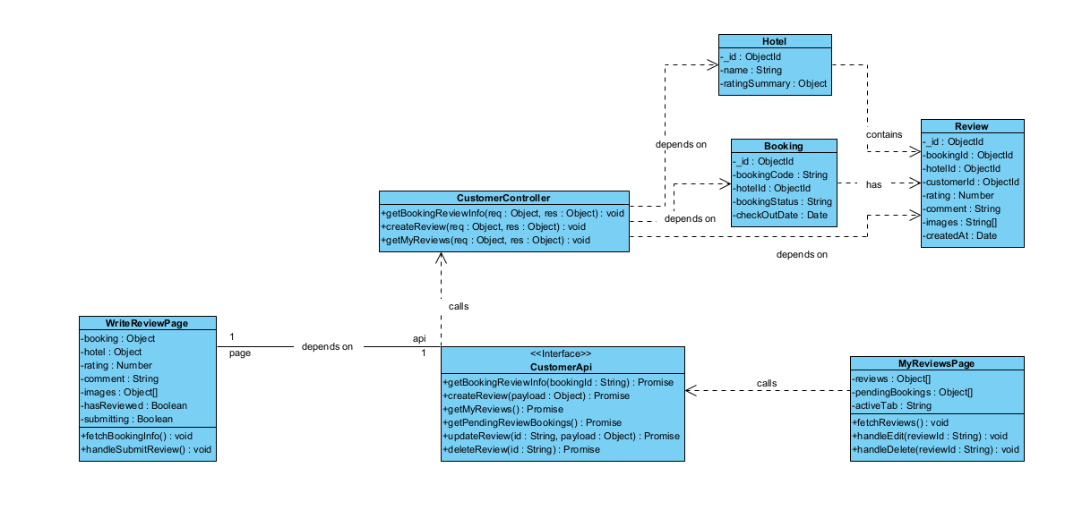

b. Sequence Diagram
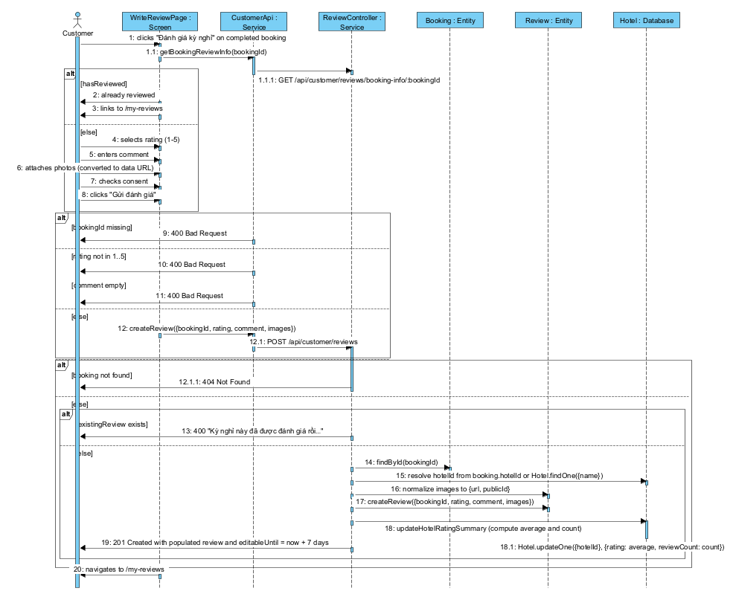

7. Submit Dispute

a. Class Diagram
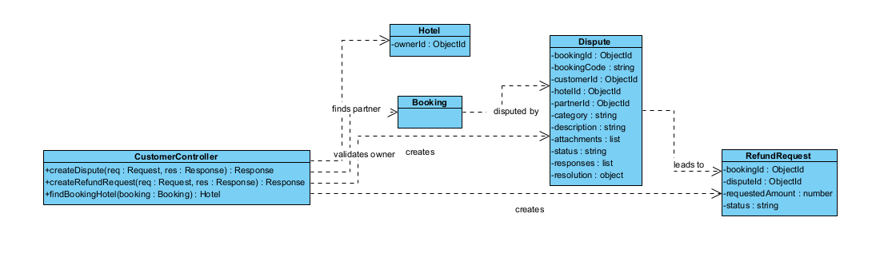

b. Sequence Diagram
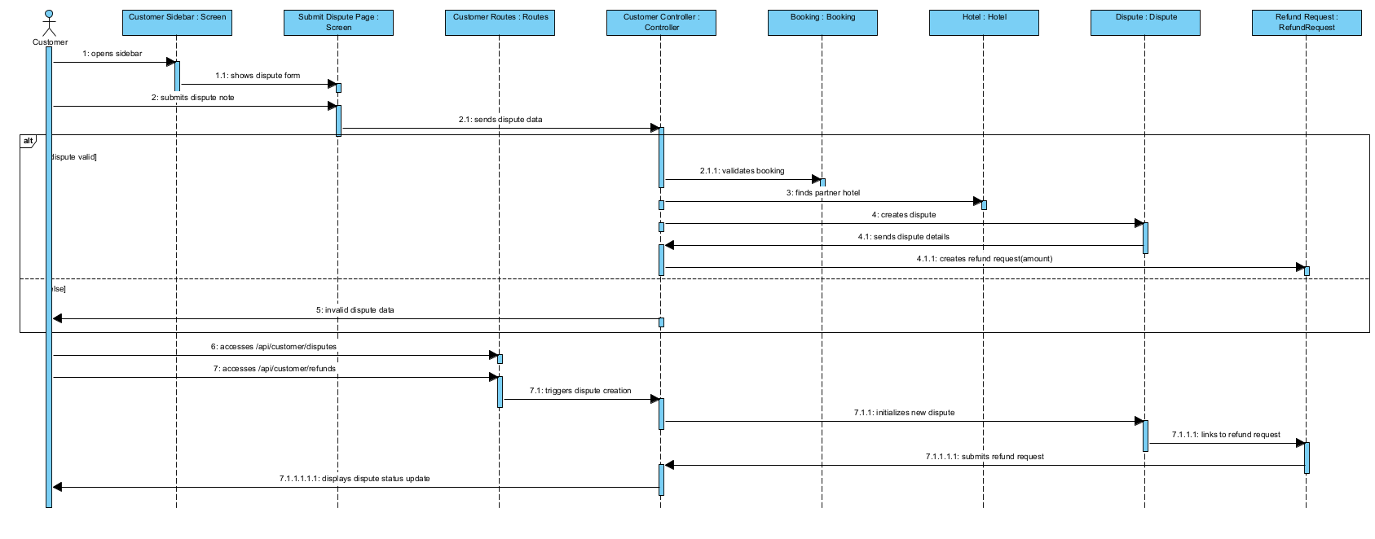

8. User Account Management

a. Class Diagram
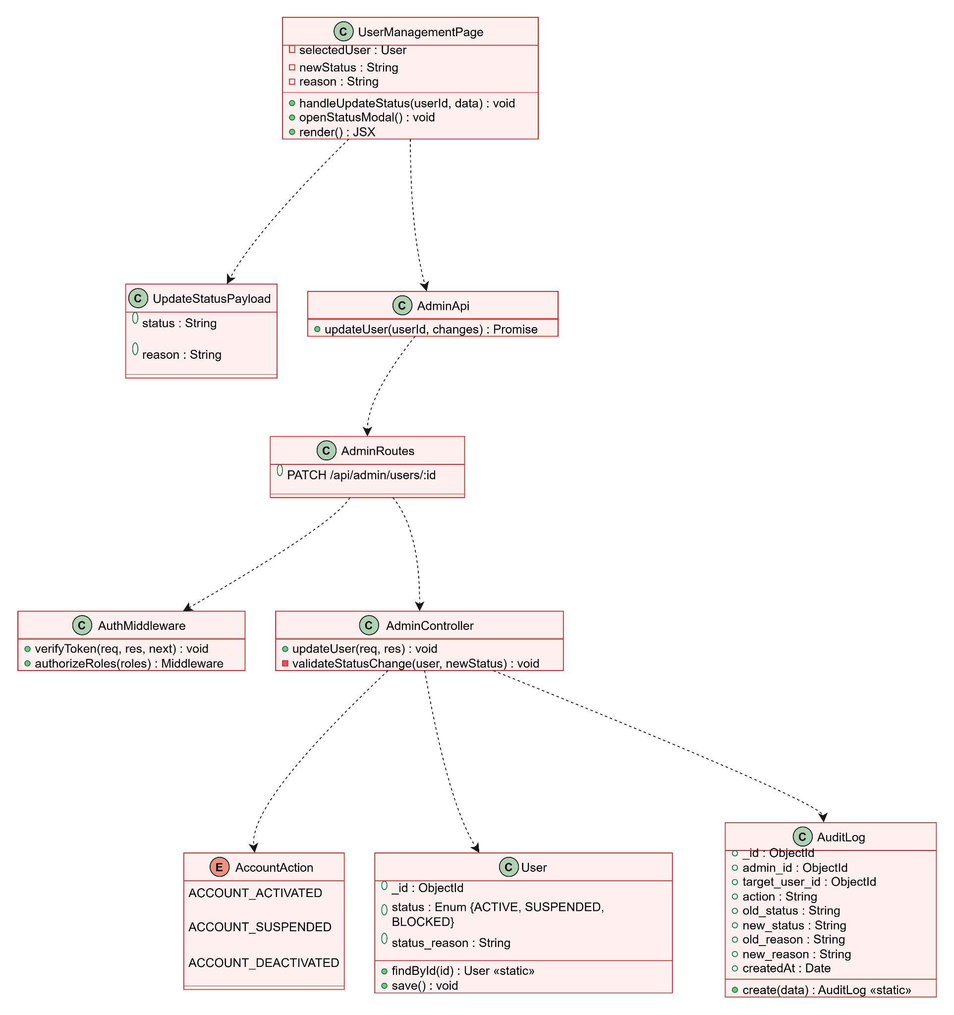

b. Sequence Diagram

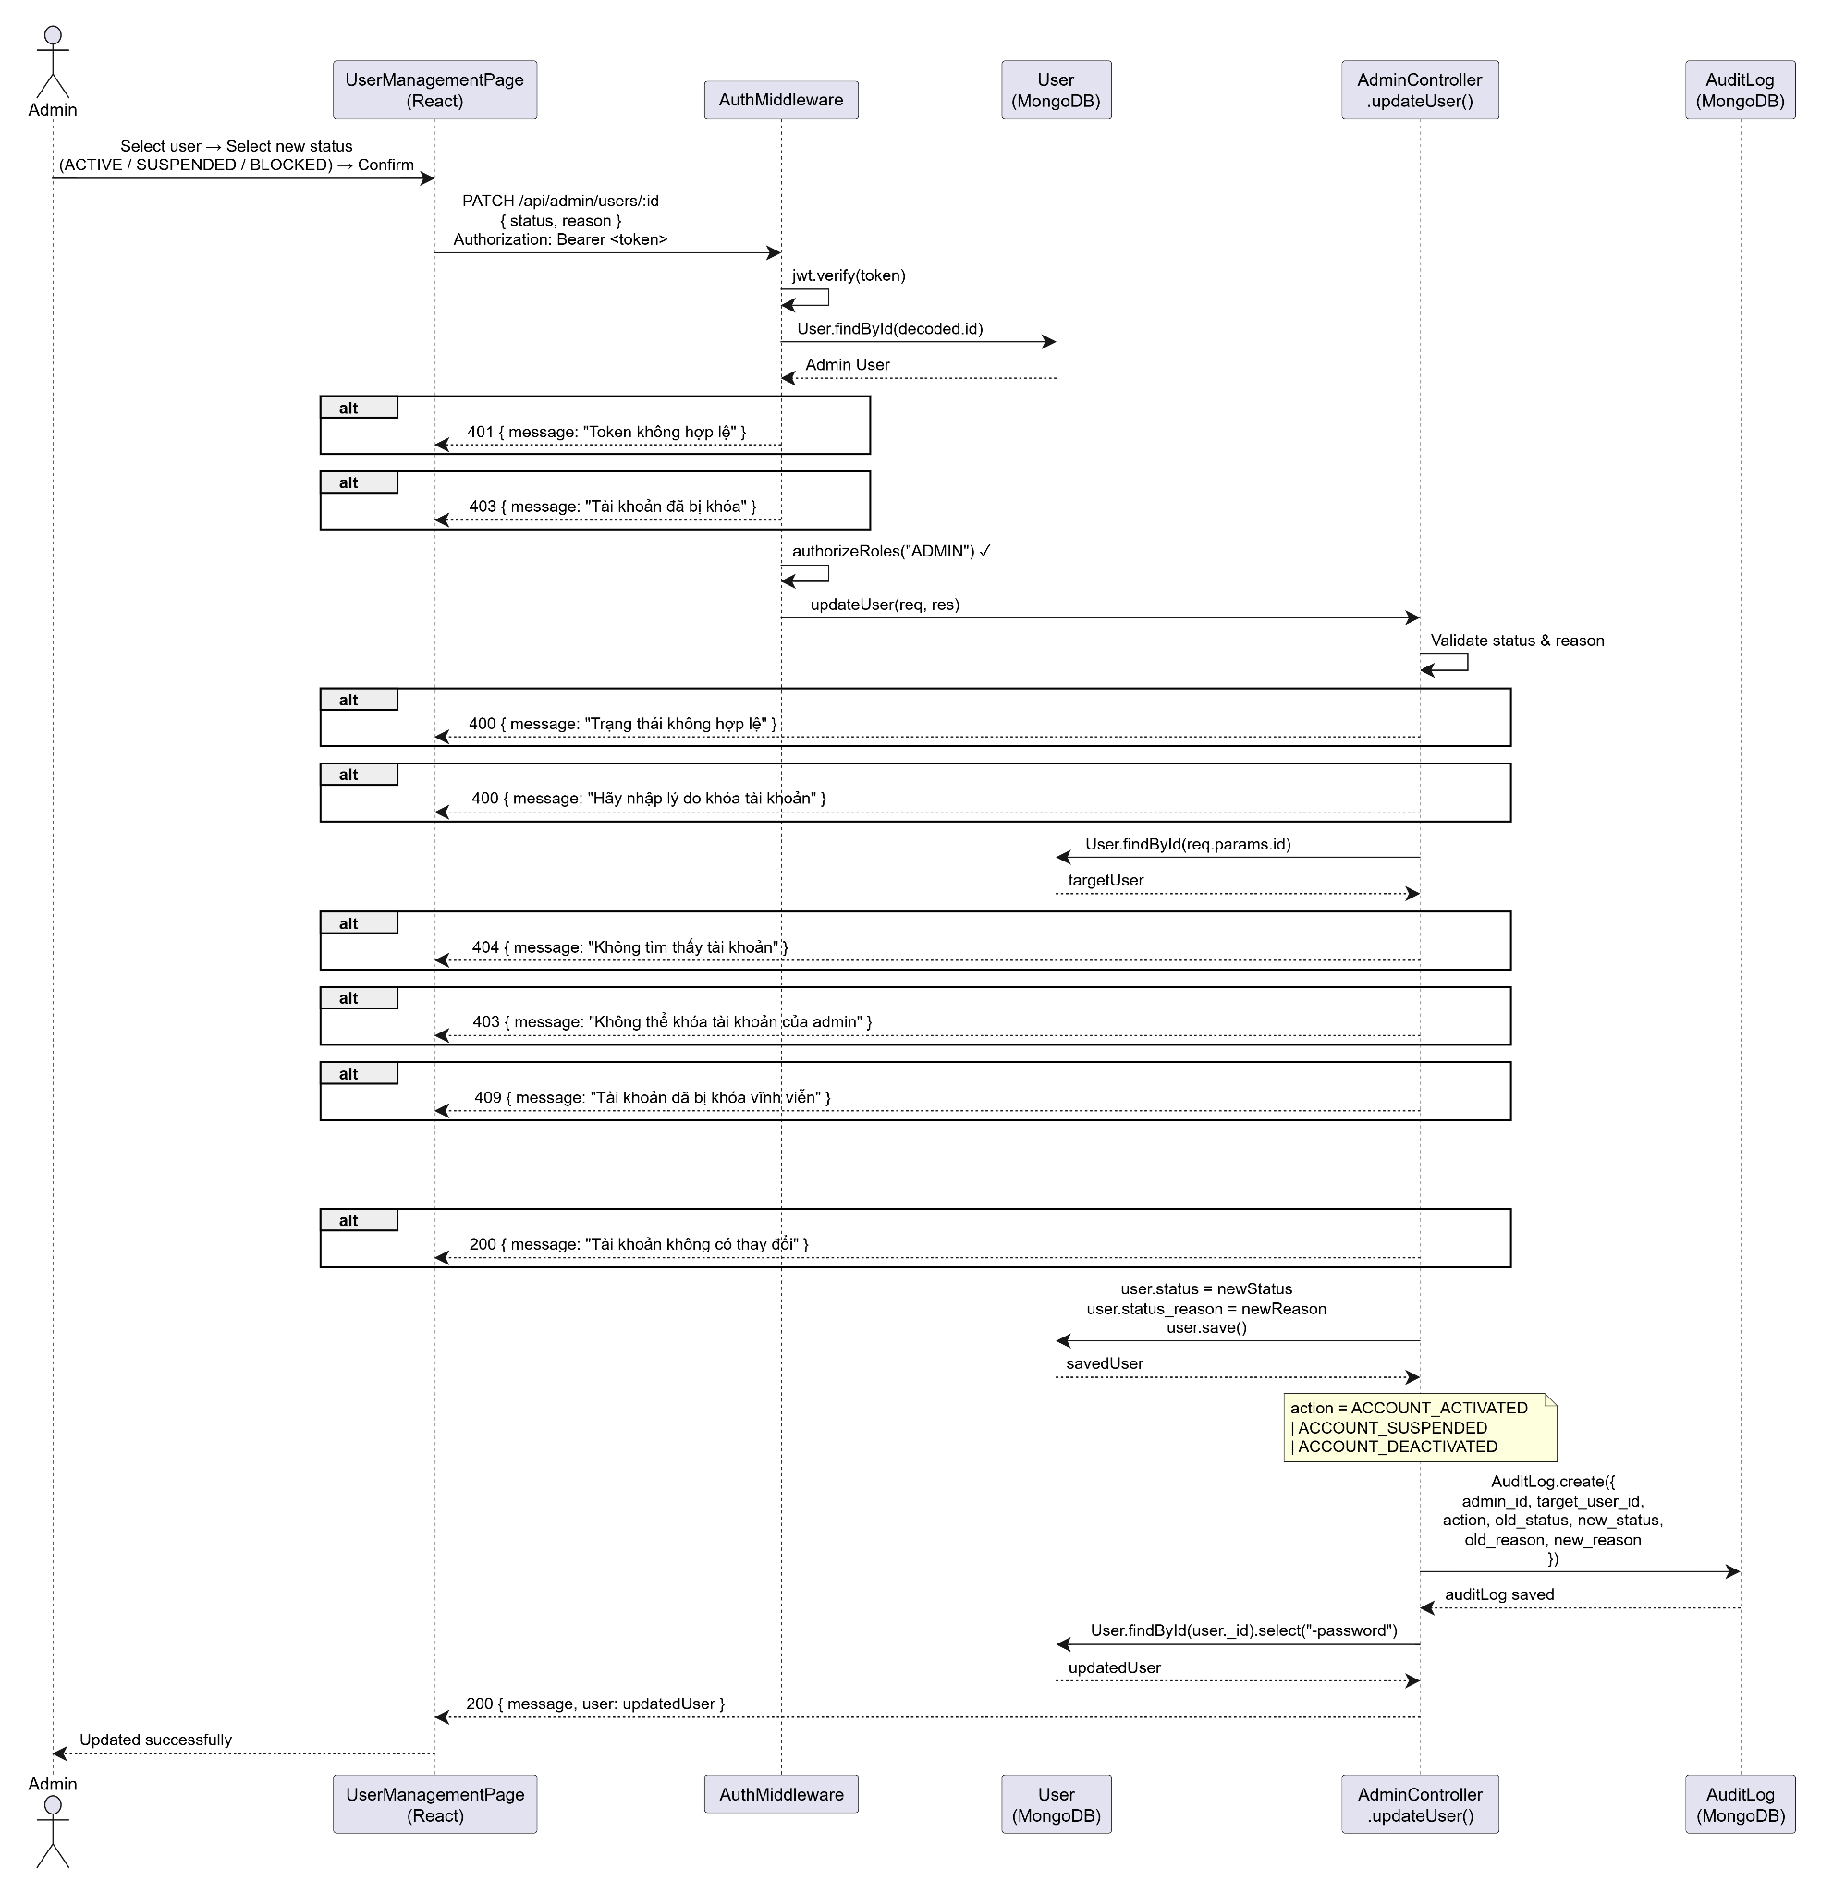

9. Configure System Settings

a. Class Diagram
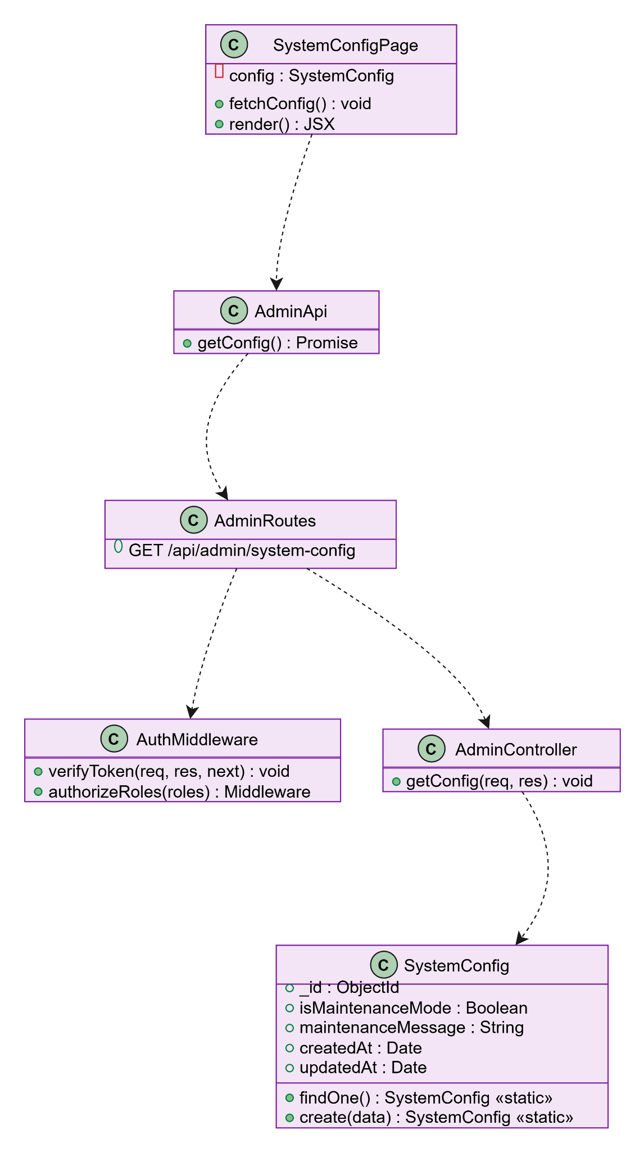

b. Sequence Diagram
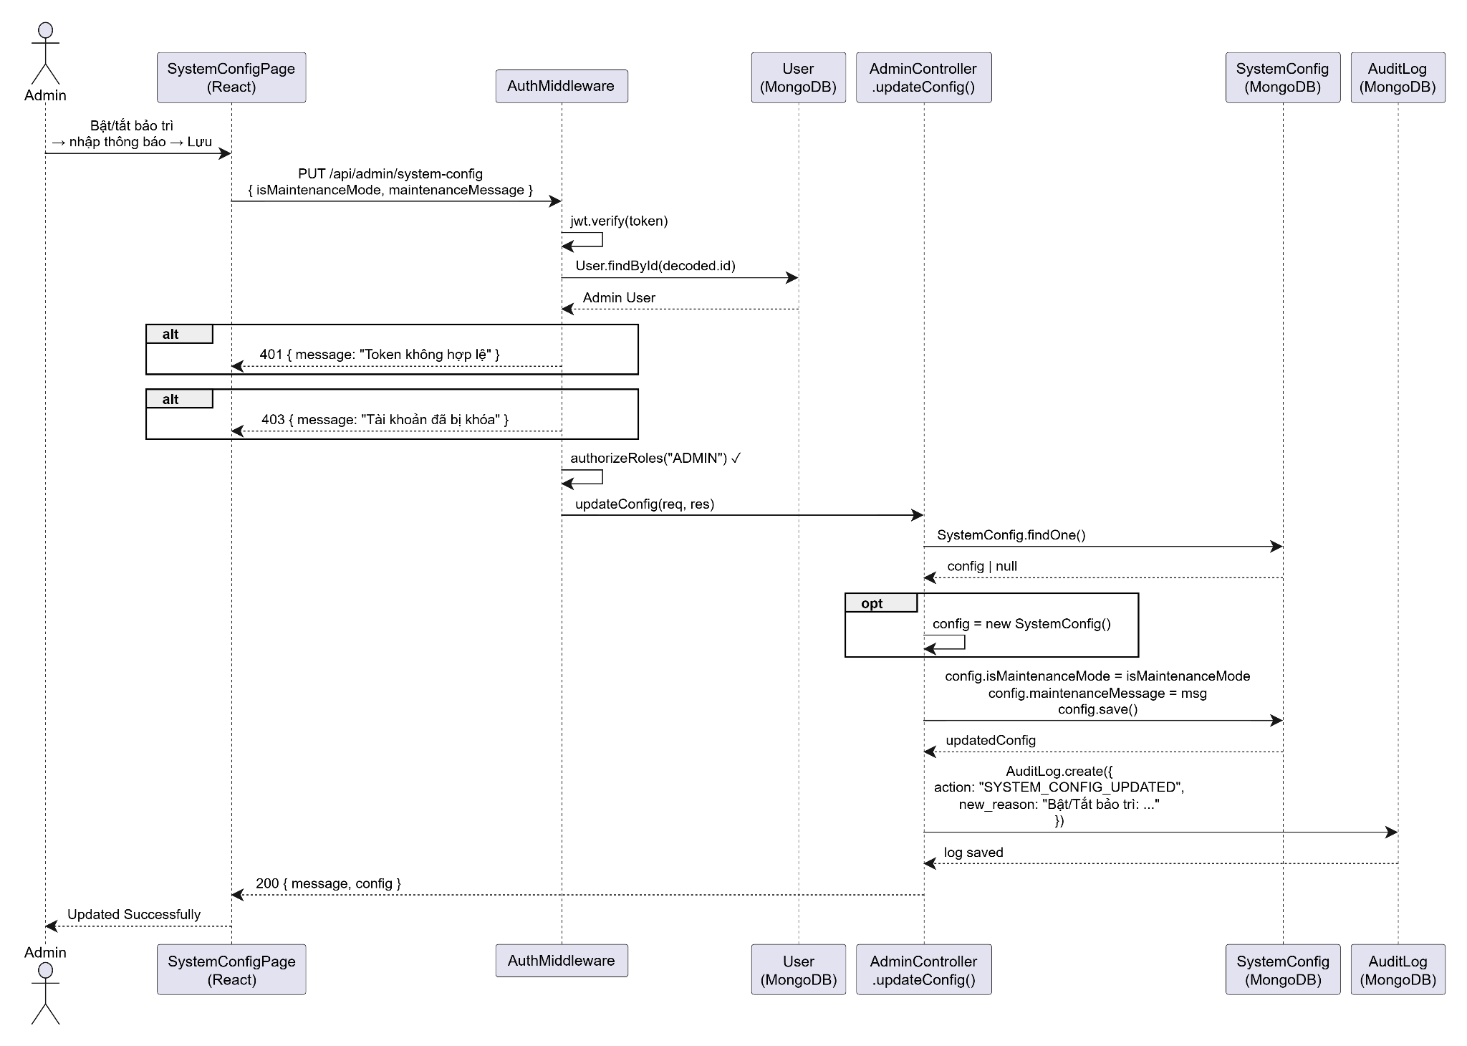

10. Register Hotel

a. Class Diagram
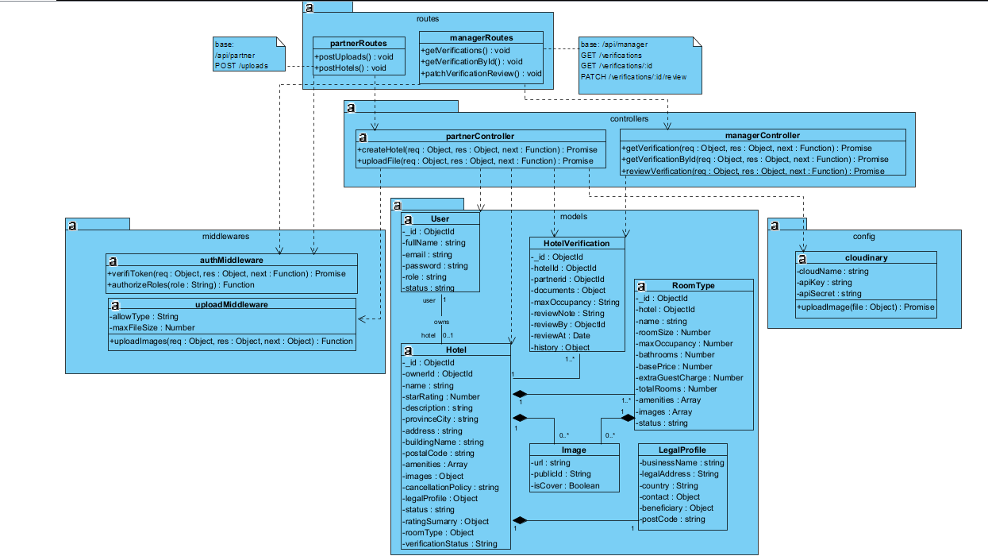

b. Sequence Diagram


