

Software Requirement Specification

VinaStay System

– Hanoi, November 2026 –
Table of Contents
I. Record of Changes 3
II. Software Requirement Specification 4
1. Overall Requirements 4
1.1 Context Diagram 5
1.2 Main Business Processes 5
1.3 User Requirements 7
2. Functional Specifications 25
2.1 Authentication & Authorization 25
2.2 User Account Management 28
2.3 Hotel & Room Discovery 34
2.4 Booking Management 38
2.5 Payment & Transaction 51
2.6 Hotel Statistics & Revenue 53
2.7 Feedback & Reviews 64
2.8 Dispute & Support Management 67
2.9 Customer Support & Interaction 75
2.10 System Configuration & Administration 81
2.11 Hotel Registration and Managements 85
3. Non-Functional Requirements 104
3.1 External Interfaces 104
3.2 Quality Attributes 104
4. Requirement Appendix 106
4.1 Business Rules 106
4.2 Application Messages 111
4.3 Other Requirements… 111
III. Functional Requirements 112
1. Authentication & Authorization Module 112
1.1. Register Screen 112
1.2. Login Screen 115
2. User Account Management Module 116
2.1. View Profile Screen 116
2.2. Change Password Screen 117
2.3. Edit Profile Screen 118
2.4. View User Accounts & Roles Screen 119
3. Hotel & Room Discovery Module 120
3.1. Search Hotel Screen 120
3.2. View Hotel Details Screen 121
4. Booking Management Module 123
4.1. Book Room & Make Payment Screen 123
4.2. View Booking History Screen 125
4.3. Cancel Booking Screen 126
4.4. Manage Booking Screen (Hotel Partner) 127
5. Hotel Statistics & Revenue Module 127
5.1. View Statistics Screen 127
6. Feedback & Reviews Module 127
6.1. Review & Rating List Screen 127
6.2. Submit Review & Rating Screen 128
6.3. Edit Reviews Screen 129
7. Dispute & Support Management Module 131
7.1. Submit Dispute Screen 131
7.2. Handle Customer Disputes Screen 132
7.3. Resolve Partner Issues Screen 132
8. Customer Support & Interaction Module 132
8.1. Request Hotel Service Screen 132
8.2. Handle Customer Request Screen 132
9. System Configuration & Administration Module 132
9.1. Manage Commission Policy Screen 132
9.2. Admin Dashboard Screen 132
9.3. Configure System Settings Screen 133
9.4. View System Logs & Monitoring Screen 133
10. Hotel Registration & Management Module 134
10.1. Register Hotel Screen 134
10.2. Manage Hotel Information Screen 142
10.3. Manage Room Type Screen 145
10.4. Add Room Type Screen 148
10.5. Edit Room Type Screen 152

I. Record of Changes
Date | A*  M, D | In charge | Change Description
*A - Added M - Modified D - Deleted
t

II. Software Requirement Specification

1. Overall Requirements
The VinaStay System is a web-based hotel booking platform that connects travelers and hotel owners. The system aims to replace traditional and manual booking methods, which are often slow, prone to booking mistakes, and vulnerable to scams or incorrect room information.
The system provides a centralized platform for searching hotels, checking real-time room availability, making online payments, and managing bookings. It helps customers easily find and book the right rooms at clear prices, while helping hotels manage their rooms and increase bookings.
The system supports multiple user roles, including System Admin, Operations Manager, Hotel Partner, Customer, and Guest. Admins manage user accounts and system settings. Operations Managers verify hotel listings, handle complaints, approve refunds, and pay hotel partners. Hotel Partners update hotel details, set room prices, and manage room status. Customers search for rooms, make payments, track their bookings, and leave reviews. Meanwhile, Guests can browse hotels and create a new account.
In addition, the system provides helpful features such as booking cancellation, dispute reporting, and automatic payment processing through a payment gateway. Hotel photos and videos are stored safely in cloud storage to keep the system fast.
The system also provides a dedicated portal for hotel partners. Partners can register their hotels, update room information, and track their revenue easily.
Overall, the VinaStay System makes hotel booking simple and reliable, protects user payments, and helps hotels manage their business effectively.

1.1 Context Diagram
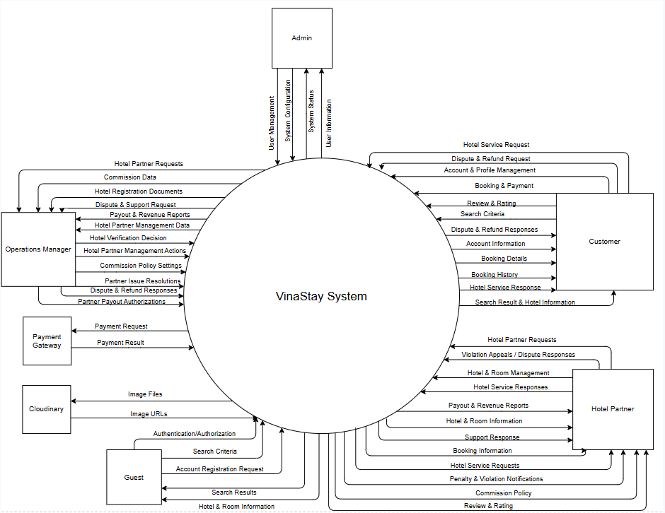

1.2 Main Business Processes

1.2.1 Booking room

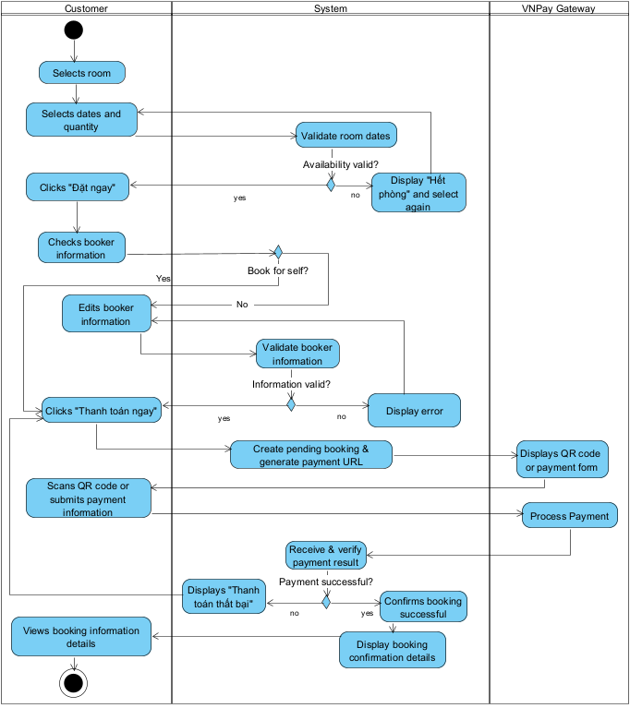

1.2.2 Register hotel
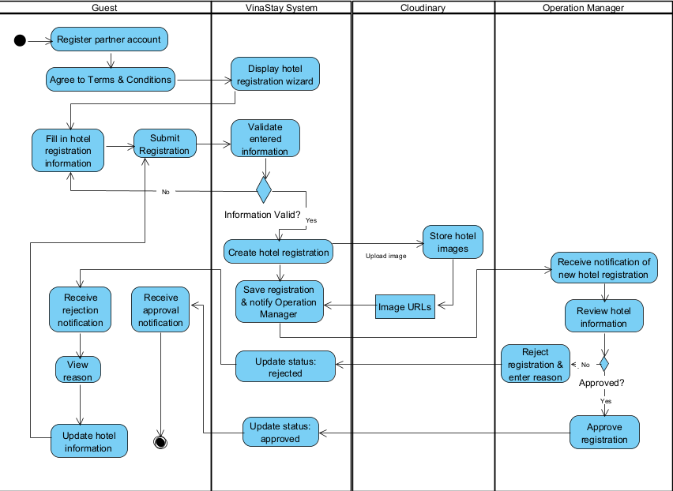

1.3 User Requirements

1.3.1 Actors

# | Actor | Description
1 | Admin | A technical administrator responsible for user account and role management (User/Role Administration), configuring system settings (System Configuration), and monitoring platform operations and health (System Status).
2 | Operations Manager | A platform operational staff member responsible for reviewing and verifying hotel partner credentials (Hotel Verification Information), handling customer disputes (Dispute Reports), issuing refund approvals (Refund Approvals), and overseeing commission data to authorize partner payout settlements (Payout Approvals)
3 | Hotel Partner | An accommodation provider (hotel owner or property manager) responsible for submitting registration profiles, managing hotel listings, maintaining room categories and inventories, setting prices, receiving booking details, and collecting disbursed revenues.
4 | Guest | An unauthenticated visitor who accesses the system without an account, permitted to search for accommodations, inspect room details and public rates, and submit an account registration request.
5 | Customer | An authenticated user with a verified account, authorized to book rooms, execute online payments, manage personal profiles, view reservation histories, cancel bookings, submit stay reviews/ratings, and file dispute claims for unresolved service issues.
6 | Cloudinary | A third-party cloud storage service (External System) dedicated to uploading, optimizing, and hosting multimedia assets (hotel images and videos) while serving public URLs to prevent database bloating
7 | Payment Gateway | A third-party financial processor (External System) responsible for receiving payment requests (Payment Request), securely authenticating user transactions, and returning transaction outcomes (Payment Result) to the platform.

1.3.2 Use Cases

1.3.2.1 UCs for Admin
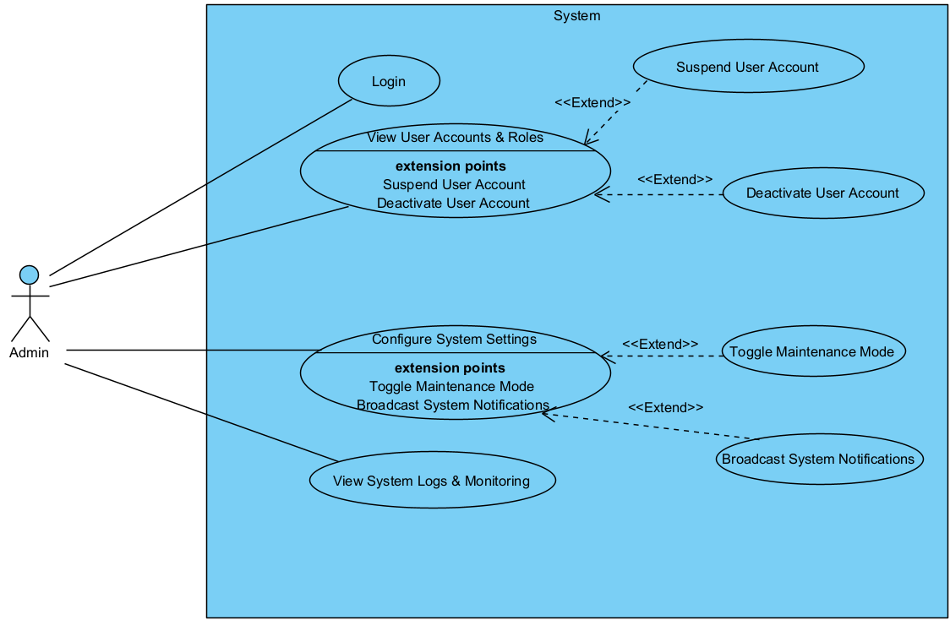

1.3.2.2 UCs for Hotel Partner

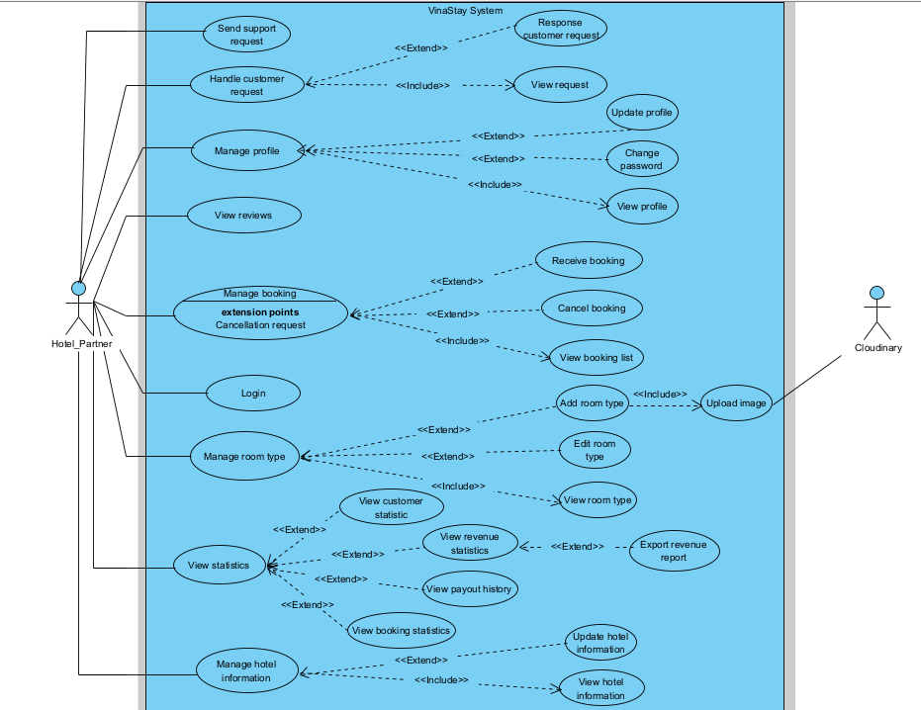

1.3.2.3 UCs for Operations Manager
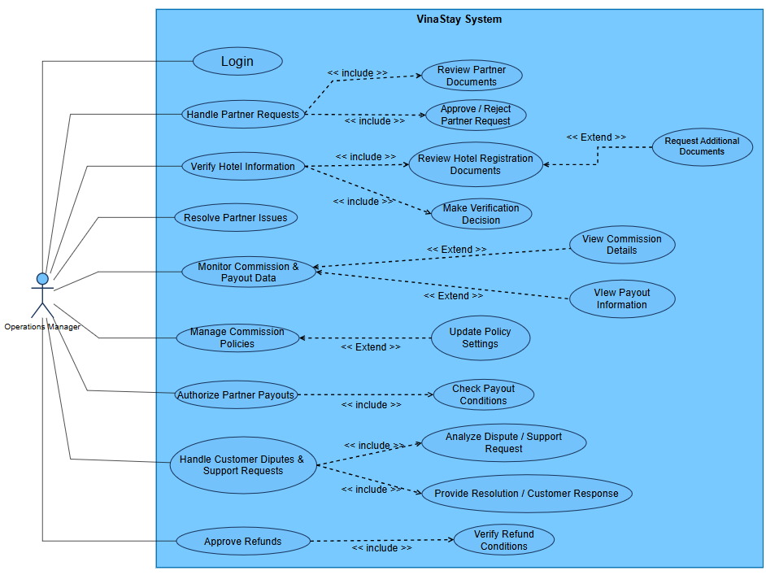

1.3.2.4 UCs for Guest
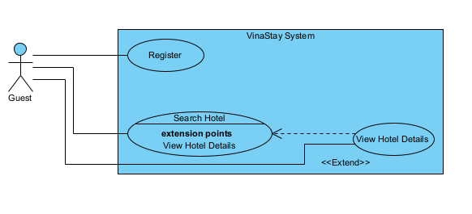

1.3.2.5 UCs for Customer
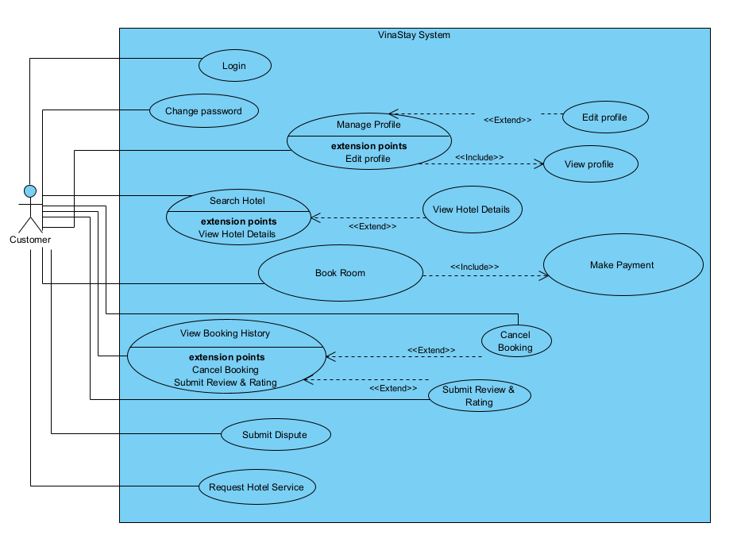

1.3.3 UC Descriptions

ID | Use case | Feature | Actor | Description
1 | Login | Authentication & Authorization | Customer,  Hotel Partner, Admin,  Operations Manager | Allows customers to authenticate into the system using their registered credentials to access personalized services.
2 | Change Password | User Account Management | Customer | Allows logged-in customers to update their current account password to maintain account security.
3 | Manage Profile | User Account Management | Customer | Allows customers to view their personal profile details and contact information.
4 | Edit Profile | User Account Management | Customer | Allows customers to update their personal information, contact details, and change their account password.
5 | View Profile | User Account Management | Customer | Allows customers to view their personal profile details and contact information.
6 | Search Hotel | Hotel & Room Discovery | Customer | Allows customers to search for hotels by destination, check-in/check-out dates, guest count, and filtering criteria.
7 | View Hotel Details | Hotel & Room Discovery | Customer | Allows customers to view comprehensive hotel information, amenities, policies, room types, and pricing rates.
8 | Book Room | Booking Management | Customer | Allows customers to select room types, fill in guest information, and initiate room reservations.
9 | Make Payment | Payment & Transaction | Customer | Allows customers to securely process online payments for their room bookings via an integrated payment gateway.
10 | View Booking History | Booking Management | Customer | Allows customers to view the comprehensive history and real-time status of their past and upcoming bookings.
11 | Cancel Booking | Booking Management | Customer | Allows customers to cancel an upcoming reservation and request refunds in accordance with system cancellation policies.
12 | Submit Review & Rating | Feedback & Reviews | Customer | Allows customers to submit numeric ratings and written feedback regarding their stay after completing check-out.
13 | Submit Dispute | Dispute & Support Management | Customer | Allows customers to submit formal complaints and disputes regarding property misrepresentations or service issues for platform mediation.
14 | Request Hotel Service | Customer Support & Interaction  User Account Management | Customer | Allows customers to send special requests (such as early check-in, late check-out, extra bed, or airport transfer) directly to the hotel partner for on-site arrangement.  Allows customers to update their personal information, contact details, and change their account password.
15 | View User Accounts & Roles | User Account Management | Admin | Allows the admin to view registered user accounts across the platform, search and filter user lists, inspect detailed accounts, and access options to suspend or deactivate user accounts.
16 | Suspend User Account | User Account Management | Admin | Allows the admin to temporarily suspend a user account due to policy violations investigation.
17 | Deactivate User Account | User Account Management | Admin | Allows the admin to permanently suspend a user account due to policy violations.
18 | Configure System Settings | System Configuration | Admin | Allows the admin to configure global platform options, application rules, operational parameters, and third-party integrations.
19 | Toggle Maintenance Mode | System Configuration | Admin | Allows the admin to enable or disable system maintenance mode to restrict public platform access during maintenance windows.
20 | Broadcast System Notifications | System Configuration | Admin | Allows the admin to broadcast platform-wide system announcements and operational notifications to all users.
21 | View System Logs & Monitoring | System Monitoring | Admin | Allows the admin to view application logs, audit trails, system performance metrics, and error reports for monitoring platform health.
22 | Register Account | Account Registration | Guest | Allows guests to create a new account by providing required account and contact information to access the system's hotel management services.
23 | Register Hotel | Hotel Registration | Guest | Allows a Guest who has just registered an account to be redirected directly to the hotel registration page and submit a hotel for listing on the platform.
24 | Manage Hotel Information | Hotel Information Management | Hotel Partner | Allows hotel partners to view and update their hotel's basic information, policies, amenities, and other hotel-related details.
25 | View Hotel Information | Hotel Information Management | Hotel Partner | Allows hotel partners to view the information of their hotels, including basic information, policies, amenities, photos and pending change requests.
26 | Update Hotel Information | Hotel Information Management | Hotel Partner | Allows hotel partners to update the information, policies and photos of their hotels; sensitive changes are submitted for verification.
27 | Manage Room Type | Room Management | Hotel Partner | Allows hotel partners to manage the room types offered by their hotel, including adding, editing, and maintaining room type information.
28 | Add Room Type | Room Type Management | Hotel Partner | Allows hotel partners to create a new room type by providing information such as room name, capacity, amenities, quantity, and pricing information.
29 | Edit Room Type | Room Type Management | Hotel Partner | Allows hotel partners to update existing room type information, including capacity, amenities, quantity, pricing, and other relevant details.
30 | View Room Type | Room Type Management | Hotel Partner | Allows hotel partners to view the list and the details of the room types of their hotel.
31 | Upload Image | Room Type Management | Hotel Partner | Allows hotel partners to upload, reorder and remove photos of their hotel or room types, which are stored on Cloudinary.
32 | Manage Booking | Booking Management | Hotel Partner | Allows hotel partners to view and manage customer bookings, review booking details, confirm bookings, and update booking statuses.
33 | View Booking List | Booking Management | Hotel Partner | Allows hotel partners to view, search and filter the bookings made at their hotels.
34 | Receive Booking | Booking Management | Hotel Partner | Allows hotel partners to acknowledge a newly received booking or report that it cannot be honoured.
35 | Cancel Booking | Booking Management | Hotel Partner | Allows hotel partners to cancel a booking when a cancellation request is received from the customer and the cancellation is approved according to the hotel's cancellation policy.
36 | Handle Customer Request | Customer Support | Hotel Partner | Allows hotel partners to receive, review, and respond to customer requests, including booking-related questions, cancellation requests, and other support inquiries.
37 | View Request | Customer Support | Hotel Partner | Allows hotel partners to view the customer requests of their hotels and the details of each request.
38 | Response Customer Request | Customer Support | Hotel Partner | Allows hotel partners to confirm, decline or reply to a customer request.
39 | View Reviews | Feedback & Reviews | Hotel Partner | Allows hotel partners to view customer reviews and feedback about their hotel and services.
40 | Manage Profile | Partner Account Management | Hotel Partner | Allows hotel partners to view and update their personal profile information, contact details, and account-related information.
41 | Send Support Request | Dispute & Support Management | Hotel Partner | Allows hotel partners to send support requests to the platform about operational, technical, payout or account issues and to track the responses.
42 | View Statistics | Statistics & Reporting | Hotel Partner | Allows hotel partners to view guest, booking, revenue and payout statistics of their hotels, export the revenue report and view the payout history
43 | View Customer Statistics | Statistics & Reporting | Hotel Partner | Allows hotel partners to view aggregated guest statistics of their hotels.
44 | View Booking Statistics | Statistics & Reporting | Hotel Partner | Allows hotel partners to view booking statistics of their hotels by status, room type and period.
45 | View Revenue Statistics | Statistics & Reporting | Hotel Partner | Allows hotel partners to view gross revenue, commission and net revenue of their hotels.
46 | Export Revenue Report | Statistics & Reporting | Hotel Partner | Allows hotel partners to export the revenue report of a selected period.
47 | View Payout History | Statistics & Reporting | Hotel Partner | Allows hotel partners to view the history of the payouts made for their hotels.
48 | Monitor Commission & Payout Data | Financial Operations | Operations Manager | Allows the Operations Manager to view platform commission details, partner payout balances and payout statuses for financial oversight.
49 | Manage Commission Policies | System Configuration / Financial Operations | Operations Manager | Allows the Operations Manager to view and update global and category-based commission rates, tiered rules and their effective dates.
50 | Authorize Partner Payouts | Payout Management | Operations Manager; external payout provider if integrated | Allows the Operations Manager to check payout conditions, review the payable amount and authorize or reject a partner payout.
51 | Handle Customer Disputes | Dispute & Support Management | Operations Manager; Customer; Hotel Partner | Allows the Operations Manager to investigate customer disputes using booking details and supporting evidence, record a resolution and notify the relevant parties.
52 | Approve Refunds | Payment & Transaction / Dispute & Support Management | Operations Manager; Payment Gateway; Customer | Allows the Operations Manager to verify refund conditions and approve or reject refund requests, with approved refunds sent for processing through the supported payment mechanism.

1.3.4 Screen Flow

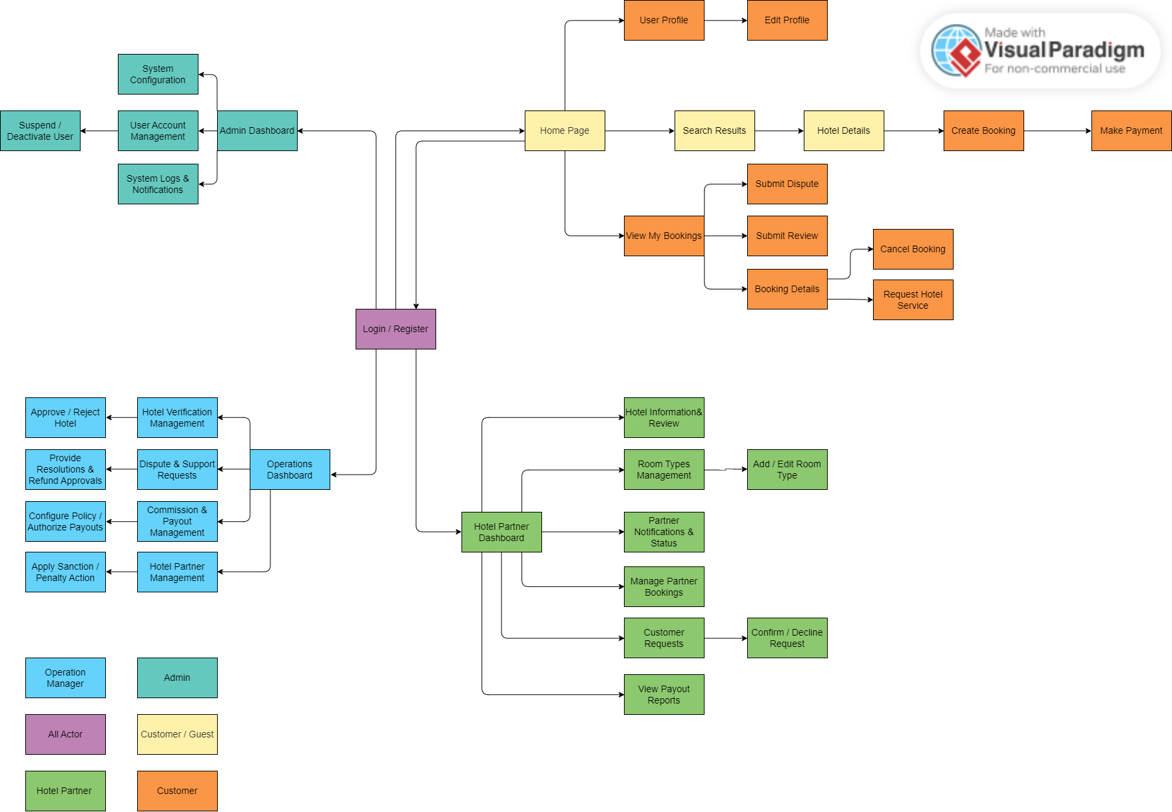

1.3.5 Screen Descriptions

# | Feature | Screen | Description
1 | Authentication | Login Screen | Secure gateway for all users to authenticate and access the system.
2 | Hotel & Room Discovery | Home Page | The main landing page featuring a central search bar and a list of featured or promoted hotels.
3 | Hotel & Room Discovery | Search Results | Displays a list of hotels matching the search criteria, equipped with filtering (price, star rating, amenities) and sorting tools.
4 | Hotel & Room Discovery | Hotel Details | A comprehensive view of a specific hotel, including an image gallery, amenities, and check-in/check-out policies.
5 | Hotel & Room Discovery | Room Details | Displays available room types, pricing, and capacity.
6 | Hotel & Room Discovery | Hotel Reviews | Displays the list of customer ratings and feedback for the selected hotel.
7 | Booking Management | Create Booking | Form for selecting room count, entering booker and guest details, specifying guest nationality, reviewing price breakdown, and finalizing reservation.
8 | Payment & Transaction | Make Payment | Redirection to the payment gateway with a temporary room-hold countdown.
9 | User Account Management | User Profile | Area for customers to view personal information.
10 | User Account Management | Edit Profile | Interface to update personal details and change the account password.
11 | Booking Management | View My Bookings | Dashboard displaying the customer's reservation history.
12 | Booking Management | Booking Details | Detailed view of a specific reservation including post-booking actions.
13 | Booking Management | Cancel Booking | Form calculating cancellation fees/refunds based on the hotel policy .
14 | Feedback & Reviews | Submit Review | Form for customers to submit star ratings and photos after checkout .
15 | Customer Support | Request Hotel Service | Form for customers to request special services.
16 | Dispute & Support | Submit Dispute | Form for customers to report issues and request refunds .
17 | Hotel Partner Dashboard | Hotel Partner Dashboard | The central hub for hotel partners to navigate their management tools
18 | Hotel Registration | Hotel Registration | Multi-step form for partners to submit legal documents and hotel info for verification.
19 | Room Management | Room Types Management | Dashboard for partners to view and manage room inventory.
20 | Room Management | Add / Edit Room Type | Form to configure room capacity, pricing, amenities, and upload photos.
21 | Partner Hotel Management | Hotel Information & Review | Interface for partners to update hotel details, amenities, policies, and view reviews.
22 | Partner Booking Management | Manage Partner Bookings | List for partners to track reservations.
23 | Customer Support | Customer Requests | Screen for partners to view special service requests from customers.
24 | Customer Support | Confirm / Decline Request | Action screen for partners to approve or reject customer service requests.
25 | Partner Financials | View Payout Reports | Dashboard displaying partner revenue, commission deductions, and payout status.
26 | Operations Dashboard | Operations Dashboard | The central hub for Operations Managers to monitor platform activities.
27 | Operations Verification | Hotel Verification Management | Screen for Ops Managers to review submitted hotel legal documents.
28 | Operations Verification | Approve / Reject Hotel | Action screen to finalize the verification decision for a new hotel listing.
29 | Operations Dispute Management | Dispute & Support Requests | Interface to investigate customer complaints and partner support tickets.
30 | Operations Dispute Management | Provide Resolutions & Refund Approvals | Action screen to issue final dispute judgments and authorize customer refunds.
31 | Operations Financial Management | Commission & Payout Management | Dashboard to track overall platform commissions and partner payouts.
32 | Operations Financial Management | Configure Policy / Authorize Payouts | Action screen to set commission rates and release funds to partners.
33 | Admin Dashboard | Admin Dashboard | The central hub for the System Administrator
34 | Admin User Management | Suspend / Deactivate User | Action screen to lock or ban violating user accounts.
35 | Admin User Management | User Account Management | Screen to view all registered users across the platform.
36 | Admin System Configuration | System Configuration | Screen to turn on maintenance mode and broadcast notifications to all users.
37 | Admin Monitoring | System Logs & Notifications | Dashboard to view system health, error logs, and broadcast announcements.

1.3.6 Screen Authorization

Screen / Feature | Admin | Operations Manager | Hotel Partner | Guest | Customer
Register |  |  | X | X | X
Login Screen | X | X | X |  | X
Home Page |  |  |  | X | X
Search Results |  |  |  |  | X
Hotel Details & Reviews |  | X |  |  | X
Room Details |  |  |  |  | X
Create Booking |  |  |  |  | X
Make Payment |  |  |  |  | X
User Profile |  |  | X |  | X
View My Bookings |  |  |  |  | X
Booking Details |  |  |  |  | X
Cancel Booking |  |  | X |  | X
Submit Review / Submit Dispute |  |  |  |  | X
Request Hotel Service |  |  |  |  | X
Hotel Partner Dashboard |  |  | X
Hotel Information & Review |  |  | X
Hotel Registration |  |  | X
Room Types Management (Add/Edit) |  |  | X
Manage Partner Bookings |  |  | X
Customer Requests (Confirm/Decline) |  |  | X
View Payout Reports |  |  | X
Operations Dashboard |  | X
Hotel Verification Management (Approve/Reject) |  | X
Dispute & Support Requests (Resolutions/Refunds) |  | X
Commission & Payout Management (Config/Authorize) |  | X
Admin Dashboard | X
User Account Management (Suspend/Deactivate) | X
System Configuration | X
System Logs & Notifications | X

1.3.7 Non-UI Functions
# | Feature | System Function | Description
1 | Security & Authentication | Password Hashing | The system automatically encrypts user passwords using strong hashing algorithms (e.g., bcrypt) before storing them in the database.
2 | Booking Management | Auto-Release Room Hold | A scheduled background process that transitions "Pending Payment" bookings to "Expired" after the 15-minute timeout and returns the room inventory to the system.
3 | Inventory Management | Real-time Inventory Sync | Automatically updates and locks room quantities at the database level to prevent double-booking during concurrent user checkout sessions.
4 | Booking Management | Auto-Update Booking Status | A cron job that automatically transitions active booking statuses to "Completed" after the check-out date if not manually updated by the Hotel Partner, initiating the customer dispute window.
5 | System Notification | Event-Driven Mail/Push Dispatcher | An asynchronous background service that triggers emails and notifications (e.g., OTPs, Booking Confirmations, Payout Alerts) without freezing the UI.
6 | Cloud Integration | Asynchronous Media Optimization | The system seamlessly uploads raw images to Cloudinary in the background, which compresses and resizes the media before returning the URL to the database.

1.3.8 Entity Relationship Diagram
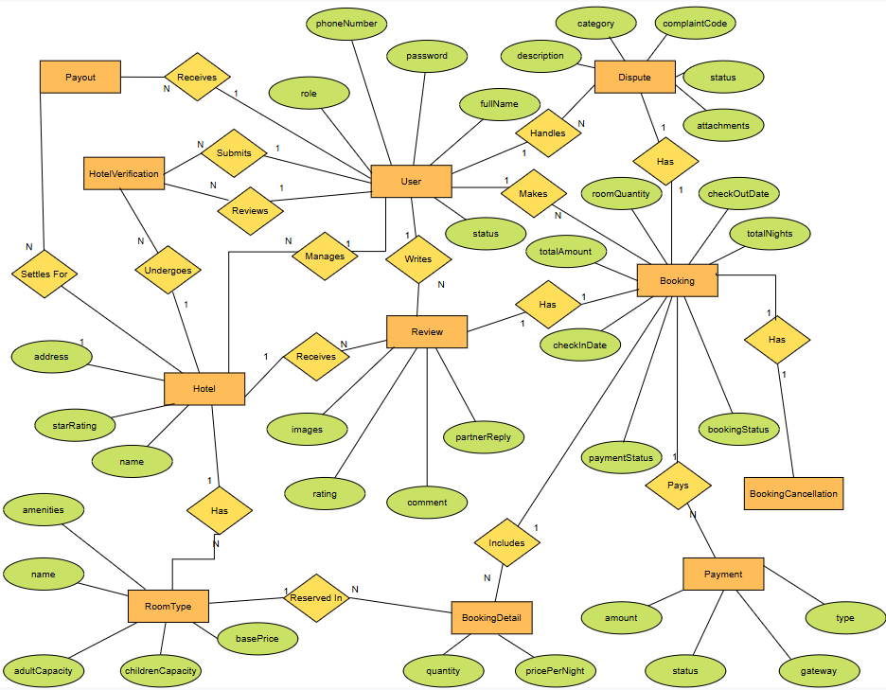
Entities Description

# | Entity | Description
1 | User | Represents system user accounts containing fullName, phoneNumber, passwordHash, role, and status.
2 | Hotel | Represents registered accommodation properties, including name, starRating, address, provinceCity, description, totalReviews, status, and legacyProfile.
3 | RoomType | Defines specific room categories offered by a hotel, including name, adultCapacity, childrenCapacity, totalRooms, basePrice, and amenities.
4 | Booking | Stores reservation records made by users, tracking checkInDate, checkOutDate, totalNights, roomQuantity, totalAmount, bookingStatus, and paymentStatus.
5 | Review | Contains feedback submitted by users for hotels, including rating, comment, images, and partnerReply.
6 | Payment | Captures transaction details for bookings, recording type, amount, gateway, and status.
7 | Complaint | Stores complaint records submitted by users or handled by staff, including complaintCode, category, description, status, and attachments.

2. Usecase Specifications

2.1 Authentication & Authorization

2.1.1 Register
Use Case Name: | Register | Created by: | KhanhNHB
Primary Actor: | Guest | Secondary Actor: | None
Description: | Allows guests to create a new account by providing required personal, contact, and security information to access personalized booking services.
Triggers | The user clicks the "Đăng ký" button on the navigation bar or login screen.
Preconditions | 1. The user is currently unauthenticated (Guest).  2. The registration page is accessible.
Postconditions | 1. A new user record is created in the database with role CUSTOMER and status ACTIVE.  2. The password is securely hashed using bcrypt (salt rounds: 10).  3. The user is redirected to the Login page (/login) with a success message.
Normal Flow | 1. The guest opens the Customer Registration page.  2. The system renders the registration form.  3. The guest enters full name (fullName), phone number (phoneNumber), email address (email), password (password), and confirm password (confirmPassword).  4. The guest clicks the "Tạo tài khoản Khách Hàng" button.  5. The system validates submitted data (field completeness, valid email syntax, phone format, password $≥6$ characters, matching confirmation password).  6. The system checks that the email address is not already registered in the system.  7. The system hashes the password and creates the user document with status ACTIVE.  8. The system displays a success alert and redirects the user to /login.
Alternative Flows: | Alt 1: Switch Registration Role  1. The user clicks "Chọn vai trò khác".  2. The system redirects the user to the role selection gateway (/register).
Exceptions | Exc 1: Email Already Registered  1. The email address already exists in the database.  2. The system displays: "Email đã tồn tại".  Exc 2: Password Mismatch or Too Short  1. Password is under 6 characters or confirmation does not match.  2. The system displays: "Mật khẩu phải có ít nhất 6 ký tự" or "Mật khẩu xác nhận không khớp".
Priority | High
Frequency of use | High
Business Rules: | [BR-04] Profile Validation: Required profile fields must contain valid information.  [BR-05] Password Security: Passwords must be securely hashed before storage.
Other information | Newly registered accounts default to the CUSTOMER role and become active immediately without requiring email verification.

2.1.2 Login
Use Case Name: | Login | Created by: | KhanhNHB
Primary Actor: | Admin ,Customer, Hotel Partner, Operations Manager | Secondary Actor: | None
Description: | Allows registered users to securely authenticate into the system using their registered credentials and access functions according to their assigned role.
Triggers | The user enters their email and password and clicks the "Đăng nhập" button.
Preconditions | 1. The user has a registered account.  2. The account is active and not blocked.  3. The login page is accessible.
Postconditions | 1. The user credentials are verified against the hashed password.  2. A JSON Web Token (JWT) with 1-day validity is generated and saved in client localStorage.  3. The customer is redirected to the application homepage (/).
Normal Flow | 1. The user opens the Login page.  2. The user enters registered email and password.  3. The user clicks the "Đăng nhập" button.  4. The system validates that both fields are populated.  5. The system queries the user record by email.  6. The system verifies that the account status is not BLOCKED, SUSPENDED, or DEACTIVATED.  7. The system verifies password correctness using bcrypt.compare.  8. The system issues a signed JWT containing user ID and role.  9. The client stores the token and redirects the Customer to the homepage.
Alternative Flows: | Alt 1: Login with Different Role  1. The system identifies the user's assigned role.  2. The system redirects the user to the corresponding dashboard.
Exceptions | Exc 1: Invalid Credentials  1. Email is not found or password does not match.  2. The system displays: "Email không tồn tại" or "Mật khẩu không chính xác".  Exc 2: Account Suspended/Blocked  1. Account status is SUSPENDED or BLOCKED.  2. The system rejects authentication and displays: "Tài khoản của bạn đã bị tạm khóa hoặc vô hiệu hóa".
Priority | High
Frequency of use | High (Executed by every user at the end of their work shift or session)
Business Rules: | [BR-01] Credential Validation: The system must verify the user's credentials before creating an authentication session.  [BR-02] Role-Based Authorization: Users can only access functions permitted by their assigned role.  [BR-03] Account Status: Blocked or inactive accounts must not be allowed to authenticate.
Other information | Authentication is handled using secure authentication mechanisms such as JWT/session-based authentication. Passwords must never be stored as plain text.

2.2 User Account Management

2.2.1 View Profile

Use Case Name: | View Profile | Created by: | KhanhNHB
Primary Actor: | Customer, Hotel Partner | Secondary Actor: | None
Description: | Allows customers to view their personal profile details and contact information.
Triggers | The customer selects "Profile của tôi" from the application interface.
Preconditions | 1. The customer is logged in.  2. The customer has an active account.
Postconditions | The customer's current profile information is displayed on screen.
Normal Flow | 1. The customer selects "Profile của tôi".  2. The system retrieves and displays the customer's current profile information (full name, email, phone number, avatar, address).
Extension Points: | 1. Edit Profile : Allows the customer to update personal profile details or change password.
Exceptions | Exc 1: Profile Retrieval Failure  1. The system fails to retrieve user profile data.  2. The system displays an error message and retry option.
Priority | Medium
Frequency of use | Medium
Business Rules: | [BR-04] Profile Validation: Required profile fields must contain valid information.
Other information | Sensitive account information must only be accessible by the authenticated customer.

2.2.2 Change Password
Use Case Name: | Change Password | Created by: | KhanhNHB
Primary Actor: | Customer, Hotel Partner | Secondary Actor: | None
Description: | Allows logged-in customers to update their current account password to maintain account security.
Triggers | The customer selects "Đổi mật khẩu" on the View Profile page or account security settings.
Preconditions | 1. The customer is logged in.  2. The customer has access to their account security settings.
Postconditions | 1. The customer's new password is securely hashed and updated in the system.  2. A confirmation message is displayed, and a security alert email is sent.
Normal Flow | 1. The customer selects "Đổi mật khẩu".  2. The customer enters their current password, new password, and confirms the new password.  3. The customer clicks "Lưu mật khẩu mới".  4. The system verifies the current password and checks the complexity of the new password.  5. The system securely hashes and saves the new password in the database.  6. The system displays a success message and sends a security notification email.
Alternative Flows: | Alt 1: Cancel Change Password  1. The customer selects "Hủy".  2. The system discards all entered inputs and returns to the Profile page.
Exceptions | Exc 1: Incorrect Current Password  1. The entered current password does not match system records.  2. The system displays: "Mật khẩu hiện tại không chính xác."  Exc 2: Password Complexity Failure / Mismatch  1. The new password fails security strength rules or confirmation password does not match.  2. The system displays inline validation error messages.
Priority | High
Frequency of use | Low
Business Rules: | [BR-05] Password Security: Passwords must be securely hashed before storage.
Other information | Changes take effect immediately across all active user sessions.

2.2.3 Edit Profile
Use Case Name: | Edit Profile | Created by: | KhanhNHB
Primary Actor: | Customer, Hotel Partner | Secondary Actor: | None
Description: | Allows customers to update their personal information, contact details, and change their account password.
Triggers | The customer selects "Chỉnh sửa Profile" or "Đổi mật khẩu" on the View Profile page.
Preconditions | 1. The customer is logged in.  2. The customer is viewing their profile page.
Postconditions | 1. The customer's updated profile information or password is saved in the system.  2. A confirmation message is displayed.
Normal Flow | 1. The customer opens the Edit Profile section.  2. The customer modifies personal details (name, phone number, address, avatar).  3. The customer clicks "Lưu Profile".  4. The system validates the submitted information.  5. The system updates the customer profile in the database.  6. The system displays a success message.
Alternative Flows: | Alt 1: Change Password  1. The customer selects "Đổi mật khẩu".  2. The customer enters the current password, new password, and confirms the new password.  3. The system verifies current password and validates new password complexity.  4. The system securely hashes and updates the new password.  5. The system displays a success message.
Exceptions | Exc 1: Invalid Information  1. Submitted data violates validation rules.  2. The system displays inline validation errors.  Exc 2: Incorrect Current Password  1. The entered current password is incorrect.  2. The system rejects password change and prompts the customer to re-enter.
Priority | Medium
Frequency of use | Medium
Business Rules: | [BR-04] Profile Validation: Required profile fields must contain valid information.  [BR-05] Password Security: Passwords must be securely hashed before storage.
Other information | Changes take effect immediately across all sessions.

2.2.4 View User Accounts & Roles
Use Case Name: | View User Accounts & Roles | Created by: | DuyNT
Primary Actor: | Admin | Secondary Actor: | None
Description: | Allows the admin to view registered user accounts across the platform, search and filter user lists, inspect detailed accounts, and access options to suspend or deactivate user accounts.
Triggers | Admin selects "Quản lý tài khoản" from the admin dashboard.
Preconditions | 1. Admin is authenticated and logged into the system.  2. Admin has system administrative permissions.
Postconditions | 1. User account status is updated in the system upon administrative action.  2. Audit log records the administrative action.
Normal Flow | 1. The admin navigates to the User Account Management page.  2. The system retrieves and displays the list of user accounts with search and filter options.  3. The admin searches or selects a specific user account.  4. The system presents account details and status (Hoạt động, Tạm khóa, Bị khóa)
Extension Points: | 1. Suspend User Account: Allows the admin to temporarily suspend a user account due to policy violations investigation.  2. Deactivate User Account: Allows the admin to permanently suspend a user account due to policy violations.
Alternative Flows: | Alt 1: Filter/Search Users  1. The admin applies filters (by role, account status, registration date).  2. The system updates and displays matching user accounts.  Alt 2: Suspend User Account (Extension)  1. The admin selects a user account and chooses "Tạm khóa".  2. The admin enters the suspension reason and duration.  3. The system updates the account status to “Tạm khóa” and logs the action.  Alt 3: Deactivate User Account (Extension)  1. The admin selects a user account and chooses "Khóa".  2. The admin enters the deactivation justification and confirms.  3. The system updates the account status flag to “Bị khóa”, revokes active JWT sessions, and records an audit log.
Exceptions: | Exc 1: Self-Deactivation/Demotion  1. The admin attempts to suspend or remove admin permissions from their own active account.  2. The system blocks the operation and displays: "Không thể khóa tài khoản của admin."
Priority | High
Frequency of use | Medium
Business Rules: | [BR-24] Admin Access Restriction: Only accounts with Admin role can access user management functions.  [BR-25] Audit Logging: All account status changes must be logged with timestamp and admin ID.
Other information | Essential for platform governance and security control.

2.2.5 Manage Profile

Use Case Name: | Manage Profile | Created by: | VinhHX
Primary Actor: | Hotel Partner | Secondary Actor: | None
Description: | Allows hotel partners to view their personal profile and to keep it up to date. The use case includes View Profile (2.2.1) and is extended by Edit Profile (2.2.3) and Change Password (2.2.2); these three use cases are shared with the Customer role and are also available to the Hotel Partner.
Triggers | The Hotel Partner selects "Hồ sơ của tôi" from the account menu.
Preconditions | 1. The user is logged in with the Hotel Partner role.
Postconditions | 1. The profile of the partner is displayed.  2. If the profile or the password is changed, the change is saved as described in Edit Profile (2.2.3) or Change Password (2.2.2).
Normal Flow | 1. The Hotel Partner selects "Hồ sơ của tôi".  2. The system retrieves the account of the partner (View Profile, 2.2.1).  3. The system displays the full name, email address, phone number, avatar, role and account status.  4. The Hotel Partner selects an action: edit the profile or change the password.
Alternative Flows: | Alt 1: Update Profile  1. The Hotel Partner selects "Chỉnh sửa hồ sơ".  2. The system continues with Edit Profile (2.2.3). The full name, phone number and avatar can be changed; the email address, role and account status are read-only (BR-52).  Alt 2: Change Password  1. The Hotel Partner selects "Đổi mật khẩu".  2. The system continues with Change Password (2.2.2). The incorrect current password is reported with MSG03.
Exceptions | Exc 1: Profile Not Available  1. The account data cannot be retrieved.  2. The system displays an error message and a retry option.  Exc 2: Session Expired  1. The login session has expired.  2. The system redirects the partner to the login page (Login, 2.1.2).
Priority | Medium
Frequency of use | Low
Business Rules: | [BR-52] Account Identity: The email address (login identifier), role and account status cannot be changed by the partner in this function; they are managed by the Admin.
Other information | Hotel-related contact details (hotel email, phone number and address) are not part of the personal profile; they are maintained in Manage Hotel Information (2.11.2).

2.3 Hotel & Room Discovery

2.3.1 Search Hotel

Use Case Name: | Search Hotel | Created by: | KhanhNHB
Primary Actor: | Customer, Guest | Secondary Actor: | None
Description: | Allows customers and guests to search for available hotels based on destination, check-in/check-out dates, guest count, and optional filtering criteria.
Triggers | The user accesses the search bar on the homepage or navigation menu and submits search criteria.
Preconditions | 1. The system homepage or search interface is accessible.  2. Hotel listings and room availability data are active in the system.
Postconditions | 1. The system displays a list of matching hotels.  2. The user can select a hotel to view detailed information and prices.
Normal Flow | 1. The user opens the search page or homepage.  2. The user enters a destination, check-in/check-out dates, and guest count.  3. The user optionally selects filtering criteria (price range, star rating, amenities, location).  4. The user clicks "Tìm kiếm".  5. The system validates search parameters and queries available hotels matching the criteria.  6. The system displays the matching hotel search results list.
Alternative Flows: | Alt 1: Apply Additional Filters  1. On the search results page, the user updates filter options (e.g., sort by price, minimum star rating).  2. The system instantly updates and displays the filtered list of hotels.
Exceptions | Exc 1: No Hotels Found  1. No hotels match the selected search criteria or dates.  2. The system displays: "Không tìm thấy khách sạn phù hợp. Vui lòng thử lại với tiêu chí khác."  Exc 2: Invalid Date Range  1. The check-out date is earlier than or equal to the check-in date.  2. The system prompts the user to select a valid date range.
Priority | High
Frequency of use | High
Business Rules: | [BR-06] Date Validation: Check-in date must be today or in the future, and check-out date must be after check-in date.  [BR-07] Real-Time Availability: Search results must only display hotels with active room inventory for the selected dates.
Other information | Public feature accessible by both Guests and authenticated Customers.

2.3.2 View Hotel Details

Use Case Name: | View Hotel Details | Created by: | KhanhNHB
Primary Actor: | Customer, Guest | Secondary Actor: | None
Description: | Allows customers and guests to view comprehensive hotel information, amenities, policies, room types, and pricing rates.
Triggers | The user clicks on a hotel from the search results list.
Preconditions | Hotel details and room data are active in the system.
Postconditions | The hotel details page is displayed showing comprehensive information, room types, and rates.
Normal Flow | 1. The user selects a hotel from the search results.  2. The system retrieves and displays comprehensive hotel details, amenities, policies, and available room types.  3. The user inspects room options and pricing.
Alternative Flows: | Alt 1: View Room Details  1. The customer selects a room type.  2. The system displays room capacity, amenities, price, and availability.  Alt 2: View Reviews  1. The customer opens the review section.  2. The system displays ratings and customer feedback.
Exceptions: | Exc 1: Hotel Not Found  1. The requested hotel does not exist or has been removed.  2. The system displays an appropriate error message.
Priority | High
Frequency of use | High
Business Rules: | [BR-08] Accurate Information: Hotel information displayed to customers must reflect the latest available data.  [BR-09] Pricing: Room prices must be displayed according to the applicable pricing configuration.
Other information | Hotel Partners are responsible for maintaining hotel information, room information, and applicable policies.

2.4 Booking Management

2.4.1 Book Room

Use Case Name: | Book Room | Created by: | KhanhNHB
Primary Actor: | Customer | Secondary Actor: | None
Description: | Allows customers to select room types, quantity of rooms, fill in guest information, validate check-in/check-out dates, apply snapshot pricing, and initiate room reservations with a 15-minute temporary hold.
Triggers | The customer clicks "Tiến hành đặt phòng" from the Hotel Details summary card.
Preconditions | 1. The customer is authenticated with the CUSTOMER role.  2. At least one room is selected with verified inventory for the stay dates.
Postconditions | 1. A booking document is created in the database with status PENDING_PAYMENT and paymentStatus: "UNPAID".  2. A 15-minute temporary room inventory hold is engaged.  3. The customer is redirected to the VNPay Sandbox payment gateway.
Normal Flow | 1. The customer reviews the stay summary (hotel name, address, dates, nights, room types, quantities).  2. The system pre-fills booker info: Full Name (fullName), Phone (phoneNumber), and Email (email).  3. The customer chooses guest occupancy option: "Tôi là người nhận phòng" (self) or "Tôi đặt phòng cho người khác" (entering designated staying guest's full name and phone number).  4. The customer enters optional special requests (specialRequests) such as estimated arrival time, quiet room, or high floor.  5. The customer selects the payment method (VNPAY).  6. The system displays price breakdown: Room subtotal, taxes & service fees (10%), and total amount.  7. The customer clicks "Thanh toán qua VNPAY".  8. The system re-checks real-time inventory, reserves rooms, creates a pending booking record, generates a unique booking code, and redirects the browser to the VNPay payment URL.
Alternative Flows: | Alt 1: Book for Another Person  1. The customer unchecks "Tôi là người lưu trú".  2. The customer provides primary guest details while booker contact information remains tied to the account.
Exceptions: | Exc 1: Room Inventory Depleted  1. A room type becomes unavailable prior to pending order creation.  2. The system rejects checkout and prompts the user to select alternative rooms.
Priority | High
Frequency of use | High
Business Rules: | [BR-10] Real-Time Availability: Rooms can only be reserved if active inventory exists for the specified dates and quantity.  [BR-11] Temporary Hold: Reserved rooms are held temporarily in Pending Payment state for 15 minutes.
Other information | Integrates with VNPay gateway for online payment processing.

2.4.2 View Booking History

Use Case Name: | View Booking History | Created by: | KhanhNHB
Primary Actor: | Customer | Secondary Actor: | None
Description: | Allows customers to view their list of upcoming, completed, and cancelled bookings.
Triggers | The customer clicks "Đặt phòng của tôi" on the account menu
Preconditions | The customer is logged into the system with an active account.
Postconditions | 1. The customer's booking history list is displayed on screen.  2. The customer can filter or select specific booking entries to view detailed info.
Normal Flow | 1. The customer accesses the Booking History page.  2. The system queries all bookings matching the customer ID or email.  3. The system categorizes bookings into 5 status tabs with item counters: All (ALL), Upcoming (UPCOMING), Pending Payment (PENDING), Completed (COMPLETED), and Cancelled (CANCELLED).  4. The customer switches between tabs to view cards displaying: Booking Code, Hotel Name, Stay Dates, Room Details, Total Price, and Payment Status.  5. Contextual actions are presented per card:  - Upcoming: "Hủy đặt phòng" (triggers Cancel Booking) and "Xem chi tiết" (Confirmation page).  - Pending Payment: Real-time countdown timer (MM:SS remaining of 15 min), "Thanh toán ngay" (re-opens VNPay checkout), and "Hủy".  - Completed: "Đánh giá kỳ nghỉ" (if not yet reviewed), "Xem đánh giá" (if reviewed), and "Xem chi tiết".  - Cancelled: Cancellation status badge and "Xem chi tiết".
Alternative Flows: | Alt 1: Filter Bookings by Status  1. The customer selects a tab or filter option (e.g., "Sắp tới", "Đã hoàn thành", "Đã hủy").  2. The system displays only the bookings matching the selected status category.
Exceptions: | Exc 1: No Booking History Found  1. The customer has no recorded bookings in the system.  2. The system displays an empty state message with a option to search and book rooms.
Priority | High
Frequency of use | High
Business Rules: | [BR-12] Customer Data Privacy: Customers are strictly restricted to viewing only their own booking records.
Other information | Cancelled bookings remain accessible in history for record-keeping and audit purposes.

2.4.3 Cancel Booking

Use Case Name: | Cancel Booking | Created by: | KhanhNHB
Primary Actor: | Customer | Secondary Actor: | Payment Gateway
Description: | Allows customers to cancel an upcoming reservation, evaluate automated cancellation penalty policies, specify cancellation reasons, and release room inventory.
Triggers | The user clicks the "Hủy đặt phòng" button on a specific booking detail page.
Preconditions | The booking status is CONFIRMED and the stay has not concluded.
Postconditions | 1. Booking status is updated to CANCELLED.  2. Room inventory is released back to hotel availability.  3 .Cancellation fee and refund amounts are computed and saved with refundStatus: "PENDING".
Normal Flow | 1. The customer opens /booking/cancel/:idOrCode.  2. The system loads reservation info, hotel policy, and calculates fee terms via calculateCancellationDetails:  - Policy Evaluation: The system compares the cancellation time with the hotel's refund deadline: 14:00 on the check-in date minus 1 day (policy "1 day") or minus 3 days (policy "3 days").  - Free Cancellation Window: If the cancellation is made before the deadline, the system refunds 100% of the amount paid. If it is made after the deadline, no refund is given and the cancellation fee equals 100% of the amount paid. Under the "Non-refundable" policy, no refund is given at any time.  - Late Cancellation Window: If cancelled past the deadline, penalty fee equals the first night's rate (firstNightCost), and the remainder is refunded.  - Non-Refundable Policy: Penalty is 100% and refund is 0 VND.  3. The system displays the refund summary breakdown (Total Paid, Cancellation Fee, Net Refund Amount).  4. The customer selects a cancellation reason from the preset dropdown (Thay đổi lịch trình, Tìm được giá tốt hơn, Lý do cá nhân/sức khỏe, Thời tiết xấu/sự cố di chuyển, Kế hoạch bị hủy, Lý do khác).  5. The customer optionally enters additional notes (cancellationNote).  6. The customer checks the mandatory policy acknowledgment checkbox.  7. The customer clicks "Xác nhận hủy đặt phòng".  8. The system updates the booking to CANCELLED, stores cancellation timestamp, fee, and refund values, frees room inventory, and presents a success confirmation modal.
Alternative Flows: | Alt 1: Keep Booking  1. The customer clicks "Giữ lại đơn đặt phòng".  2. The system aborts cancellation and returns to booking history.
Exceptions: | Exc 1: Cancellation Not Allowed  1. The booking is outside the cancellation period or otherwise ineligible.  2. The system rejects the cancellation request.
Priority | High
Frequency of use | Medium
Business Rules: | [BR-13] Cancellation Policy: Refunds and cancellation charges are governed by individual hotel partner cancellation terms.  [BR-17] Refund Cancellation: If the cancellation is made before the deadline, the system refunds 100% of the amount paid. If it is made after the deadline, no refund is given and the cancellation fee equals 100% of the amount paid. Under the "Non-refundable" policy, no refund is given at any time.
Other information | Automatic refund processing depends on integration capabilities with payment gateways.

2.4.4 Manage Booking

Use Case Name: | Manage Booking | Created by: | VinhHX
Primary Actor: | Hotel Partner | Secondary Actor: | Customer
Description: | Allows hotel partners to view the bookings made at their hotels, review booking details and update the stay status of each booking (checked-in, completed, no-show). It also allows the partner to acknowledge newly received bookings and to cancel a booking of the hotel, either by approving a cancellation request from the customer according to the hotel's cancellation policy or on the partner's own initiative when the hotel cannot honour the booking.
Triggers | The Hotel Partner selects "Quản lý đặt phòng" from the partner menu, or opens a booking from a new-booking notification.
Preconditions | 1. The user is logged in with the Hotel Partner role.  2. The partner owns at least one approved hotel.
Postconditions | 1. The booking list and booking details are displayed.  2. If a status is updated, the new status, time and actor are saved in the booking status history.  3. The customer is notified of relevant status changes.  4. When a new booking is acknowledged, it is marked as Received and the customer is notified.  5. When a booking is cancelled, its status becomes Cancelled, the reserved rooms are released and a refund request or cancellation-fee record is created according to the cancellation policy applied to the booking.
Normal Flow | 1. The Hotel Partner opens the "Quản lý đặt phòng" page.  2. The system retrieves the bookings of all hotels owned by the partner, sorted by check-in date (upcoming first).  3. The system displays for each booking: booking reference, guest name, hotel, room type, number of rooms, check-in/check-out dates, total amount, payment status and booking status.  4. The Hotel Partner optionally searches or filters the list by hotel, status, date range, booking reference or guest name.  5. The Hotel Partner selects a booking.  6. The system displays the booking details: guest contact information, number of guests, room type and quantity, dates, price breakdown, payment status, cancellation policy applied, special requests and status history.  7. The Hotel Partner selects an available status action: "Nhận phòng" (Checked-in), "Hoàn thành" (Completed) or "Khách không đến" (No-show).  8. The system validates the transition, updates the status, records the status history and notifies the customer.  9. The system displays a success message and refreshes the booking.
Alternative Flows: | Alt 1: Open from New-Booking Notification  1. The system notifies the partner when a booking becomes Confirmed.  2. The Hotel Partner opens the notification and the system continues from step 6.  Alt 2: Handle Special Request  1. The booking contains a special request or service request.  2. The Hotel Partner selects "Xem yêu cầu" and the system continues with Handle Customer Request (2.9.2).  Alt 3: Cancel Booking  1. The Hotel Partner selects "Hủy đặt phòng" on a Confirmed booking.  2. The system displays the booking, the customer's cancellation request and reason (if any), the cancellation policy applied when the booking was made, and the calculated refund amount and cancellation fee; the partner is asked to confirm.  3. The Hotel Partner confirms the cancellation.  4. The system re-checks that the booking is still Confirmed, sets it to Cancelled, releases the room inventory and records the status history (reason, time, actor).  5. If the refund amount is greater than zero, the system sends the refund request to the Payment Gateway; otherwise it records the cancellation fee only.  6. The system notifies the customer (refund amount, expected refund time) and displays a success message.  Alt 4: Receive (Acknowledge) a New Booking  1. The Hotel Partner opens a booking marked "Mới" (a Confirmed booking not yet acknowledged).  2. The system displays the booking details; the Hotel Partner checks that the rooms can be provided for the stay dates.  3. The Hotel Partner selects "Xác nhận đã nhận".  4. The system re-checks that the booking is still Confirmed, marks it as Received, records the time and actor, and notifies the customer.  5. If the booking is not acknowledged within the acknowledgement period, the system sends a reminder to the partner and, if it remains unacknowledged, flags the booking to the Operations Manager (BR-65).  Alt 5: Reject Cancellation Request  1. The customer's cancellation request is outside the free-cancellation window and the partner does not agree to cancel.  2. The Hotel Partner selects "Từ chối" and enters a reason.  3. The system keeps the booking Confirmed, sets the request to Declined and notifies the customer with the reason.  Alt 6: Partner-Initiated Cancellation or Unable to Honour a Booking  1. The Hotel Partner selects "Hủy đặt phòng" (or "Không thể phục vụ" when acknowledging a booking) on a Confirmed booking without a customer request.  2. The Hotel Partner selects a cancellation reason and enters a note; both are mandatory.  3. The system sets the refund to 100% of the amount paid, flags the cancellation for review by the Operations Manager and continues with step 3 of Alt 3 (BR-55).
Exceptions | Exc 1: No Bookings Found  1. The partner has no bookings, or no booking matches the filters.  2. The system displays an empty-state message. (MSG14)  Exc 2: Invalid Status Transition  1. The selected action is not allowed for the booking (e.g., Checked-in before the check-in date, or on an unpaid or cancelled booking).  2. The system rejects the action, explains the reason and leaves the booking unchanged.  Exc 3: Booking Not Accessible  1. The booking does not exist or does not belong to the partner's hotels.  2. The system displays "not found" and reveals no booking data.  Exc 4: Booking Changed Concurrently  1. The booking was cancelled or updated by another process while the partner was viewing it.  2. The system rejects the action and refreshes the booking with its current status.  Exc 5: Cancellation Not Allowed  1. The booking is not in Confirmed status (e.g., already Checked-in, Completed or Cancelled).  2. The system rejects the cancellation and displays: "Không thể hủy đặt phòng này vì đặt phòng không ở trạng thái Đã xác nhận." (MSG10).  Exc 6: Missing Cancellation Reason  1. The partner leaves the mandatory reason empty (Alt 5 or Alt 6).  2. The system displays a validation message and does not continue. (MSG17)  Exc 7: Refund Processing Failure  1. The booking was cancelled successfully but the refund transaction cannot be processed immediately.  2. The system records the refund as Pending, retries automatically, notifies the customer and notifies the Operations Manager if the retry fails.
Priority | High
Frequency of use | High
Business Rules: | [BR-51] Booking Access Scope: A Hotel Partner can only view and update bookings of hotels they own. Guest contact details are shown only for bookings that are Confirmed or later.  [BR-52] Status Transition: A Confirmed booking can be set to Checked-in on or after the check-in date, and to No-show after the check-in date has passed without check-in; a Checked-in booking can be set to Completed. Completed, No-show and Cancelled are final statuses; cancellation follows Alt 3 to Alt 6. [Time thresholds to be confirmed]  [BR-53] Status History: Every status change records the new status, time and actor in the booking status history, and the customer is notified of relevant changes.  [BR-13] Cancellation Policy: Refunds and cancellation charges are governed by individual hotel partner cancellation terms.  [BR-35] Policy Change Scope: Changes to cancellation and other booking policies apply only to bookings made after the change. Existing bookings keep the policy in force when they were made.  [BR-55] Partner-Initiated Cancellation: When a booking is cancelled by the partner without a customer request, the customer is refunded in full and the cancellation fee is not charged. The Operations Manager may review repeated partner-initiated cancellations. [Penalty policy to be confirmed]  [BR-56] Cancellation Reason and Audit: A cancellation made or rejected by the partner requires a reason. Every cancellation records the time, actor and reason in the booking status history.  [BR-65] Booking Acknowledgement: A new Confirmed booking should be acknowledged by the partner within a set period. Unacknowledged bookings trigger a reminder and are flagged to the Operations Manager. Acknowledgement does not change the booking or payment status. [Period to be confirmed]

2.4.5 View Booking List

Use Case Name: | View Booking List | Created by: | VinhHX
Primary Actor: | Hotel Partner | Secondary Actor: | None
Description: | Allows hotel partners to view the list of bookings made at their hotels and to search, filter and sort it. This use case is included in Manage Booking (2.4.4).
Triggers | The Hotel Partner selects "Quản lý đặt phòng" from the partner menu.
Preconditions | 1. The user is logged in with the Hotel Partner role.  2. The partner owns at least one approved hotel.
Postconditions | 1. The booking list matching the criteria is displayed.  2. No data is changed.
Normal Flow | 1. The Hotel Partner opens the "Quản lý đặt phòng" page.  2. The system retrieves the bookings of all hotels owned by the partner, sorted by check-in date (upcoming first).  3. The system displays, for each booking: booking reference, guest name, hotel, room type, number of rooms, check-in/check-out dates, total amount, payment status, booking status and a "Mới" mark for new bookings that are not yet acknowledged.  4. The Hotel Partner optionally searches or filters the list by hotel, status, date range, booking reference or guest name.  5. The system refreshes the list with the new criteria.
Alternative Flows: | Alt 1: Sort and Paginate  1. The Hotel Partner changes the sort order (check-in date, booking date, amount) or the page.  2. The system reloads the list in the new order or page.  Alt 2: Open Booking Details  1. The Hotel Partner selects a booking.  2. The system continues with Manage Booking (2.4.4) from the display of the booking details.
Exceptions | Exc 1: No Bookings Found  1. The partner has no bookings, or no booking matches the criteria.  2. The system displays: "Không tìm thấy đặt phòng nào phù hợp." (MSG14).  Exc 2: Invalid Date Range  1. The end date is before the start date.  2. The system displays a validation message and keeps the previous list.  Exc 3: Data Load Failure  1. The bookings cannot be retrieved.  2. The system displays an error message and a retry option.
Priority | High
Frequency of use | High
Business Rules: | [BR-33] Hotel Ownership: A Hotel Partner can only view and manage the data of the hotels they own, including hotel information, room types, bookings, customer requests, reviews, statistics, revenue and payouts.  [BR-49] Guest Contact Visibility: Guest contact details are shown only for bookings that are Confirmed or later.
Other information | Guest contact details are not shown in the list; they are shown in the booking details (BR-49).

2.4.6 Receive Booking

Use Case Name: | Receive Booking | Created by: | VinhHX
Primary Actor: | Hotel Partner | Secondary Actor: | Customer
Description: | Allows hotel partners to acknowledge a newly received booking by confirming that the hotel can provide the booked rooms for the stay dates, or to report that the booking cannot be honoured. This use case extends Manage Booking (2.4.4) (Alt 4).
Triggers | The Hotel Partner opens a booking marked "Mới", or opens a new-booking notification.
Preconditions | 1. The user is logged in with the Hotel Partner role.  2. The booking belongs to a hotel of the partner and is Confirmed (paid) but not yet acknowledged.
Postconditions | 1. The booking is marked as Received; its booking and payment status are unchanged.  2. The time and actor are saved in the booking status history and the customer is notified.
Normal Flow | 1. The Hotel Partner opens a booking marked "Mới".  2. The system displays the booking details: guest, room type and quantity, stay dates, price breakdown, payment status, special requests and the cancellation policy applied.  3. The Hotel Partner checks that the rooms can be provided for the stay dates.  4. The Hotel Partner selects "Xác nhận đã nhận".  5. The system re-checks that the booking is still Confirmed, marks it as Received and records the time and actor in the status history.  6. The system notifies the customer and displays: "Đã xác nhận nhận đặt phòng {mã đặt phòng}." (MSG15).
Alternative Flows: | Alt 1: Booking Cannot Be Honoured  1. The hotel cannot provide the rooms and the Hotel Partner selects "Không thể phục vụ".  2. The system continues with Cancel Booking (Hotel Partner) (2.4.7), Alt 2 (Partner-Initiated Cancellation).  Alt 2: Acknowledgement Overdue  1. The booking is not acknowledged within the acknowledgement period.  2. The system sends a reminder to the partner and, if the booking remains unacknowledged, flags it to the Operations Manager (BR-62).
Exceptions | Exc 1: Booking Changed Concurrently  1. The booking was cancelled or updated by another process while the partner was viewing it.  2. The system rejects the action and refreshes the booking with its current status.  Exc 2: Booking Not Accessible  1. The booking does not exist or does not belong to the partner's hotels.  2. The system displays "not found" and reveals no booking data.
Priority | High
Frequency of use | High
Business Rules: | [BR-33] Hotel Ownership: A Hotel Partner can only view and manage the data of the hotels they own, including hotel information, room types, bookings, customer requests, reviews, statistics, revenue and payouts.  [BR-49] Guest Contact Visibility: Guest contact details are shown only for bookings that are Confirmed or later.  [BR-51] Status History: Every status change records the new status, time and actor in the booking status history, and the customer is notified of relevant changes.  [BR-62] Booking Acknowledgement: A new Confirmed booking should be acknowledged by the partner within a set period. Unacknowledged bookings trigger a reminder and are flagged to the Operations Manager. Acknowledgement does not change the booking or payment status. [Period to be confirmed]
Other information | Acknowledgement is a confirmation by the hotel only; it does not change the booking or payment status.

2.4.7 Cancel Booking (Hotel Partner)

Use Case Name: | Cancel Booking (Hotel Partner) | Created by: | VinhHX
Primary Actor: | Hotel Partner | Secondary Actor: | Customer, Payment Gateway
Description: | Allows hotel partners to cancel a Confirmed booking of their hotel, either by approving a cancellation request from the customer according to the hotel's cancellation policy or on the partner's own initiative when the hotel cannot honour the booking, and to reject a customer's cancellation request. This use case extends Manage Booking (2.4.4) (Alt 3, Alt 5 and Alt 6). The cancellation by the customer is specified in Cancel Booking (2.4.3).
Triggers | The Hotel Partner selects "Hủy đặt phòng" on a Confirmed booking, or handles a cancellation request of a customer.
Preconditions | 1. The user is logged in with the Hotel Partner role.  2. The booking belongs to a hotel of the partner and is Confirmed.
Postconditions | 1. The booking status becomes Cancelled and the reserved rooms are released.  2. A refund request or a cancellation-fee record is created according to the cancellation policy applied to the booking.  3. The reason, time and actor are saved in the booking status history and the customer is notified.
Normal Flow | 1. The Hotel Partner selects "Hủy đặt phòng" on a Confirmed booking.  2. The system displays the booking, the customer's cancellation request and reason (if any), the cancellation policy applied when the booking was made, and the calculated refund amount and cancellation fee.  3. The Hotel Partner confirms the cancellation.  4. The system re-checks that the booking is still Confirmed, sets it to Cancelled, releases the room inventory and records the status history (reason, time, actor).  5. If the refund amount is greater than zero, the system sends the refund request to the Payment Gateway; otherwise it records the cancellation fee only.  6. The system notifies the customer (refund amount, expected refund time) and displays: "Đã hủy đặt phòng {mã đặt phòng}. Khách hàng sẽ được thông báo." (MSG16).
Alternative Flows: | Alt 1: Reject Cancellation Request  1. The customer's cancellation request is outside the free-cancellation window and the partner does not agree to cancel.  2. The Hotel Partner selects "Từ chối" and enters a reason.  3. The system keeps the booking Confirmed, sets the request to Declined and notifies the customer with the reason.  Alt 2: Partner-Initiated Cancellation  1. The Hotel Partner cancels a Confirmed booking without a customer request (or selected "Không thể phục vụ" in Receive Booking, 2.4.6).  2. The Hotel Partner selects a cancellation reason and enters a note; both are mandatory.  3. The system sets the refund to 100% of the amount paid, flags the cancellation for review by the Operations Manager and continues with step 3 of the normal flow (BR-53).
Exceptions | Exc 1: Cancellation Not Allowed  1. The booking is not in Confirmed status (e.g., already Checked-in, Completed or Cancelled).  2. The system rejects the cancellation and displays: "Không thể hủy đặt phòng này vì đặt phòng không ở trạng thái Đã xác nhận." (MSG10).  Exc 2: Missing Cancellation Reason  1. The partner leaves the mandatory reason (or note) empty in Alt 1 or Alt 2.  2. The system displays: "Vui lòng chọn lý do và nhập ghi chú." (MSG17) and does not continue.  Exc 3: Booking Changed Concurrently  1. The booking was cancelled or updated by another process while the partner was viewing it.  2. The system rejects the action and refreshes the booking with its current status.  Exc 4: Refund Processing Failure  1. The booking was cancelled successfully but the refund transaction cannot be processed immediately.  2. The system records the refund as Pending, retries automatically, notifies the customer and notifies the Operations Manager if the retry fails.
Priority | High
Frequency of use | Medium
Business Rules: | [BR-33] Hotel Ownership: A Hotel Partner can only view and manage the data of the hotels they own, including hotel information, room types, bookings, customer requests, reviews, statistics, revenue and payouts.  [BR-49] Guest Contact Visibility: Guest contact details are shown only for bookings that are Confirmed or later.  [BR-50] Status Transition: A Confirmed booking can be set to Checked-in on or after the check-in date, and to No-show after the check-in date has passed without check-in; a Checked-in booking can be set to Completed. Completed, No-show and Cancelled are final statuses; cancellation follows Alt 3 to Alt 6. [Time thresholds to be confirmed]  [BR-51] Status History: Every status change records the new status, time and actor in the booking status history, and the customer is notified of relevant changes.  [BR-13] Cancellation Policy: Refunds and cancellation charges are governed by individual hotel partner cancellation terms.  [BR-35] Existing Booking Protection: Changes to room price, capacity and amenities, and to cancellation and other booking policies, apply only to bookings made after the change. Existing bookings keep the price, conditions and policy agreed when they were made.  [BR-53] Partner-Initiated Cancellation: When a booking is cancelled by the partner without a customer request, the customer is refunded in full and the cancellation fee is not charged. The Operations Manager may review repeated partner-initiated cancellations. [Penalty policy to be confirmed]  [BR-54] Cancellation Reason: A cancellation made or rejected by the partner requires a reason, which is recorded in the booking status history (BR-51).

2.5 Payment & Transaction

2.5.1 Make Payment (VNPAY Sandbox)

Use Case Name: | Make Payment | Created by: | KhanhNHB
Primary Actor: | Customer | Secondary Actor: | VNPay Payment Gateway
Description: | Allows customers to pay for their room booking exclusively via the VNPay payment gateway. Manages retries within the active 15-minute hold, IPN handling, signature verification, idempotency, and late payment reconciliation.
Triggers | The customer submits a room booking or clicks "Thanh toán ngay" on a Pending Payment booking.
Preconditions | A pending booking document with status PENDING_PAYMENT exists.
Postconditions | 1. Payment transaction parameters are verified and logged.  2. Booking status transitions to CONFIRMED and paymentStatus to PAID.  3. Electronic booking confirmation is rendered.
Normal Flow | 1. The customer is redirected to the VNPay Sandbox portal.  2. The customer completes payment authorization and OTP verification on VNPay.  3. VNPay redirects the browser back to /booking/vnpay-return with signed return parameters.  4. The system validates signature integrity and response code (vnp_ResponseCode === '00').  5. The system transitions booking status to CONFIRMED, marks paymentStatus: "PAID", records vnpayTransaction metadata, and displays a success screen.  6. After a 3-second countdown, the customer is automatically redirected to the electronic invoice confirmation page (/booking/confirmation/:bookingCode).
Alternative Flows: | Alt 1: Payment Failure / User Cancellation  1. Payment fails or is aborted by the user on the gateway.  2. VNPay returns a non-zero response code.  3. The system returns the user to the booking page with an explanatory error alert, permitting re-attempts within the remaining 15-minute window.
Exceptions: | Exc 1: Invalid Signature / Security Check Failure  1. Checksum validation fails on IPN/Return payload.  2. The system rejects webhook response, logs security warning, and leaves booking status unchanged.  Exc 2: Payment Timeout (15-Minute Expiration)  1. No successful payment was confirmed within 15 minutes.  2. Scheduled background process transitions booking to Expired and releases room hold.
Priority | High
Frequency of use | High
Business Rules: | [BR-14] Secure Payment Processing: All payments require HMAC SHA512 signature validation and idempotent processing.  [BR-15] Payment Deadline: Payment must be completed within 15 minutes of reservation creation.
Other information | Background reconciliation cron job periodically syncs dangling transactions with VNPay gateway API.

2.6 Hotel Statistics & Revenue

2.6.1 View Statistics

Use Case Name: | View Statistics | Created by: | VinhHX
Primary Actor: | Hotel Partner | Secondary Actor: | None
Description: | Allows hotel partners to view the statistics of their hotels for a selected period and hotel: an overview, guest statistics, booking statistics, revenue statistics (with export of the revenue report) and the payout history.
Triggers | The Hotel Partner selects "Thống kê" from the partner menu.
Preconditions | 1. The user is logged in with the Hotel Partner role.  2. The partner owns at least one approved hotel.
Postconditions | 1. The statistics for the selected period and hotel are displayed.  2. If a revenue report is exported, the file is downloaded and the export is recorded in the audit log.  3. No other data is changed.
Normal Flow | 1. The Hotel Partner opens "Thống kê" (default: current month, all hotels owned).  2. The system retrieves the booking, guest, revenue and payout data of the selected hotels for the period.  3. The system displays the overview: total guests, total bookings, occupancy rate, gross revenue, net revenue and the status of the latest payout.  4. The system displays the trend of bookings and revenue by day or month, depending on the period length.  5. The Hotel Partner changes the period (this month, last month, last 3 months, custom range) or the hotel filter.  6. The system refreshes the overview and the trend for the new criteria.
Alternative Flows: | Alt 1: View Guest Statistics  1. The Hotel Partner selects "Thống kê khách".  2. The system retrieves the guests of the Completed and Checked-in bookings of the selected hotels for the period.  3. The system displays the total guests, new guests, returning guests and the average number of guests per booking.  4. The system displays the number of guests by day or month and the breakdown by origin (domestic or international) and by room type.  Alt 2: View Booking Statistics  1. The Hotel Partner selects "Thống kê đặt phòng".  2. The system retrieves the bookings of the selected hotels whose check-in date falls in the period.  3. The system displays the number of bookings by status (Confirmed, Checked-in, Completed, Cancelled, No-show), the cancellation rate, the no-show rate, the occupancy rate and the average length of stay.  4. The system displays the number of bookings by day or month and by room type.  5. The Hotel Partner may select a status figure; the system opens the booking list of Manage Booking (2.4.4) filtered by that status and period.  Alt 3: View Revenue Statistics  1. The Hotel Partner selects "Thống kê doanh thu".  2. The system retrieves the revenue-generating bookings of the selected hotels for the period.  3. The system displays gross revenue, platform commission, net revenue, the number of completed bookings, the number of cancelled bookings and the retained cancellation fees.  4. The system displays the revenue trend and the breakdown by hotel and room type (booking count, gross revenue, commission, net revenue), paginated.  5. The Hotel Partner may select a booking line; the system displays the booking details as in Manage Booking (2.4.4).  Alt 4: Export Revenue Report  1. On the revenue statistics, the Hotel Partner selects "Xuất báo cáo".  2. The system displays the export options: file format (XLSX, CSV or PDF), period and hotel (pre-filled from the current filters).  3. The Hotel Partner selects the format and confirms.  4. The system validates the options and the size of the report, then generates the report: hotel name, period, one line per booking (booking reference, stay dates, room type, gross amount, commission, net amount) and the totals.  5. The system downloads the file, named with the hotel name and the period, and displays a success message.  Alt 5: View Payout History  1. The Hotel Partner selects "Lịch sử thanh toán".  2. The system lists the payouts of the partner, newest first, with payout reference, period, hotel, gross amount, commission, adjustments, net amount, payout date and status (Pending, Processing, Paid, Failed).  3. The Hotel Partner optionally filters by hotel, status or date range.  4. The Hotel Partner selects a payout.  5. The system displays the payout detail: the included bookings, gross amount, commission, adjustments (cancellations and refunds), net amount, masked receiving bank account and transaction reference.
Exceptions | Exc 1: No Data  1. No data exists for the selected period and hotels.  2. The system displays: "Không có dữ liệu thống kê trong khoảng thời gian đã chọn." (MSG11).  Exc 2: Invalid Date Range  1. The end date is before the start date, or the range exceeds the maximum allowed range.  2. The system displays a validation message and keeps the previous results. (MSG18)  Exc 3: Hotel or Payout Not Accessible  1. The requested hotel or payout does not belong to the partner.  2. The system denies access and reveals no data.  Exc 4: Data Load Failure  1. The statistics data cannot be retrieved.  2. The system displays an error message and a retry option.  Exc 5: No Payouts Yet  1. The partner has no payout, or none matches the filters.  2. The system displays: "Bạn chưa có khoản thanh toán nào." (MSG12).  Exc 6: Export Failure  1. There is no data to export, the report exceeds the maximum number of lines, or the report cannot be generated.  2. The system displays the reason (for no data: "Không có dữ liệu thống kê trong khoảng thời gian đã chọn." (MSG11)), does not generate a file and lets the partner narrow the selection or retry.
Priority | Medium
Frequency of use | Medium
Business Rules: | [BR-33] Hotel Ownership: A Hotel Partner can only view and manage the data of the hotels they own, including hotel information, room types, bookings, customer requests, reviews, statistics, revenue and payouts.  [BR-55] Revenue Recognition: Revenue is recognised when a booking is Completed. A cancelled booking contributes only the cancellation fee retained under the cancellation policy (BR-13). Refunded amounts are not counted as revenue. [Recognition rule to be confirmed]  [BR-56] Commission Display: Platform commission is calculated with the commission rate in force when the booking was made (BR-26) and is shown separately from the gross and net amounts.  [BR-57] Export Limits: A report contains only the data of the partner's own hotels and no guest contact details. The maximum period and the maximum number of lines per report are defined in system configuration. [Values to be confirmed]  [BR-58] Statistics and Payout Visibility: Statistics, revenue reports and the payout history are read-only. The receiving bank account number is masked, showing only the last four digits.  [BR-63] Guest Statistics Privacy: Guest statistics are aggregated. Names, contact details and identity information of individual guests are never shown.  [BR-64] Statistics Definitions: Statistics are calculated from bookings by status. Occupancy rate is the number of booked room-nights divided by the number of available room-nights (room quantity of Active room types multiplied by the number of days). A guest is returning if the guest has a previous Completed booking at the same hotel. [Definitions to be confirmed]
Other information | Payout execution and commission configuration are performed by the Admin and the Operations Manager and are outside this use case. The payout schedule is to be confirmed.

2.6.2 View Customer Statistics

Use Case Name: | View Customer Statistics | Created by: | VinhHX
Primary Actor: | Hotel Partner | Secondary Actor: | None
Description: | Allows hotel partners to view aggregated statistics of the guests of their hotels for a selected period and hotel. This use case extends View Statistics (2.6.1) (Alt 1).
Triggers | The Hotel Partner selects "Thống kê khách" on the statistics page.
Preconditions | 1. The user is logged in with the Hotel Partner role.  2. The partner owns at least one approved hotel.
Postconditions | 1. The guest statistics for the selected period and hotel are displayed.  2. No data is changed.
Normal Flow | 1. The Hotel Partner selects "Thống kê khách".  2. The system retrieves the guests of the Completed and Checked-in bookings of the selected hotels for the period.  3. The system displays the total guests, new guests, returning guests and the average number of guests per booking.  4. The system displays the number of guests by day or month and the breakdown by origin (domestic or international) and by room type.
Alternative Flows: | Alt 1: Change Period or Hotel  1. The Hotel Partner changes the period (this month, last month, last 3 months, custom range) or the hotel filter.  2. The system refreshes the figures for the new criteria.
Exceptions | Exc 1: No Data  1. No data exists for the selected period and hotels.  2. The system displays: "Không có dữ liệu thống kê trong khoảng thời gian đã chọn." (MSG11).  Exc 2: Invalid Date Range  1. The end date is before the start date, or the range exceeds the maximum allowed range.  2. The system displays: "Khoảng thời gian không hợp lệ. Ngày kết thúc phải sau ngày bắt đầu và không vượt quá {số ngày} ngày." (MSG18) and keeps the previous results.  Exc 3: Data Load Failure  1. The statistics data cannot be retrieved.  2. The system displays an error message and a retry option.
Priority | Medium
Frequency of use | Medium
Business Rules: | [BR-33] Hotel Ownership: A Hotel Partner can only view and manage the data of the hotels they own, including hotel information, room types, bookings, customer requests, reviews, statistics, revenue and payouts.  [BR-58] Statistics and Payout Visibility: Statistics, revenue reports and the payout history are read-only. The receiving bank account number is masked, showing only the last four digits.  [BR-63] Guest Statistics Privacy: Guest statistics are aggregated. Names, contact details and identity information of individual guests are never shown.  [BR-64] Statistics Definitions: Statistics are calculated from bookings by status. Occupancy rate is the number of booked room-nights divided by the number of available room-nights (room quantity of Active room types multiplied by the number of days). A guest is returning if the guest has a previous Completed booking at the same hotel. [Definitions to be confirmed]

2.6.3 View Booking Statistics

Use Case Name: | View Booking Statistics | Created by: | VinhHX
Primary Actor: | Hotel Partner | Secondary Actor: | None
Description: | Allows hotel partners to view statistics of the bookings of their hotels for a selected period and hotel. This use case extends View Statistics (2.6.1) (Alt 2).
Triggers | The Hotel Partner selects "Thống kê đặt phòng" on the statistics page.
Preconditions | 1. The user is logged in with the Hotel Partner role.  2. The partner owns at least one approved hotel.
Postconditions | 1. The booking statistics for the selected period and hotel are displayed.  2. No data is changed.
Normal Flow | 1. The Hotel Partner selects "Thống kê đặt phòng".  2. The system retrieves the bookings of the selected hotels whose check-in date falls in the period.  3. The system displays the number of bookings by status (Confirmed, Checked-in, Completed, Cancelled, No-show), the cancellation rate, the no-show rate, the occupancy rate and the average length of stay.  4. The system displays the number of bookings by day or month and by room type.
Alternative Flows: | Alt 1: Change Period or Hotel  1. The Hotel Partner changes the period (this month, last month, last 3 months, custom range) or the hotel filter.  2. The system refreshes the figures for the new criteria.  Alt 2: Open Bookings by Status  1. The Hotel Partner selects a status figure.  2. The system opens the booking list of View Booking List (2.4.5) filtered by that status and period.
Exceptions | Exc 1: No Data  1. No data exists for the selected period and hotels.  2. The system displays: "Không có dữ liệu thống kê trong khoảng thời gian đã chọn." (MSG11).  Exc 2: Invalid Date Range  1. The end date is before the start date, or the range exceeds the maximum allowed range.  2. The system displays: "Khoảng thời gian không hợp lệ. Ngày kết thúc phải sau ngày bắt đầu và không vượt quá {số ngày} ngày." (MSG18) and keeps the previous results.  Exc 3: Data Load Failure  1. The statistics data cannot be retrieved.  2. The system displays an error message and a retry option.
Priority | Medium
Frequency of use | Medium
Business Rules: | [BR-33] Hotel Ownership: A Hotel Partner can only view and manage the data of the hotels they own, including hotel information, room types, bookings, customer requests, reviews, statistics, revenue and payouts.  [BR-58] Statistics and Payout Visibility: Statistics, revenue reports and the payout history are read-only. The receiving bank account number is masked, showing only the last four digits.  [BR-64] Statistics Definitions: Statistics are calculated from bookings by status. Occupancy rate is the number of booked room-nights divided by the number of available room-nights (room quantity of Active room types multiplied by the number of days). A guest is returning if the guest has a previous Completed booking at the same hotel. [Definitions to be confirmed]

2.6.4 View Revenue Statistics

Use Case Name: | View Revenue Statistics | Created by: | VinhHX
Primary Actor: | Hotel Partner | Secondary Actor: | None
Description: | Allows hotel partners to view the revenue of their hotels for a selected period and hotel, with the platform commission and the net revenue. This use case extends View Statistics (2.6.1) (Alt 3) and is extended by Export Revenue Report (2.6.5).
Triggers | The Hotel Partner selects "Thống kê doanh thu" on the statistics page.
Preconditions | 1. The user is logged in with the Hotel Partner role.  2. The partner owns at least one approved hotel.
Postconditions | 1. The revenue statistics for the selected period and hotel are displayed.  2. No data is changed.
Normal Flow | 1. The Hotel Partner selects "Thống kê doanh thu".  2. The system retrieves the revenue-generating bookings of the selected hotels for the period.  3. The system displays gross revenue, platform commission, net revenue, the number of completed bookings, the number of cancelled bookings and the retained cancellation fees.  4. The system displays the revenue trend and the breakdown by hotel and room type (booking count, gross revenue, commission, net revenue), paginated.
Alternative Flows: | Alt 1: Change Period or Hotel  1. The Hotel Partner changes the period (this month, last month, last 3 months, custom range) or the hotel filter.  2. The system refreshes the figures for the new criteria.  Alt 2: Open Booking Details  1. The Hotel Partner selects a booking line.  2. The system displays the booking details as in Manage Booking (2.4.4).  Alt 3: Export Revenue Report  1. The Hotel Partner selects "Xuất báo cáo".  2. The system continues with Export Revenue Report (2.6.5).
Exceptions | Exc 1: No Data  1. No data exists for the selected period and hotels.  2. The system displays: "Không có dữ liệu thống kê trong khoảng thời gian đã chọn." (MSG11).  Exc 2: Invalid Date Range  1. The end date is before the start date, or the range exceeds the maximum allowed range.  2. The system displays: "Khoảng thời gian không hợp lệ. Ngày kết thúc phải sau ngày bắt đầu và không vượt quá {số ngày} ngày." (MSG18) and keeps the previous results.  Exc 3: Data Load Failure  1. The statistics data cannot be retrieved.  2. The system displays an error message and a retry option.
Priority | Medium
Frequency of use | Medium
Business Rules: | [BR-33] Hotel Ownership: A Hotel Partner can only view and manage the data of the hotels they own, including hotel information, room types, bookings, customer requests, reviews, statistics, revenue and payouts.  [BR-55] Revenue Recognition: Revenue is recognised when a booking is Completed. A cancelled booking contributes only the cancellation fee retained under the cancellation policy (BR-13). Refunded amounts are not counted as revenue. [Recognition rule to be confirmed]  [BR-56] Commission Display: Platform commission is calculated with the commission rate in force when the booking was made (BR-26) and is shown separately from the gross and net amounts.  [BR-58] Statistics and Payout Visibility: Statistics, revenue reports and the payout history are read-only. The receiving bank account number is masked, showing only the last four digits.

2.6.5 Export Revenue Report

Use Case Name: | Export Revenue Report | Created by: | VinhHX
Primary Actor: | Hotel Partner | Secondary Actor: | None
Description: | Allows hotel partners to export the revenue statistics of their hotels for a selected period as a report file. This use case extends View Revenue Statistics (2.6.4).
Triggers | The Hotel Partner selects "Xuất báo cáo" on the revenue statistics page.
Preconditions | 1. The user is logged in with the Hotel Partner role.  2. The partner owns at least one approved hotel.  3. The revenue statistics of the selected period are displayed.
Postconditions | 1. The report file is generated and downloaded.  2. The export is recorded in the audit log.
Normal Flow | 1. The Hotel Partner selects "Xuất báo cáo".  2. The system displays the export options: format (PDF or Excel), period and hotels (default: the current criteria).  3. The Hotel Partner selects the format and confirms.  4. The system validates the period and the size of the report against the limits.  5. The system generates the report with the revenue lines (booking, stay dates, room type, gross revenue, commission, net revenue) and the totals.  6. The system downloads the file and records the export in the audit log.
Alternative Flows: | Alt 1: Cancel Export  1. The Hotel Partner closes the export dialog.  2. The system closes the dialog and no file is generated.
Exceptions | Exc 1: Export Failure  1. There is no data to export, the report exceeds the maximum number of lines, or the report cannot be generated.  2. The system displays the reason (for no data: MSG11; otherwise: "Không thể xuất báo cáo. Vui lòng thu hẹp khoảng thời gian hoặc thử lại." (MSG19)), does not generate a file and lets the partner narrow the selection or retry.  Exc 2: Invalid Date Range  1. The end date is before the start date, or the range exceeds the maximum allowed range.  2. The system displays: "Khoảng thời gian không hợp lệ. Ngày kết thúc phải sau ngày bắt đầu và không vượt quá {số ngày} ngày." (MSG18) and keeps the previous results.
Priority | Medium
Frequency of use | Low
Business Rules: | [BR-33] Hotel Ownership: A Hotel Partner can only view and manage the data of the hotels they own, including hotel information, room types, bookings, customer requests, reviews, statistics, revenue and payouts.  [BR-57] Export Limits: A report contains only the data of the partner's own hotels and no guest contact details. The maximum period and the maximum number of lines per report are defined in system configuration. [Values to be confirmed]  [BR-63] Guest Statistics Privacy: Guest statistics are aggregated. Names, contact details and identity information of individual guests are never shown.

2.6.6 View Payout History

Use Case Name: | View Payout History | Created by: | VinhHX
Primary Actor: | Hotel Partner | Secondary Actor: | None
Description: | Allows hotel partners to view the history of the payouts made by the platform for their hotels. This use case extends View Statistics (2.6.1) (Alt 5). Payout execution is performed by the Operations Manager and is outside this use case.
Triggers | The Hotel Partner selects "Lịch sử thanh toán" on the statistics page.
Preconditions | 1. The user is logged in with the Hotel Partner role.  2. The partner owns at least one approved hotel.
Postconditions | 1. The payout history is displayed.  2. No data is changed.
Normal Flow | 1. The Hotel Partner selects "Lịch sử thanh toán".  2. The system retrieves the payouts of the partner's hotels, newest first.  3. The system displays, for each payout: payout reference, period, hotel, gross amount, commission, net payout amount, status (Pending, Paid) and payment date.  4. The Hotel Partner optionally filters by hotel, status or date range.  5. The Hotel Partner selects a payout.  6. The system displays the payout details: the bookings included, the amounts and the receiving bank account (masked to the last four digits).
Alternative Flows: | Alt 1: Open Booking Details  1. The Hotel Partner selects a booking line of a payout.  2. The system displays the booking details as in Manage Booking (2.4.4).
Exceptions | Exc 1: No Payouts Yet  1. The partner has no payout, or none matches the filters.  2. The system displays: "Bạn chưa có khoản thanh toán nào." (MSG12).  Exc 2: Payout Not Accessible  1. The requested payout does not belong to the partner.  2. The system denies access and reveals no data.  Exc 2: Invalid Date Range  1. The end date is before the start date, or the range exceeds the maximum allowed range.  2. The system displays: "Khoảng thời gian không hợp lệ. Ngày kết thúc phải sau ngày bắt đầu và không vượt quá {số ngày} ngày." (MSG18) and keeps the previous results.  Exc 3: Data Load Failure  1. The statistics data cannot be retrieved.  2. The system displays an error message and a retry option.
Priority | Medium
Frequency of use | Medium
Business Rules: | [BR-33] Hotel Ownership: A Hotel Partner can only view and manage the data of the hotels they own, including hotel information, room types, bookings, customer requests, reviews, statistics, revenue and payouts.  [BR-58] Statistics and Payout Visibility: Statistics, revenue reports and the payout history are read-only. The receiving bank account number is masked, showing only the last four digits.
Other information | The payout schedule is to be confirmed.

2.7 Feedback & Reviews

2.7.1 Submit Review & Rating

Use Case Name: | Submit Review & Rating | Created by: | KhanhNHB
Primary Actor: | Customer | Secondary Actor: | None
Description: | Allows customers with completed stays to submit star ratings, comments, and photos for the hotel.
Triggers | Customer clicks "Đánh giá" on a completed booking in Booking History.
Preconditions | 1. Booking status is "Completed" (stay completed).  2. The customer has not previously submitted a review for this booking.
Postconditions | 1. Rating and written review are stored.  2. Overall hotel average rating score is updated publicly.
Normal Flow | 1. The customer selects an unreviewed completed stay.  2. The system renders stay details (hotel name, address, room type, dates).  3. The customer selects an overall rating from 1 to 5 stars (1: Rất tệ, 2: Không hài lòng, 3: Bình thường, 4: Hài lòng, 5: Rất hài lòng).  4. The customer inputs written feedback (comment).  5. The customer attaches photos from their device (JPG/PNG, $≤10$ MB/file).  6. The customer checks the experiential authenticity confirmation checkbox.  7. The customer clicks "Gửi đánh giá".  8. The system persists the review and updates hotel aggregates.
Alternative Flows: | Alt 1: Edit/Delete Review  1. Customers modify or delete their review within 7 days of posting.
Exceptions: | Exc 1: Duplicate Submission  1. Customer attempts to submit another review for an already reviewed stay.
Priority | Medium
Frequency of use | Medium
Business Rules: | [BR-18] Verified Stay Only: Only customers with completed bookings can submit reviews.  [BR-19] Content Moderation: Reviews containing inappropriate content or profanity are automatically flagged.
Other information | Publicly visible on hotel detail page to assist other guests.

2.7.2 View Reviews

Use Case Name: | View Reviews | Created by: | VinhHX
Primary Actor: | Hotel Partner | Secondary Actor: | None
Description: | Allows hotel partners to view the ratings and written feedback that customers have submitted about their hotels.
Triggers | The Hotel Partner selects "Đánh giá của khách" from the partner menu.
Preconditions | 1. The user is logged in with the Hotel Partner role.  2. The partner owns at least one approved hotel.
Postconditions | 1. The rating summary and the review list of the selected hotel are displayed.  2. No data is changed.
Normal Flow | 1. The Hotel Partner opens "Đánh giá của khách" (the hotel selected last, or the only hotel, is selected by default).  2. The system retrieves the published reviews of the selected hotel.  3. The system displays the rating summary: overall average score, total number of reviews, distribution by star (1–5) and average score per criterion.  4. The system displays the review list (newest first, paginated) with reviewer display name, star rating, comment, photos, review date, room type and stay dates.  5. The Hotel Partner browses the list and selects a review to view its full content and photos.
Alternative Flows: | Alt 1: Filter and Sort Reviews  1. The Hotel Partner filters by star rating, date range, room type or "chỉ hiển thị đánh giá có bình luận", and sorts by newest, oldest, highest or lowest rating.  2. The system updates the review list accordingly.  Alt 2: Switch Hotel  1. A partner with multiple hotels selects another hotel.  2. The system reloads the summary and the review list for that hotel.
Exceptions | Exc 1: No Reviews Yet  1. The selected hotel has no published reviews.  2. The system displays: "Khách sạn chưa có đánh giá nào."  Exc 2: Hotel Not Accessible  1. The requested hotel does not belong to the partner.  2. The system denies access.  Exc 3: Data Load Failure  1. The reviews cannot be retrieved.  2. The system displays an error message and a retry option.
Priority | Medium
Frequency of use | Medium
Business Rules: | [BR-30] Review Visibility: A Hotel Partner can only view published reviews of hotels they own. Reviews hidden by content moderation (BR-19) are not shown to the partner.  [BR-31] Read-Only Reviews: Hotel Partners cannot edit, delete, hide or reply to reviews through this function.  [BR-32] Reviewer Privacy: Reviews show only the reviewer's display name, rating, comment, photos, review date, room type and stay dates. Contact details are never shown.
Other information | Replying to reviews and reporting inappropriate reviews are outside the scope of this use case and can be specified as separate use cases if required.

2.8 Dispute & Support Management

2.8.1 Submit Dispute

Use Case Name: | Submit Dispute | Created by: | KhanhNHB
Primary Actor: | Customer | Secondary Actor: | Operations Manager
Description: | Allows customers to file formal complaints regarding hotel service issues, property misrepresentation, or refund requests.
Triggers | Customer clicks "Báo cáo khiếu nại" on booking detail page.
Preconditions | 1. Booking exists under customer accounts.  2. Dispute is submitted within the allowable dispute window.
Postconditions | 1. Dispute ticket is generated with status "Pending".  2. Operations Manager receives notification to investigate.
Normal Flow | 1. Customer opens booking details and clicks "Báo cáo khiếu nại".  2. Customer selects dispute category, inputs explanation, and uploads proof (photos/receipts).  3. Customer submits dispute.  4. System logs dispute tickets and alerts Operations Manager for review and mediation.
Alternative Flows: | Alt 1: Withdraw Dispute  1. The customer resolves the issue directly with the hotel partner and closes the ticket.
Exceptions: | Exc 1: Dispute Time Limit Expired  1. Ticket submission attempted after maximum allowable days post check-out.
Priority | Medium
Frequency of use | Low
Business Rules: | [BR-20] Dispute Reporting Window: Disputes can be filed at any time regarding stay or property misrepresentation issues without a time limit restriction.  [BR-21] Required Evidence: Supporting documents or photos are mandatory for property misrepresentation claims.
Other information | Mediated by Operations Manager.

2.8.2 Send Support Request

Use Case Name: | Send Support Request | Created by: | VinhHX
Primary Actor: | Hotel Partner | Secondary Actor: | Operations Manager, Cloudinary
Description: | Allows hotel partners to send a support request to the platform about operational, technical, payout or account issues, and to track the platform's responses.
Triggers | The Hotel Partner selects "Gửi yêu cầu hỗ trợ" from the partner menu or the help section.
Preconditions | 1. The user is logged in with the Hotel Partner role.  2. The account is active and not blocked.
Postconditions | 1. A support request is created with the status Open and a unique reference.  2. Attached files are stored on Cloudinary.  3. The Operations Manager is notified of the new request.  4. The partner can track the status and the responses of the request.
Normal Flow | 1. The Hotel Partner selects "Gửi yêu cầu hỗ trợ".  2. The system displays the support request form: category (Booking, Room and pricing, Payout and revenue, Hotel verification, Technical issue, Other), related hotel (optional), related booking reference (optional), subject, description and attachments (optional).  3. The Hotel Partner fills in the form.  4. The Hotel Partner selects "Gửi yêu cầu".  5. The system validates the submitted information.  6. The system creates the support request with the status Open, stores the attachments and generates a reference.  7. The system notifies the Operations Manager.  8. The system displays the confirmation with the reference (MSG13).
Alternative Flows: | Alt 1: Track Support Requests  1. The Hotel Partner selects "Yêu cầu đã gửi".  2. The system lists the partner's support requests with reference, subject, category, submitted time and status (Open, In Progress, Resolved, Closed).  3. The Hotel Partner selects a request and the system displays its details and the responses of the Operations Manager.  Alt 2: Reply to a Response  1. The Hotel Partner opens a request in status In Progress or Resolved and enters a follow-up message.  2. The system saves the message, sets the request to In Progress and notifies the Operations Manager.  Alt 3: Cancel Request  1. The Hotel Partner selects "Hủy" on the form.  2. The system discards the entered data and no request is created.
Exceptions | Exc 1: Missing or Invalid Information  1. The category, subject or description is empty or too short.  2. The system highlights the errors and does not submit the request.  Exc 2: Invalid Attachment  1. A file has an invalid format or size, the maximum number of files is exceeded, or Cloudinary is unavailable.  2. The system rejects the file, keeps the other entered data and lets the partner retry.  Exc 3: Related Booking or Hotel Not Accessible  1. The entered booking reference does not exist or does not belong to the partner's hotels.  2. The system displays an error and does not submit the request.  Exc 4: Session Expired  1. The session expires while the partner is filling in the form.  2. The system asks the partner to log in again; the entered data is not saved.
Priority | Medium
Frequency of use | Low
Business Rules: | [BR-36] Media Requirements: Allowed formats and maximum sizes for photos and videos are defined in system configuration (default: JPG/PNG, up to 5 MB per photo). Media is stored on Cloudinary. Legal documents are stored as private files.  [BR-59] Support Request Content: A support request requires a category, a subject and a description. A request can have at most 5 attachments. [Limits to be confirmed]  [BR-60] Support Request Scope: A Hotel Partner can only view their own support requests and can only link a request to hotels and bookings they own (BR-33).  [BR-61] Support Response Target: The Operations Manager should respond to a support request within 24 hours. Requests not answered in time are flagged to the Operations Manager.
Other information | This use case is used by the partner to contact the platform. Disputes raised by customers are handled in Submit Dispute (2.8.1), and customer requests to the hotel are handled in Handle Customer Request (2.9.2).

2.8.3 Handle Customer Disputes
Use Case Name: | Request Hotel Service | Created by: | AnhDVH
Primary Actor: | Operations Manager | Secondary Actor: | Customer, Hotel Partner; Payment Gateway
Description: | Allows the Operations Manager to investigate customer disputes concerning hotel service issues, property misrepresentation or related refund requests, evaluate the evidence and booking terms, record a resolution and notify the relevant parties
Triggers | The Operations Manager selects a pending dispute from the Operations Dashboard or opens a dispute notification generated by Submit Dispute (2.8.1).
Preconditions | 1. The Operations Manager is authenticated and has permission to manage dispute cases.  2. A dispute ticket exists and is available for review.  3. The case is within the applicable reporting window, normally 48 hours from the relevant check-in or check-out date (BR-20).  4. Required supporting evidence is available for a property-misrepresentation claim (BR-21).
Postconditions | 1. The case review, decision, reason and relevant timestamps are stored.  2. The customer and, where relevant, the Hotel Partner are notified of the recorded outcome or the information still required.  3. If a refund is appropriate, a refund request is forwarded to Approve Refunds (2.8.5) or the agreed refund-approval process.  4. The case status is updated; the allowed final status values must be confirmed by the team.
Normal Flow | 1. The Operations Manager opens the Dispute & Support Requests screen.  2. The system displays pending disputes with booking reference, hotel, submission date, category and current status.  3. The Operations Manager selects a dispute.  4. The system displays the dispute description, booking details, applicable cancellation policy and supporting files.  5. The Operations Manager checks the reporting window and confirms whether required evidence has been submitted.  6. Where necessary, the Operations Manager requests clarification or a response from the customer or Hotel Partner.  7. The Operations Manager evaluates the available evidence against the booking information and applicable policy.  8. The Operations Manager records a resolution decision, rationale and any approved next action.  9. If the decision includes a refund, the Operations Manager initiates the Approve Refunds use case (2.8.5).  10. The system saves the decision, updates the case record and notifies the relevant parties.
Alternative Flows: | Alt 1: Additional Information Required  1. The evidence is incomplete or the facts require clarification.  2. The Operations Manager records the missing information and requests it from the appropriate party.  3. The case remains open/pending until the information is received; the exact status name is to be confirmed.  Alt 2: Customer Withdraws Dispute  1. The customer withdraws the dispute after resolving the issue directly with the Hotel Partner.  2. The system records the withdrawal and closes the case without a refund decision, unless a separate outstanding obligation remains.  Alt 3: Dispute Not Supported  1. The evidence does not support the claim or the claim falls outside the permitted reporting window.  2. The Operations Manager records the reason and the system notifies the customer.
Exceptions: | Exc 1: Dispute Outside Reporting Window  1. The ticket is outside the permitted window.  2. The system prevents normal investigation or requires an explicitly authorized exception; the exception policy must be confirmed.  Exc 2: Missing Mandatory Evidence  1. A property-misrepresentation claim lacks supporting evidence.  2. The system flags the case and prevents a final decision until the evidence requirement is met or a documented exception is approved.  Exc 3: Booking or Attachment Unavailable  1. The related booking or evidence cannot be retrieved.  2. The system displays an error and allows retry without losing the case record.  Exc 4: Case Already Finalized  1. The case was resolved or withdrawn by another process.  2. The system prevents a conflicting update and reloads the current case status.
Priority | High
Frequency of use | Medium
Business Rules: | [BR-20] Dispute Reporting Window: Disputes must be filed within 48 hours of the relevant check-in or check-out date.  [BR-21] Required Evidence: Supporting documents or photos are mandatory for property-misrepresentation claims.  [BR-13] Cancellation Policy: Refunds and cancellation charges are governed by the cancellation terms applicable to the booking.  [BR-28] Log Retention & Privacy: System logs must redact sensitive personal payload data and retain records for auditing.
Other information | The current SRS specifies dispute submission but does not define the complete OM decision matrix, final status vocabulary, escalation levels or service-level target. These should be confirmed before implementation.

2.8.4 Resolve Partner Issues
Use Case Name: | Submit Dispute
Primary Actor: | Customer
Description: | Allows customers to file formal complaints regarding hotel service issues, property misrepresentation, or refund requests.
Triggers | Customer clicks "Báo cáo khiếu nại" on booking detail page.
Preconditions | 1. Booking exists under customer accounts.  2. Dispute is submitted within the allowable dispute window.
Postconditions | 1. Dispute ticket is generated with status "Pending".  2. Operations Manager receives notification to investigate.
Normal Flow | 1. Customer opens booking details and clicks "Báo cáo khiếu nại".  2. Customer selects dispute category, inputs explanation, and uploads proof (photos/receipts).  3. Customer submits dispute.  4. System logs dispute tickets and alerts Operations Manager for review and mediation.
Alternative Flows: | Alt 1: Withdraw Dispute  1. The customer resolves the issue directly with the hotel partner and closes the ticket.
Exceptions: | Exc 1: Dispute Time Limit Expired  1. Ticket submission attempted after maximum allowable days post check-out.
Priority | Medium
Frequency of use | Low
Business Rules: | [BR-20] Dispute Reporting Window: Disputes must be filed within 48 hours of check-in or check-out date.  [BR-21] Required Evidence: Supporting documents or photos are mandatory for property misrepresentation claims.
Other information | Mediated by Operations Manager.

2.8.5 Approve Refunds

2.9 Customer Support & Interaction

2.9.1 Request Hotel Service

Use Case Name: | Request Hotel Service | Created by: | KhanhNHB
Primary Actor: | Customer | Secondary Actor: | Hotel Partner
Description: | Allows customers to submit special requests (early check-in, late check-out, extra bed, airport transfer) directly to Hotel Partner.
Triggers | Customer submits special request during booking or via active booking details page.
Preconditions | Customer has an active or confirmed booking reservation.
Postconditions | A special request is logged and forwarded to the Hotel Partner.
Normal Flow | 1. Customer opens booking details and selects "Yêu cầu dịch vụ".  2. Customer selects service type (extra bed, shuttle, etc.) and specifies notes/time.  3. Customer submits request.  4. System alerts Hotel Partner.  5. Hotel Partner confirms/declines request and attaches applicable surcharges.
Alternative Flows: | Alt 1: Request during initial booking  1. Request submitted along with room reservation.
Exceptions: | Exc 1: Service Unavailable  1. Hotel Partner declines request due to lack of capacity.
Priority | Low
Frequency of use | Medium
Business Rules: | [BR-22] Partner Confirmation: Special requests are subject to hotel availability and partner approval.  [BR-23] Service Surcharges: Any additional service charges must be clearly disclosed and accepted by the customer.
Other information | Enhances customer stay customization.

2.9.2 Handle Customer Request

Use Case Name: | Handle Customer Request | Created by: | VinhHX
Primary Actor: | Hotel Partner | Secondary Actor: | Customer
Description: | Allows hotel partners to receive, review and respond to requests sent by customers for their bookings, including special service requests, cancellation requests and other booking-related inquiries.
Triggers | The Hotel Partner receives a new-request notification or opens "Yêu cầu của khách" from the partner menu.
Preconditions | 1. The user is logged in with the Hotel Partner role.  2. At least one customer request exists for a booking of the partner's hotels.
Postconditions | 1. The request status is updated (Confirmed, Declined, Answered or Closed).  2. The customer is notified of the response.  3. Any surcharge disclosed to the customer is recorded on the request.
Normal Flow | 1. The Hotel Partner opens "Yêu cầu của khách".  2. The system lists the requests of the partner's hotels with type, booking reference, guest name, check-in date, submitted time and status (pending first, then by check-in date).  3. The Hotel Partner optionally filters by hotel, request type or status.  4. The Hotel Partner selects a request.  5. The system displays the request details: type (e.g., early check-in, late check-out, extra bed, airport transfer), requested time, the customer's notes, related booking information and previous responses.  6. The Hotel Partner selects "Xác nhận" and optionally enters a surcharge amount and a note.  7. The system validates the response, sets the request to Confirmed and records the surcharge.  8. The system notifies the customer of the confirmation and the surcharge, if any.
Alternative Flows: | Alt 1: Decline Request  1. The Hotel Partner selects "Từ chối" and enters a reason.  2. The system sets the request to Declined and notifies the customer with the reason.  Alt 2: Cancellation Request  1. The selected request is a cancellation request.  2. The system continues with Manage Booking (2.4.4), Alt 3 (Cancel Booking); the request status follows the outcome.  Alt 3: Reply to General Inquiry  1. The selected request is a booking-related question.  2. The Hotel Partner types a reply and clicks "Gửi phản hồi".  3. The system stores the reply, sets the request to Answered and notifies the customer.
Exceptions | Exc 1: Request No Longer Valid  1. The booking was cancelled or completed, or the customer withdrew the request.  2. The system closes the request automatically, informs the partner and performs no action.  Exc 2: Missing or Invalid Response  1. The reason or reply is empty, or the surcharge is negative or not numeric.  2. The system displays a validation message and does not send the response. (MSG22)  Exc 3: Response Deadline Exceeded  1. The request remains unanswered past the deadline.  2. The system flags the request and escalates it to the Operations Manager.
Priority | Medium
Frequency of use | Medium
Business Rules: | [BR-33] Hotel Ownership: A Hotel Partner can only view and manage the data of the hotels they own, including hotel information, room types, bookings, customer requests, reviews, statistics, revenue and payouts.  [BR-46] Response Content: Declining a request or replying to an inquiry requires a non-empty message. A confirmation may include a surcharge, which must be a non-negative amount disclosed to the customer (BR-22, BR-23).  [BR-47] Response Deadline (Requests): Requests should be answered within 24 hours and before the check-in date. Unanswered requests are flagged to the partner and escalated to the Operations Manager. [Value to be confirmed]  [BR-48] Surcharge Settlement: Surcharges for additional services are settled directly between the customer and the hotel unless online payment for services is introduced. They are not part of the platform booking amount.
Other information | This use case is the partner-side counterpart of Request Hotel Service (2.9.1). Alt 2 and Alt 3 depend on customer-side functions that are not yet specified: 2.4.3 covers self-service cancellation only and 2.9.1 covers service requests only.

2.9.3 View Request

Use Case Name: | View Request | Created by: | VinhHX
Primary Actor: | Hotel Partner | Secondary Actor: | Customer
Description: | Allows hotel partners to view the requests sent by customers for bookings of their hotels, and the details of each request. This use case is included in Handle Customer Request (2.9.2).
Triggers | The Hotel Partner receives a new-request notification or selects "Yêu cầu của khách" from the partner menu.
Preconditions | 1. The user is logged in with the Hotel Partner role.  2. At least one customer request exists for a booking of the partner's hotels.
Postconditions | 1. The request list or the request details are displayed.  2. No data is changed.
Normal Flow | 1. The Hotel Partner opens "Yêu cầu của khách".  2. The system lists the requests of the partner's hotels with type, booking reference, guest name, check-in date, submitted time and status (pending first, then by check-in date).  3. The Hotel Partner optionally filters by hotel, request type or status.  4. The Hotel Partner selects a request.  5. The system displays the request details: type (e.g., early check-in, late check-out, extra bed, airport transfer, cancellation, inquiry), requested time, the customer's notes, related booking information and previous responses.
Alternative Flows: | Alt 1: Open from Notification  1. The Hotel Partner opens a new-request notification.  2. The system continues from step 5.  Alt 2: Respond to the Request  1. The Hotel Partner selects "Phản hồi" on the request details.  2. The system continues with Response Customer Request (2.9.4).
Exceptions | Exc 1: No Requests  1. The partner has no request, or none matches the filters.  2. The system displays: "Chưa có yêu cầu nào từ khách hàng." (MSG20).  Exc 2: Request Not Accessible  1. The request does not exist or is not attached to a booking of the partner's hotels.  2. The system displays "not found" and reveals no data.
Priority | Medium
Frequency of use | Medium
Business Rules: | [BR-33] Hotel Ownership: A Hotel Partner can only view and manage the data of the hotels they own, including hotel information, room types, bookings, customer requests, reviews, statistics, revenue and payouts.

2.9.4 Response Customer Request

Use Case Name: | Response Customer Request | Created by: | VinhHX
Primary Actor: | Hotel Partner | Secondary Actor: | Customer
Description: | Allows hotel partners to respond to a customer request by confirming it (with an optional surcharge), declining it with a reason, or replying to an inquiry. This use case extends Handle Customer Request (2.9.2).
Triggers | The Hotel Partner selects "Phản hồi" on the details of a pending request.
Preconditions | 1. The user is logged in with the Hotel Partner role.  2. The request is attached to a booking of the partner's hotels and is pending.
Postconditions | 1. The request status is updated (Confirmed, Declined or Answered).  2. The customer is notified of the response.  3. Any surcharge disclosed to the customer is recorded on the request.
Normal Flow | 1. The Hotel Partner selects "Phản hồi" on a pending request.  2. The system displays the response form.  3. The Hotel Partner selects "Xác nhận" and optionally enters a surcharge amount and a note.  4. The system validates the response (surcharge not negative and numeric).  5. The system sets the request to Confirmed and records the surcharge.  6. The system notifies the customer of the confirmation and the surcharge, if any, and displays: "Phản hồi đã được gửi đến khách hàng." (MSG21).
Alternative Flows: | Alt 1: Decline Request  1. The Hotel Partner selects "Từ chối" and enters a reason.  2. The system sets the request to Declined and notifies the customer with the reason.  Alt 2: Cancellation Request  1. The request is a cancellation request.  2. The system continues with Cancel Booking (Hotel Partner) (2.4.7); the request status follows the outcome.  Alt 3: Reply to General Inquiry  1. The request is a booking-related question.  2. The Hotel Partner types a reply and selects "Gửi phản hồi".  3. The system stores the reply, sets the request to Answered and notifies the customer.
Exceptions | Exc 1: Request No Longer Valid  1. The booking was cancelled or completed, or the customer withdrew the request.  2. The system closes the request automatically, informs the partner and performs no action.  Exc 2: Missing or Invalid Response  1. The reason or reply is empty, or the surcharge is negative or not numeric.  2. The system displays: "Nội dung phản hồi không được để trống và phụ phí phải là số không âm." (MSG22) and does not send the response.  Exc 3: Response Deadline Exceeded  1. The request remains unanswered past the deadline.  2. The system flags the request and escalates it to the Operations Manager (BR-47).
Priority | Medium
Frequency of use | Medium
Business Rules: | [BR-33] Hotel Ownership: A Hotel Partner can only view and manage the data of the hotels they own, including hotel information, room types, bookings, customer requests, reviews, statistics, revenue and payouts.  [BR-46] Response Content: Declining a request or replying to an inquiry requires a non-empty message. A confirmation may include a surcharge, which must be a non-negative amount disclosed to the customer (BR-22, BR-23).  [BR-47] Response Deadline (Requests): Requests should be answered within 24 hours and before the check-in date. Unanswered requests are flagged to the partner and escalated to the Operations Manager. [Value to be confirmed]  [BR-48] Surcharge Settlement: Surcharges for additional services are settled directly between the customer and the hotel unless online payment for services is introduced. They are not part of the platform booking amount.

2.10 System Configuration & Administration

2.10.1 Manage Commission Policy

Use Case Name: | View Commission Policy | Created by: | AnhDVH
Primary Actor: | Operation Manager | Secondary Actor: | None
Description: | Allows the operations manager to view global commission rates and category-based commission policies currently configured in the system.
Triggers | Operations manager selects "Quản lý chính sách hoa hồng" from admin configuration settings.
Preconditions | 1. Operations manager is logged in with administrative access.  2. Commission policy settings are accessible.
Postconditions | Commission rates and rules are retrieved and displayed to the operations manager.
Normal Flow | 1. The operations manager opens the Commission Policy page.  2. The system retrieves and displays current global and category-based commission rates.
Extension Points: | 1. Edit Commission (<<Extend>>): Allows the operations manager to edit and modify current commission rates or tiered rules for hotel categories.
Alternative Flows: | Alt 1: Edit Commission (Extension)  1. The operations manager clicks "Chỉnh sửa hoa hồng" on the Commission Policy page.  2. The operations manager updates commission percentages or sets tiered rules for specific hotel categories and specifies the effective start date.  3. The operations manager clicks "Lưu thay đổi".  4. The system validates policy values, updates commission records, and displays a success notification.
Exceptions: | Exc 1: Invalid Percentage Value  1. The operations manager enters negative numbers or values exceeding allowable thresholds during edit.  2. The system displays validation errors and prevents saving.
Priority | High
Frequency of use | Low
Business Rules: | [BR-26] Valid Rate Range: Commission rates must be positive values within approved bounds (0% to 50%).
Other information | Directly impacts platform revenue calculation and payout distribution to hotel partners.

2.10.2 Configure System Settings

Use Case Name: | Configure System Settings | Created by: | DuyNT
Primary Actor: | Admin | Secondary Actor: | None
Description: | Allows the admin to configure system maintenance states, manage operational options, and dispatch platform broadcast notifications.
Triggers | Admin accesses "Cấu hình hệ thống" from the top navigation bar.
Preconditions | Admin is authenticated with administrator privileges.
Postconditions | System maintenance settings and broadcast notifications are updated and logged.
Normal Flow | 1. The admin navigates to the System Configuration page.  2. The system retrieves and displays current configuration parameters (Maintenance Mode toggle and broadcast message settings).  3. The admin modifies settings as needed.  4. The admin clicks "Gửi thông báo" (or "Lưu cấu hình").  5. The system saves configuration changes and logs the action.  6. The system displays a confirmation message.
Extension Points: | 1. Toggle Maintenance Mode (<<Extend>>): Extension point allowing the admin to switch the platform into or out of operational maintenance mode.  2. Broadcast System Notifications (<<Extend>>): Extension point allowing the admin to broadcast technical announcements or maintenance alerts across the platform.
Alternative Flows: | Alt 1: Toggle Maintenance Mode (Extension)  1. The admin turns ON the maintenance mode toggle.  2. The system restricts non-admin access and displays the specified maintenance banner across the platform.  Alt 2: Broadcast System Notifications (Extension)  1. The admin enters/updates the broadcast message in the notification input box.  2. The admin clicks "Gửi thông báo".  3. The system validates the content, logs the broadcast event, and dispatches the message to all target users.
Exceptions: | Exc 1: Empty Required Fields  1. The admin triggers a broadcast or enables maintenance mode with an empty message body.  2. The system prompts the admin to enter valid notification text before saving.
Priority | High
Frequency of use | Low
Business Rules: | [BR-27] Configuration & Broadcast Auditability: All maintenance toggles and broadcasted announcements must be recorded in the system audit log.
Other information | Controls platform operational availability and system-wide communications.

2.10.3 View System Logs & Monitoring

Use Case Name: | View System Logs & Monitoring | Created by: | DuyNT
Primary Actor: | Admin | Secondary Actor: | None
Description: | Allows the admin to view administrative audit trails, review account status modification histories, and inspect error logs.
Triggers | Admin selects "Nhật ký hệ thống" from the top navigation bar.
Preconditions | 1. Admin is logged into the admin portal.  2. Logging and monitoring service is active.
Postconditions | System audit logs are filtered and displayed in a tabular format.
Normal Flow | 1. The admin opens the System Logs page.  2. The system retrieves and displays audit logs in a 4-column data table (Timestamp, Account, Log Type, Details).  3. The admin applies filters (Log Type, Time Range, Keyword Search) to inspect specific logs.  4. The system updates and displays matching log records.
Alternative Flows: | None.
Exceptions: | Exc 1: Log Query Timeout  1. Database connection fails or log retrieval times out.  2. The system displays an error message and retry prompt.
Priority | Medium
Frequency of use | High
Business Rules: | [BR-28] Audit Log Retention: Audit records must remain immutable and record admin actions (status updates, system toggles) for security auditing.
Other information | Essential for system traceability, security compliance, and tracking administrative changes.

2.10.5 Monitor Commission & Payout Data

2.10.6 Authorize Partner Payouts

2.11 Hotel Registration and Managements

2.11.1 Register Hotel
Use Case Name: | Register Hotel | Created by: | VinhHX
Primary Actor: | Guest | Secondary Actor: | Operations Manager, Cloudinary
Description: | Allows a registered user to submit a hotel for listing on the platform by providing hotel information, facilities, policies, photos and legal documents. The submission is reviewed and verified by an Operations Manager; once approved, the user becomes a Hotel Partner and can manage the hotel. After successfully registering an account, the Guest is redirected directly to the hotel registration page. Each account may register only one hotel.
Triggers | Once a Guest complete account registration process for the purpose creating a hotel, the system automatically redirects them to the hotel registration page.
Preconditions | 1. The guest has successfully registered an account.  2. The account doesn’t own any hotels yet.
Postconditions | 1. A hotel registration is created with the status "PENDING"; the hotel is not visible to customers.  2. Photos are stored on Cloudinary and legal documents are stored as private files.  3. The Operations Manager is notified.  4. The applicant receives a registration reference and can track the status.  5. When approved, the user receives the Hotel Partner role and the hotel status becomes "Approved".
Normal Flow | 1. The Guest completes account registration .  2. The system automatically redirects the Guest to the hotel registration wizard .  3. The user enters the hotel location, including country/region, province/city, address, building name (if applicable), and postal code.  4. The user confirms the hotel's location on the map.  5. The user selects the facilities and amenities available at the hotel, such as swimming pool, parking, spa, Wi-Fi, restaurant, airport shuttle, air conditioning, and other applicable facilities.  6. The user configures the hotel's room types and room information, including room type, room size, maximum occupancy, number of bathrooms, minimum room price, additional guest charges, and other applicable room settings.  7. The user specifies whether breakfast is available and enters the applicable breakfast price if required.  8. The user configures the hotel's pricing and payment/revenue information, including applicable introductory promotions and the preferred payment/revenue collection method.  9. The user uploads the hotel's main photos and additional property/room photos.  10. The system uploads the submitted photos to Cloudinary and associates the resulting media with the hotel registration.  11. The user enters the hotel's detailed information, including hotel name, star rating, and cancellation policy.  12. The user provides the required legal and ownership information, including the legal name, registered address, country, postal code, owner information, nationality, date of birth, residence information, and other required account/contact information.  13. The user provides any additional required ownership or management information and confirms the submitted information.  14. The system validates all required information, uploaded files, hotel data, room data, and applicable business rules.  15. The system checks whether a hotel with the same identifying information is already registered.  16. The user reviews the registration information and accepts the applicable Terms and Conditions.  17. The user submits the hotel registration.  18. The system creates the hotel registration with status "Pending Verification".  19. The system stores the submitted hotel information and private legal information.  20. The system sends the hotel registration and verification request to the Operations Manager.  21. The system provides the applicant with a registration reference and allows the applicant to track the verification status.  22. The Operations Manager reviews the submitted hotel registration and supporting information.  23. If the registration satisfies the verification requirements, the Operations Manager approves the registration.  24. The system changes the hotel status to "Approved" and grants the applicant the Hotel Partner role.  25. The approved hotel becomes eligible to be managed by the Hotel Partner and listed to customers according to the platform's listing requirements.
Alternative Flows: | Alt 1: Save and Exit Registration  1. The user selects "Lưu và thoát" during the registration process.  2.The system saves the entered information as a draft where possible.  3.The user can return later and continue the hotel registration.  Alt 2: Return to Previous Step  1.The user selects "Quay trở lại".  2.The system returns to the previous registration step.  3.Previously entered information is retained.  4.The user modifies the information and continues the registration.  Alt 3: Registration Rejected During Verification  1.The Operations Manager reviews the submitted registration.  2.The submitted information does not satisfy the verification requirements.  3.The Operations Manager rejects the registration and records the reason.  4.The system changes the registration status to "Rejected".  5.The system notifies the applicant of the rejection and reason.  6.Where applicable, the applicant can correct the information and resubmit the registration.
Exceptions | Exc 1: Missing or Invalid Information  1. A mandatory field is empty or a value is invalid.  2. The system highlights the errors and does not submit the registration.  Exc 2: Duplicate Hotel  1. A hotel with the same name and address is already registered.  2. The system rejects the submission and displays: "Khách sạn này đã được đăng ký. Vui lòng liên hệ hỗ trợ nếu bạn là chủ sở hữu."  Exc 3: File Upload Failure  1. A file has an invalid format or size, or Cloudinary is unavailable.  2. The system rejects the file, keeps the other entered data and lets the user retry.  Exc 4: Session Expired  1. The session expires while the user is filling in the form.  2. The system keeps the data entered so far as a draft where possible and asks the user to log in again.
Priority | High
Frequency of use | Low (once per hotel)
Business Rules: | [BR-65] Registration Eligibility: A Guest is redirected to the hotel registration page after successfully registering an account. Each account can register only one hotel.  [BR-66] Duplicate Hotel: A hotel with the same name and address cannot be registered more than once.  [BR-67] Registration Verification: A new registration has the status Pending Verification and is hidden from customers until the Operations Manager approves it. On approval the applicant receives the Hotel Partner role. A rejection requires a reason, and the applicant may correct the information and resubmit.  [BR-68] Mandatory Registration Data: To submit, the applicant must provide the hotel location, at least one room type with a valid price, hotel photos, the legal and ownership information, and accept the Terms and Conditions. A draft can be saved without these.  [BR-36] Media Requirements: Allowed formats and maximum sizes for photos and videos are defined in system configuration (default: JPG/PNG, up to 5 MB per photo). Media is stored on Cloudinary. Legal documents are stored as private files.

2.11.2 Manage Hotel Information

Use Case Name: | Manage Hotel Information | Created by: | VinhHX
Primary Actor: | Hotel Partner | Secondary Actor: | Cloudinary, Operations Manager
Description: | Allows hotel partners to view and update the information of their approved hotels: basic information, location, facilities and amenities, policies, and photos/videos.
Triggers | The Hotel Partner selects "Khách sạn của tôi" and chooses a hotel to view or edit.
Preconditions | 1. The user is logged in with the Hotel Partner role.  2. The hotel belongs to the partner and has the status "Approved".
Postconditions | 1. The updated information is saved; non-sensitive changes are published immediately on the hotel details page.  2. Sensitive changes are submitted as a change request "Pending Verification"; the current published data remains visible.  3. Photos and videos are stored on Cloudinary.
Normal Flow | 1. The Hotel Partner opens "Khách sạn của tôi".  2. The system displays the partner's hotels with name, location and status.  3. The Hotel Partner selects a hotel.  4. The system displays the hotel information: basic information, address, description, contact details, facilities and amenities, policies (check-in/check-out times, cancellation policy, house rules), photos and videos.  5. The Hotel Partner edits one or more fields.  6. The Hotel Partner clicks "Lưu thay đổi".  7. The system validates the submitted information.  8. The system saves the changes: non-sensitive fields are published immediately; sensitive fields are submitted for verification.  9. The system displays a success message indicating which changes are live and which are pending verification.
Alternative Flows: | Alt 1: Manage Photos and Videos  1. The Hotel Partner adds, replaces, reorders or removes photos/videos and selects the cover photo.  2. The system uploads new files to Cloudinary, shows previews and updates the media list when the partner saves.  Alt 2: Update Policies  1. The Hotel Partner changes check-in/check-out times, the cancellation policy or house rules.  2. The system saves the change and displays a notice that it applies only to new bookings.  Alt 3: Cancel Editing  1. The Hotel Partner clicks "Hủy".  2. The system discards the unsaved changes.
Exceptions | Exc 1: Invalid Information  1. A field violates the validation rules.  2. The system displays validation errors and does not save the changes.  Exc 2: Pending Change Request Exists  1. A previous change to sensitive fields is still under verification.  2. The system locks those fields and informs the partner.  Exc 3: Media Upload Failure  1. A file has an invalid format or size, or Cloudinary is unavailable.  2. The system saves the other changes and informs the partner which files failed.  Exc 4: Hotel Suspended  1. The hotel has been suspended.  2. The system shows the hotel information in read-only mode with the suspension status.  Exc 5: Hotel Not Accessible  1. The requested hotel does not belong to the partner.  2. The system denies access.
Priority | High
Frequency of use | Medium
Business Rules: | [BR-33] Hotel Ownership: A Hotel Partner can only view and manage the data of the hotels they own, including hotel information, room types, bookings, customer requests, reviews, statistics, revenue and payouts.  [BR-34] Verification of Sensitive Changes: Changes to the legal hotel name, address or legal documents require Operations Manager approval; the currently published data remains visible until approval. All other changes take effect immediately.  [BR-35] Existing Booking Protection: Changes to room price, capacity and amenities, and to cancellation and other booking policies, apply only to bookings made after the change. Existing bookings keep the price, conditions and policy agreed when they were made.  [BR-36] Media Requirements: Allowed formats and maximum sizes for photos and videos are defined in system configuration (default: JPG/PNG, up to 5 MB per photo). Media is stored on Cloudinary. Legal documents are stored as private files.  [BR-37] Suspended Hotel: A hotel suspended by the Operations Manager or Admin is read-only for its partner and is not shown in search results.  [BR-69] Media Limits: A hotel can have at most 20 photos and a room type at most 10 photos; exactly one hotel photo is the cover photo, and the first photo of a room type is its thumbnail. Photos can be reordered and removed. [Limits to be confirmed].
Other information | Temporarily closing a hotel (hiding it from search) and managing existing bookings during closure are not covered by this use case.

2.11.3 Manage Room Type

Use Case Name: | Manage Room Type | Created by: | VinhHX
Primary Actor: | Hotel Partner | Secondary Actor: | None
Description: | Allows hotel partners to view and manage the room types of their hotel: list, search, activate/deactivate and delete room types. This use case is the entry point to Add Room Type and Edit Room Type.
Triggers | The Hotel Partner selects a hotel and clicks "Loại phòng".
Preconditions | 1. The user is logged in with the Hotel Partner role.  2. The hotel belongs to the partner and has the status "Approved".
Postconditions | 1. The list of room types is displayed.  2. Any status change or deletion is saved and immediately reflected in search results and booking availability.
Normal Flow | 1. The Hotel Partner opens "Loại phòng" of a hotel.  2. The system retrieves the room types of the hotel.  3. The system displays the list with photo, room type name, maximum occupancy, quantity, base price per night and status (Active/Inactive).  4. The Hotel Partner optionally searches by name or filters by status.  5. The Hotel Partner selects an action for a room type, or clicks "Thêm loại phòng", as described in the alternative flows.
Alternative Flows: | Alt 1: Add Room Type  1. The Hotel Partner clicks "Thêm loại phòng".  2. The system continues with Add Room Type (2.11.4).  Alt 2: Edit Room Type  1. The Hotel Partner clicks "Chỉnh sửa" on a room type.  2. The system continues with Edit Room Type (2.11.5).  Alt 3: Deactivate Room Type  1. The Hotel Partner clicks "Ngừng bán" on an Active room type.  2. The system displays a confirmation stating that the room type will be hidden from search and new bookings, while existing bookings remain valid, and warns if it is the last Active room type.  3. The Hotel Partner confirms and the system sets the status to Inactive.  Alt 4: Reactivate Room Type  1. The Hotel Partner clicks "Mở bán" on an Inactive room type.  2. The system validates the price and quantity and sets the status to Active.  Alt 5: Delete Room Type  1. The Hotel Partner clicks "Xóa" on a room type.  2. The system checks that the room type has no upcoming bookings and asks for confirmation.  3. The Hotel Partner confirms and the system deletes the room type and removes it from the list.
Exceptions | Exc 1: No Room Types  1. The hotel has no room types.  2. The system displays an empty state with the "Thêm loại phòng" button. (MSG23)  Exc 2: Deletion Not Allowed  1. The room type has upcoming bookings.  2. The system rejects the deletion and suggests deactivating the room type instead.  Exc 3: Hotel Not Accessible  1. The hotel does not belong to the partner or is not Approved.  2. The system denies access.
Priority | High
Frequency of use | Medium
Business Rules: | [BR-33] Hotel Ownership: A Hotel Partner can only view and edit hotels, room types and related data of hotels they own.  [BR-38] Room Type Deactivation: An Inactive room type is hidden from search and cannot be booked. Existing bookings of the room type are not affected.  [BR-39] Room Type Deletion: A room type with upcoming bookings (Pending Payment, Confirmed or Checked-in) cannot be deleted. Deletion is a soft delete so that booking history remains intact.  [BR-40] Minimum Listing Requirement: A hotel appears in search results only if it has at least one Active room type with a valid price. The partner is warned before deactivating or deleting the last Active room type.
Other information | Daily availability, blocked rooms and date-specific rates are not managed here.

2.11.4 Add Room Type

Use Case Name: | Add Room Type | Created by: | VinhHX
Primary Actor: | Hotel Partner | Secondary Actor: | Cloudinary
Description: | Allows hotel partners to create a new room type for their hotel by providing room name, capacity, amenities, quantity, photos and pricing information.
Triggers | The Hotel Partner clicks "Thêm loại phòng" on the Manage Room Type page.
Preconditions | 1. The user is logged in with the Hotel Partner role.  2. The hotel belongs to the partner and has the status "Approved".
Postconditions | 1. The new room type is saved with the status Active (or Inactive if the partner chose so).  2. The room inventory is initialized from the quantity.  3. Room photos are stored on Cloudinary.  4. An Active room type with a valid price becomes available in search and booking.
Normal Flow | 1. The Hotel Partner clicks "Thêm loại phòng".  2. The system displays the room type form.  3. The Hotel Partner enters room type name, description, bed type, room size (m²), maximum occupancy (adults/children), quantity and base price per night (VND).  4. The Hotel Partner selects the room amenities.  5. The Hotel Partner uploads room photos; the system uploads them to Cloudinary and displays previews.  6. The Hotel Partner clicks "Lưu".  7. The system validates the mandatory data and business rules.  8. The system creates the room type as Active, initializes the inventory, displays a success message and returns to the room type list.
Alternative Flows: | Alt 1: Save as Inactive  1. The Hotel Partner selects the status "Chưa mở bán" before saving.  2. The system creates the room type as Inactive; it is not shown to customers until activated.  Alt 2: Cancel  1. The Hotel Partner clicks "Hủy".  2. The system discards the entered data.
Exceptions | Exc 1: Missing or Invalid Data  1. A mandatory field is empty, or the price is not greater than 0, or the quantity or occupancy is less than 1.  2. The system highlights the errors and does not save the room type.  Exc 2: Duplicate Room Type Name  1. The hotel already has a room type with the same name.  2. The system displays: "Tên loại phòng đã tồn tại." (MSG09)  Exc 3: Photo Upload Failure  1. A photo has an invalid format or size, or Cloudinary is unavailable.  2. The system rejects the photo, keeps the other data and lets the partner retry.
Priority | High
Frequency of use | Medium
Business Rules: | [BR-41] Mandatory Room Type Data: A room type must have a name, maximum occupancy (≥ 1), quantity (≥ 1), base price per night and at least 1 photo.  [BR-42] Unique Room Type Name: Room type names must be unique within the same hotel.  [BR-43] Price Rule: The base price is per room per night in VND and must be greater than 0. It is the price displayed to customers (including taxes and service charges); the platform commission is deducted at payout according to the commission policy. [Pricing model to be confirmed]  [BR-44] Quantity Rule: Quantity is the number of physical rooms of this type and is the basis of the daily room inventory. It must be a positive integer not exceeding the configured limit.
Other information | This use case sets a single base price per night. Date-specific rates and daily availability are not covered (see open issues in Appendix B).

2.11.5 Edit Room Type

Use Case Name: | Edit Room Type | Created by: | VinhHX
Primary Actor: | Hotel Partner | Secondary Actor: | Cloudinary
Description: | Allows hotel partners to update existing room type information, including capacity, amenities, quantity, pricing and other details.
Triggers | The Hotel Partner clicks "Chỉnh sửa" on a room type in the Manage Room Type page.
Preconditions | 1. The user is logged in with the Hotel Partner role.  2. The room type exists, is not deleted and belongs to an approved hotel of the partner.
Postconditions | 1. The updated room type information is saved.  2. New price, capacity and amenities apply to bookings made after the update; existing bookings are unchanged.  3. The room inventory reflects the new quantity.
Normal Flow | 1. The Hotel Partner clicks "Chỉnh sửa" on a room type.  2. The system displays the room type form pre-filled with the current data.  3. The Hotel Partner modifies one or more fields.  4. The Hotel Partner clicks "Lưu thay đổi".  5. The system validates the mandatory data, the business rules and the impact on existing bookings.  6. The system saves the changes, updates the inventory and displays a success message.
Alternative Flows: | Alt 1: Manage Room Photos  1. The Hotel Partner adds, removes or reorders room photos.  2. The system uploads new photos to Cloudinary and updates the photo list when the partner saves.  Alt 2: Cancel Editing  1. The Hotel Partner clicks "Hủy".  2. The system discards the unsaved changes.
Exceptions | Exc 1: Missing or Invalid Data  1. A mandatory field is empty, or a value violates the validation rules.  2. The system displays validation errors and does not save the changes.  Exc 2: Quantity Below Booked Rooms  1. The new quantity is lower than the highest number of rooms already booked on a future date.  2. The system rejects the change and displays the affected dates and the minimum allowed quantity.  Exc 3: Duplicate Room Type Name  1. Another room type of the hotel already uses the new name.  2. The system displays: "Tên loại phòng đã tồn tại." (MSG09)  Exc 4: Room Type Not Available  1. The room type was deleted or is not accessible.  2. The system displays an error message and returns to the room type list.  Exc 5: Photo Upload Failure  1. A photo has an invalid format or size, or Cloudinary is unavailable.  2. The system saves the other changes and informs the partner which photos failed.
Priority | High
Frequency of use | Medium
Business Rules: | [BR-35] Existing Booking Protection: Changes to room price, capacity and amenities, and to cancellation and other booking policies, apply only to bookings made after the change. Existing bookings keep the price, conditions and policy agreed when they were made.  [BR-45] Quantity Reduction Limit: The quantity cannot be reduced below the highest number of rooms of this type already booked on any future date.  [BR-42] Unique Room Type Name: Room type names must be unique within the same hotel.  [BR-43] Price Rule: The base price is per room per night in VND and must be greater than 0. It is the price displayed to customers (including taxes and service charges); the platform commission is deducted at payout according to the commission policy. [Pricing model to be confirmed]
Other information | Changing a room type to Inactive or deleting it is done in Manage Room Type (2.11.3).

2.11.6 View Room Type

Use Case Name: | View Room Type | Created by: | VinhHX
Primary Actor: | Hotel Partner | Secondary Actor: | None
Description: | Allows hotel partners to view the room types of their hotel and the details of each room type. This use case is included in Manage Room Type (2.11.3).
Triggers | The Hotel Partner selects a hotel and clicks "Loại phòng".
Preconditions | 1. The user is logged in with the Hotel Partner role.  2. The hotel belongs to the partner and has the status "Approved".
Postconditions | 1. The list of room types or the room type details are displayed.  2. No data is changed.
Normal Flow | 1. The Hotel Partner opens "Loại phòng" of a hotel.  2. The system retrieves the room types of the hotel.  3. The system displays the list with photo, room type name, maximum occupancy, quantity, base price per night and status (Active/Inactive).  4. The Hotel Partner optionally searches by name or filters by status.  5. The Hotel Partner selects a room type.  6. The system displays the room type details: description, bed type, room size, occupancy, amenities, photos, quantity, base price and status.
Alternative Flows: | Alt 1: Manage the Room Type  1. The Hotel Partner selects an action (add, edit, deactivate, reactivate or delete).  2. The system continues with Manage Room Type (2.11.3).
Exceptions | Exc 1: No Room Types  1. The hotel has no room types.  2. The system displays: "Khách sạn chưa có loại phòng nào." (MSG23) with the "Thêm loại phòng" button.  Exc 2: Hotel Not Accessible  1. The hotel does not belong to the partner or is not Approved.  2. The system denies access.
Priority | High
Frequency of use | High
Business Rules: | [BR-33] Hotel Ownership: A Hotel Partner can only view and manage the data of the hotels they own, including hotel information, room types, bookings, customer requests, reviews, statistics, revenue and payouts.  [BR-38] Room Type Deactivation: An Inactive room type is hidden from search and cannot be booked. Existing bookings of the room type are not affected.  [BR-40] Minimum Listing Requirement: A hotel appears in search results only if it has at least one Active room type with a valid price. The partner is warned before deactivating or deleting the last Active room type.

2.11.7 Upload Image

Use Case Name: | Upload Image | Created by: | VinhHX
Primary Actor: | Hotel Partner | Secondary Actor: | Cloudinary
Description: | Allows hotel partners to upload photos for their hotel or a room type. The photos are stored on Cloudinary. This use case is included in Add Room Type (2.11.4) and extended by Edit Room Type (2.11.5) and Manage Hotel Information (2.11.2).
Triggers | The Hotel Partner selects "Tải ảnh lên" while adding or editing a room type, or while managing the photos of a hotel.
Preconditions | 1. The user is logged in with the Hotel Partner role.  2. The hotel belongs to the partner.
Postconditions | 1. The uploaded photos are stored on Cloudinary and their URLs are attached to the hotel or the room type.  2. The photo list shows the previews in the chosen order.
Normal Flow | 1. The Hotel Partner selects "Tải ảnh lên" and chooses one or more image files.  2. The system validates the format, size and number of photos (BR-36, BR-69).  3. The system uploads the files to Cloudinary.  4. Cloudinary compresses the images and returns their public URLs.  5. The system displays the previews and adds the photos to the list; they are saved when the partner saves the hotel or room type.
Alternative Flows: | Alt 1: Reorder or Choose Cover Photo  1. The Hotel Partner drags a photo to a new position or selects it as the cover photo.  2. The system updates the order and the cover photo in the list.  Alt 2: Remove Photo  1. The Hotel Partner selects "Xóa" on a photo.  2. The system removes the photo from the list; the last photo of a room type cannot be removed (BR-41).
Exceptions | Exc 1: Invalid File  1. A file has an unsupported format or exceeds the maximum size, or the maximum number of photos is exceeded.  2. The system displays: "Ảnh không hợp lệ. Chỉ chấp nhận định dạng JPG, PNG và dung lượng tối đa {dung lượng} MB." (MSG24) and rejects that file only.  Exc 2: Cloud Storage Unavailable  1. Cloudinary is unavailable or the upload fails.  2. The system informs the partner which files failed, keeps the other data and lets the partner retry.
Priority | High
Frequency of use | Medium
Business Rules: | [BR-36] Media Requirements: Allowed formats and maximum sizes for photos and videos are defined in system configuration (default: JPG/PNG, up to 5 MB per photo). Media is stored on Cloudinary. Legal documents are stored as private files.  [BR-69] Media Limits: A hotel can have at most 20 photos and a room type at most 10 photos; exactly one hotel photo is the cover photo, and the first photo of a room type is its thumbnail. Photos can be reordered and removed. [Limits to be confirmed]

2.11.8 View Hotel Information

Use Case Name: | View Hotel Information | Created by: | VinhHX
Primary Actor: | Hotel Partner | Secondary Actor: | None
Description: | Allows hotel partners to view the information of their hotels. This use case is included in Manage Hotel Information (2.11.2).
Triggers | The Hotel Partner selects "Khách sạn của tôi".
Preconditions | 1. The user is logged in with the Hotel Partner role.  2. The partner owns at least one hotel.
Postconditions | 1. The hotel list and the information of the selected hotel are displayed.  2. No data is changed.
Normal Flow | 1. The Hotel Partner opens "Khách sạn của tôi".  2. The system displays the partner's hotels with name, location and status.  3. The Hotel Partner selects a hotel.  4. The system displays the hotel information: basic information, address, description, contact details, facilities and amenities, policies (check-in/check-out times, cancellation policy, house rules), photos and videos, and any change request pending verification.
Alternative Flows: | Alt 1: Update the Information  1. The Hotel Partner selects "Chỉnh sửa".  2. The system continues with Update Hotel Information (2.11.9).
Exceptions | Exc 1: Hotel Suspended  1. The hotel has been suspended.  2. The system shows the hotel information in read-only mode with the suspension status (BR-37).  Exc 2: Hotel Not Accessible  1. The requested hotel does not belong to the partner.  2. The system denies access.
Priority | High
Frequency of use | Medium
Business Rules: | [BR-33] Hotel Ownership: A Hotel Partner can only view and manage the data of the hotels they own, including hotel information, room types, bookings, customer requests, reviews, statistics, revenue and payouts.  [BR-37] Suspended Hotel: A hotel suspended by the Operations Manager or Admin is read-only for its partner and is not shown in search results.

2.11.9 Update Hotel Information

Use Case Name: | Update Hotel Information | Created by: | VinhHX
Primary Actor: | Hotel Partner | Secondary Actor: | Cloudinary, Operations Manager
Description: | Allows hotel partners to update the information, policies and photos of their approved hotels. Sensitive changes are submitted to the Operations Manager for verification. This use case extends Manage Hotel Information (2.11.2) and includes Upload Image (2.11.7) for photos.
Triggers | The Hotel Partner selects "Chỉnh sửa" on the hotel information page.
Preconditions | 1. The user is logged in with the Hotel Partner role.  2. The hotel belongs to the partner and has the status "Approved".
Postconditions | 1. The updated information is saved; non-sensitive changes are published immediately on the hotel details page.  2. Sensitive changes are submitted as a change request "Pending Verification"; the current published data remains visible.  3. Photos and videos are stored on Cloudinary.
Normal Flow | 1. The Hotel Partner selects "Chỉnh sửa" on the hotel information page.  2. The system displays the editable hotel information.  3. The Hotel Partner edits one or more fields.  4. The Hotel Partner selects "Lưu thay đổi".  5. The system validates the submitted information.  6. The system saves the changes: non-sensitive fields are published immediately; sensitive fields are submitted for verification.  7. The system displays: "Đã lưu thông tin khách sạn." (MSG25) and, for sensitive fields, "Thay đổi đã được gửi và đang chờ xác minh. Thông tin hiện tại vẫn được hiển thị cho đến khi được duyệt." (MSG26).
Alternative Flows: | Alt 1: Manage Photos and Videos  1. The Hotel Partner adds, replaces, reorders or removes photos/videos and selects the cover photo.  2. The system continues with Upload Image (2.11.7) and updates the media list when the partner saves.  Alt 2: Update Policies  1. The Hotel Partner changes check-in/check-out times, the cancellation policy or house rules.  2. The system saves the change and displays a notice that it applies only to new bookings (BR-35).  Alt 3: Cancel Editing  1. The Hotel Partner selects "Hủy".  2. The system discards the unsaved changes.
Exceptions | Exc 1: Invalid Information  1. A field violates the validation rules.  2. The system displays validation errors and does not save the changes.  Exc 2: Pending Change Request Exists  1. A previous change to sensitive fields is still under verification.  2. The system locks those fields and informs the partner.  Exc 3: Media Upload Failure  1. A file has an invalid format or size, or Cloudinary is unavailable.  2. The system saves the other changes and informs the partner which files failed (MSG24).  Exc 4: Hotel Suspended  1. The hotel has been suspended.  2. The system shows the hotel information in read-only mode with the suspension status.
Priority | High
Frequency of use | Medium
Business Rules: | [BR-33] Hotel Ownership: A Hotel Partner can only view and manage the data of the hotels they own, including hotel information, room types, bookings, customer requests, reviews, statistics, revenue and payouts.  [BR-34] Verification of Sensitive Changes: Changes to the legal hotel name, address or legal documents require Operations Manager approval; the currently published data remains visible until approval. All other changes take effect immediately.  [BR-35] Existing Booking Protection: Changes to room price, capacity and amenities, and to cancellation and other booking policies, apply only to bookings made after the change. Existing bookings keep the price, conditions and policy agreed when they were made.  [BR-36] Media Requirements: Allowed formats and maximum sizes for photos and videos are defined in system configuration (default: JPG/PNG, up to 5 MB per photo). Media is stored on Cloudinary. Legal documents are stored as private files.  [BR-37] Suspended Hotel: A hotel suspended by the Operations Manager or Admin is read-only for its partner and is not shown in search results.  [BR-69] Media Limits: A hotel can have at most 20 photos and a room type at most 10 photos; exactly one hotel photo is the cover photo, and the first photo of a room type is its thumbnail. Photos can be reordered and removed. [Limits to be confirmed]
Other information | Temporarily closing a hotel (hiding it from search) and managing existing bookings during closure are not covered by this use case.

3. Non-Functional Requirements

3.1 External Interfaces

3.1.1 Payment Gateway Interface
The system integrates with third-party financial processors via encrypted APIs to handle online booking payments, verify transaction statuses, and issue refund confirmations.

3.1.2 Cloud Storage Interface
The system connects with Cloudinary's cloud storage service API to securely upload, optimize, and host multimedia assets including hotel, property, and room images and videos, serving public URLs to optimize platform performance.

3.2 Quality Attributes

3.2.1 Usability
The platform shall provide an intuitive, responsive web interface accessible across desktop and mobile devices, ensuring simple navigation for searching hotels, booking rooms, and managing account profiles.
- The user interface shall present clear validation messaging, guidance, and inline error feedback for form submissions (such as registration, login, and room management).
- The system shall support multi-role portals tailored specifically to System Admins, Operations Managers, Hotel Partners, Customers, and Guests.

3.2.2 Performance
- The system shall process and display real-time hotel search and availability query results within 2 seconds under standard load conditions.
- The temporary room hold mechanism shall reliably lock room inventory for 15 minutes during checkout to prevent double-booking without degrading system throughput.
Cloudinary integration shall optimize image/video loading times to ensure page rendering remains fast across high-traffic operations.

3.2.3 Security
- All user passwords must be securely hashed using industry-standard hashing algorithms before being stored in the database [BR-05].
- User authentication shall utilize secure session/JWT token mechanisms, enforcing role-based access control (RBAC) to restrict features based on assigned user roles [BR-02, BR-24].
- All external data communications, including payment processing and cloud storage transactions, shall be transmitted over encrypted channels (HTTPS/TLS) [BR-14].
- Administrative actions, account status updates, and critical system events shall be recorded in audit logs with timestamps and user identifiers while redacting sensitive payload data [BR-25, BR-28].

4. Requirement Appendix

4.1 Business Rules

ID | Rule Definition
BR-01 | Credential Validation: The system must verify the user's credentials before creating an authentication session.
BR-02 | Role-Based Authorization: Users can only access functions permitted by their assigned role.
BR-03 | Account Status: Blocked or inactive accounts must not be allowed to authenticate.
BR-04 | Profile Validation: Required profile fields must contain valid information.
BR-05 | Password Security: Passwords must be securely hashed before storage.
BR-06 | Date Validation: Check-in date must be today or in the future, and check-out date must be after check-in date.
BR-07 | Real-Time Availability: Search results must only display hotels with active room inventory for the selected dates.
BR-08 | Accurate Information: Hotel information displayed to customers must reflect the latest available data.
BR-09 | Pricing: Room prices must be displayed according to the applicable pricing configuration.
BR-10 | Real-Time Availability: Rooms can only be reserved if active inventory exists for the specified dates.
BR-11 | Temporary Hold: Reserved rooms are held temporarily while payment processing is completed.
BR-12 | Customer Data Privacy: Customers are strictly restricted to viewing only their own booking records.
BR-13 | Cancellation Policy: The system compares the cancellation time with the hotel's refund deadline: 14:00 on the check-in date minus 1 day (policy "1 day") or minus 3 days (policy "3 days").
BR-14 | Secure Payment Processing: All payments must be processed securely via encrypted APIs.
BR-15 | Payment Deadline: Payment must be completed within 15 minutes of reservation hold.
BR-16 | Booking Hold Release: Unpaid bookings are automatically cancelled and room inventory is released after the 15-minute payment window expires.
BR-17 | Refund Calculation: If the cancellation is made before the deadline, the system refunds 100% of the amount paid. If it is made after the deadline, no refund is given and the cancellation fee equals 100% of the amount paid. Under the "Non-refundable" policy, no refund is given at any time.
BR-18 | Verified Stay Only: Only customers with completed bookings can submit reviews.
BR-19 | Content Moderation: Reviews containing inappropriate content or profanity are automatically flagged.
BR-20 | Dispute Reporting Window: Disputes can be filed at any time regarding stay or property misrepresentation issues without a time limit restriction.
BR-21 | Required Evidence: Supporting documents or photos are mandatory for property misrepresentation claims.
BR-22 | Partner Confirmation: Special requests are subject to hotel availability and partner approval.
BR-23 | Service Surcharges: Any additional service charges must be clearly disclosed and accepted by the customer.
BR-24 | Admin Access Restriction: Only accounts with Admin role can access user management functions.
BR-25 | Audit Logging: All account status changes and role modifications must be logged with timestamp and admin ID.
BR-26 | Valid Rate Range: Commission rates must be positive values within approved bounds (0% to 50%).
BR-27 | Configuration & Broadcast Auditability: All maintenance toggles and broadcast announcements must be recorded in the system audit log.
BR-28 | Audit Log Retention: Audit records must remain immutable and record admin actions (status updates, system toggles) for security auditing.
BR-29 | Review Visibility: A Hotel Partner can only view published reviews of hotels they own. Reviews hidden by content moderation (BR-19) are not shown to the partner.
BR-30 | Review Visibility: A Hotel Partner can only view published reviews of hotels they own. Reviews hidden by content moderation (BR-19) are not shown to the partner.
BR-31 | Read-Only Reviews: Hotel Partners cannot edit, delete, hide or reply to reviews through this function.
BR-32 | Reviewer Privacy: Reviews show only the reviewer's display name, rating, comment, photos, review date, room type and stay dates. Contact details are never shown.
BR-33 | Hotel Ownership: A Hotel Partner can only view and manage the data of the hotels they own, including hotel information, room types, bookings, customer requests, reviews, statistics, revenue and payouts.
BR-34 | Verification of Sensitive Changes: Changes to the legal hotel name, address or legal documents require Operations Manager approval; the currently published data remains visible until approval. All other changes take effect immediately.
BR-35 | Existing Booking Protection: Changes to room price, capacity and amenities, and to cancellation and other booking policies, apply only to bookings made after the change. Existing bookings keep the price, conditions and policy agreed when they were made.
BR-36 | Media Requirements: Allowed formats and maximum sizes for photos and videos are defined in system configuration (default: JPG/PNG, up to 5 MB per photo). Media is stored on Cloudinary. Legal documents are stored as private files.
BR-37 | Suspended Hotel: A hotel suspended by the Operations Manager or Admin is read-only for its partner and is not shown in search results.
BR-38 | Room Type Deactivation: An Inactive room type is hidden from search and cannot be booked. Existing bookings of the room type are not affected.
BR-39 | Room Type Deletion: A room type with upcoming bookings (Pending Payment, Confirmed or Checked-in) cannot be deleted. Deletion is a soft delete so that booking history remains intact.
BR-40 | Minimum Listing Requirement: A hotel appears in search results only if it has at least one Active room type with a valid price. The partner is warned before deactivating or deleting the last Active room type.
BR-41 | Mandatory Room Type Data: A room type must have a name, maximum occupancy (≥ 1), quantity (≥ 1), base price per night and at least 1 photo.
BR-42 | Unique Room Type Name: Room type names must be unique within the same hotel.
BR-43 | Price Rule: The base price is per room per night in VND and must be greater than 0. It is the price displayed to customers (including taxes and service charges); the platform commission is deducted at payout according to the commission policy. [Pricing model to be confirmed]
BR-44 | Quantity Rule: Quantity is the number of physical rooms of this type and is the basis of the daily room inventory. It must be a positive integer not exceeding the configured limit.
BR-45 | Quantity Reduction Limit: The quantity cannot be reduced below the highest number of rooms of this type already booked on any future date.
BR-46 | Response Content: Declining a request or replying to an inquiry requires a non-empty message. A confirmation may include a surcharge, which must be a non-negative amount disclosed to the customer (BR-22, BR-23).
BR-47 | Response Deadline (Requests): Requests should be answered within 24 hours and before the check-in date. Unanswered requests are flagged to the partner and escalated to the Operations Manager. [Value to be confirmed]
BR-48 | Surcharge Settlement: Surcharges for additional services are settled directly between the customer and the hotel unless online payment for services is introduced. They are not part of the platform booking amount.
BR-49 | Guest Contact Visibility: Guest contact details are shown only for bookings that are Confirmed or later.
BR-50 | Status Transition: A Confirmed booking can be set to Checked-in on or after the check-in date, and to No-show after the check-in date has passed without check-in; a Checked-in booking can be set to Completed. Completed, No-show and Cancelled are final statuses; cancellation follows Alt 3 to Alt 6. [Time thresholds to be confirmed]
BR-51 | Status History: Every status change records the new status, time and actor in the booking status history, and the customer is notified of relevant changes.
BR-52 | Account Identity: The email address (login identifier), role and account status cannot be changed by the partner in this function; they are managed by the Admin.
BR-53 | Partner-Initiated Cancellation: When a booking is cancelled by the partner without a customer request, the customer is refunded in full and the cancellation fee is not charged. The Operations Manager may review repeated partner-initiated cancellations. [Penalty policy to be confirmed]
BR-54 | Cancellation Reason: A cancellation made or rejected by the partner requires a reason, which is recorded in the booking status history (BR-51).
BR-55 | Revenue Recognition: Revenue is recognised when a booking is Completed. A cancelled booking contributes only the cancellation fee retained under the cancellation policy (BR-13). Refunded amounts are not counted as revenue. [Recognition rule to be confirmed]
BR-56 | Commission Display: Platform commission is calculated with the commission rate in force when the booking was made (BR-26) and is shown separately from the gross and net amounts.
BR-57 | Export Limits: A report contains only the data of the partner's own hotels and no guest contact details. The maximum period and the maximum number of lines per report are defined in system configuration. [Values to be confirmed]
BR-58 | Statistics and Payout Visibility: Statistics, revenue reports and the payout history are read-only. The receiving bank account number is masked, showing only the last four digits.
BR-59 | Support Request Content: A support request requires a category, a subject and a description. A request can have at most 5 attachments. [Limits to be confirmed]
BR-60 | Support Request Scope: A Hotel Partner can only view their own support requests and can only link a request to hotels and bookings they own (BR-33).
BR-61 | Support Response Target: The Operations Manager should respond to a support request within 24 hours. Requests not answered in time are flagged to the Operations Manager.
BR-62 | Booking Acknowledgement: A new Confirmed booking should be acknowledged by the partner within a set period. Unacknowledged bookings trigger a reminder and are flagged to the Operations Manager. Acknowledgement does not change the booking or payment status. [Period to be confirmed]
BR-63 | Guest Statistics Privacy: Guest statistics are aggregated. Names, contact details and identity information of individual guests are never shown.
BR-64 | Statistics Definitions: Statistics are calculated from bookings by status. Occupancy rate is the number of booked room-nights divided by the number of available room-nights (room quantity of Active room types multiplied by the number of days). A guest is returning if the guest has a previous Completed booking at the same hotel. [Definitions to be confirmed]
BR-65 | Registration Eligibility: A Guest is redirected to the hotel registration page after successfully registering an account. Each account can register only one hotel.
BR-66 | Duplicate Hotel: A hotel with the same name and address cannot be registered more than once.
BR-67 | Registration Verification: A new registration has the status Pending Verification and is hidden from customers until the Operations Manager approves it. On approval the applicant receives the Hotel Partner role. A rejection requires a reason, and the applicant may correct the information and resubmit.
BR-68 | Mandatory Registration Data: To submit, the applicant must provide the hotel location, at least one room type with a valid price, hotel photos, the legal and ownership information, and accept the Terms and Conditions. A draft can be saved without these.
BR-69 | Media Limits: A hotel can have at most 20 photos and a room type at most 10 photos; exactly one hotel photo is the cover photo, and the first photo of a room type is its thumbnail. Photos can be reordered and removed. [Limits to be confirmed]
BR-70 | Mandatory Registration Data: To submit, the applicant must provide the hotel location, at least one room type with a valid price, hotel photos, the legal and ownership information, and accept the Terms and Conditions. A draft can be saved without these.
BR-71 | Dispute Decision Record: Every Operations Manager dispute decision must store the case reference, decision, reason, operator and timestamp.
BR-72 | Refund Integrity: A refund must be linked to an eligible booking/payment, and duplicate refund execution must be prevented.
BR-73 | Payout Eligibility: Payout calculation must use eligible revenue and the commission rate in force when the booking was made; payouts must be traceable to source bookings and adjustments.
BR-74 | Payout Authorization: Each payout authorization/rejection must record the operator, amount, decision, time and reason.
BR-75 | Partner Support SLA: Support requests should receive an initial response within 24 hours; overdue requests must be flagged/escalated.
BR-76 | Sensitive Change Audit: Each approval/rejection of a sensitive hotel-information change must record the before/after values or a secure reference to them, operator, timestamp and reason.

4.2 Application Messages

# | Message code | Message Type | Context | Content
1 | MSG01 | Error | Register (Email duplicate) | Email này đã được sử dụng. Vui lòng thử đăng nhập hoặc sử dụng email khác.
2 | MSG02 | Error | Login (Invalid credentials) | Invalid email or password.
3 | MSG03 | Error | Change Password (Incorrect current password) | Mật khẩu hiện tại không chính xác.
4 | MSG04 | Error | Manage User Accounts & Roles (Self-modification) | Cannot modify or suspend your own active administrator account.
5 | MSG05 | Error / Info | Search Hotel (No results) | Không tìm thấy khách sạn phù hợp. Vui lòng thử lại với tiêu chí khác.
6 | MSG06 | Error | Book Room (Room unavailable) | Phòng đã được đặt bởi người khác. Vui lòng chọn loại phòng khác.
7 | MSG07 | Info | View Reviews (Empty list) | Khách sạn chưa có đánh giá nào.
8 | MSG08 | Error | Register Hotel (Duplicate hotel) | Khách sạn này đã được đăng ký. Vui lòng liên hệ hỗ trợ nếu bạn là chủ sở hữu.
9 | MSG09 | Error | Manage / Add / Edit Room Type (Duplicate name) | Tên loại phòng đã tồn tại.
10 | MSG10 | Error | Manage Booking - Cancel Booking (Hotel Partner, not allowed) | Không thể hủy đặt phòng này vì đặt phòng không ở trạng thái Đã xác nhận.
11 | MSG11 | Info | View Statistics (No data) | Không có dữ liệu thống kê trong khoảng thời gian đã chọn.
12 | MSG12 | Info | View Statistics - Payout History (Empty list) | Bạn chưa có khoản thanh toán nào.
13 | MSG13 | Success | Send Support Request (Submitted) | Yêu cầu hỗ trợ đã được gửi. Mã yêu cầu của bạn là {mã yêu cầu}.

4.3 Other Requirements…

III. Functional Requirements

1. Authentication & Authorization Module

1.1. Register Screen
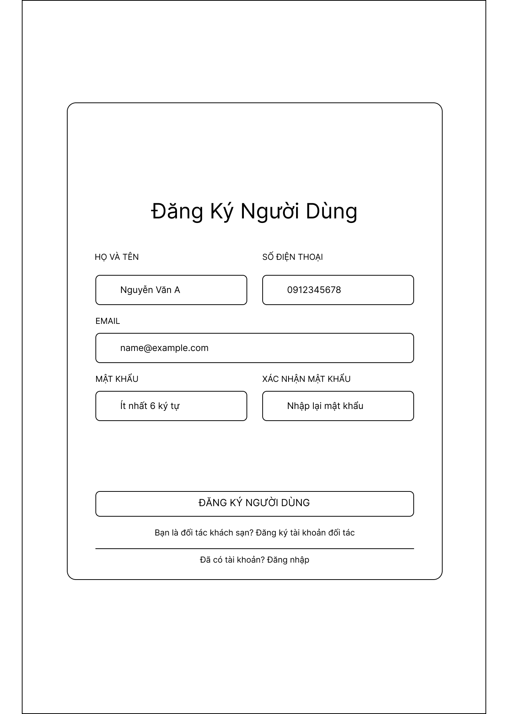

Field Name | Description
fullName | Full Name
phoneNumber | Phone Number
email | Email Address
password | Password
confirmPassword | Confirm Password
role | Account Role: Customer / Hotel Partner
verificationCode | Email Verification Code for mandatory email verification before account activation

1.2. Login Screen
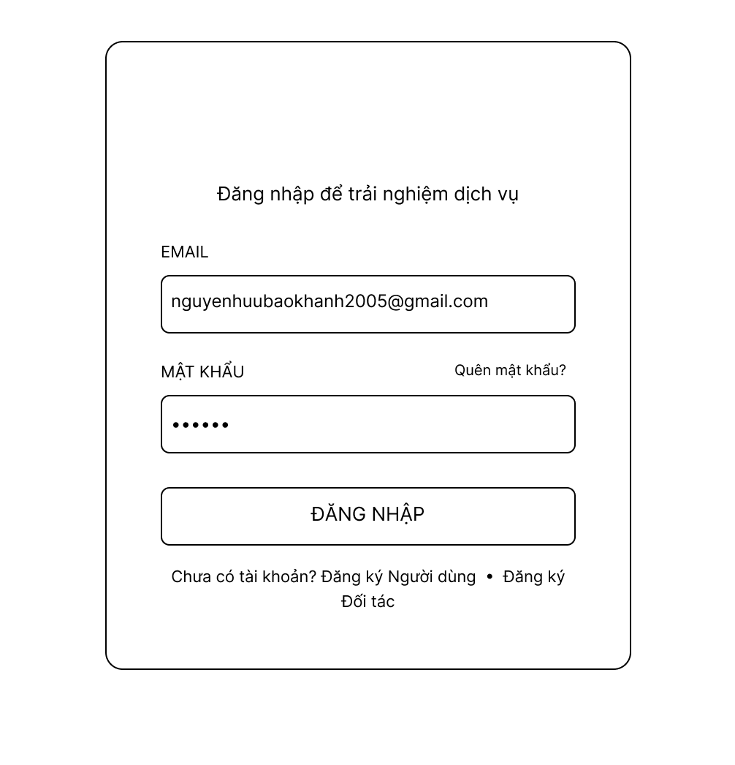

Field Name | Description
email | Registered email address used as the login identifier. Must be verified.
password | Account password matching the registered credentials.
forgotPasswordLink | Interactive link ("Quên mật khẩu") to initiate the password recovery flow via email.
loginButton | Action button ("Đăng nhập") to submit authentication credentials.

2. User Account Management Module

2.1. View Profile Screen
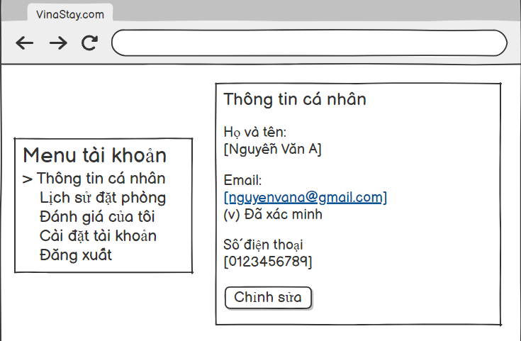

Field Name | Description
Account Menu | Navigation sidebar allowing the customer to switch between account management sections (e.g., Personal Information, Booking History, My Reviews, Account Settings, Logout).
Section Header | Title indicating the current active management view (e.g., Personal Information).
Full Name Display | Text field showing the user's full legal name.
Email Display | Field showing the user's registered email address.
Email Verification Status | Status indicator showing whether the user's email has been verified by the system.
Phone Number Display | Field showing the user's contact phone number.
Edit Button | Action button to modify personal account information to the database.

2.2. Change Password Screen
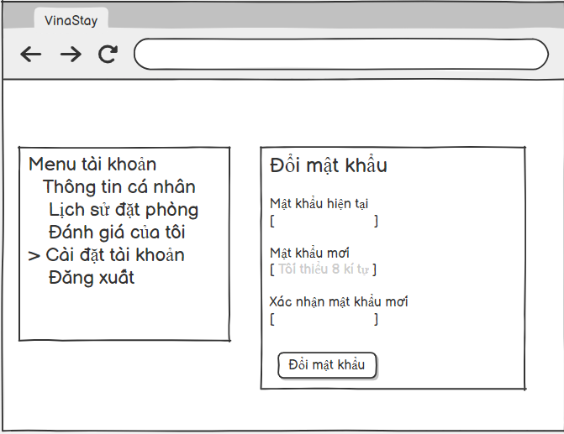

Field Name | Description
Account Menu | Navigation sidebar allowing the customer to switch between account management sections (e.g., Personal Information, Booking History, My Reviews, Account Settings, Logout).
Section Header | Title indicating the current active management view (e.g., Change Password).
Current Password Input | Text field showing or allowing updates to the user's full legal name.
New Password Input | Field showing the user's registered email address.
New Password Verification Input | Status indicator showing whether the user's email has been verified by the system.
Change Password Button | Action button to change password account to the database.

2.3. Edit Profile Screen
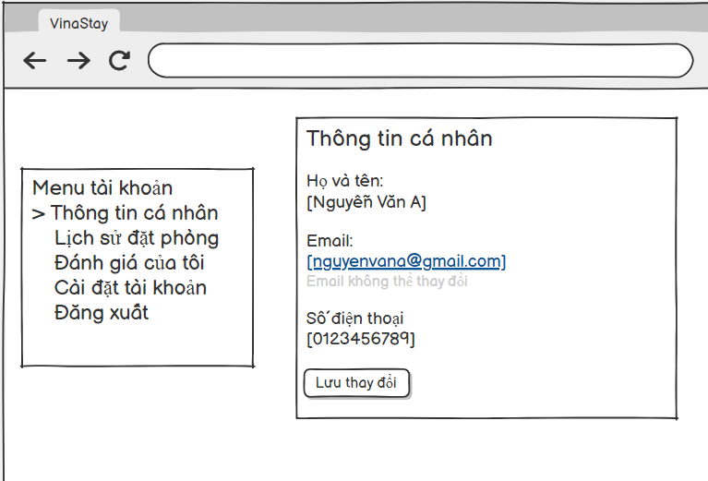

Field Name | Description
Account Menu | Navigation sidebar allowing the customer to switch between account management sections (e.g., Personal Information, Booking History, My Reviews, Account Settings, Logout).
Section Header | Title indicating the current active management view (e.g., Personal Information).
Full Name Input / Display | Text field showing or allowing updates to the user's full legal name.
Email Input / Display | Field showing the user's registered email address.
Email Verification Status | Status indicator showing whether the user's email has been verified by the system.
Phone Number Input / Display | Field showing or allowing updates to the user's contact phone number.
Save Button | Action button to save the modify personal account information to the database.

2.4. View User Accounts & Roles Screen
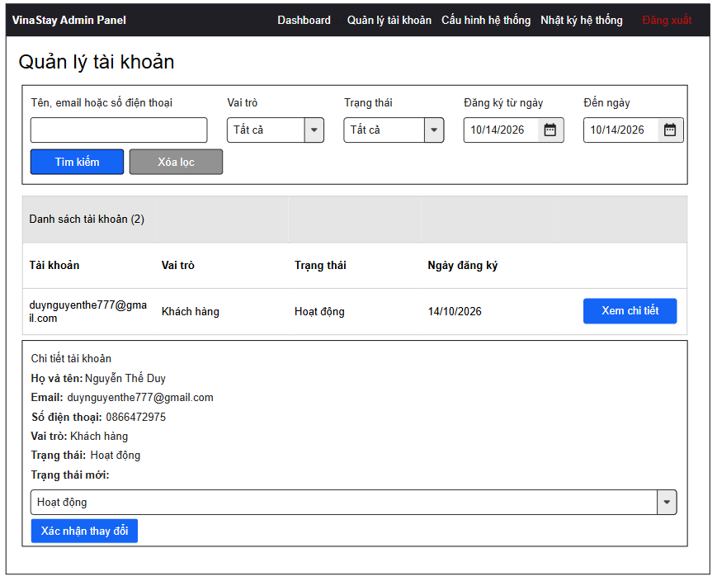
Field Name | Description
Search Bar | Text input field allowing administrators to search for users by name, email address, or phone number.
Role Filter | Dropdown filter to narrow down user records by specific assigned roles (e.g., All, Admin, Operations Manager, Hotel Partner, Customer).
Status Filter | Dropdown filter to filter the list by current account status (e.g., All, Active, Temporarily Locked, Blocked).
User List Table - Account / Email | Column displaying the user's primary login credential or registered email address.
User List Table - Full Name | Displays the registered full name of the account holder in the user detail view.
User List Table - Phone Number | Displays the user's registered phone number in the detailed user view section.
User List Table - Role | Column displaying the system permission role currently assigned to the user.
User List Table - Registration Date | Column indicating the date when the account was registered.
User List Table - Account Status | Column showing the current operational status of the account (e.g., Active, Temporarily Locked, Blocked).
User List Table - Actions | Action buttons (such as "View Details" and "Confirm Changes") allowing administrators to inspect user details, select a new status from the dropdown, and update account permissions.

3. Hotel & Room Discovery Module

3.1. Search Hotel Screen
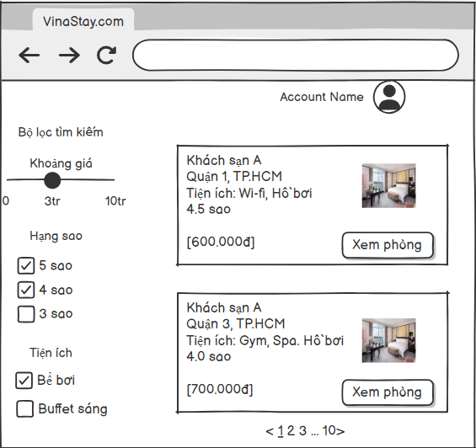

Field Name | Description
Price Range Filter | A slider component allowing users to filter hotels within a specific budget range (e.g., from 0 to 10M VND).
Star Rating Filter | Checkboxes to filter search results by hotel star ratings (e.g., 5 Stars, 4 Stars, 3 Stars).
Amenities Filter | Checkboxes to filter hotels based on preferred amenities (e.g., Swimming Pool, Breakfast Buffet).
Hotel Name | The commercial or official name of the hotel displayed in the search result card.
Location / Address | Summary of the geographical area or district where the hotel is located (e.g., District 1, HCMC).
Hotel Amenities (Snippet) | Key features and facilities offered by the hotel shown directly on the result card (e.g., Wi-Fi, Swimming Pool, Gym).
Average Star Rating | The aggregated rating score of the hotel based on customer reviews (e.g., 4.5 stars, 4.0 stars).
Base Price / Night | The starting or reference price per night for rooms at the hotel (e.g., 600.000đ ).
Thumbnail Image | A preview image representing the hotel property or room sample.
View Room Button | An action button that redirects the user from the search list to the detailed view of the selected hotel.
Pagination | Navigation links showing result page numbers to browse through multiple pages of search results.

3.2. View Hotel Details Screen
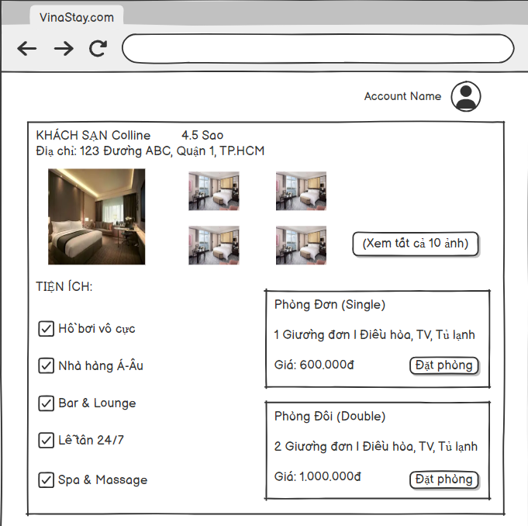

Field Name | Description
Hotel Title | The full official name of the hotel displayed at the top of the details page.
Official Star Rating | The official certified star rating of the hotel property.
Full Address | The complete street address and location details of the hotel.
Photo Gallery Grid | A layout displaying primary and secondary high-resolution photos of the hotel interior and rooms.
View All Photos Link | A button or link to open the full media gallery containing all property photos.
Hotel Amenities List | A comprehensive list of upscale facilities provided by the hotel with accompanying icons (e.g., Infinity Pool, Euro-Asian Restaurant, 24/7 Reception).
Room Type Name | The specific category or tier of the room (e.g., Single Room, Double Room).
Room Specifications | Summary of room capacity, bed configuration, and in-room amenities (e.g., 1 Single Bed )
Room Price | The fixed nightly rate for the specific room type.
Book Room Button | An action button next to each room type to select the room and proceed to the booking checkout step.

4. Booking Management Module

4.1. Book Room & Make Payment Screen
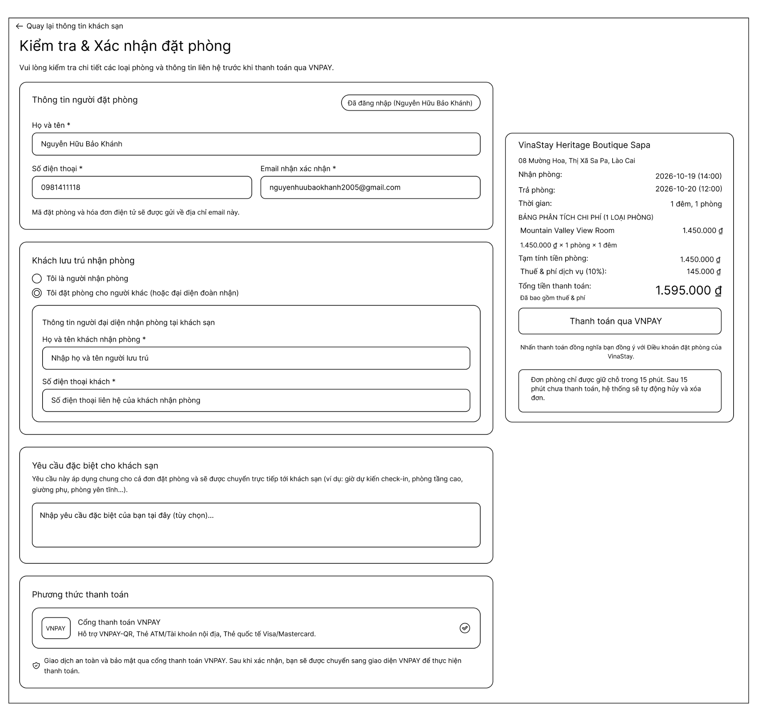

Field Name | Description
Full Name | Text input field for the full legal name of the person making the booking.
Phone Number | Input field for the contact phone number of the person booking.
Email Address | Input field for the confirmation email address where booking codes and electronic invoices are sent.
Guest Selection Radio | Radio buttons allow the user to indicate whether they are the staying guest or booking for someone else.
Guest Full Name | Optional or required input field for the primary staying guest's full name if booking on behalf of another person.
Guest Phone Number | Input field for the contact phone number of the primary staying guest.
Special Requests | Text area for optional guest notes or special requests (e.g., estimated check-in time, high floor, quiet room).
Payment Method Selection | Radio selection or payment option selection (e.g., VNPAY gateway supporting QR code, ATM/local cards, Visa/Mastercard).
Price Breakdown & Total Summary | Display section showing room subtotal, taxes & service fees (10%), check-in/check-out dates, stay duration, and total payable amount.
Payment / Checkout Button | Action button (e.g., "Thanh toán qua VNPAY") that redirects the user to the payment gateway to finalize the reservation.

4.2. View Booking History Screen
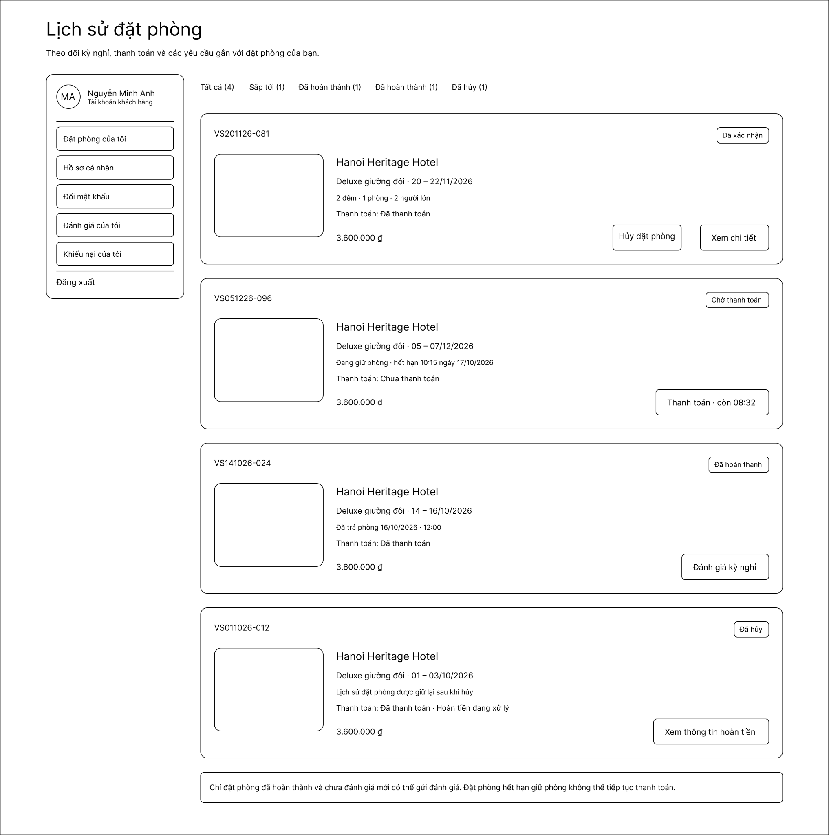

Field Name | Description
Status Filter Tabs | Filter options allowing users to view bookings by status (All, Upcoming, Completed, Cancelled).
Booking Code | Unique reference identifier for each booking reservation.
Hotel & Room Details | Information displaying hotel name, room type, stay dates, and guest count.
Payment Status & Total | Displays payment state (Paid, Unpaid) and total price charged for the stay.
Booking Action Buttons | Action buttons depending on status (e.g., View Details, Pay Now, Submit Review, View Refund Info).

4.3. Cancel Booking Screen
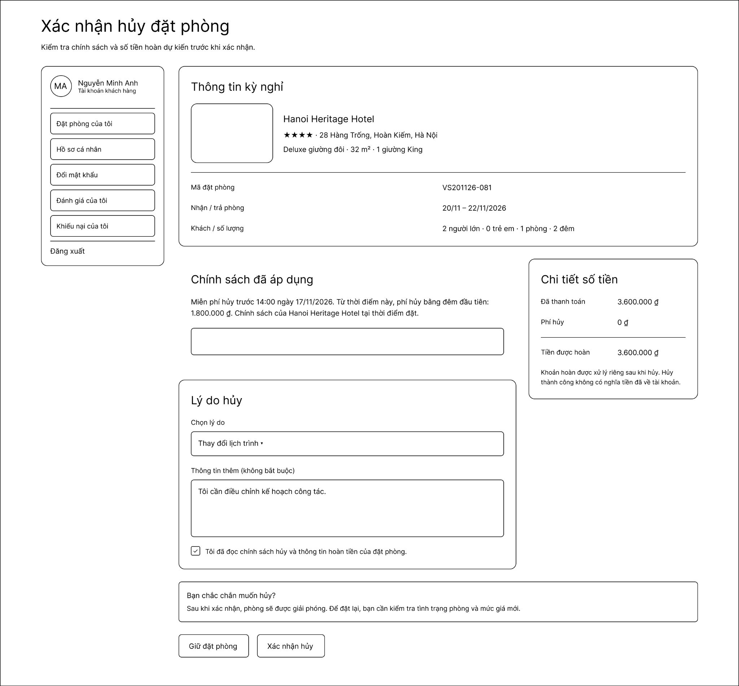

Field Name | Description
Booking Reference | Displays the unique code/identifier associated with the booking selected for cancellation.
Check-in / Check-out Dates | Shows the scheduled check-in and check-out dates and stay duration for the reservation.
Cancellation Policy Terms | Displays the specific cancellation rules and deadlines applicable to this booking based on the hotel's policy.
Calculated Cancellation Fee | Shows the fee amount deducted according to the cancellation timeline and policy terms.
Refund Amount | Displays the net estimated refund amount to be returned to the customer after deducting any cancellation fees.
Cancellation Reason Dropdown / Textarea | Selection list and optional text area allowing the user to specify or describe the reason for cancelling the reservation.
Confirmation Buttons | Action buttons ("Xác nhận hủy" to execute cancellation and "Giữ đặt phòng" to cancel the action and retain the booking).

4.4. Manage Booking Screen (Hotel Partner)

5. Hotel Statistics & Revenue Module

5.1. View Statistics Screen

6. Feedback & Reviews Module

6.1. Review & Rating List Screen
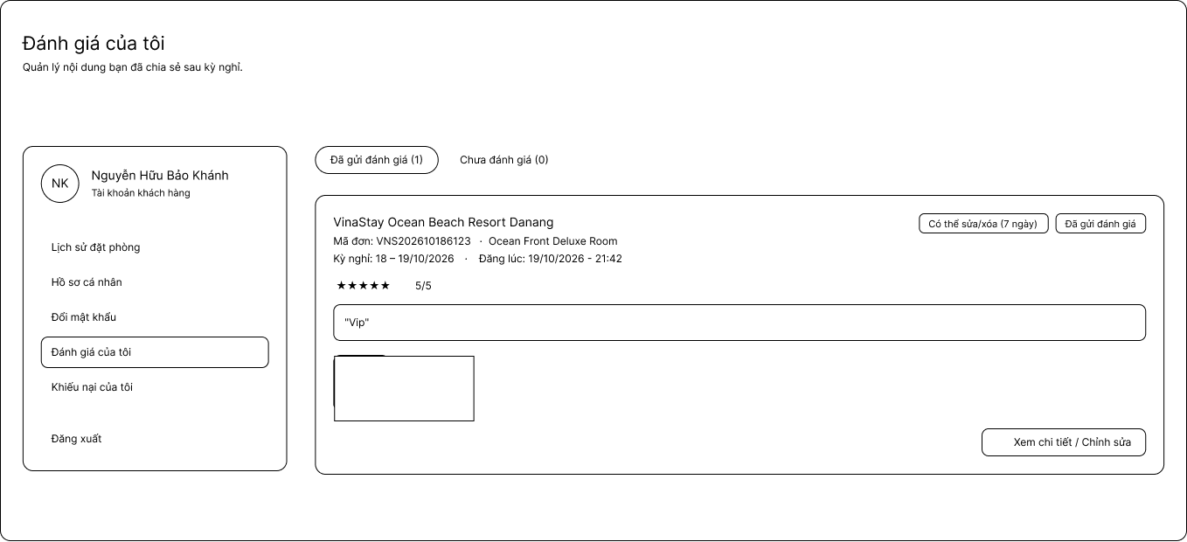

6.2. Submit Review & Rating Screen
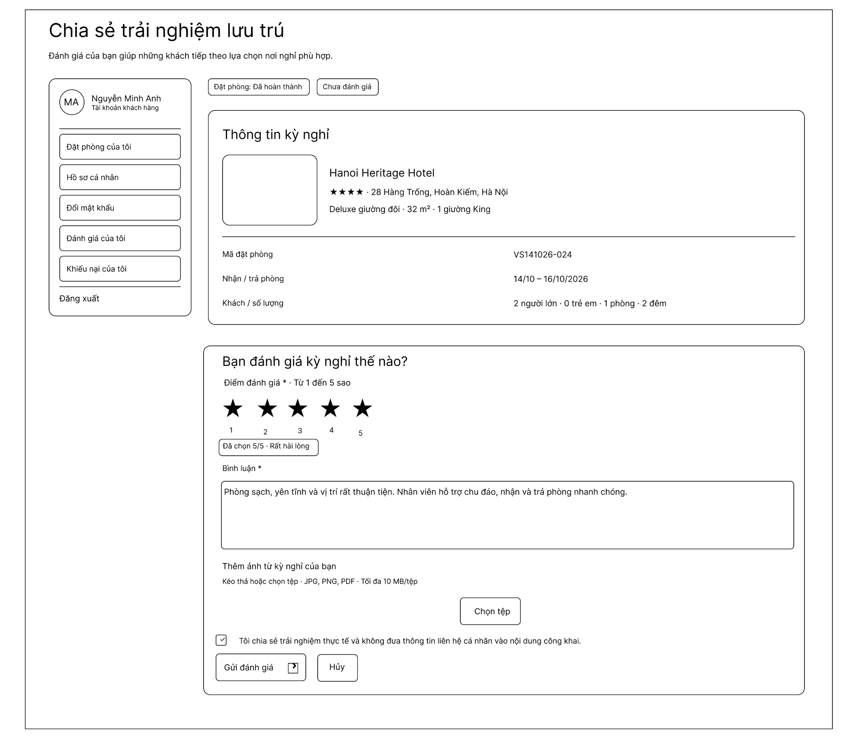

Field Name | Description
Stay Info Summary | Displays hotel name, address, room type, booking code, check-in/check-out dates, and guest details for the completed stay.
Star Rating Input | Interactive 1 to 5 star selection mechanism allowing customers to rate their overall stay experience.
Review Content Textarea | Text input area for customers to write detailed feedback and comments regarding their stay experience.
Attach Photo Button | File uploader button allowing customers to upload real photos/media from their hotel stay (supporting JPG, PNG, PDF up to 10 MB).
Public Consent Checkbox | Checkbox confirming that the customer agrees to share their genuine experience without exposing private contact info publicly.
Submit Review Button | Action button to post the rating and review content to the hotel's public page.
Cancel Button | Button to discard inputs and exit back to booking history.

6.3. Edit Reviews Screen
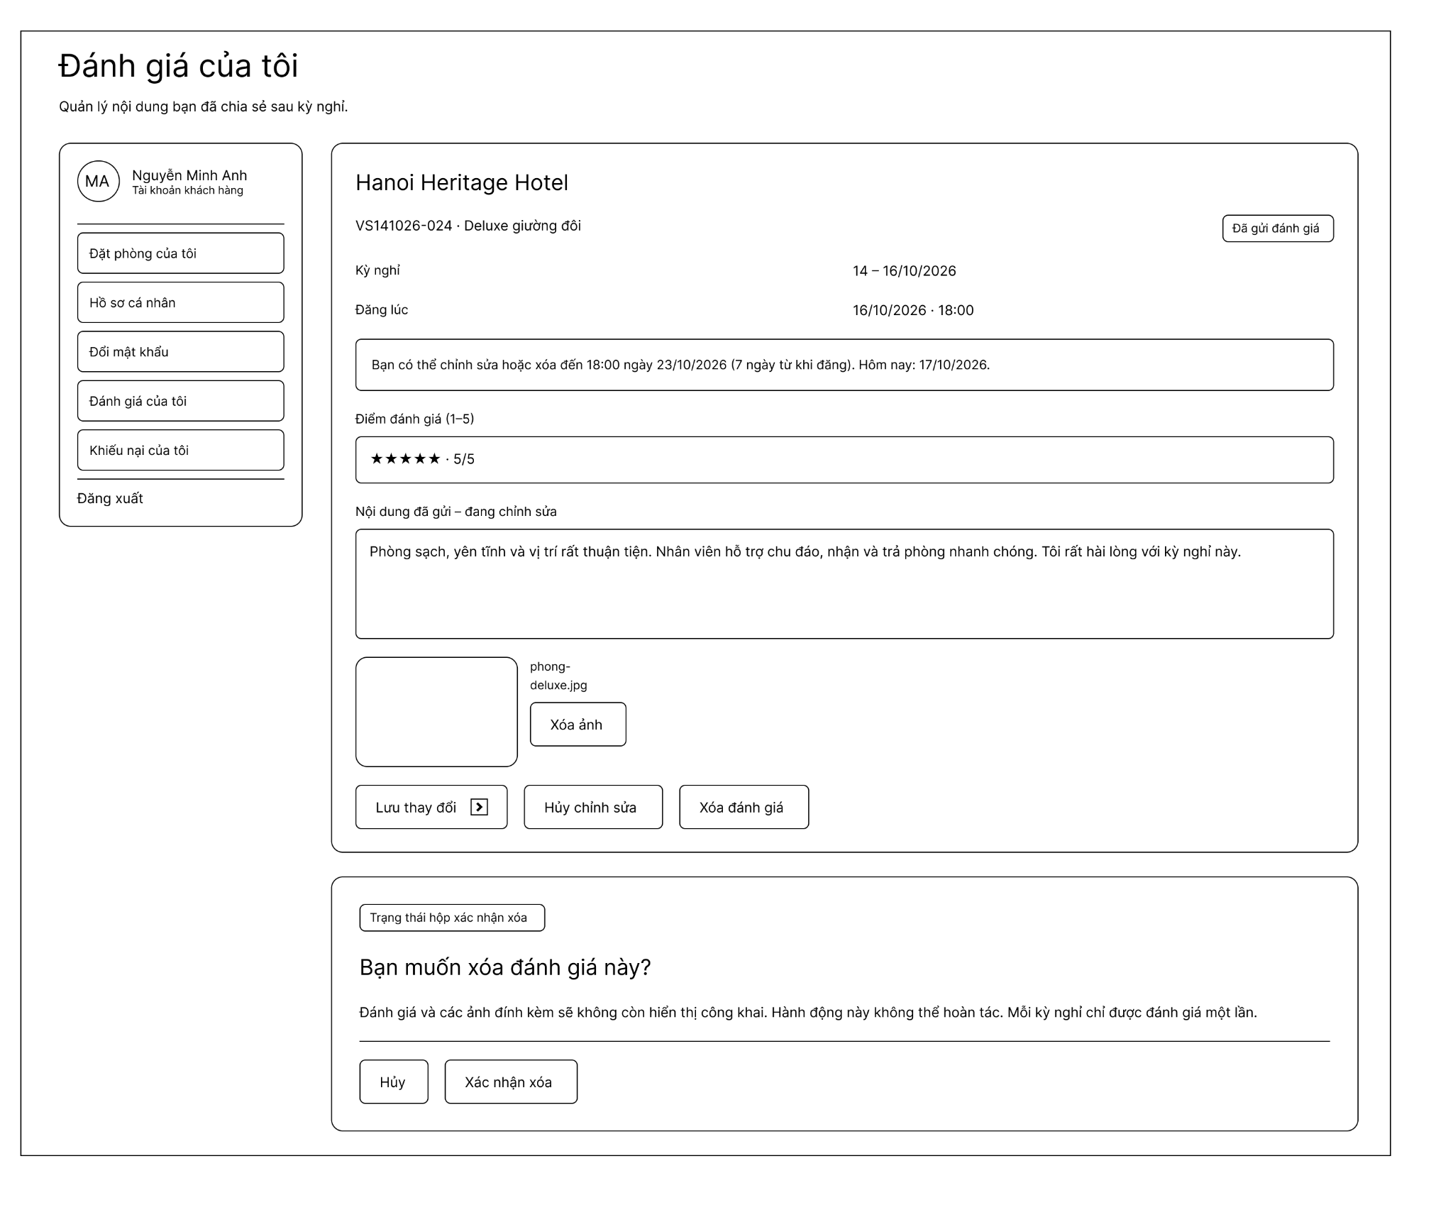

Field Name | Description
Review Details Header | Displays the hotel name, booking code, room type, stay dates, review submission timestamp, and current review status.
Modification Notice Banner | Informational message specifying the allowable time window (within 7 days) during which the customer can edit or delete their submitted review.
Star Rating Display / Edit | Interactive star component allowing customers to modify their previous rating (1 to 5 stars).
Review Content Field | Editable text area containing the submitted review comments, allowing the user to make corrections or add new feedback.
Uploaded Photo Item & Delete Button | Thumbnail preview of attached images along with a button to remove specific photos from the review.
Save Changes Button | Action button to submit and apply updated rating, comments, and media to the review record.
Cancel Edit Button | Button to discard all unsaved edits and return to the main review list.
Delete Review Button | Trigger button to open the deletion confirmation dialog to remove the review entirely.
Deletion Confirmation Dialog | Modal section confirming permanent removal of the review and its attachments, with "Cancel" and "Confirm Delete" options.

7. Dispute & Support Management Module

7.1. Submit Dispute Screen
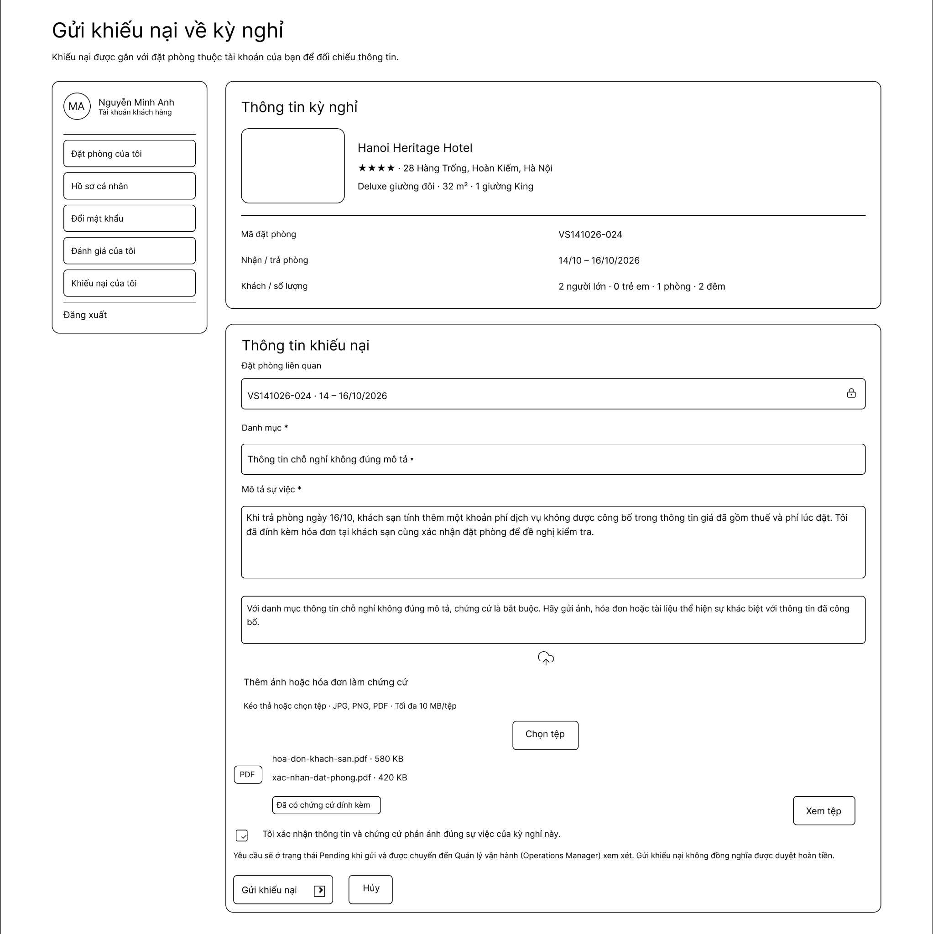

Field Name | Description
Stay Info Summary | Displays hotel name, star rating, address, room type, booking code, check-in/check-out dates, and guest count for the selected booking.
Related Booking Display | Read-only field showing the locked booking reference code and stay period tied to the dispute.
Category Dropdown | Required selector to classify the complaint category (e.g., property misrepresentation, extra charges, service issues).
Description Textarea | Required text input area where the user provides a detailed explanation of the issue encountered.
Attach Proof Button | File upload button allowing users to attach supporting evidence (photos, receipts, or documents in JPG, PNG, PDF up to 10 MB per file).
Evidence Confirmation Checkbox | Mandatory checkbox confirming the truthfulness and accuracy of the submitted dispute details and proof.
Submit Dispute Button | Action button to log the dispute ticket with status Pending for Operations Manager review.
Cancel Button | Button to discard all entered fields and exit back to booking history.

7.2. Handle Customer Disputes Screen

7.3. Resolve Partner Issues Screen

8. Customer Support & Interaction Module

8.1. Request Hotel Service Screen

8.2. Handle Customer Request Screen

9. System Configuration & Administration Module

9.1. Manage Commission Policy Screen

9.2. Admin Dashboard Screen
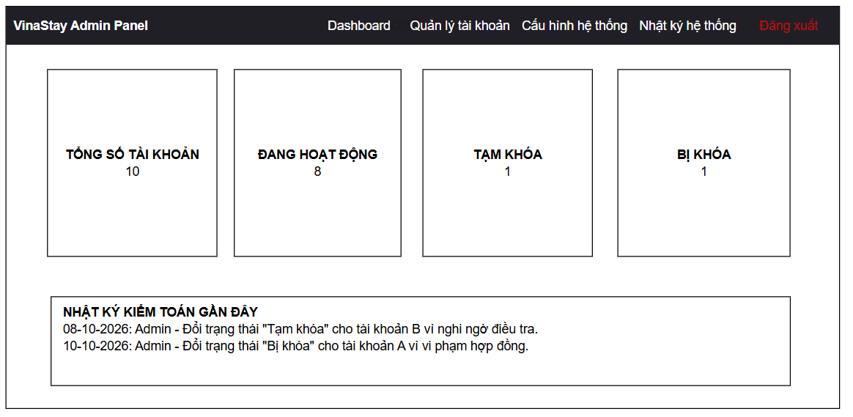

Field Name | Description
TOTAL ACCOUNTS | Card displaying the total number of registered accounts on the platform.
ACTIVE | Card displaying the number of accounts currently active in the system.
TEMPORARILY LOCKED | Card displaying the number of accounts that are temporarily locked.
BLOCKED | Card displaying the number of accounts that have been blocked.
RECENT AUDIT LOGS | Section displaying a list of recent administrative audit log entries, including timestamps, actions taken, target accounts, and reasons.

9.3. Configure System Settings Screen
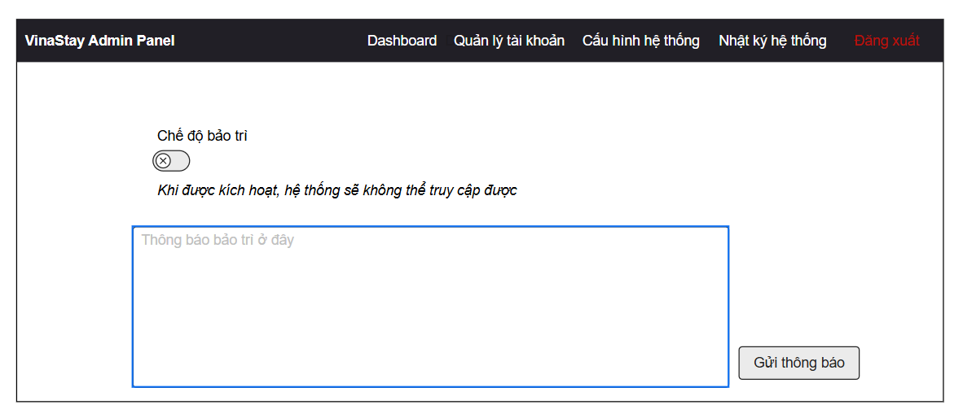

Field Name | Description
Maintenance Mode Toggle | Switch control to enable or disable system-wide maintenance mode.
Maintenance Announcement Input | Text area to enter technical maintenance notices or system alert messages displayed to users.
Send Notification Button | Action button to broadcast the entered system announcement across the platform and save configuration settings.

9.4. View System Logs & Monitoring Screen
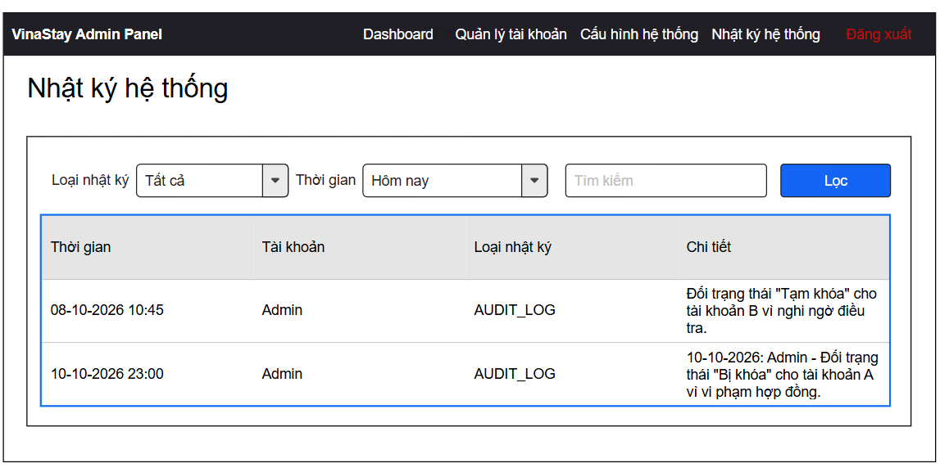
Field Name | Description
Log Type Filter | Dropdown filter to select specific log categories (e.g., All, Audit Log, System Error).
Time Range Filter | Dropdown selector to specify the time window for log retrieval (e.g., Today, Last 7 Days).
Search Input | Text input field to search logs by keyword, target account, or specific details.
Filter Button | Button to apply selected filters and refresh the log records table.
System Logs Table | 4-column table displaying log records with Timestamp, Account, Log Type, and Details.

10. Hotel Registration & Management Module

10.1. Register Hotel Screen
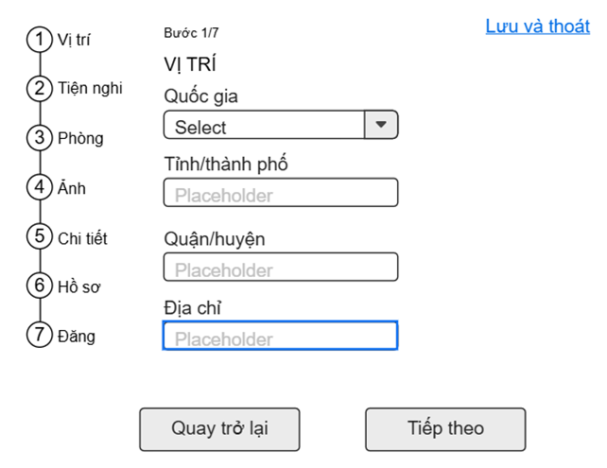

Field Name | Description
Step Navigator | Vertical list of the 7 wizard steps: Location, Amenities, Rooms, Photos, Details, Profile and Submit. The current step is highlighted. It is shown on every step of the wizard.
Step Counter | Text showing the current step out of the 7 steps of the registration.
Save and Exit Link | Link that saves the information entered so far as a draft and leaves the wizard. It is shown on every step of the wizard.
Country | Dropdown list for selecting the country where the hotel is located. Required.
Province/City | Text box for entering the province or city of the hotel. Required.
District | Text box for entering the district of the hotel. Required.
Address | Text box for entering the street address of the hotel. Required.
Back Button | Button that returns the Hotel Partner to the previous step of the wizard; the data already entered is kept.
Next Button | Button that validates the required fields of the current step and, if valid, moves to the next step; otherwise the invalid fields are highlighted with an error message.

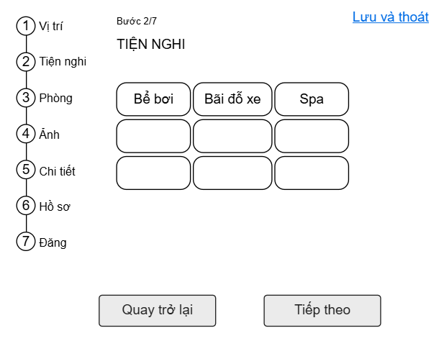

Field Name | Description
Amenity Tiles | Grid of selectable tiles, each representing a facility the hotel offers (e.g., Swimming pool, Parking, Spa). The Hotel Partner clicks a tile to select or deselect it; several amenities can be selected and selected tiles are highlighted.
Back Button | Button that returns the Hotel Partner to the previous step of the wizard; the data already entered is kept.
Next Button | Button that validates the required fields of the current step and, if valid, moves to the next step; otherwise the invalid fields are highlighted with an error message.

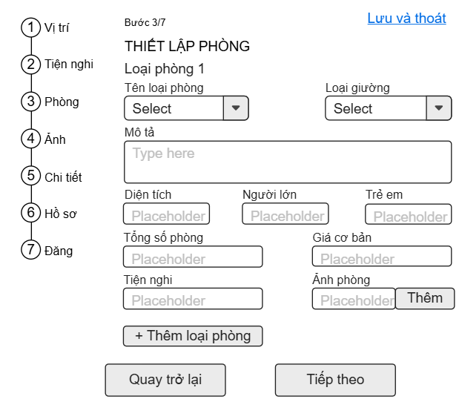

Field Name | Description
Room Type Heading | Heading of the room type block being configured; it is numbered automatically for each room type added.
Room Type Name | Dropdown list for selecting the category of the room (e.g., Single Room, Double Room). Required.
Bed Type | Dropdown list for selecting the bed configuration of the room. Required.
Description | Multi-line text area for describing the room type.
Area | Text box for entering the room area. Numeric, required.
Adults | Text box for entering the maximum number of adults the room can accommodate. Numeric, required.
Children | Text box for entering the maximum number of children the room can accommodate. Numeric.
Total Rooms | Text box for entering the number of rooms of this type that the hotel has. Numeric, required.
Base Price | Text box for entering the base nightly price of the room type. Numeric, required.
Room Amenities | Field for entering the in-room amenities of the room type.
Room Photos | Field with an "Add" (Thêm) button for attaching photos of the room type.
Add Room Type Button | Button that adds another room type block so that the hotel can define several room types.
Back Button | Button that returns the Hotel Partner to the previous step of the wizard; the data already entered is kept.
Next Button | Button that validates the required fields of the current step and, if valid, moves to the next step; otherwise the invalid fields are highlighted with an error message.

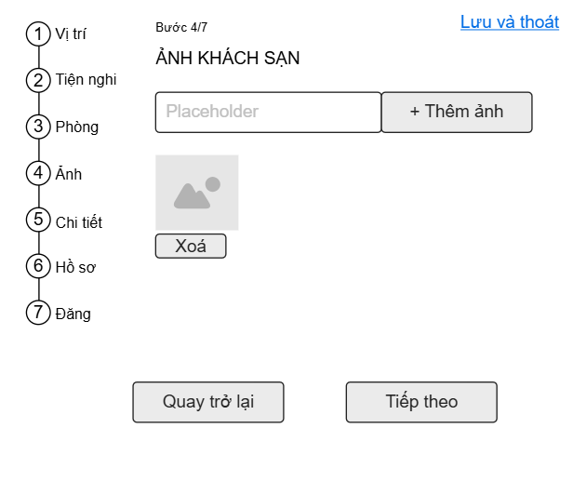

Field Name | Description
Photo Input | Input field showing the photo that is selected for upload.
Add Photo Button | Button that adds the selected photo to the hotel photo list; photos are uploaded to Cloudinary.
Photo Thumbnail | Preview of each photo added to the hotel gallery.
Delete Button | Button below each thumbnail that removes the photo from the list.
Back Button | Button that returns the Hotel Partner to the previous step of the wizard; the data already entered is kept.
Next Button | Button that validates the required fields of the current step and, if valid, moves to the next step; otherwise the invalid fields are highlighted with an error message.

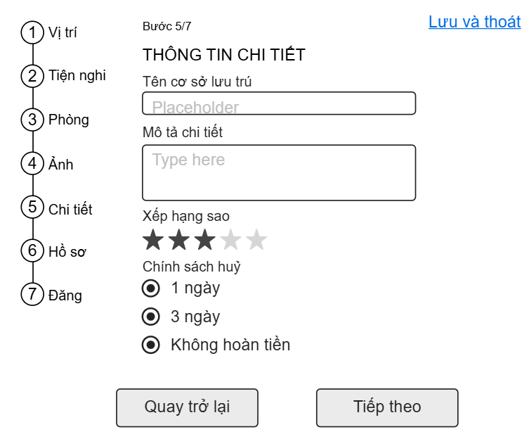

Field Name | Description
Hotel Name | Text box for entering the name of the hotel. Required.
Detailed Description | Multi-line text area for describing the hotel (location, facilities, highlights).
Star Rating | Row of five stars used to choose the official star rating of the hotel (1–5); the selected stars are filled.
Cancellation Policy | Radio button group for choosing the cancellation policy of the hotel: free cancellation up to 1 day before check-in (1 ngày), up to 3 days before check-in (3 ngày), or non-refundable (Không hoàn tiền). Only one option can be chosen. Required.
Back Button | Button that returns the Hotel Partner to the previous step of the wizard; the data already entered is kept.
Next Button | Button that validates the required fields of the current step and, if valid, moves to the next step; otherwise the invalid fields are highlighted with an error message.

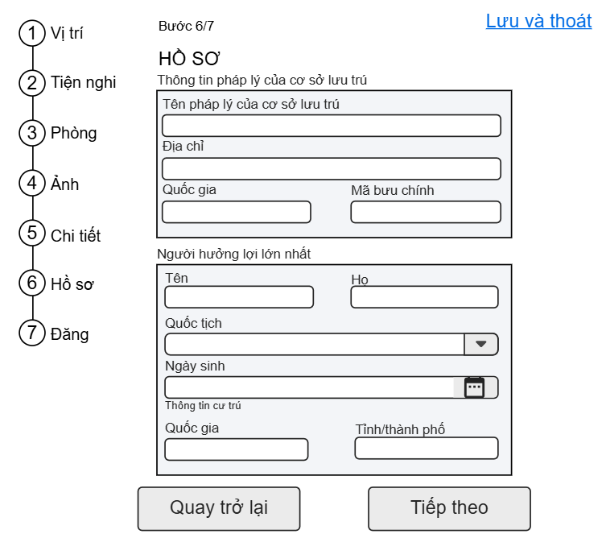

Field Name | Description
Legal Information Section | Group of fields that identify the legal entity operating the hotel.
Legal Name | Text box for entering the registered legal name of the hotel. Required.
Registered Address | Text box for entering the registered address of the hotel. Required.
Country | Text box for entering the country of the registered address. Required.
Postal Code | Text box for entering the postal code of the registered address.
Beneficial Owner Section | Group of fields that identify the ultimate beneficial owner of the hotel.
First Name | Text box for entering the owner's first name. Required.
Last Name | Text box for entering the owner's last name. Required.
Nationality | Dropdown list for selecting the owner's nationality. Required.
Date of Birth | Date field with a calendar picker for entering the owner's date of birth. Required.
Residence Information | Sub-section containing the owner's Country (Quốc gia) and Province/City (Tỉnh/thành phố) of residence. Required.
Back Button | Button that returns the Hotel Partner to the previous step of the wizard; the data already entered is kept.
Next Button | Button that validates the required fields of the current step and, if valid, moves to the next step; otherwise the invalid fields are highlighted with an error message.

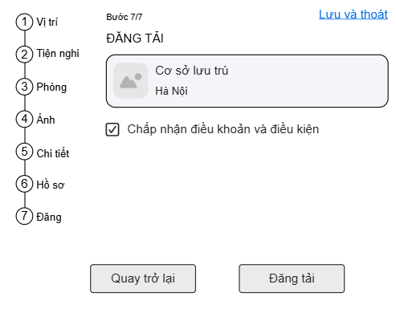

Field Name | Description
Hotel Summary Card | Card showing the main photo, the name and the city of the hotel so that the Hotel Partner can review the registration before submitting it.
Terms and Conditions Checkbox | Checkbox that the Hotel Partner must tick to accept the Terms and Conditions; submission is not allowed until it is ticked.
Back Button | Button that returns the Hotel Partner to the previous step of the wizard; the data already entered is kept.
Submit Button | Button that submits the hotel registration. The system validates the data, creates the registration with the status "Pending Verification" and notifies the Operations Manager.

10.2. Manage Hotel Information Screen
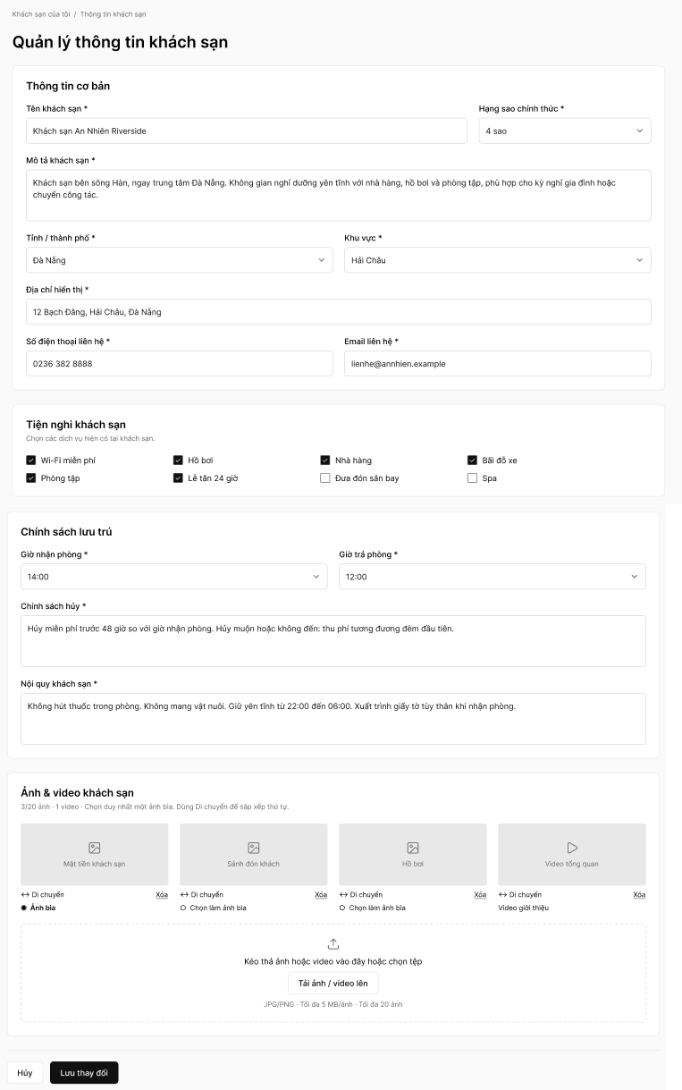

Field Name | Description
Breadcrumb | Navigation path "Khách sạn của tôi / Thông tin khách sạn". Clicking "Khách sạn của tôi" returns the Hotel Partner to the list of their hotels.
Basic Information Section | Group of fields containing the basic information, address and contact details of the hotel.
Hotel Name | Text box showing and allowing the Hotel Partner to edit the name of the hotel. Required.
Official Star Rating | Dropdown list for selecting the official star rating of the hotel (e.g., 4 sao). Required.
Hotel Description | Multi-line text area for describing the hotel (location, atmosphere, facilities, highlights). Required.
Province/City | Dropdown list for selecting the province or city where the hotel is located. Required.
District | Dropdown list for selecting the district/area of the hotel within the chosen province or city. Required.
Display Address | Text box for entering the address shown to customers on the hotel details page. Required.
Contact Phone | Text box for entering the contact phone number of the hotel. Required.
Contact Email | Text box for entering the contact email address of the hotel. Required; must be a valid email format.
Hotel Amenities Section | Group of checkboxes listing the facilities the hotel offers: Wi-Fi miễn phí, Hồ bơi, Nhà hàng, Bãi đỗ xe, Phòng tập, Lễ tân 24 giờ, Đưa đón sân bay and Spa. Several amenities can be ticked; ticked items are the ones displayed to customers.
Check-in Time | Dropdown list for selecting the check-in time of the hotel (e.g., 14:00). Required.
Check-out Time | Dropdown list for selecting the check-out time of the hotel (e.g., 12:00). Required.
Cancellation Policy | Multi-line text area for entering the cancellation policy of the hotel. Required. A change applies only to bookings made after it is saved.
House Rules | Multi-line text area for entering the house rules (smoking, pets, quiet hours, check-in documents, etc.). Required.
Photo/Video Counter | Text under the section title showing the number of photos and videos uploaded against the limit (e.g., "3/20 ảnh · 1 video"), with a note on choosing one cover photo and using Move to sort the order.
Photo/Video Tile | Thumbnail of each photo or video of the hotel with a caption (e.g., Mặt tiền khách sạn, Sảnh đón khách, Hồ bơi, Video tổng quan). The first line under each tile holds the Move and Delete controls.
Move Handle | Control on each tile used to drag the photo/video to a new position to change the display order.
Delete Link | Link on each tile that removes the photo/video from the hotel gallery.
Cover Photo Option | Radio option under each photo. The selected photo is marked "Ảnh bìa" and is the cover photo of the hotel; exactly one photo can be the cover photo. A video is labelled "Video giới thiệu" and cannot be chosen as the cover.
Upload Area | Drag-and-drop area with the "Tải ảnh / video lên" button for choosing files from the device. Accepted photos are JPG/PNG, up to 5 MB per photo and up to 20 photos per hotel. Uploaded files are stored on Cloudinary.
Cancel Button | Button that discards the unsaved changes and leaves the screen without saving.
Save Changes Button | Button that validates the submitted information and saves it. Non-sensitive changes are published immediately; sensitive changes (e.g., legal hotel name, address, legal documents) are submitted to the Operations Manager as a change request "Pending Verification" while the current data stays published. The system then displays which changes are live and which are pending.

10.3. Manage Room Type Screen
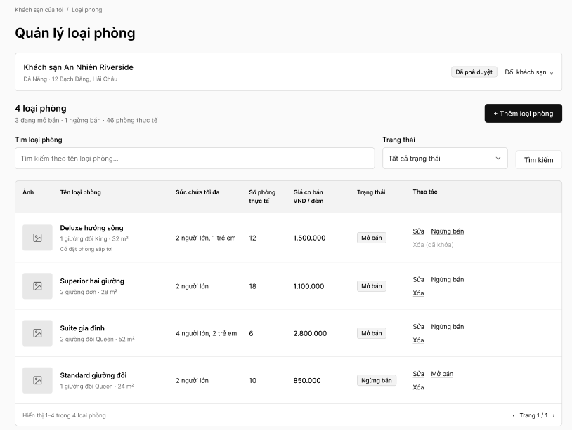

Field Name | Description
Breadcrumb | Navigation path "Khách sạn của tôi / Loại phòng". Clicking "Khách sạn của tôi" returns the Hotel Partner to the list of their hotels.
Hotel Information Card | Card showing the name, city and address of the hotel whose room types are managed (e.g., "Đà Nẵng · 12 Bạch Đằng, Hải Châu") and its status badge (e.g., "Đã phê duyệt").
Switch Hotel Dropdown | Dropdown for switching to another approved hotel of the Hotel Partner; the room type list is reloaded for the selected hotel.
Room Type Summary | Heading with the total number of room types (e.g., "4 loại phòng") and a line showing how many are on sale (đang mở bán), not on sale (ngừng bán) and the total number of physical rooms (phòng thực tế).
Add Room Type Button | Button that opens the Add Room Type screen (10.4).
Search Box | Text box for searching room types by name.
Status Filter | Dropdown list for filtering room types by status: Tất cả trạng thái (default), Mở bán (Active) or Ngừng bán (Inactive).
Search Button | Button that applies the keyword and the status filter and refreshes the list.
Photo | Column showing the thumbnail (first photo) of the room type.
Room Type Name | Column showing the room type name, with the bed configuration and room area below it (e.g., "1 giường đôi King · 32 m²"). A note "Có đặt phòng sắp tới" is displayed when the room type has upcoming bookings.
Maximum Occupancy | Column showing the maximum number of adults and children the room type can accommodate.
Actual Rooms | Column showing the number of physical rooms of the room type.
Base Price | Column showing the base price per room per night in VND.
Status | Badge showing the status of the room type: "Mở bán" (Active, visible in search and bookable) or "Ngừng bán" (Inactive, hidden from search).
Edit Link | Link that opens the Edit Room Type screen (10.5) for the selected room type.
Deactivate/Activate Link | Link that changes the status of the room type. "Ngừng bán" is shown for an Active room type; after confirmation it becomes Inactive, is hidden from search and new bookings, and existing bookings remain valid (a warning is shown for the last Active room type). "Mở bán" is shown for an Inactive room type; the system validates the price and quantity before setting it back to Active.
Delete Link | Link that deletes the room type after confirmation. It is disabled and displayed as "Xóa (đã khóa)" when the room type has upcoming bookings; such a room type can only be deactivated.
Pagination | Footer text "Hiển thị 1–4 trong 4 loại phòng" and page controls (previous/next arrows and "Trang 1 / 1") for browsing the list.

10.4. Add Room Type Screen
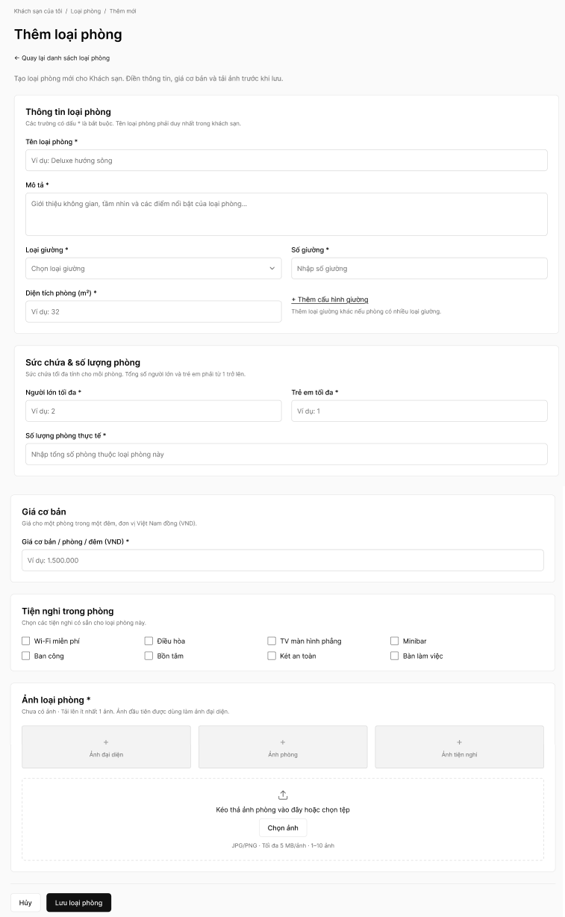

Field Name | Description
Breadcrumb | Navigation path "Khách sạn của tôi / Loại phòng / Thêm mới".
Back Link | Link that returns the Hotel Partner to the Manage Room Type screen (10.3) without saving.
Room Type Information Section | Group of fields describing the room type. Fields marked with * are mandatory.
Room Type Name | Text box for entering the name of the room type (e.g., Deluxe hướng sông). Required; must be unique within the hotel, otherwise the message "Tên loại phòng đã tồn tại." (MSG09) is displayed.
Description | Multi-line text area for describing the space, view and highlights of the room type. Required.
Bed Type | Dropdown list for selecting the bed type of the room (e.g., Giường đôi King). Required.
Number of Beds | Text box for entering the number of beds of the selected bed type. Numeric, required.
Add Bed Configuration Link | Link that adds another bed type/quantity line when the room has more than one kind of bed.
Room Area (m²) | Text box for entering the room area in square metres. Numeric, required.
Maximum Adults | Text box for entering the maximum number of adults the room can accommodate. Numeric, required.
Maximum Children | Text box for entering the maximum number of children the room can accommodate. Numeric, required. The total of adults and children must be at least 1.
Actual Room Quantity | Text box for entering the number of physical rooms of this type; it is the basis of the daily room inventory. Positive integer, required, not exceeding the configured limit.
Base Price | Text box for entering the base price per room per night in VND. Numeric, required, greater than 0.
Room Amenities | Group of checkboxes for the in-room amenities: Wi-Fi miễn phí, Điều hòa, TV màn hình phẳng, Minibar, Ban công, Bồn tắm, Két an toàn and Bàn làm việc. Several amenities can be ticked.
Room Photos Section | Section for the photos of the room type; at least 1 photo is required. Shows the message "Chưa có ảnh" until a photo is added. The first photo is used as the representative/thumbnail photo.
Photo Slots | Placeholder slots with a "+" sign showing where the added photos appear; added photos are displayed as thumbnails.
Upload Area / Choose Photo Button | Drag-and-drop area with a button for choosing photos from the device. Accepted JPG/PNG, up to 5 MB per photo, 1–10 photos per room type. Photos are stored on Cloudinary.
Cancel Button | Button that discards the entered data and returns to the Manage Room Type screen.
Save Room Type Button | Button that validates the mandatory data and business rules, creates the room type, initializes the room inventory from the quantity, displays a success message and returns to the Manage Room Type screen.

10.5. Edit Room Type Screen
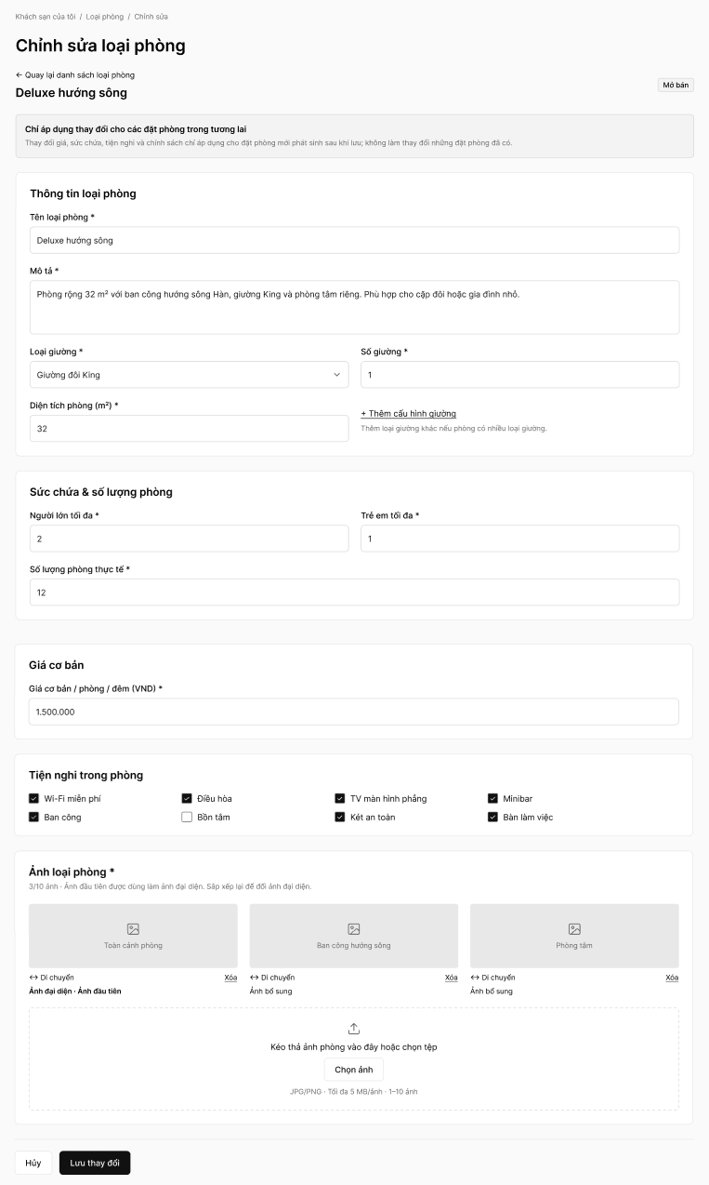
Field Name | Description
Breadcrumb | Navigation path "Khách sạn của tôi / Loại phòng / Chỉnh sửa".
Back Link | Link that returns the Hotel Partner to the Manage Room Type screen (10.3) without saving.
Room Type Heading and Status Badge | Name of the room type being edited (e.g., Deluxe hướng sông) and a badge with its current status (e.g., "Mở bán"). The status cannot be changed on this screen; it is changed on the Manage Room Type screen.
Impact Notice | Information box stating that changes to price, capacity, amenities and policies apply only to new bookings generated after saving; existing bookings are not changed.
Room Type Information Section | Group of fields describing the room type, pre-filled with the current data. Fields marked with * are mandatory.
Room Type Name | Text box for editing the name of the room type (e.g., Deluxe hướng sông). Required; must be unique within the hotel, otherwise the message "Tên loại phòng đã tồn tại." (MSG09) is displayed.
Description | Multi-line text area for describing the space, view and highlights of the room type. Required.
Bed Type | Dropdown list for changing the bed type of the room (e.g., Giường đôi King). Required.
Number of Beds | Text box for editing the number of beds of the selected bed type. Numeric, required.
Add Bed Configuration Link | Link that adds another bed type/quantity line when the room has more than one kind of bed.
Room Area (m²) | Text box for editing the room area in square metres. Numeric, required.
Maximum Adults | Text box for editing the maximum number of adults the room can accommodate. Numeric, required.
Maximum Children | Text box for editing the maximum number of children the room can accommodate. Numeric, required. The total of adults and children must be at least 1.
Actual Room Quantity | Text box for editing the number of physical rooms of this type. Positive integer, required. It cannot be lower than the highest number of rooms already booked on a future date; otherwise the change is rejected and the affected dates and minimum allowed quantity are displayed.
Base Price | Text box for editing the base price per room per night in VND. Numeric, required, greater than 0. The new price applies only to bookings made after saving.
Room Amenities | Group of checkboxes for the in-room amenities, with the amenities currently offered ticked. The Hotel Partner can tick or untick any item.
Room Photos Section | Section listing the current photos of the room type with a counter (e.g., "3/10 ảnh"). At least 1 photo is required; the first photo is the representative photo.
Photo Tile | Thumbnail of each photo with a caption and its Move and Delete controls. The first photo is marked "Ảnh đại diện · Ảnh đầu tiên"; the other photos are marked "Ảnh bổ sung".
Move Handle | Control used to drag a photo to a new position; the photo placed first becomes the representative photo.
Delete Link | Link that removes the photo from the room type.
Upload Area / Choose Photo Button | Drag-and-drop area with a button for adding more photos. Accepted JPG/PNG, up to 5 MB per photo, 1–10 photos per room type. Photos are stored on Cloudinary.
Cancel Button | Button that discards the unsaved changes and returns to the Manage Room Type screen.
Save Changes Button | Button that validates the mandatory data, the business rules and the impact on existing bookings, saves the changes, updates the inventory and displays a success message.

